ASSIGNMENT-10.6
Table Creation And Data Load
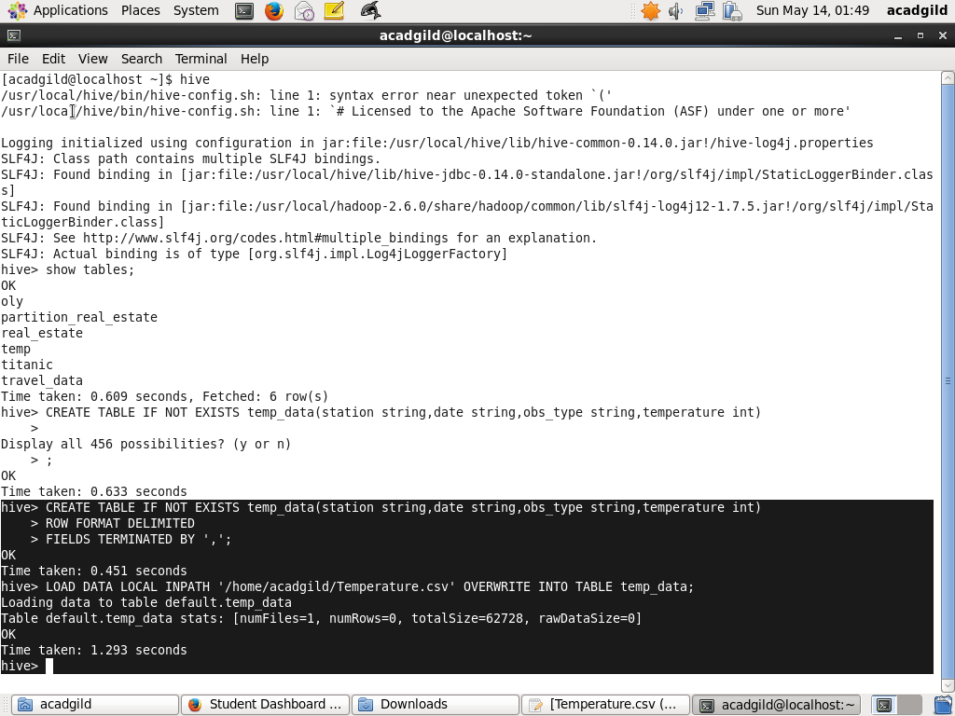
- Minimum temperature observed in a given weather station in a particular year.
Query Execution
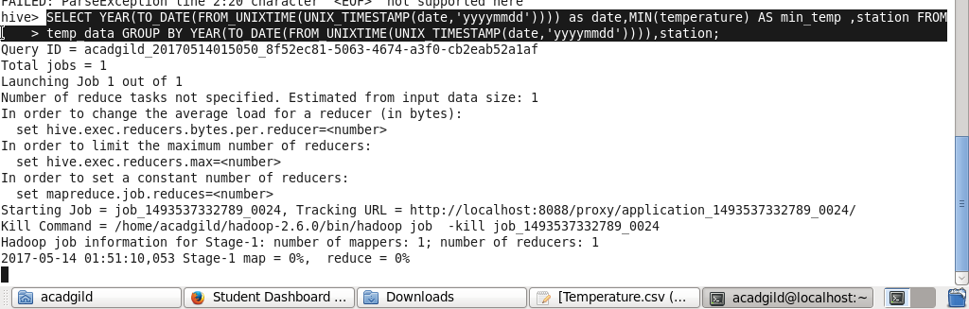
Result
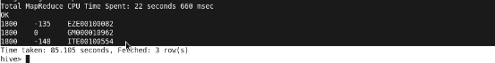

- Maximum temperature observed in a given weather station in a particular year.
Query Execution
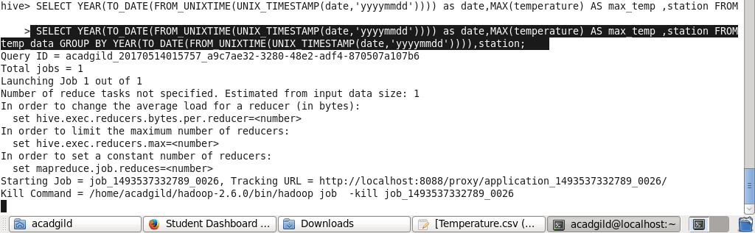
Result
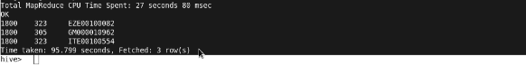
- The number of readings given by each weather station according to the dataset.
Query Execution
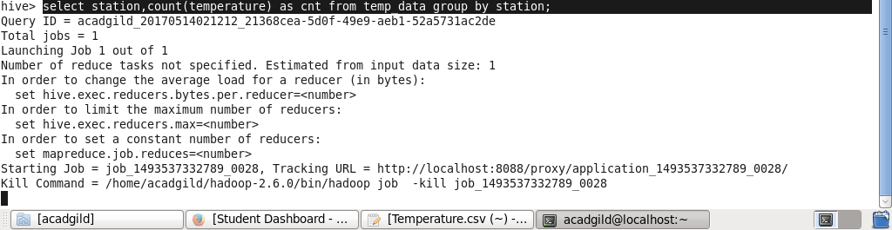

Result
