**Assignment-11.1**

1. Write a Hive program to find the number of medals won by each country in swimming.

Create the table:

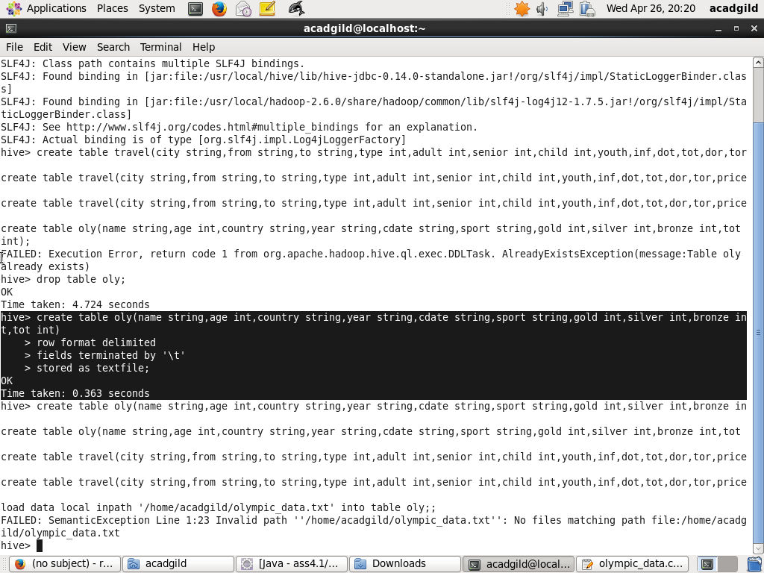

Load the data:

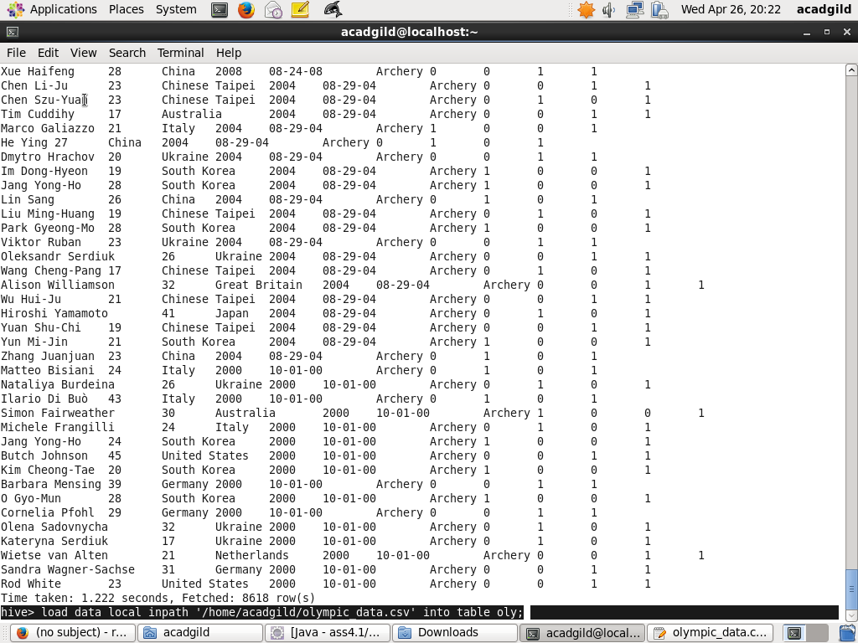

Hive query to find the number of medals won by each country in swimming:

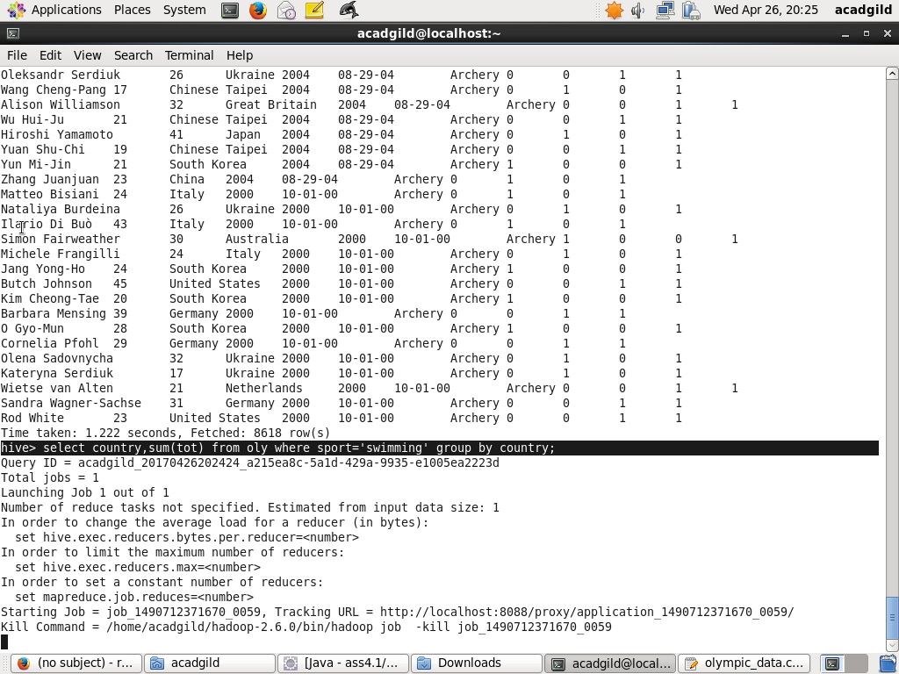

Result for the above query:

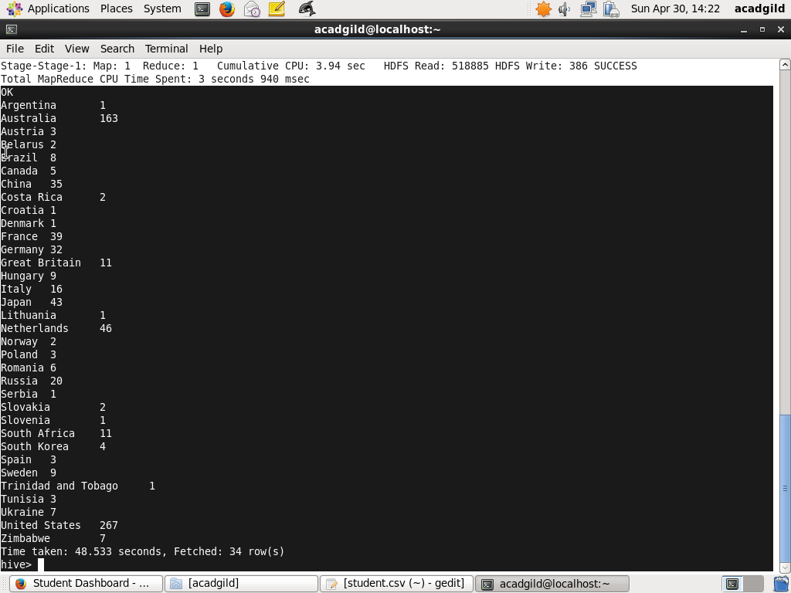

1. Write a Hive program to find the number of medals that India won year wise.

Create the table:



Load the data:



Hive query to find the number of medals that India won year wise:

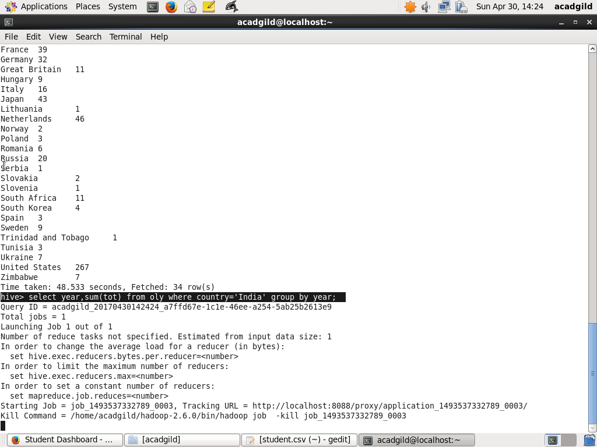

Result for the above query:

