**Assignment-11.4**

1. **Write a hive query to find the city wise list all the Condos which is not less than ten thousand.**

Create the table real_estate:

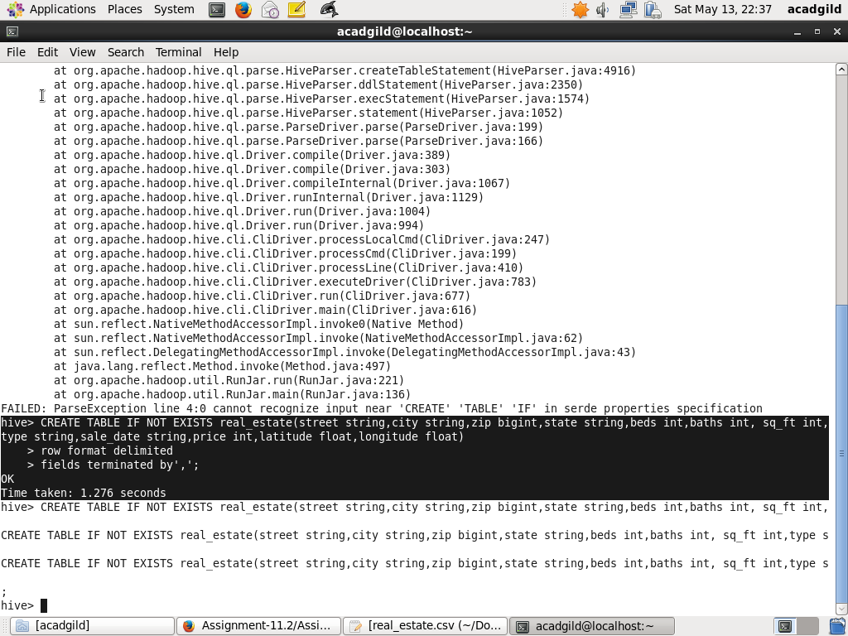

Load the data: 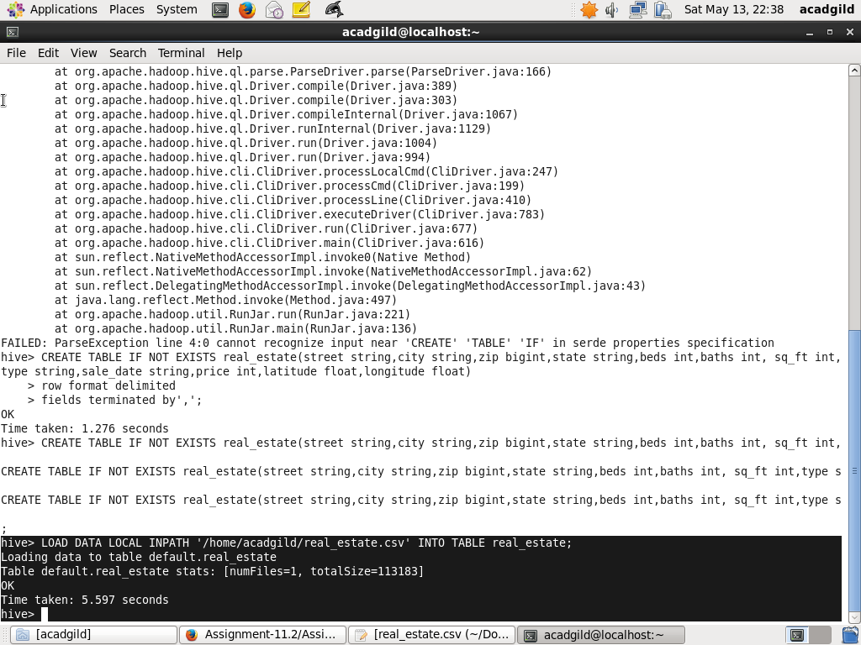

Query to find the city wise list all the Condos which is not less than ten thousand.

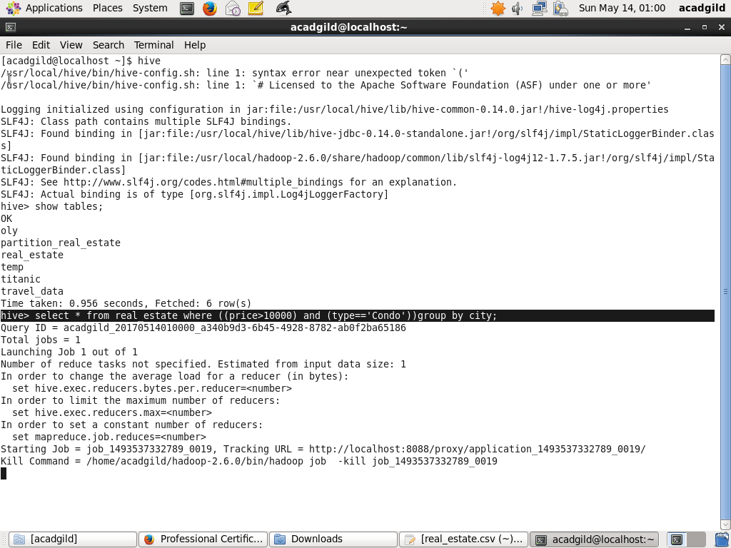

Result for the above query:

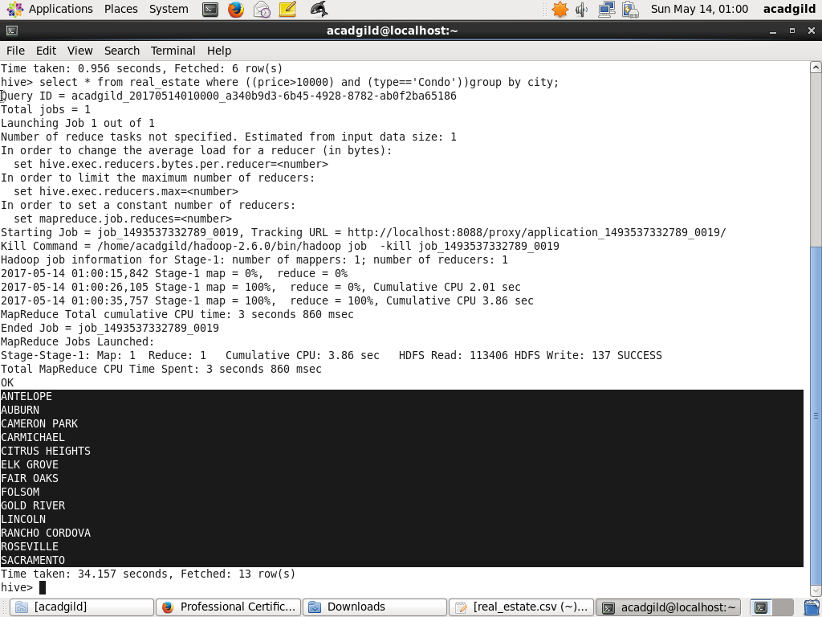

**2.Write a hive query to find which is the cheapest Condo in CA. name the city,street and price for the Condo.**

Create the table real_estate:



Load the data: 

Query to find which is the cheapest Condo in CA. name the city,street and price for the Condo:

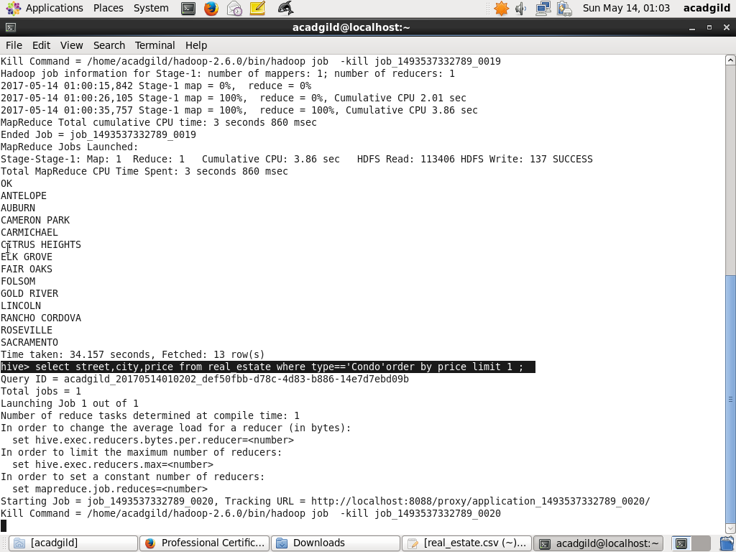

Result for the above query:

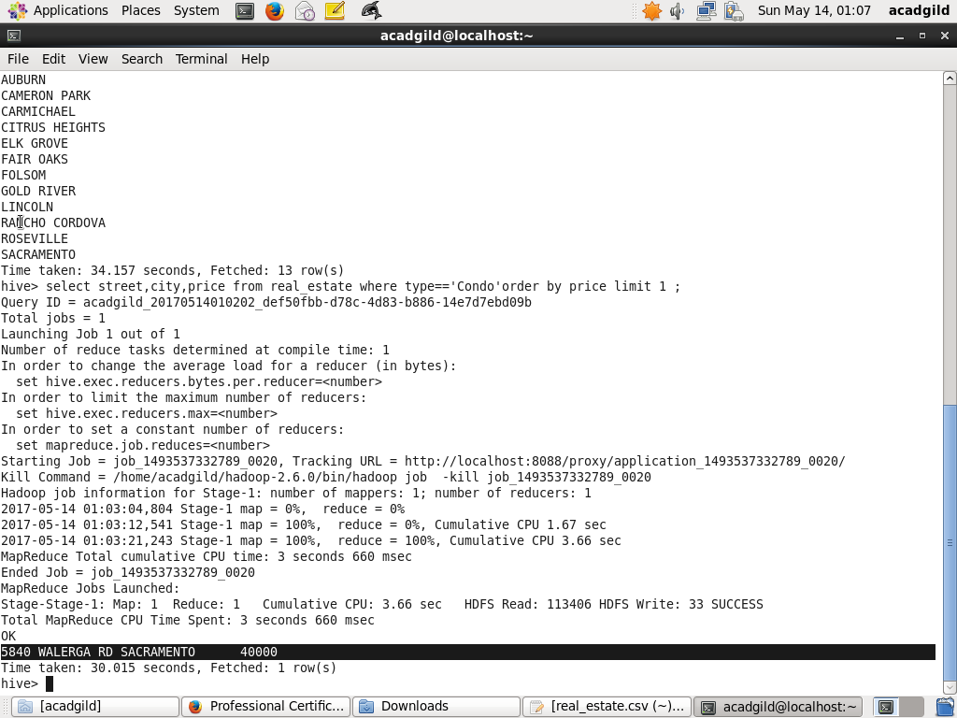

**3.Write a hive query to list top 5 residency details which lie in the budget of 60000-120000, an area more than 1450, sold after 17th may, min bedroom 3 and, min bathroom 2.**

Create the table real_estate:



Load the data: 

Query to list top 5 residency details which lie in the budget of 60000-120000, an area more than 1450, sold after 17th may, min bedroom 3 and, min bathroom 2.

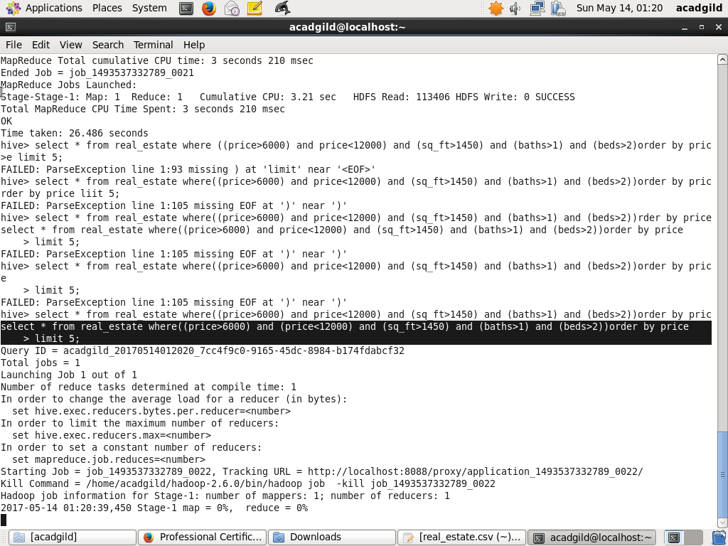

Result for the above query:

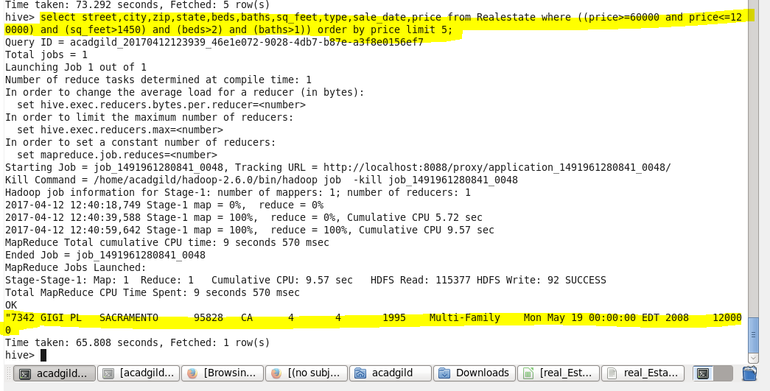

1. **Write a hive query to separate list of residential apartments with more than 2 beds. Also include columns in following order City,Baths,Sq_feet,Price,flat_type,Beds respectively.**

Create the table real_estate:



Load the data: 

Query to separate list of residential apartments with more than 2 beds:

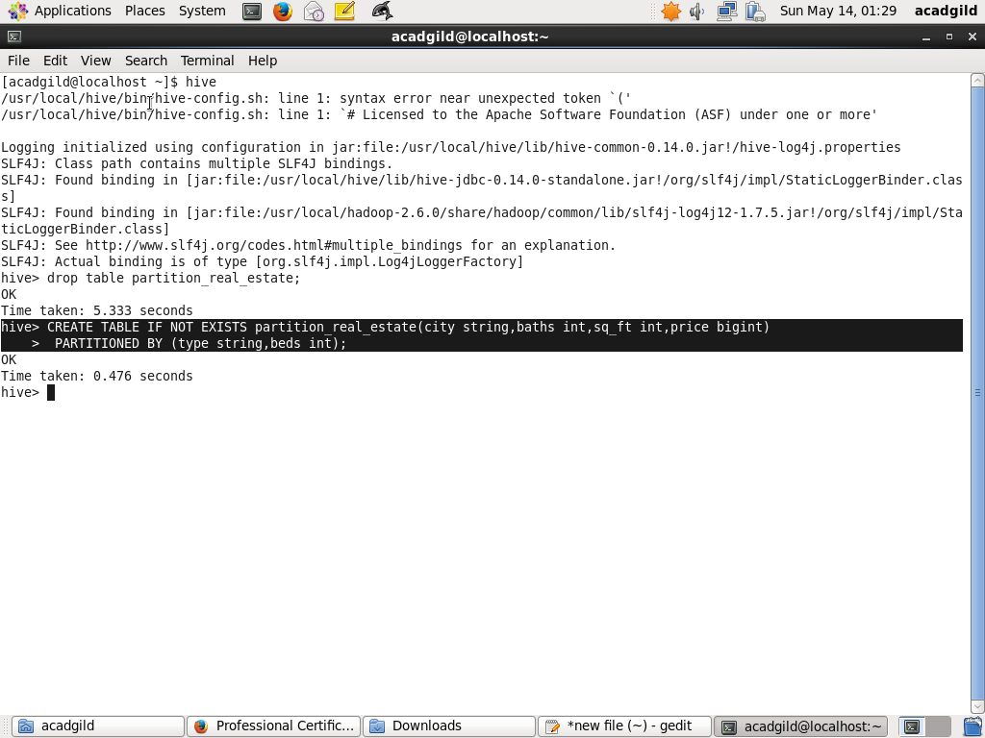

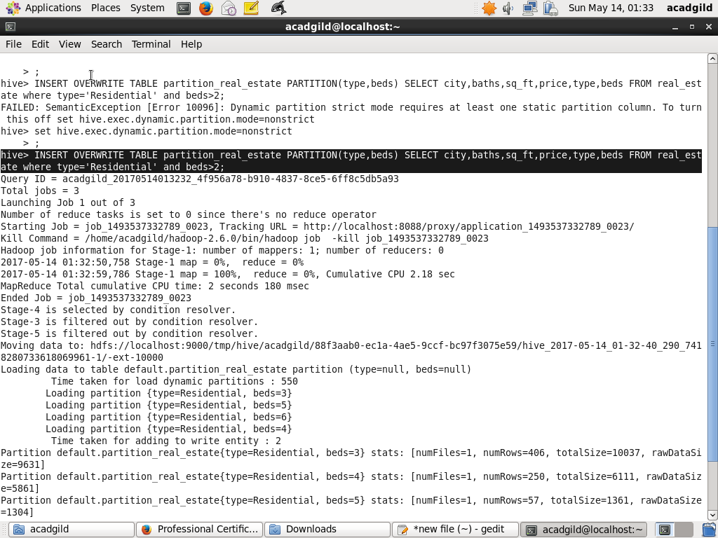

Result for the above query:

