**ASSIGNMENT-13.2**

load an input dataset from Pig to Hbase table and send the steps and screenshot of the final output

Hbase Table Creation

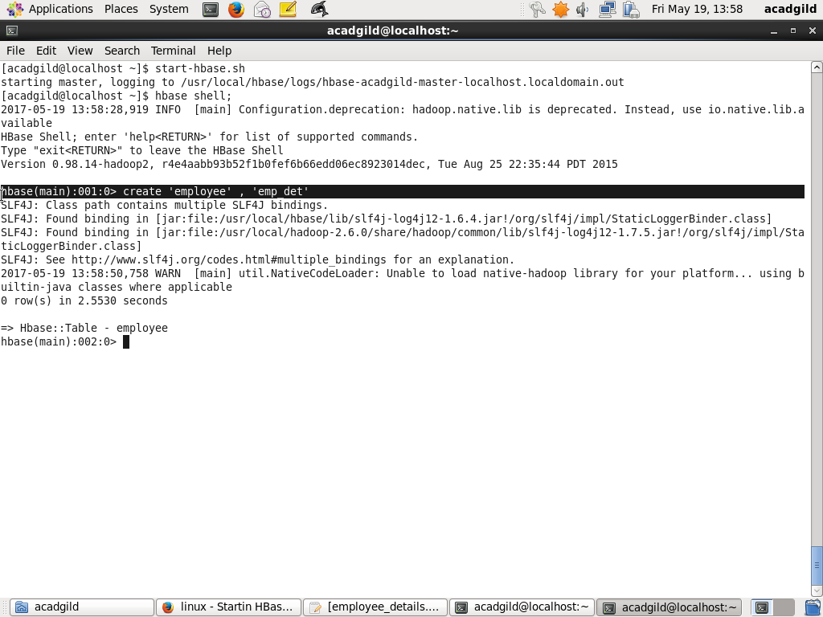

Data Load In Pig

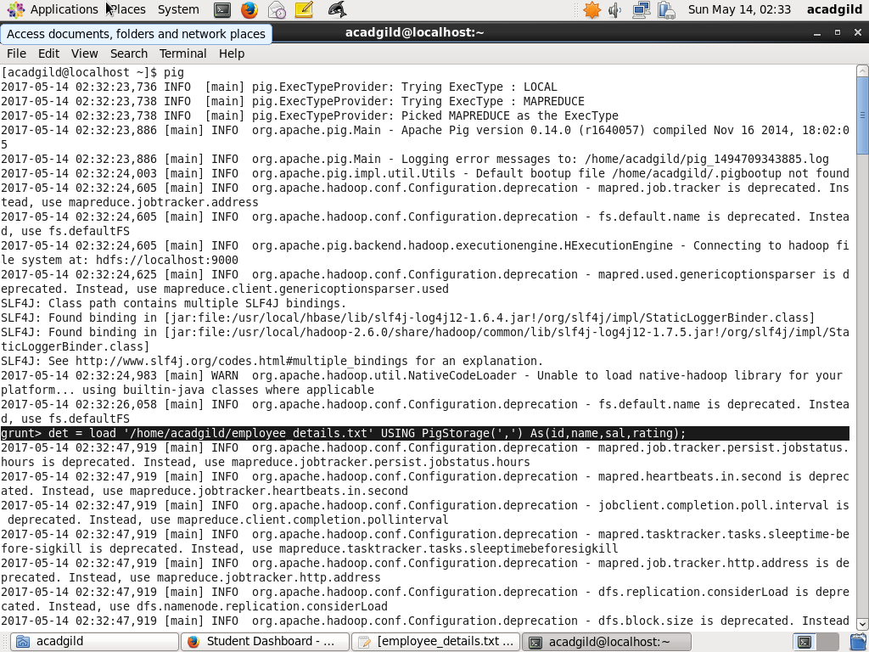

Hbase Data Load

