**Assignment-15.1**

1. **IMPORT FROM MYSQL TO HDFS**

Creating A Database In Mysql:

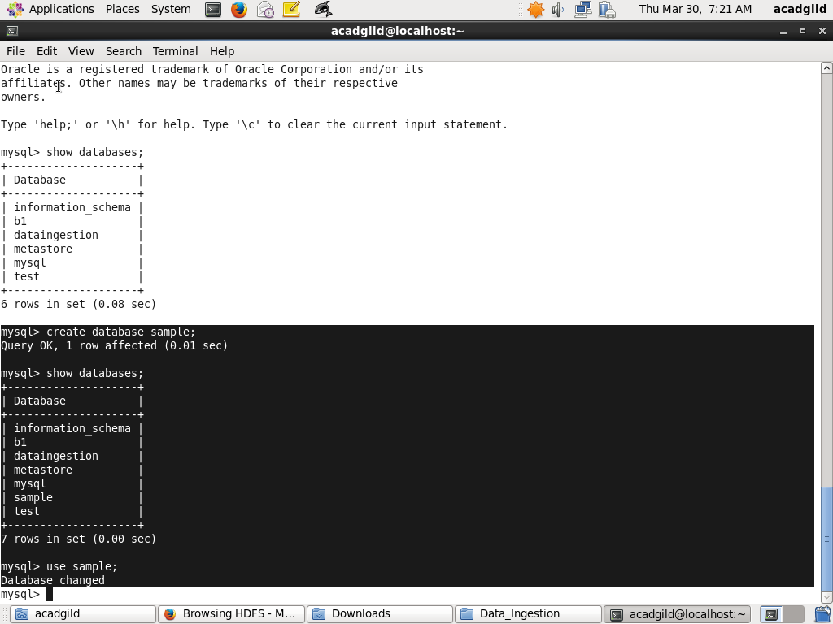

Creating The Table emp:

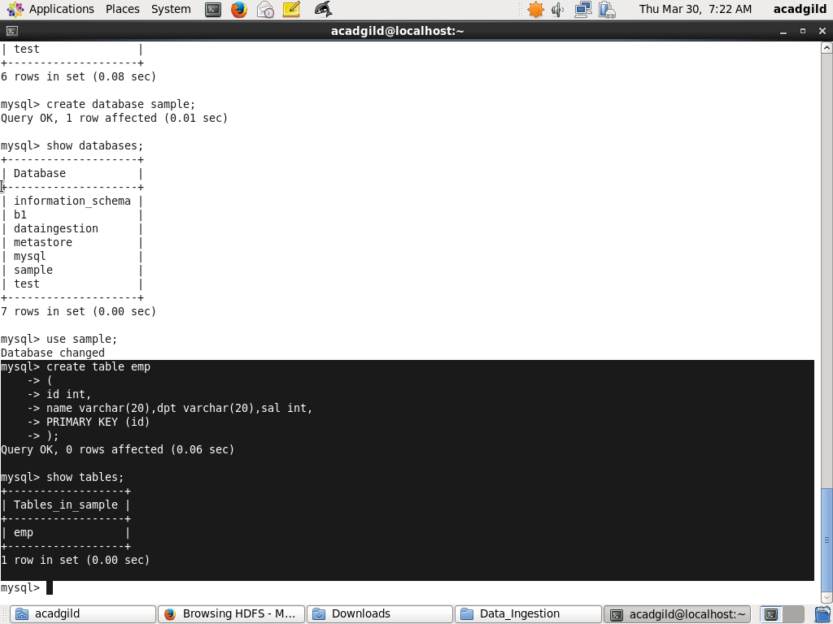

Inserting the Values:

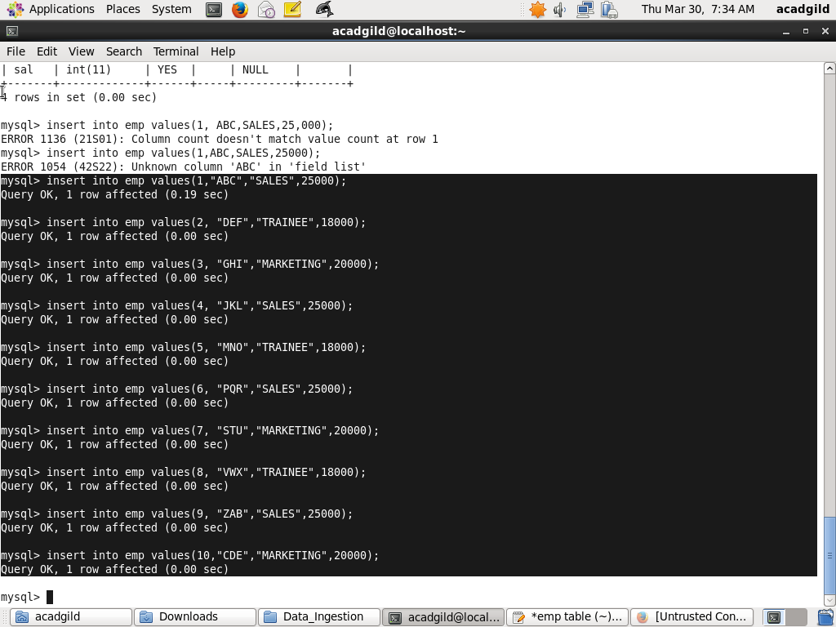

Display the emp table data:

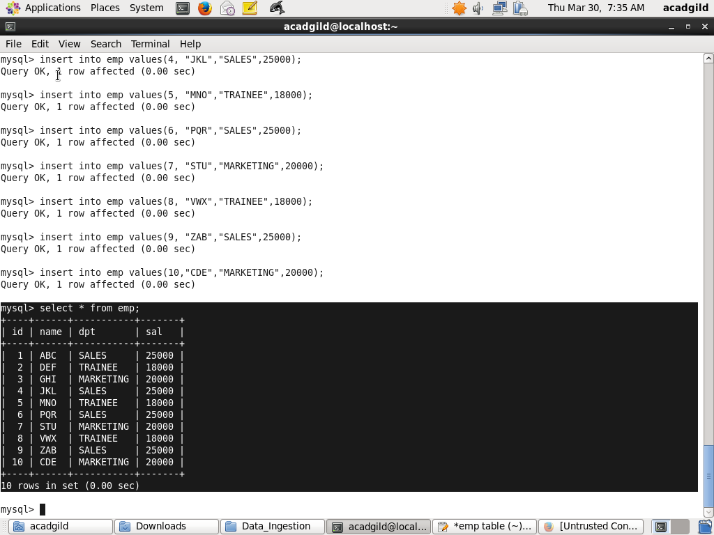

Running The Sqoop Import:

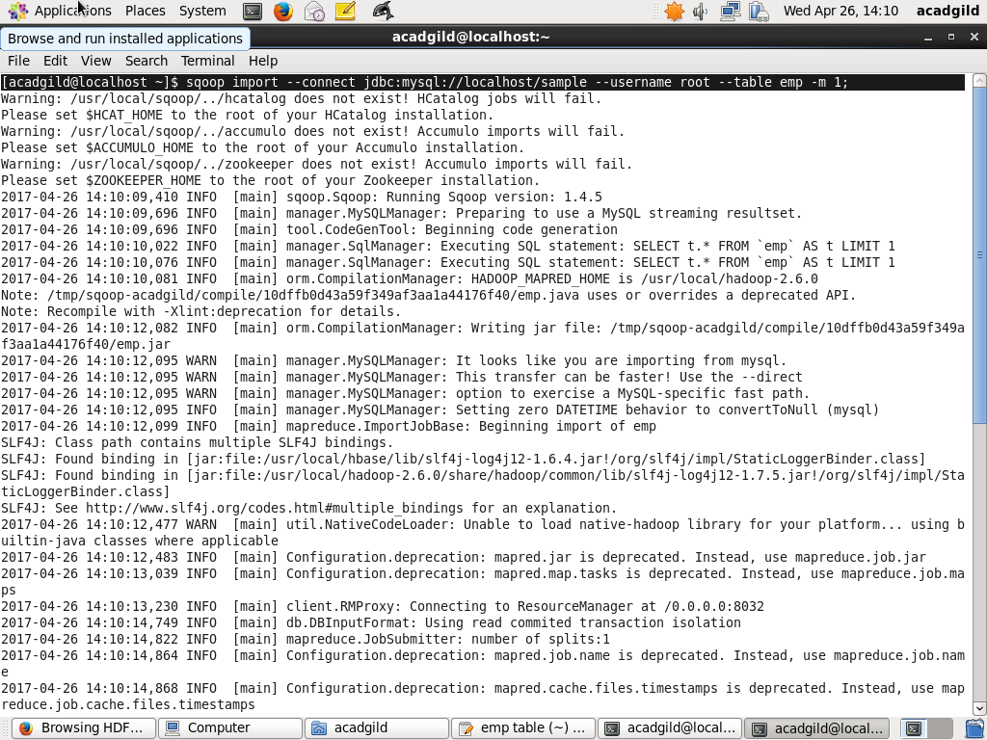

Data Stored On Hdfs:

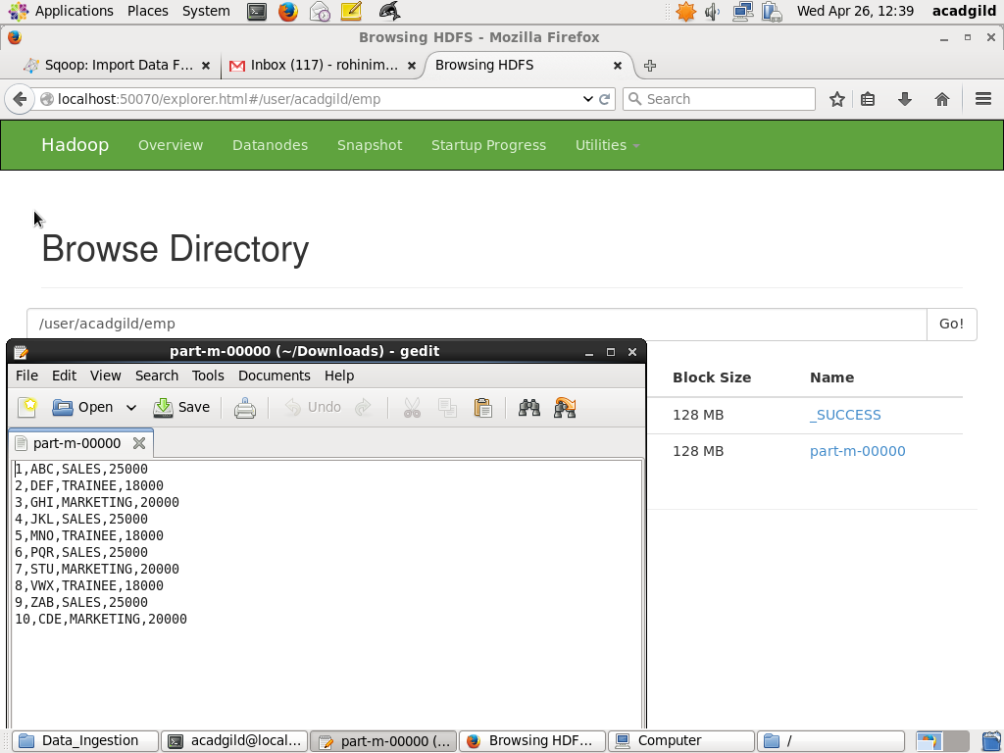

1. **IMPORT INTO HIVE**

Hive Import Using Sqoop:

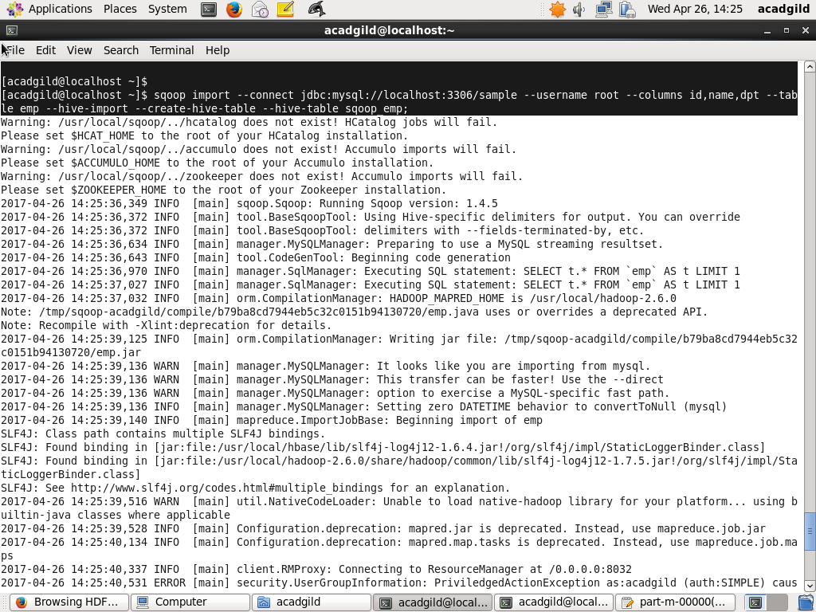

Data Stored On Hdfs:

