**Assignment-15.2**

**Perform Incremental Import operation to load data from Mysql To HDFS using Sqoop**.

Creating A Db In Mysql:

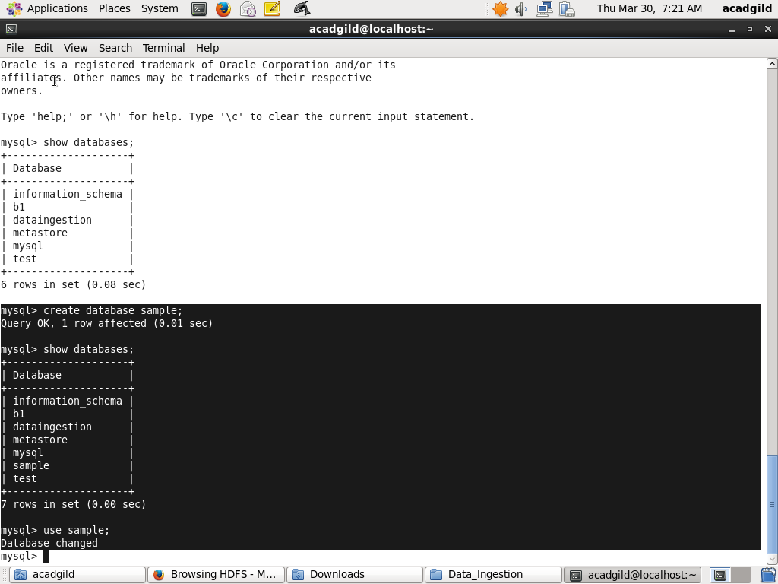

Creating The Table emp:

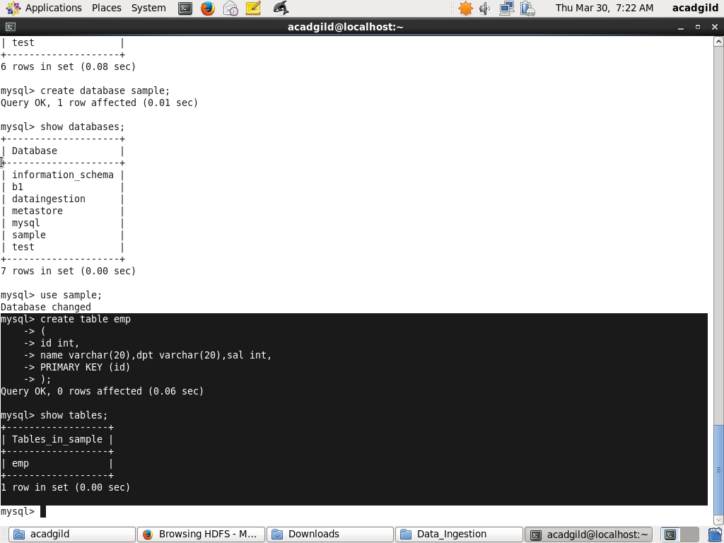

Inserting Values:

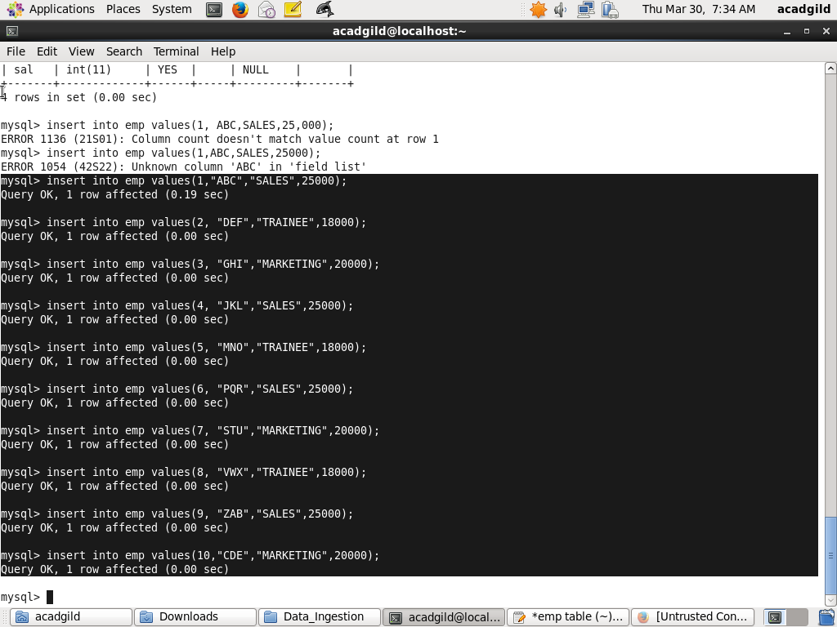

Display the emp table data:

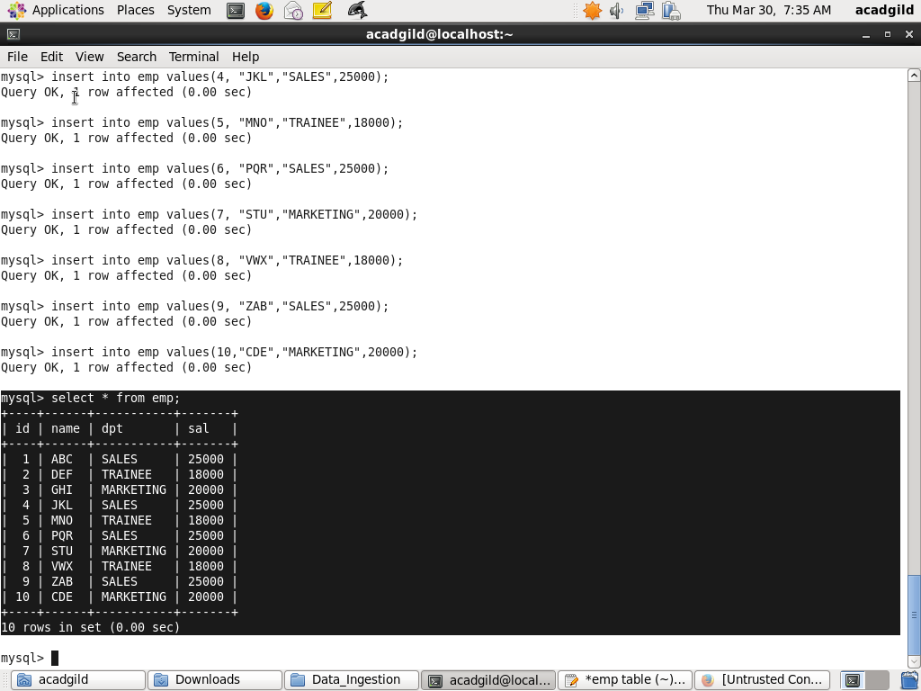

Sqoop Incremental Append:

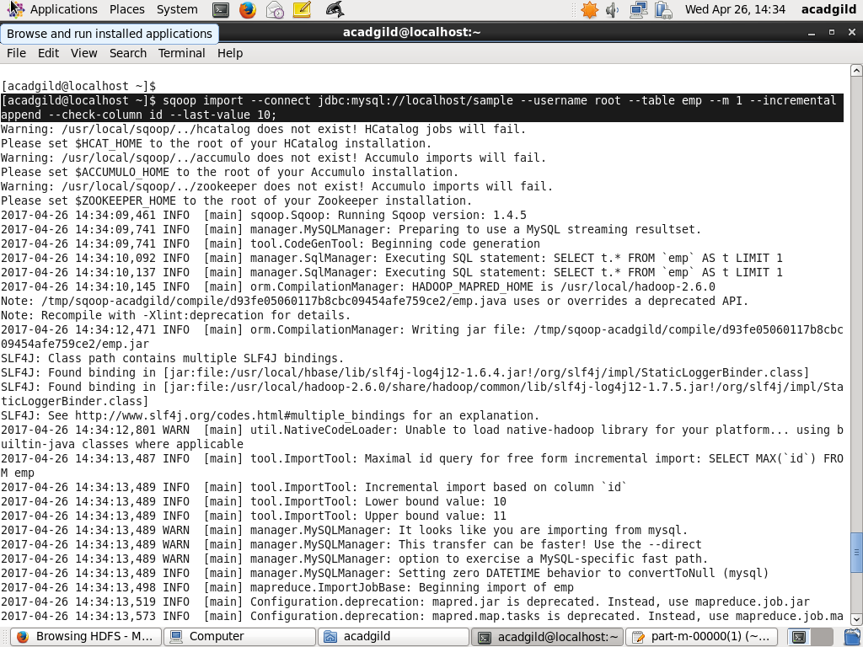

Result In Hdfs:

