**ASSIGNMENT-15.5**

**Perform Incremental Import operation using Sqoop.**

Creating A Db In Mysql

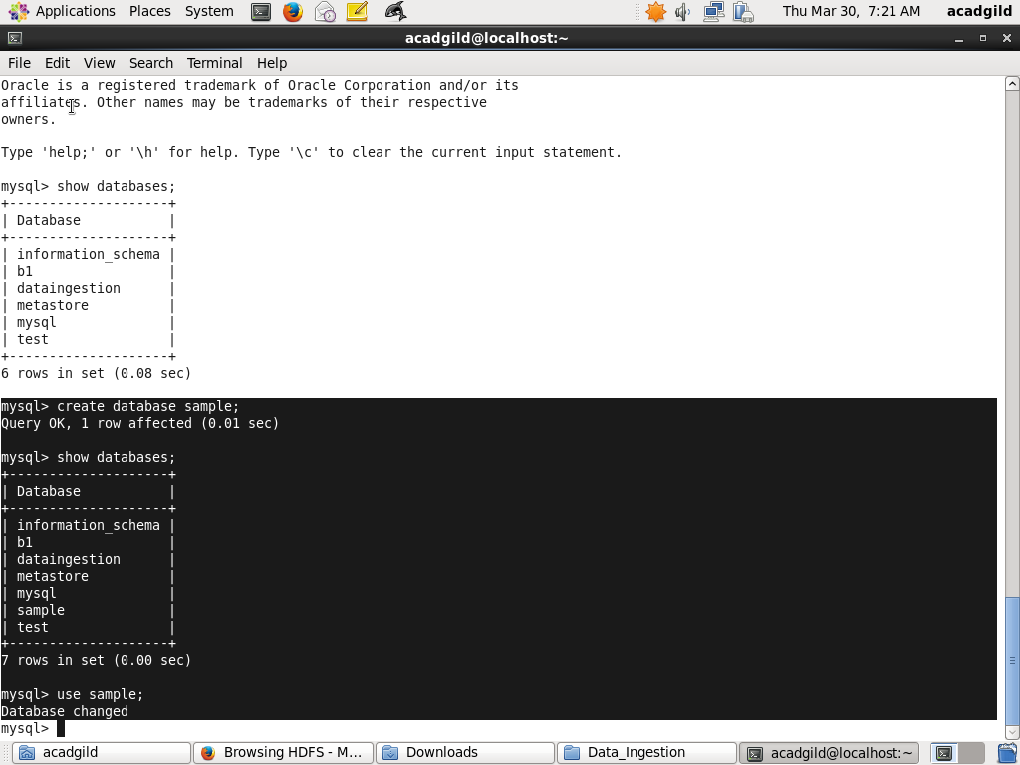

Creating The Table Emp

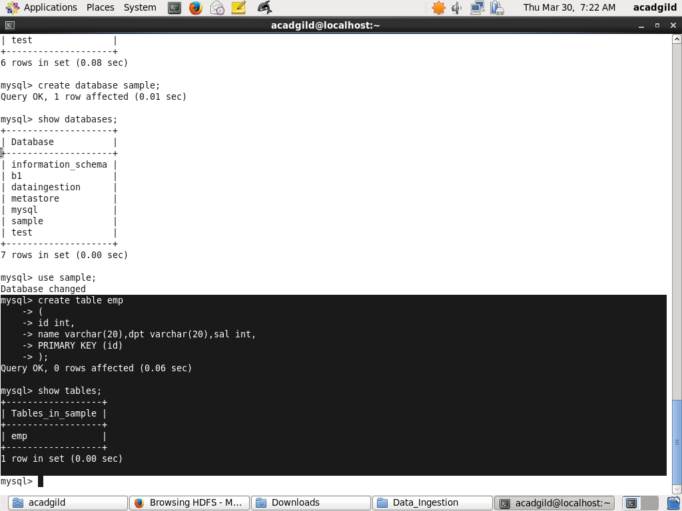

Inserting 10 Values

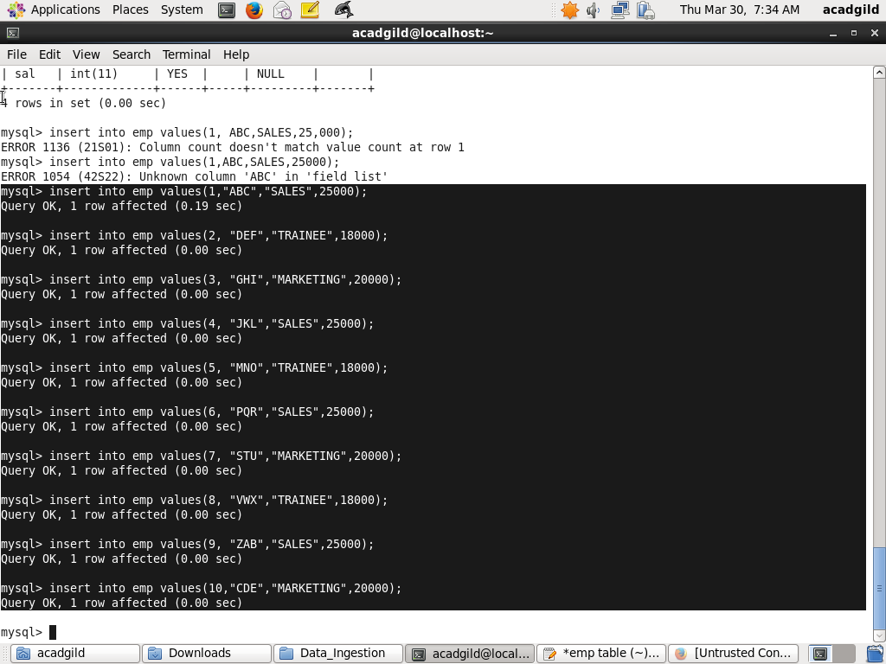

Data In Emp

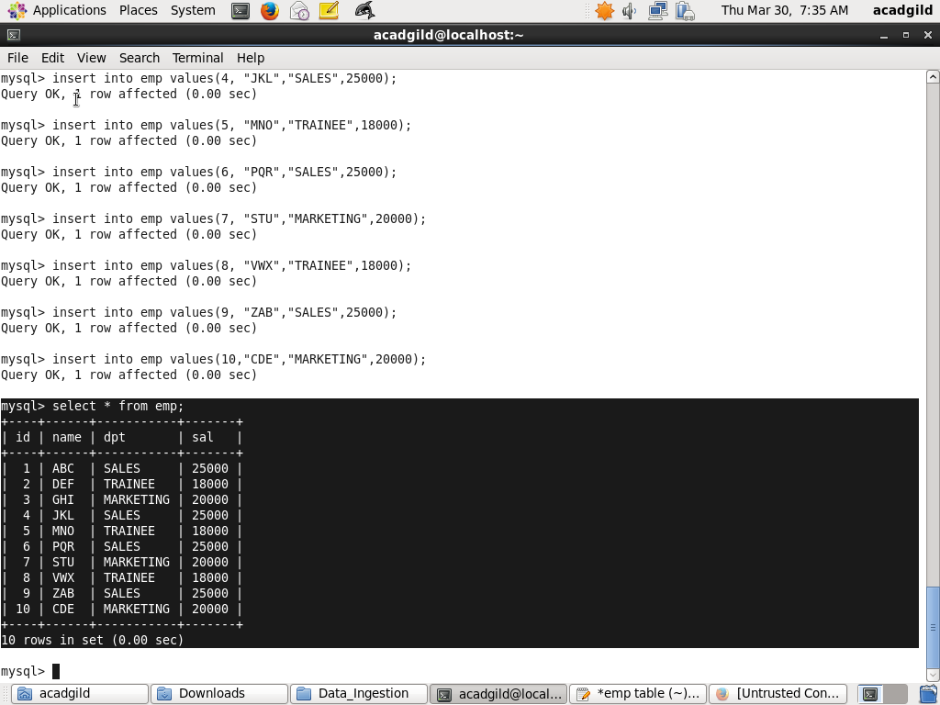

Sqoop Incremental Append

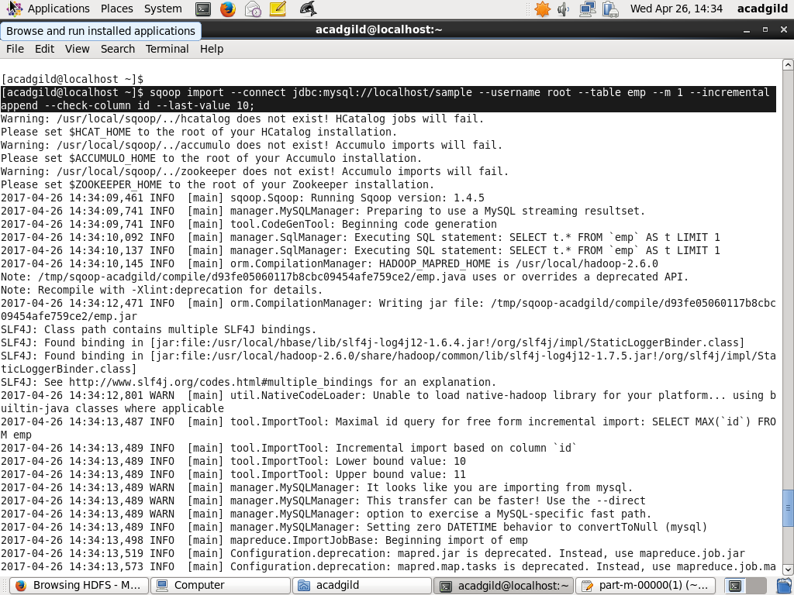

Result In Hdfs

