**1.Put Command**

**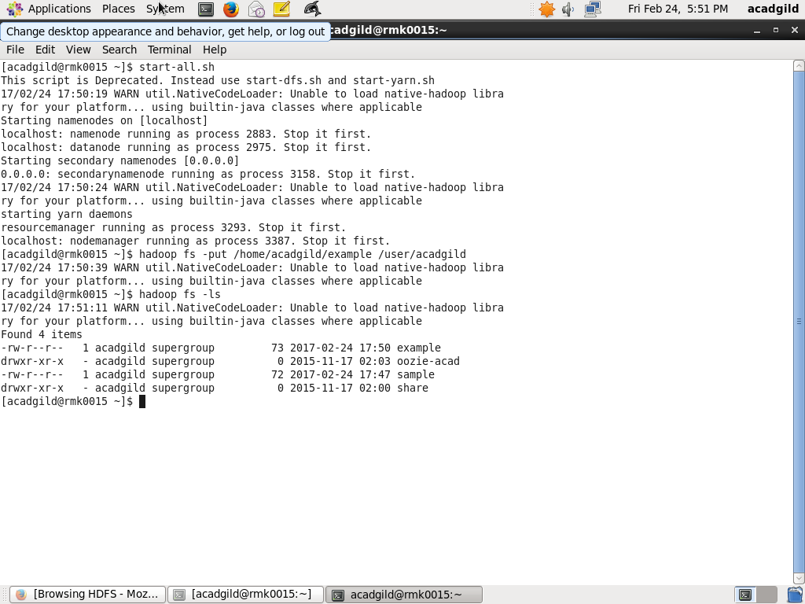**

### ****2. List Command****

**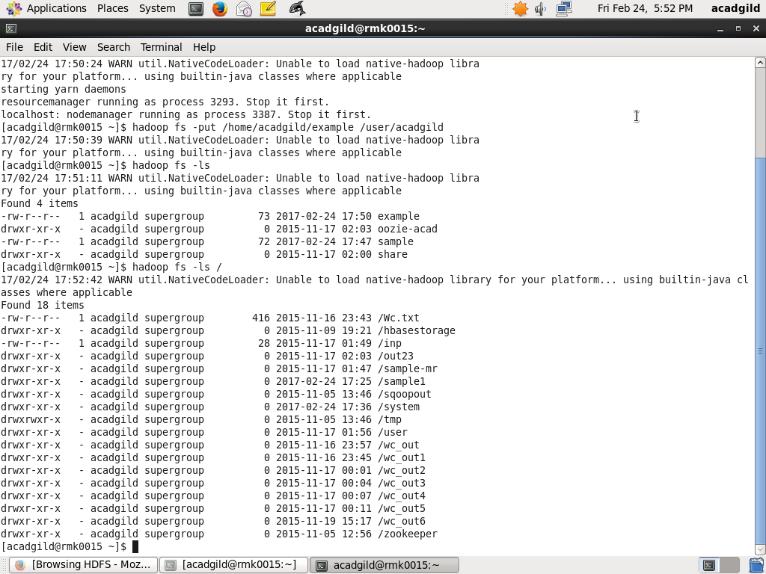**

### ****3.Get Command****

**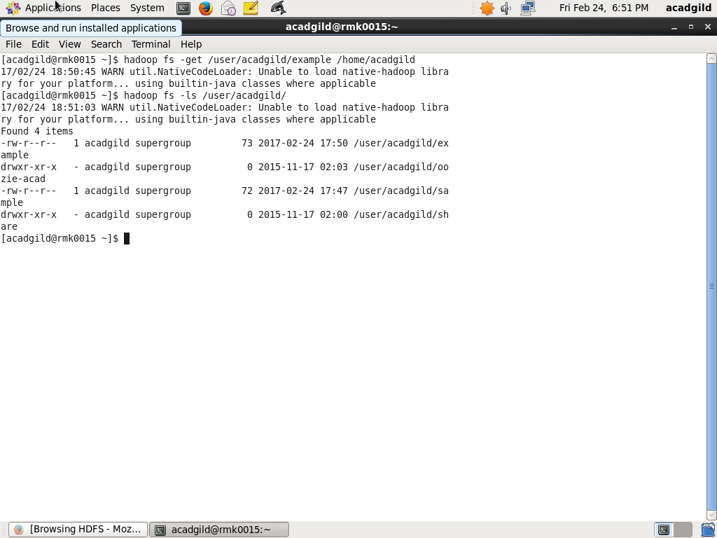**

### ****4. Make Directory Command****

### C:\Users\rmk\Desktop\New folder\VirtualBox_Acadgild_64bit_mkdir.png

### ****5. View contents of particular file****

**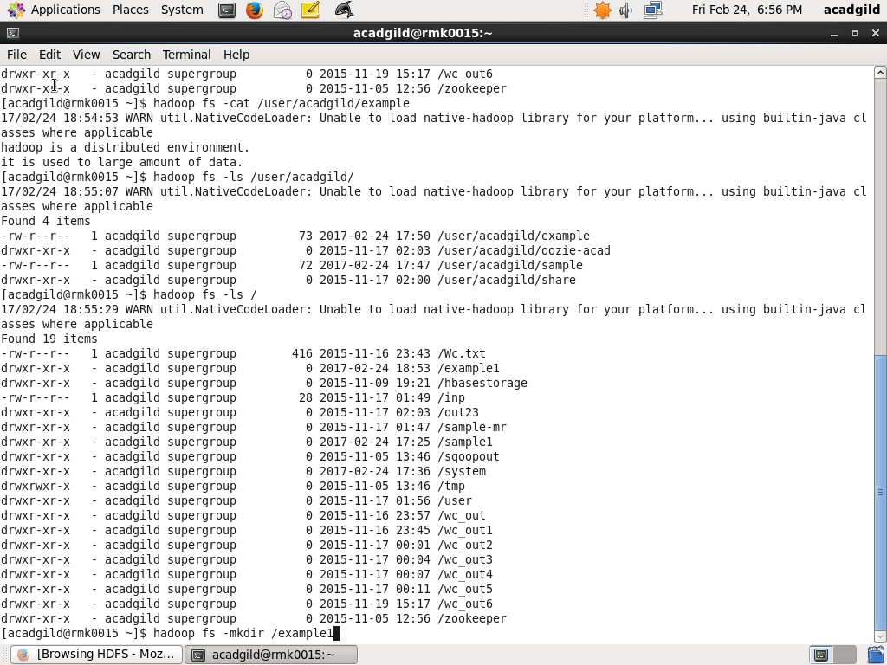**

### ****6.Duplicating a Complete File inside the HDFS.****

**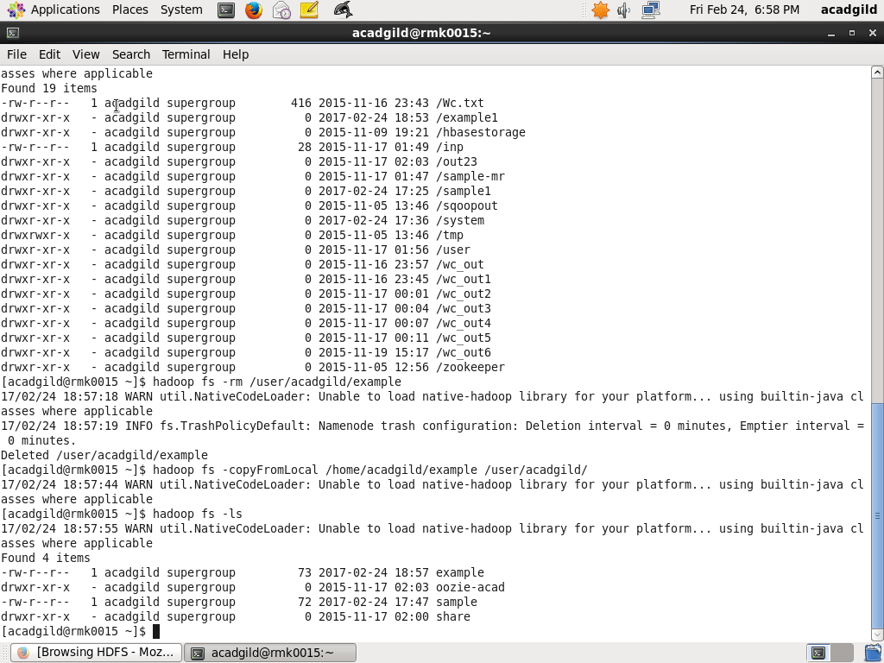**

### ****7.Duplicating a File from HDFS to the Local File System.****

**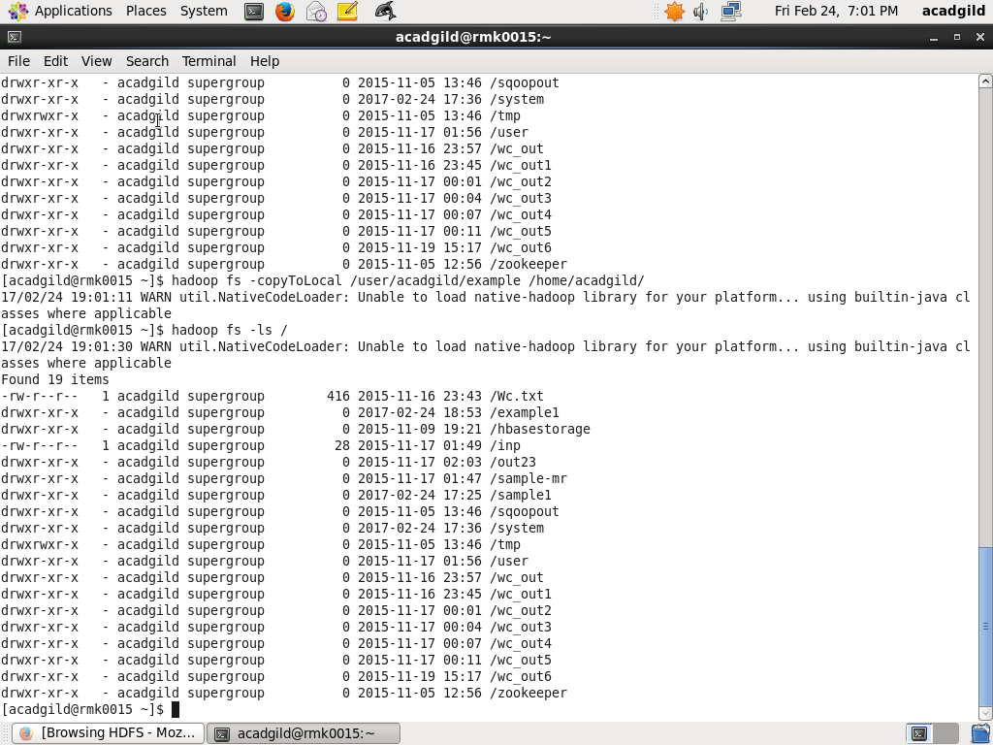**

### ****8.Removing the File****

**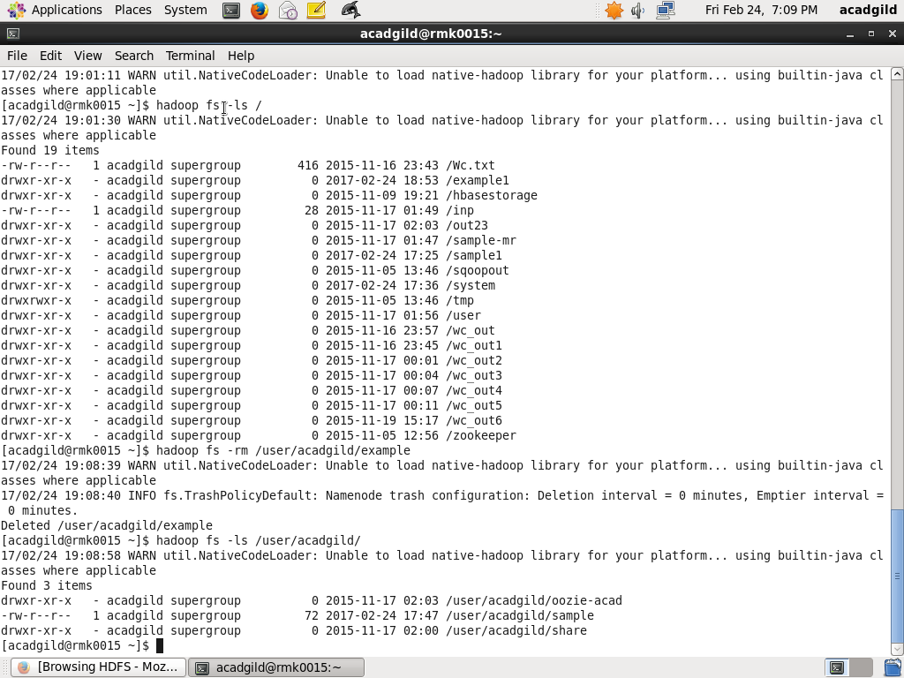**

### ****9.Run a DFS Filesystem to Check Utility****

**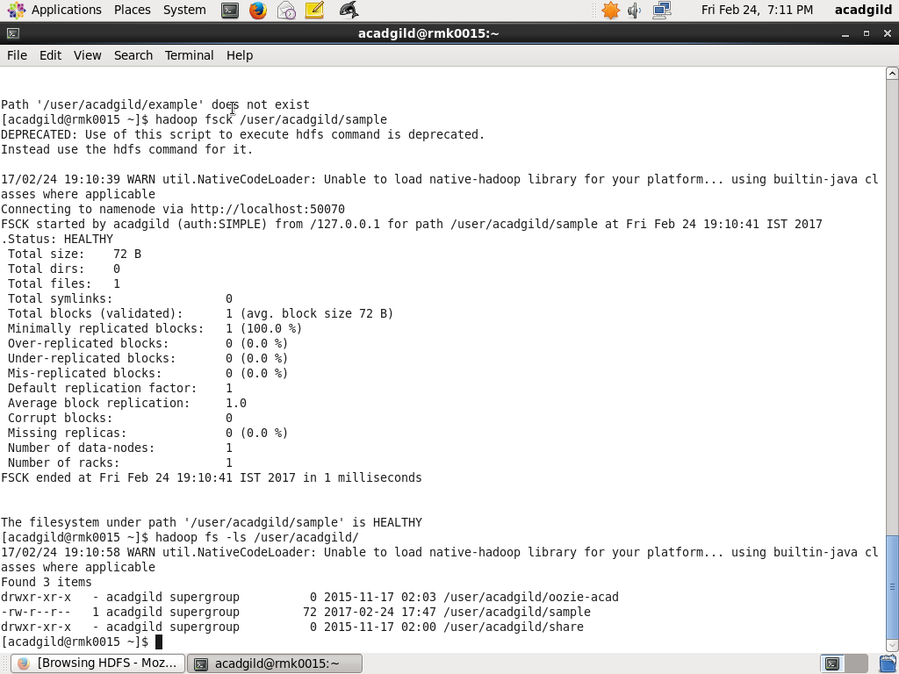**

### ****10.Run a Cluster Balancing Utility****

**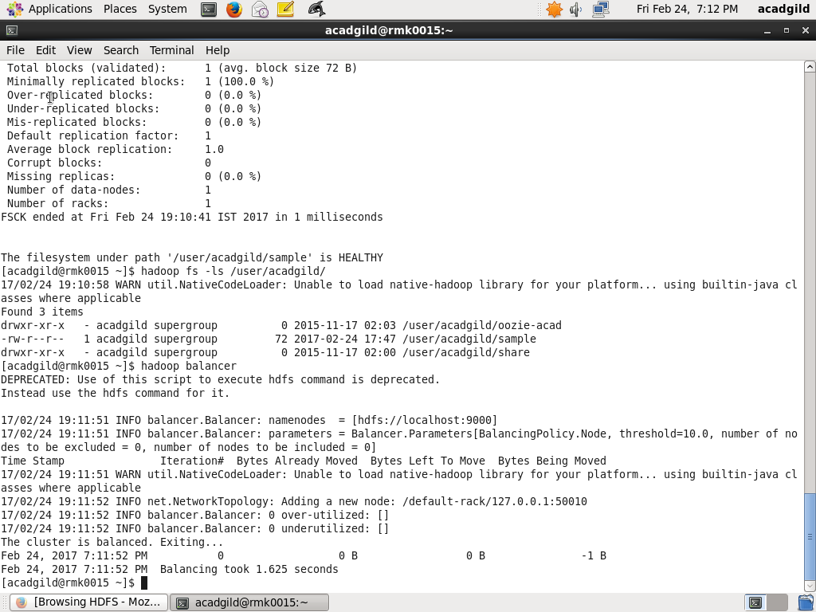**

### ****11.Check Directory Space in HDFS****

**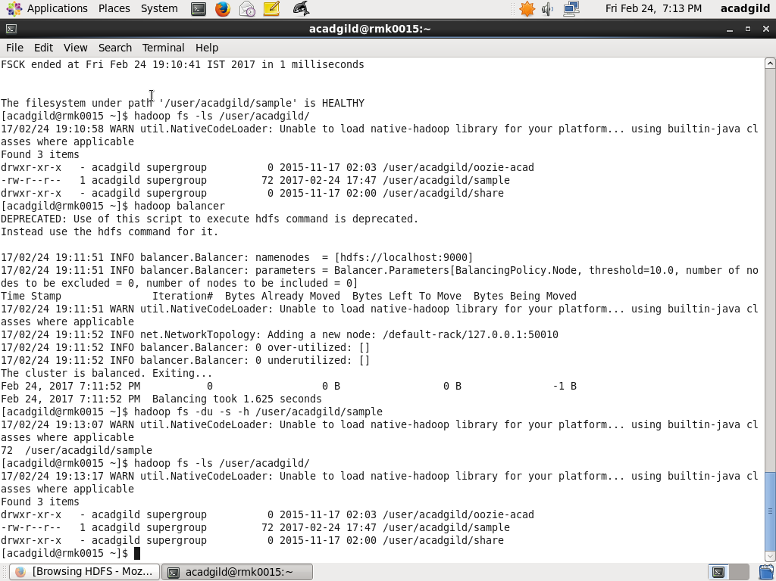**

### 12. List all the Hadoop File System Shell Commands

**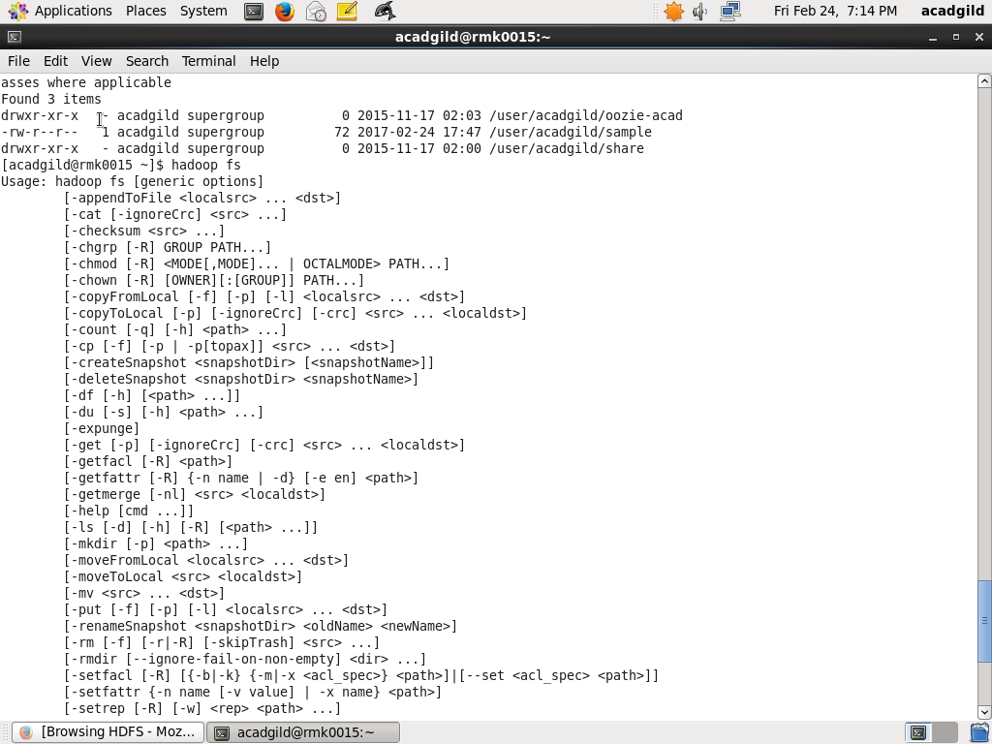**

### ****13.Asking for Help****

**