1. **Using Java API copy a file from HDFS to Local file system.**

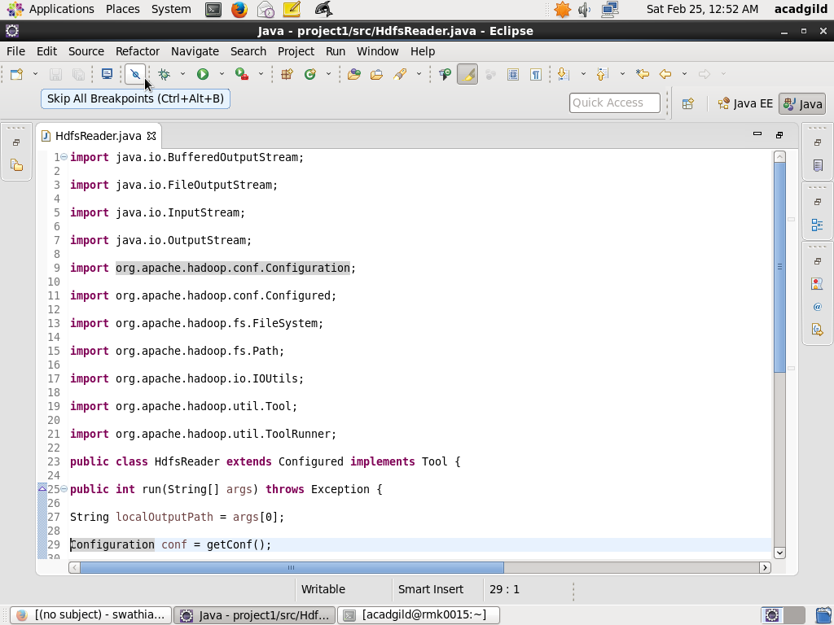

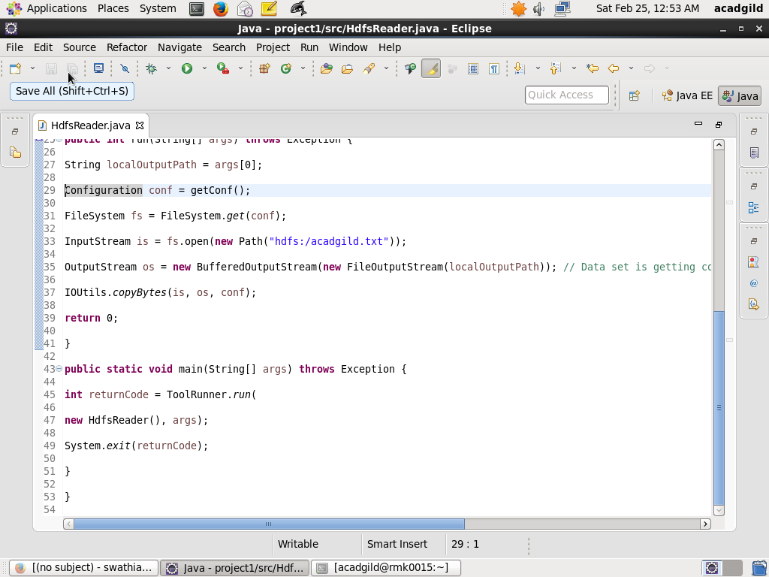 Hdfs Reader calls the method *open(*) to open a file in HDFS, which returns an Input Stream object that can be used to read the contents of the file.

We need to ensure that the file which we want to copy to Local File System is present in HDFS by using following commands.

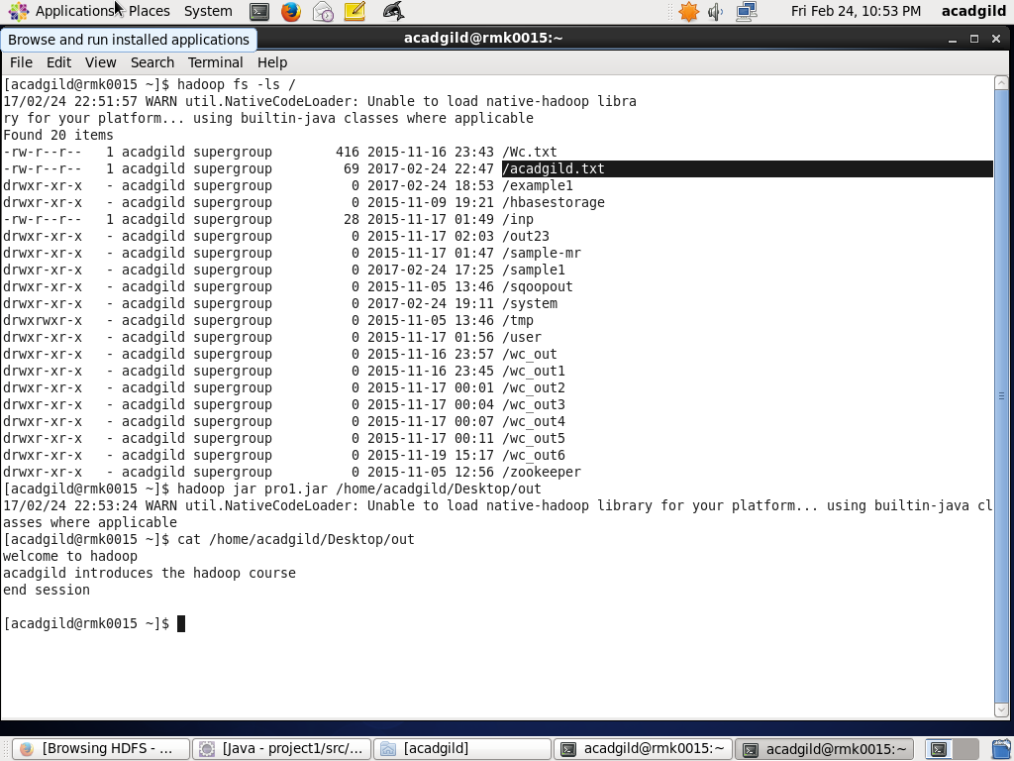

Make a jar file of the above code and run that jar file in the Hadoop environment where the file needs to be copied and type the command to check whether the content of the file acadgild.txt has been copied to specified location or not.

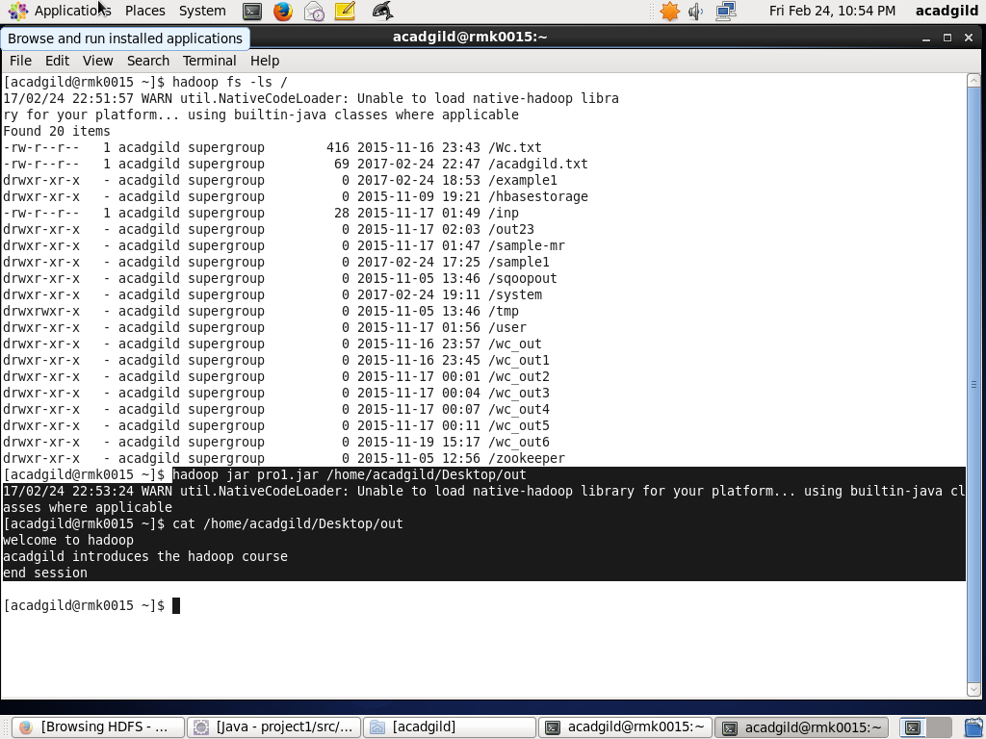

**2.Using Java API copy a file from LFS to HDFS**.

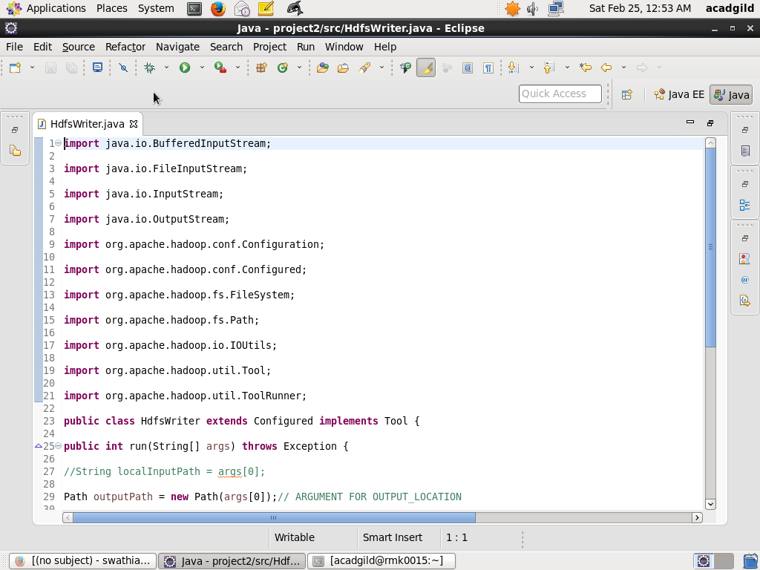

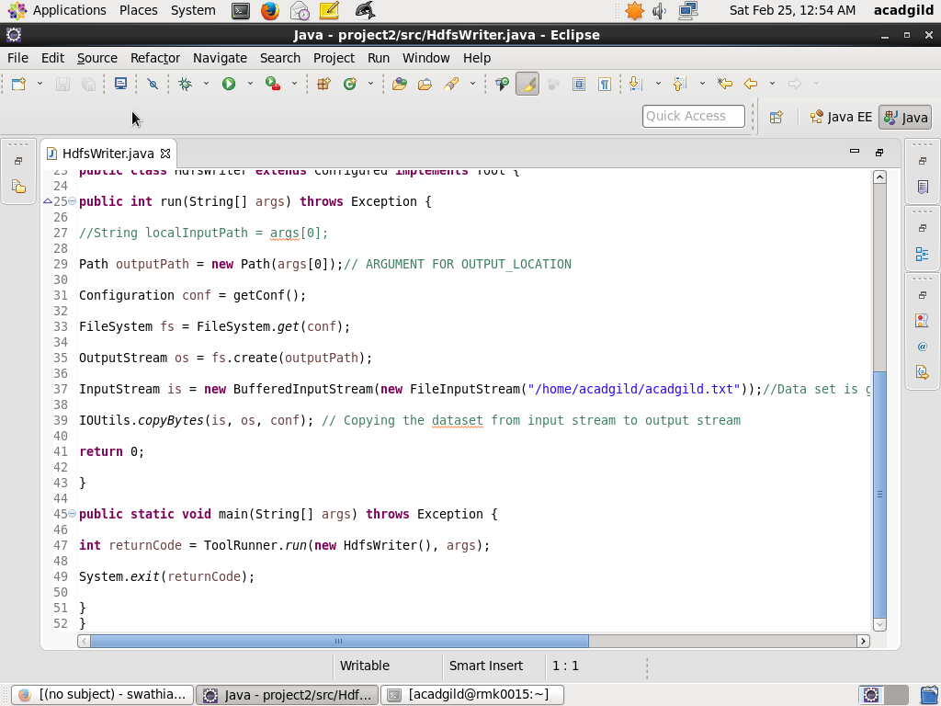

After the creation of an instance of the File System, the Hdfs Writer class calls the create() method to create a file (or overwrite if it already exists) in HDFS. The create() method returns an Output Stream object, which can be manipulated using normal Java I/O methods.

 The file which is to be placed in hdfs has to be kept in local file system and in this case the file is present in the directory

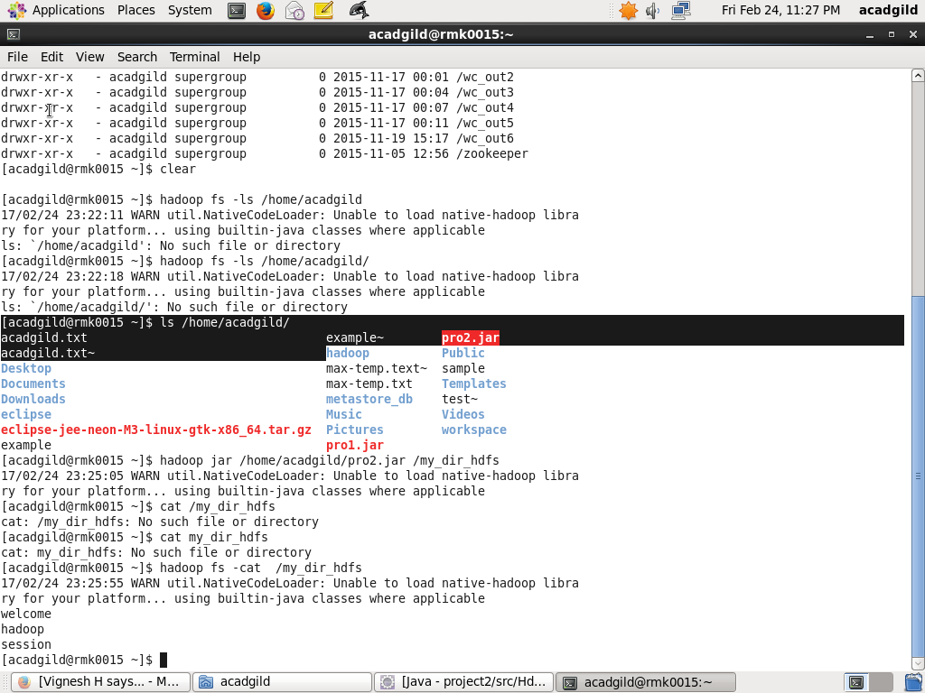

Make a jar file of the above code and run that jar file in the Hadoop environment where the file has to be copied.

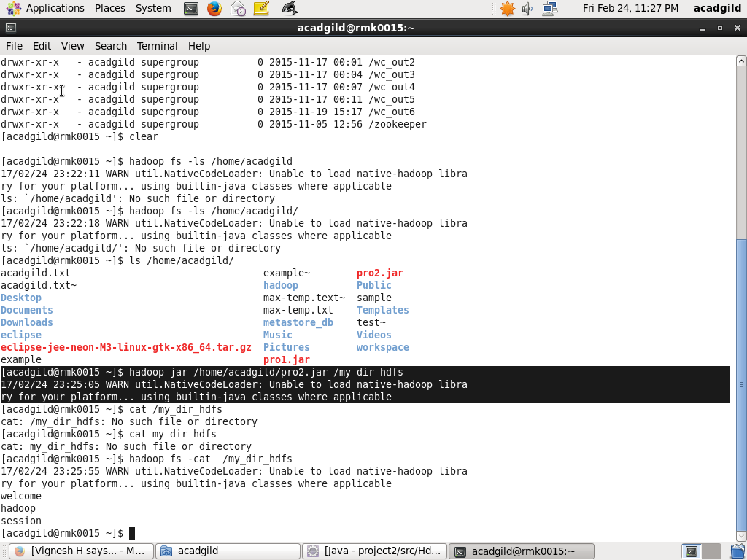

Type the command Hadoop dfs -ls / to check whether the file is present in hdfs or not. We can see the file i.e **acadgild.txt** which got copied from location **/home/acadgild/** to the hdfs.

