**ASSIGNMENT-4.4**

Mapper Class

package mapreduce;

import java.io.IOException;

import org.apache.hadoop.io.IntWritable;

import org.apache.hadoop.io.LongWritable;

import org.apache.hadoop.io.Text;

import org.apache.hadoop.mapreduce.*;

public class Mapper1 extends Mapper<LongWritable, Text, Text, IntWritable> {

Text outKey = new Text();

IntWritable outValue = new IntWritable(1);

public void map(LongWritable key, Text value, Context context)

throws IOException, InterruptedException {

String[] words = value.toString().split(",");

int surv = Integer.parseInt(words[1]);

if(surv==1){

outKey.set(words[4]);

context.write(outKey, outValue);

}

}

}

Reducer Class

package mapreduce;

import java.io.IOException;

import org.apache.hadoop.io.IntWritable;

import org.apache.hadoop.io.Text;

import org.apache.hadoop.mapreduce.Reducer;

public class Reduce extends Reducer<Text, IntWritable, Text, IntWritable>

{

IntWritable outValue = new IntWritable();

public void reduce(Text key, Iterable<IntWritable> values,Context context) throws IOException, InterruptedException

{

int sum = 0;

for (IntWritable value : values) {

sum += value.get();

}

outValue.set(sum);

context.write(key, outValue);

}

}

Driver Class

package mapreduce;

import org.apache.hadoop.fs.Path;

import org.apache.hadoop.conf.*;

import org.apache.hadoop.mapreduce.Job;

import org.apache.hadoop.mapreduce.lib.input.FileInputFormat;

import org.apache.hadoop.mapreduce.lib.input.TextInputFormat;

import org.apache.hadoop.mapreduce.lib.output.FileOutputFormat;

import org.apache.hadoop.mapreduce.lib.output.TextOutputFormat;

import org.apache.hadoop.io.IntWritable;

import org.apache.hadoop.io.Text;

public class Driver {

@SuppressWarnings("deprecation")

public static void main(String[] args) throws Exception {

Configuration conf = new Configuration();

Job job = new Job(conf, "DemoTask9");

job.setJarByClass(Driver.class);

job.setMapOutputKeyClass(Text.class);

job.setMapOutputValueClass(IntWritable.class);

job.setOutputKeyClass(Text.class);

job.setOutputValueClass(IntWritable.class);

job.setMapperClass(Mapper1.class);

job.setReducerClass(Reduce.class);

job.setInputFormatClass(TextInputFormat.class);

job.setOutputFormatClass(TextOutputFormat.class);

FileInputFormat.addInputPath(job, new Path(args[0]));

FileOutputFormat.setOutputPath(job,new Path(args[1]))

job.waitForCompletion(true);

}

}

Output

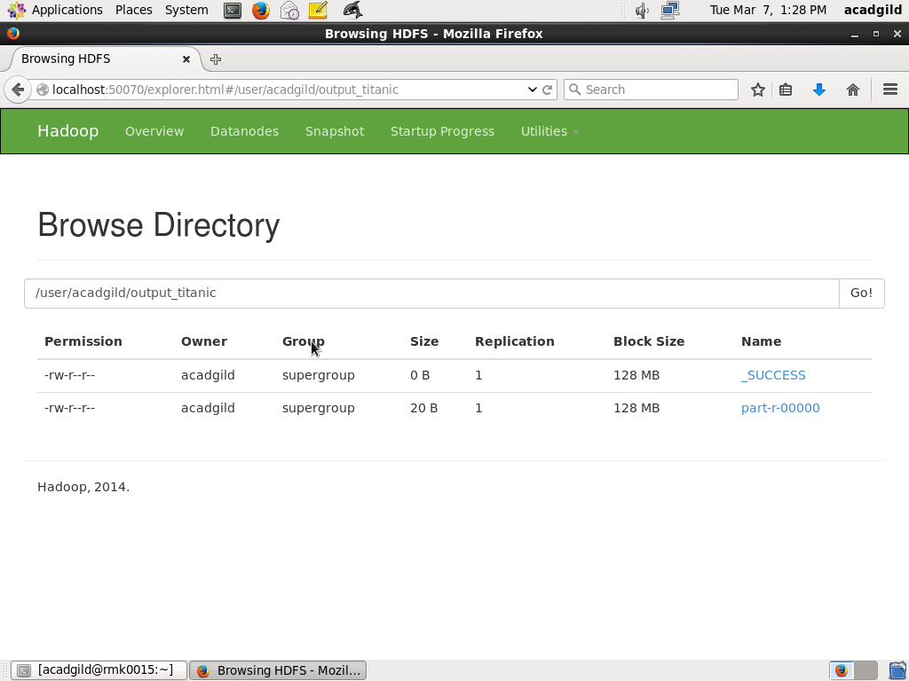

**Female 233**

**Male 109**