**Assignment 6.1**

1. Find the top five kinds of GoogleKnowlege_Occupation people who were guests in the show, in a particular time period. Take the time period as 1/11/99 to 6/11/99 i.e., 6 months

Loading the data:

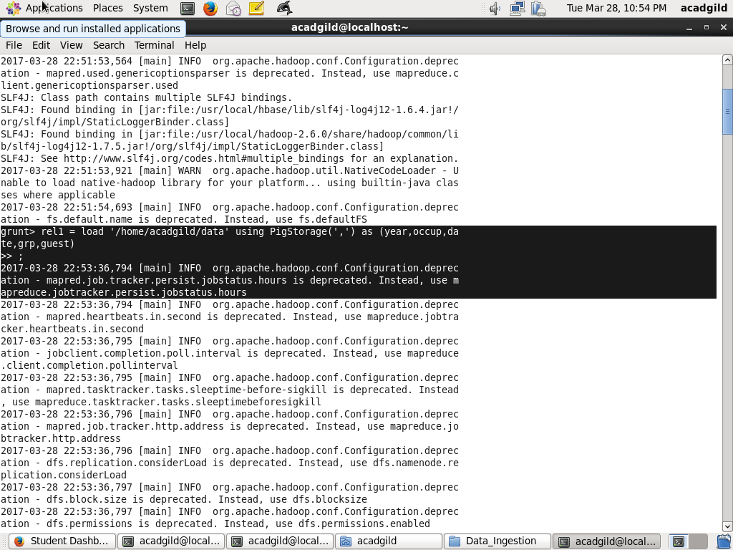

Generating the occupation and date:

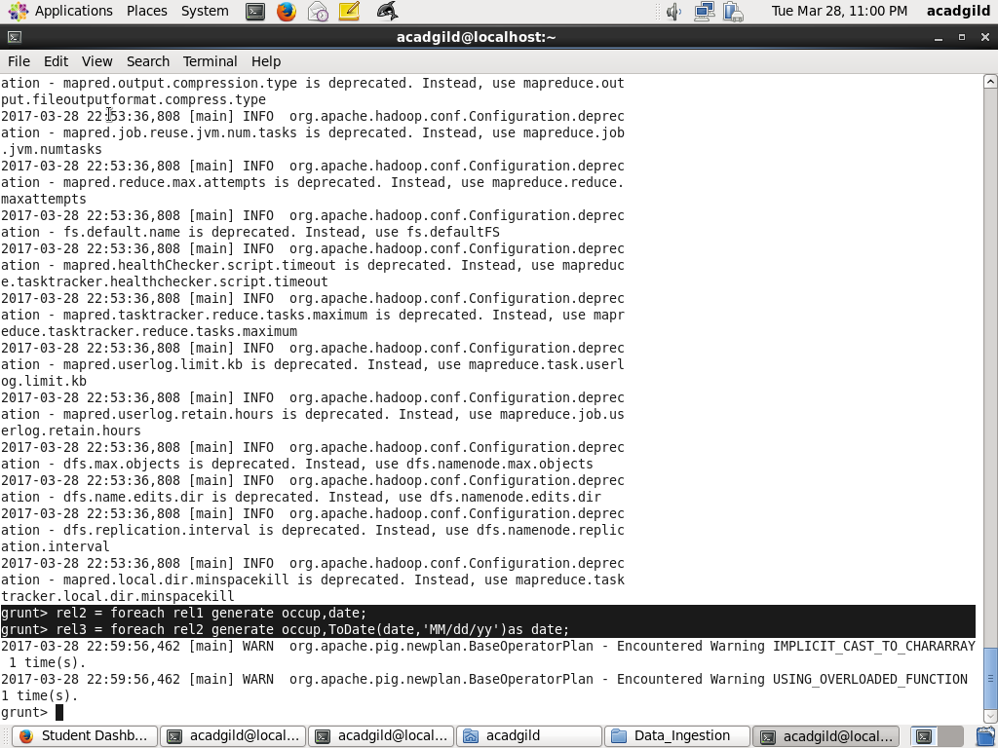

Filtering the data for getting particular month data:

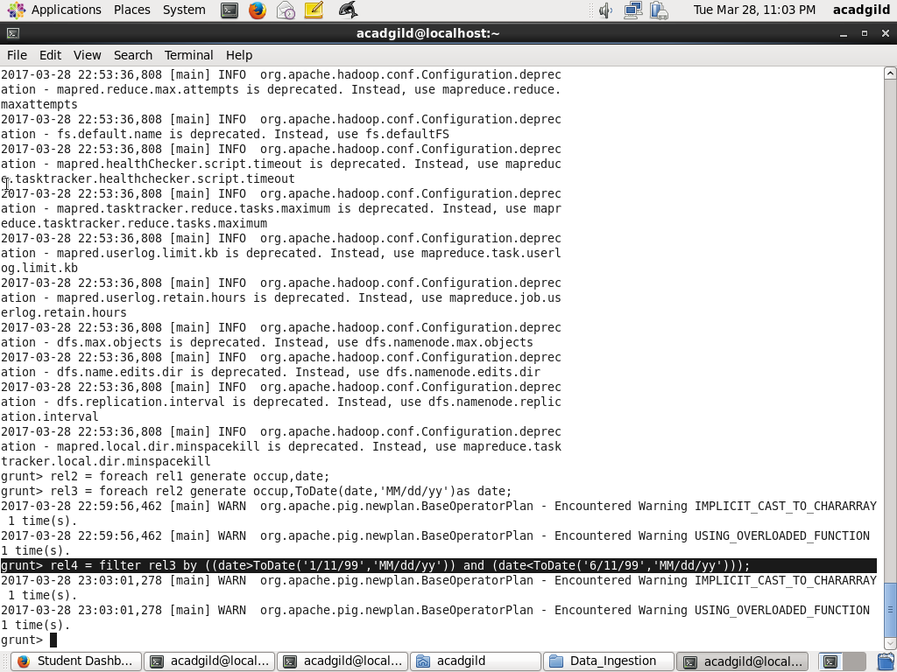

Grouping operation based on occupation:

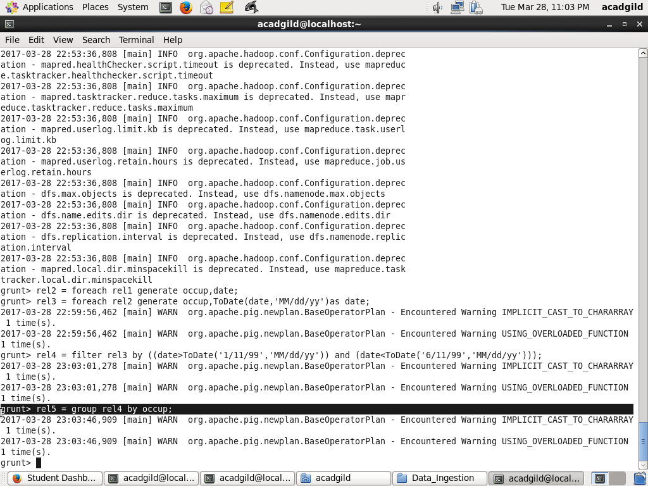

Counting data based on group occupation:

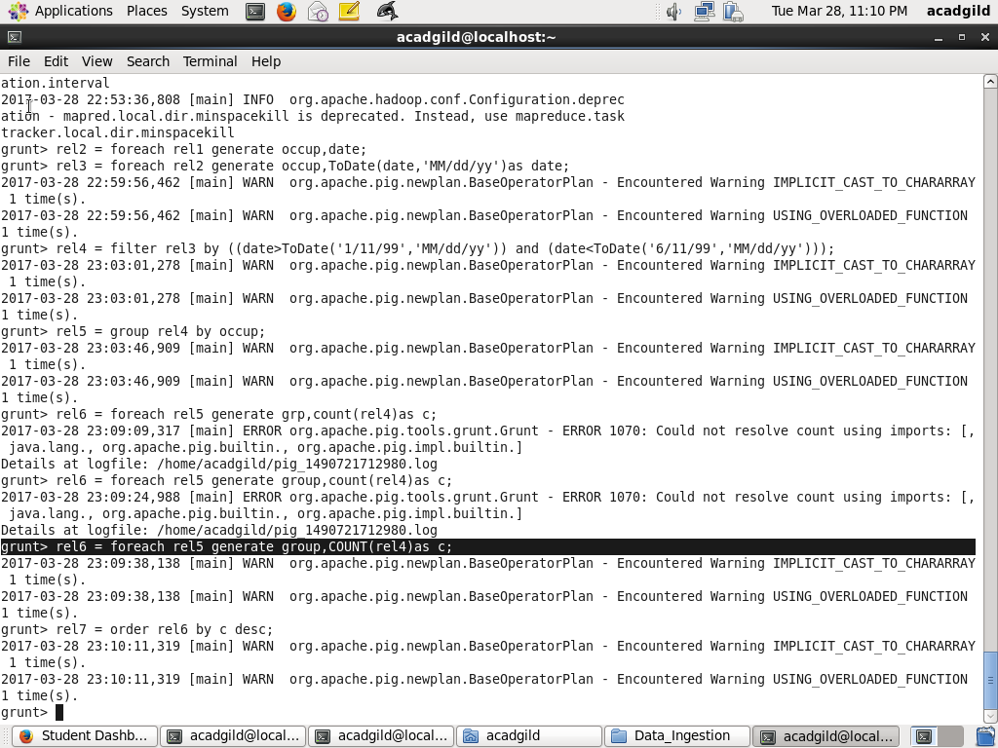

Apply the descending operation:

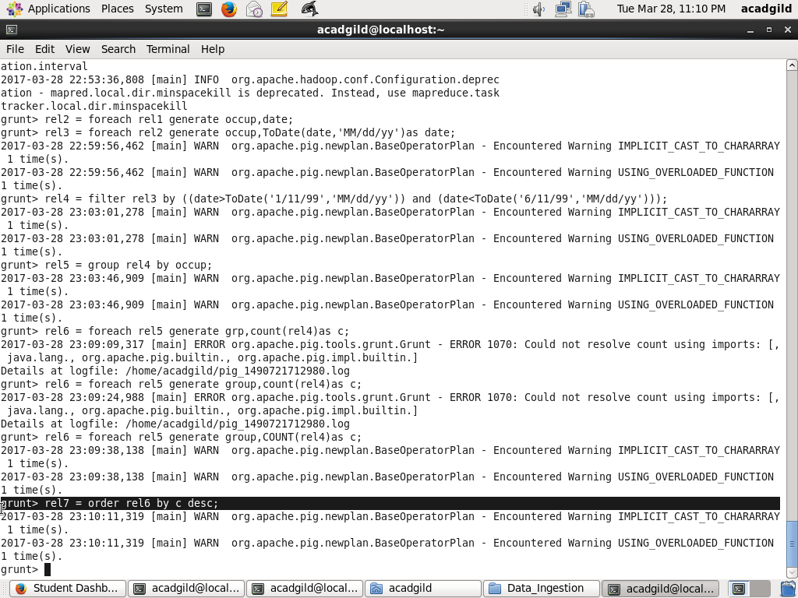

To get the top 5 data using limit operation:

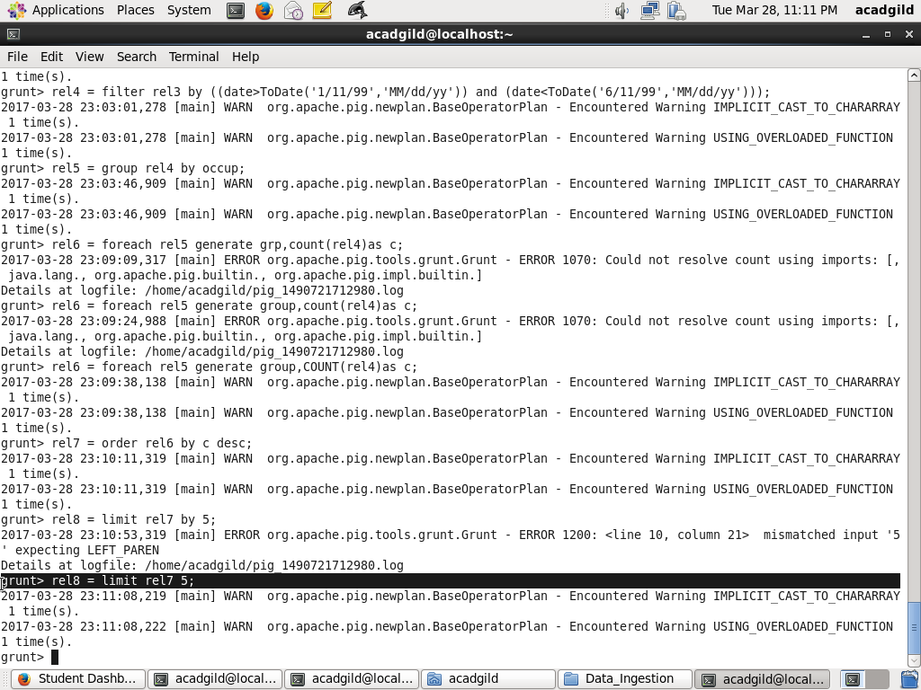

Final data result:

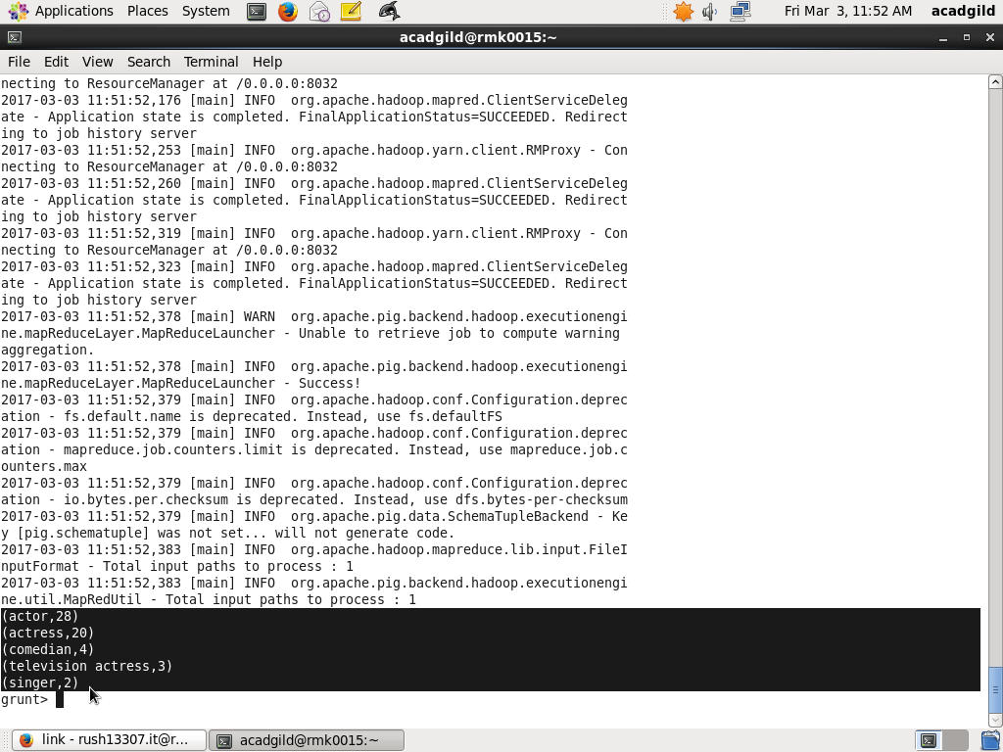

1. Find the number of Google Knowledge occupation types in each group, who have been guests on the show.

Loading the data:



Generating the data based on occupation and Group:

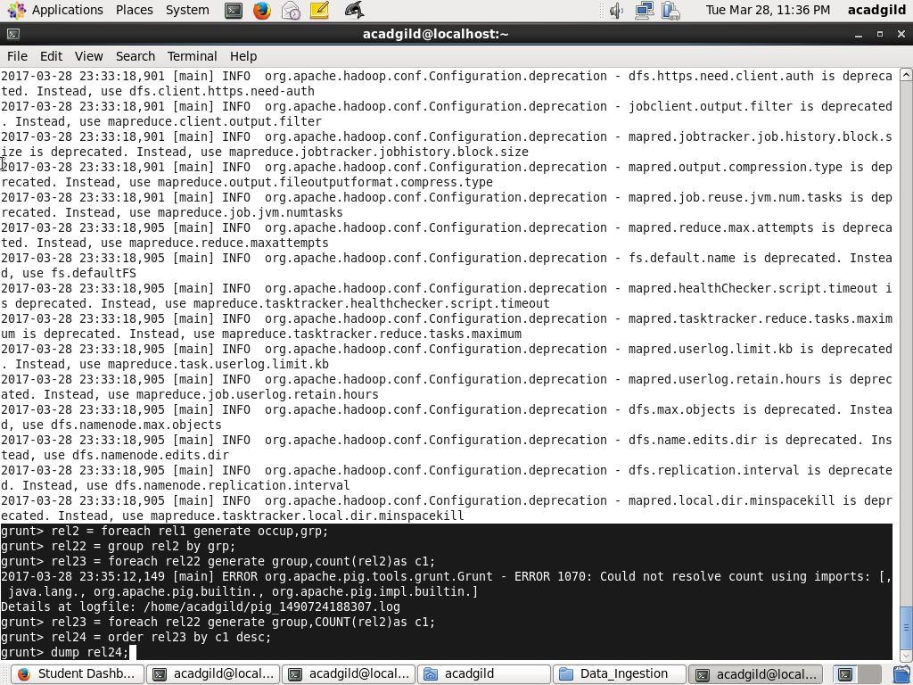

Counting operation and apply the descending operation:



Final data result:

