1.Write a pig script find the average age of male and female persons died in the titanic tragedy

Initially load the TitanicData.txt file into titanic:

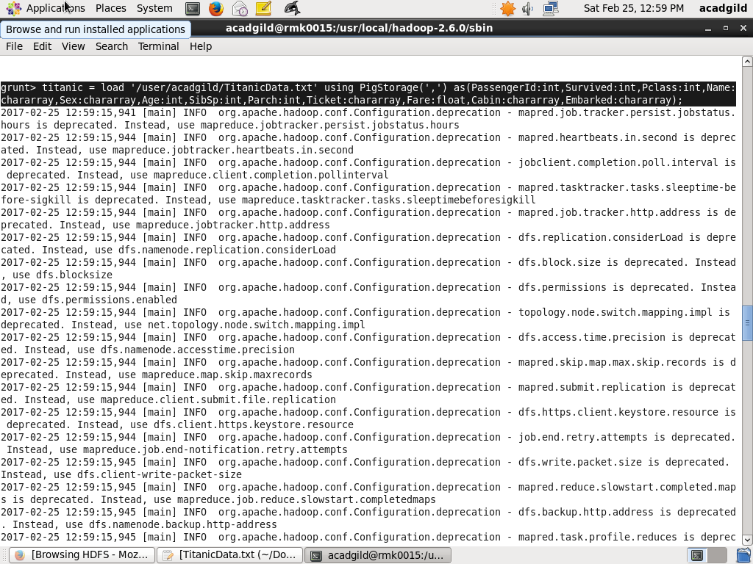

Using filter command extract the people who died in that tragedy:

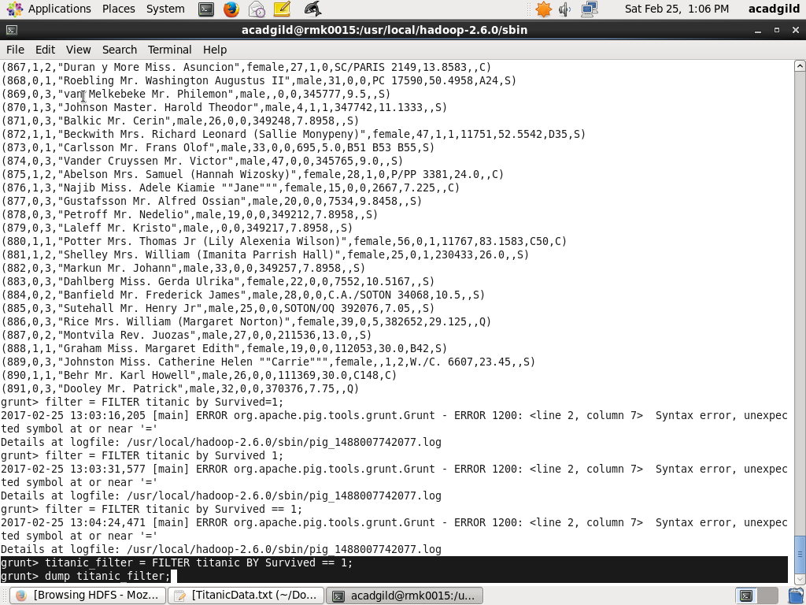

Group statement is used to grouping the data by gender

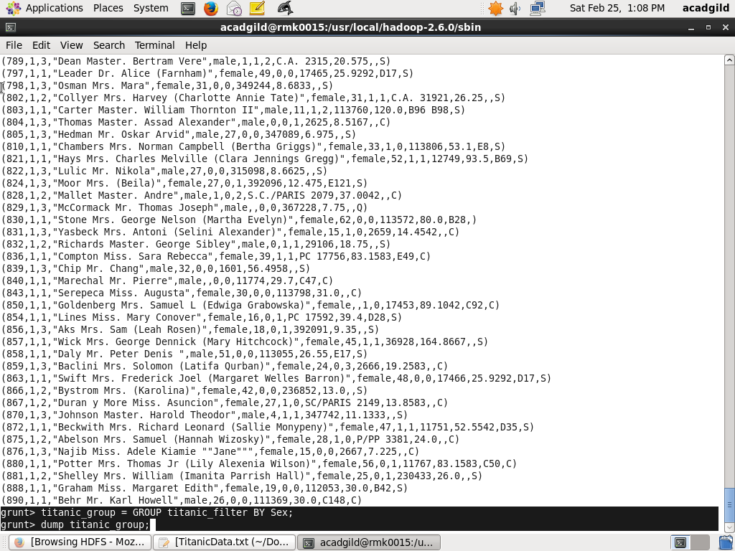

And then find the average of the male and female using avg command

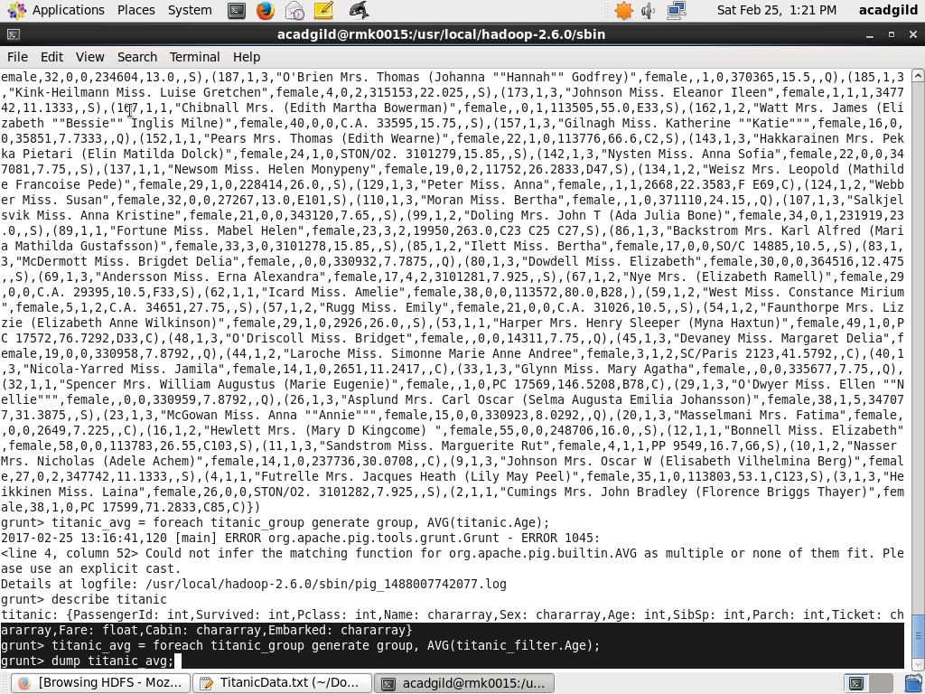

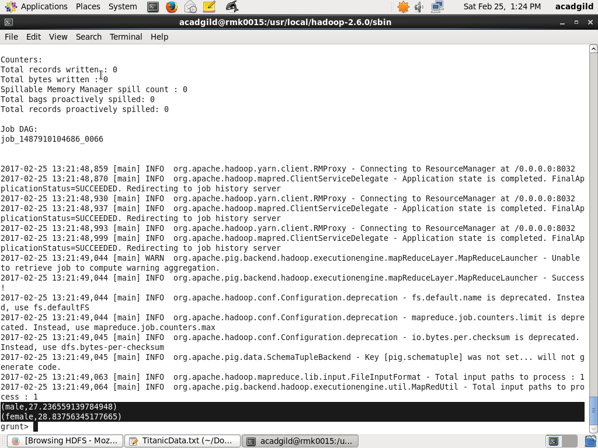

2.Write a pig script to find the number of people died and survived in each class

The number of people died in each class:

Load the data into titanic



Using filter command extract the people who died in that tragedy:



Group statement is used to grouping the data by Pclass

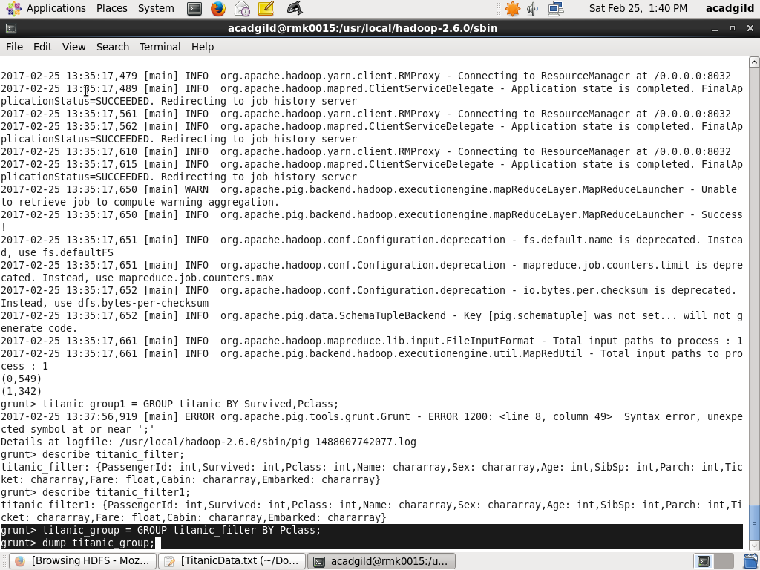

And then find the number of persons died in each class using count command

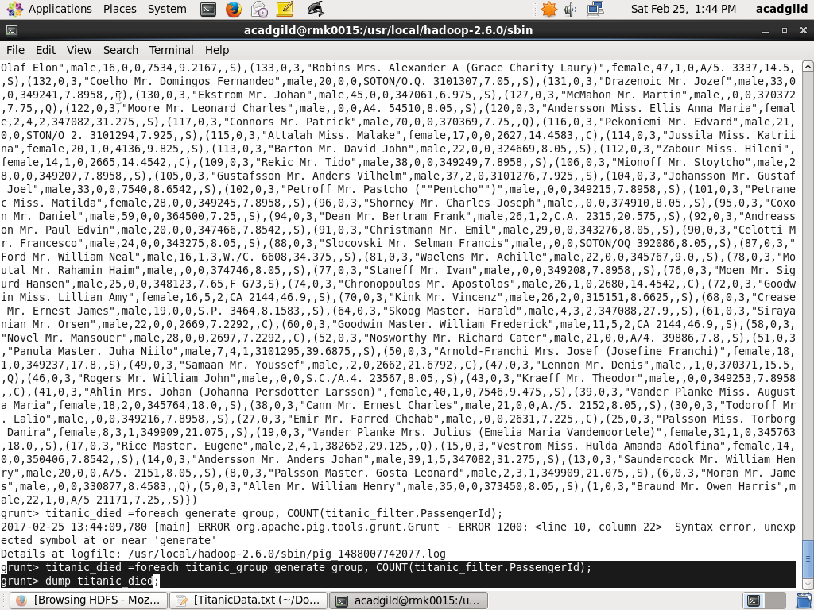

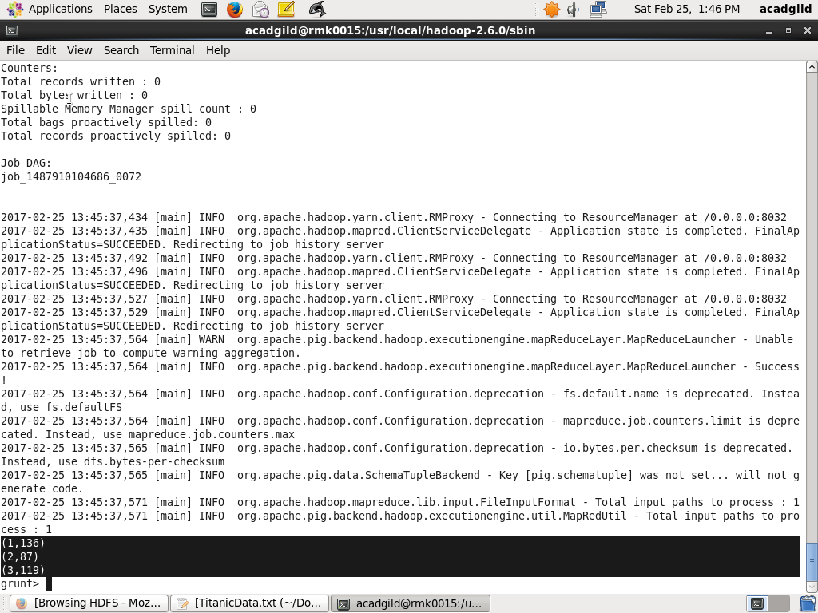

The number of people survived in each class:



Using filter command extract the people who survived in that tragedy

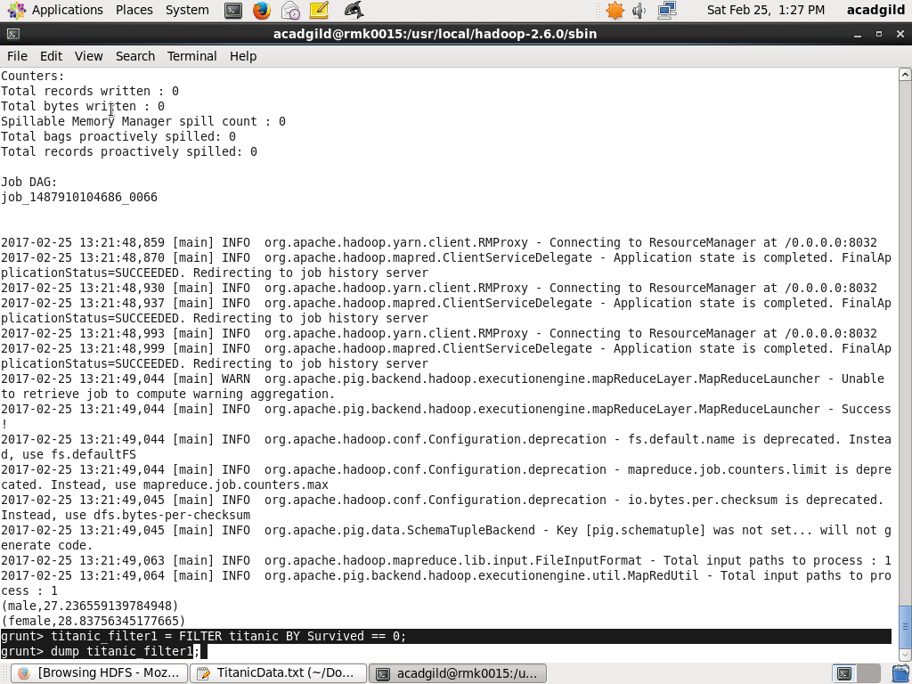

Group statement is used to grouping the data by Pclass

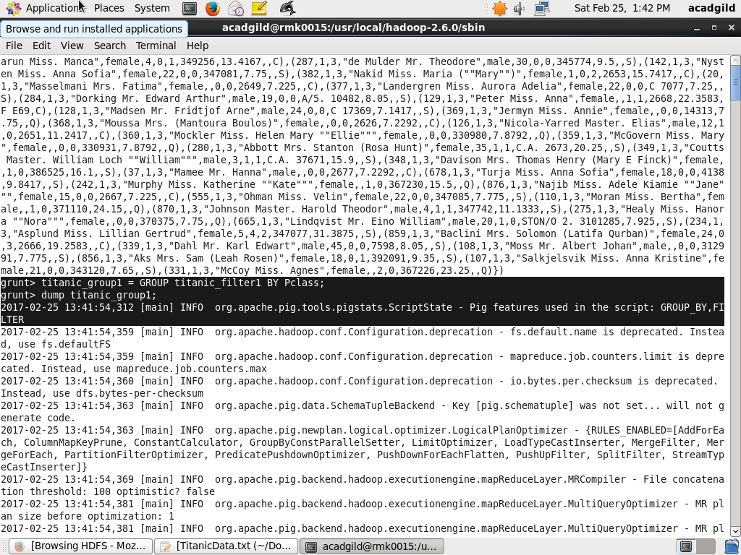

And then find the number of persons survived in each class using count command

