**Assignment6.5**

**1.Write a pig script to find the top 20 destination people travel the most: Based on the given data**

Loading the data: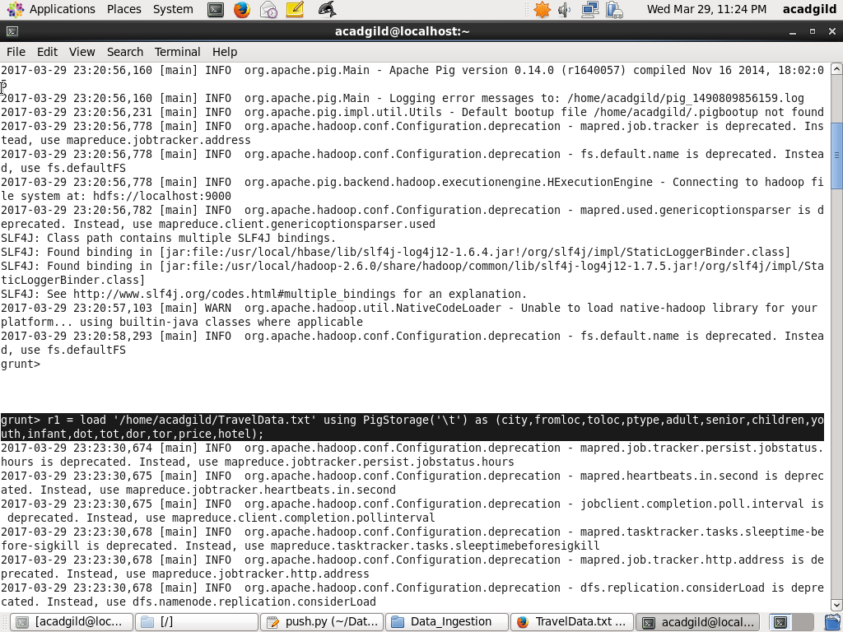

Grouping the data by destination:

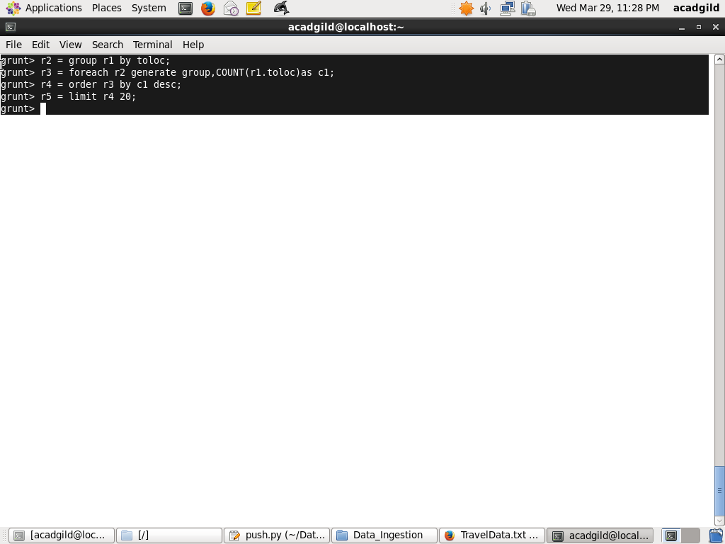

Apply the counting operation:



Apply the descending operation to get the top most destinations:



Limit the top 20 destinations:



Dumping operation:

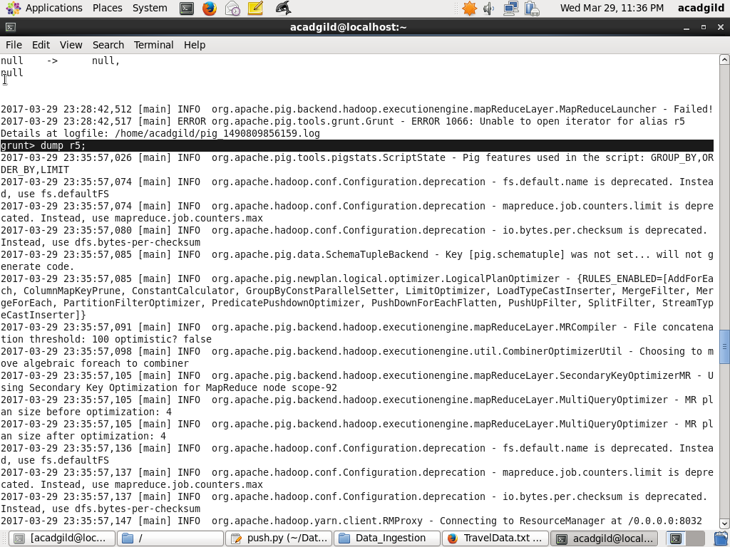

Final Result:

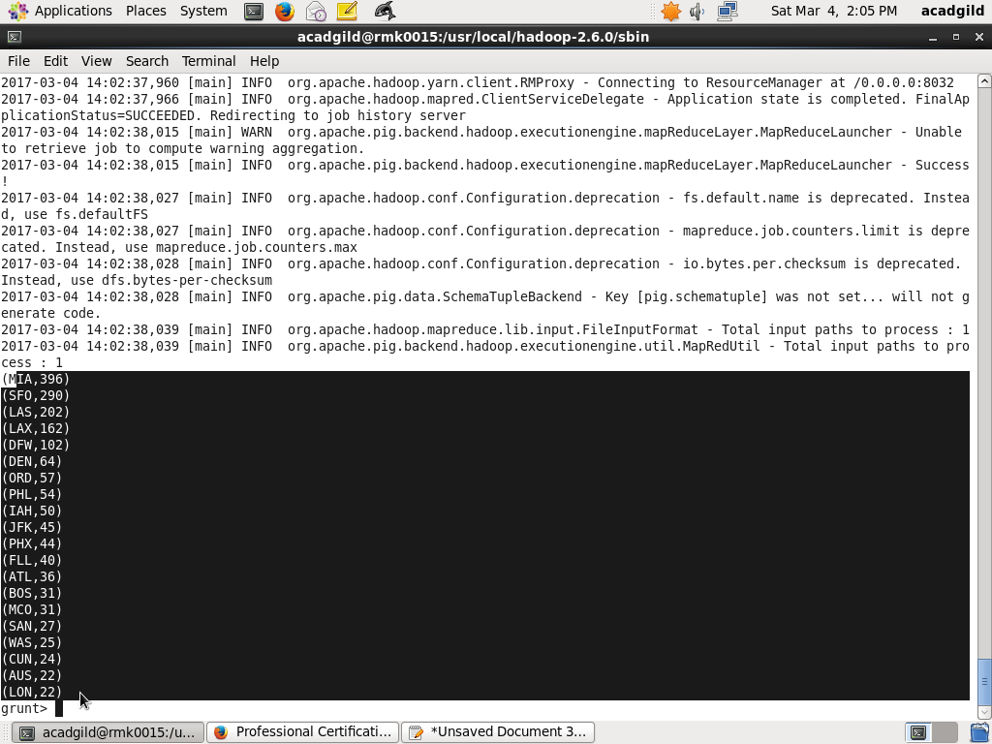

**2.Write a pig script to find the top 20 locations from where people travel the most.**

Loading the data:



Grouping the data by fromlocation:

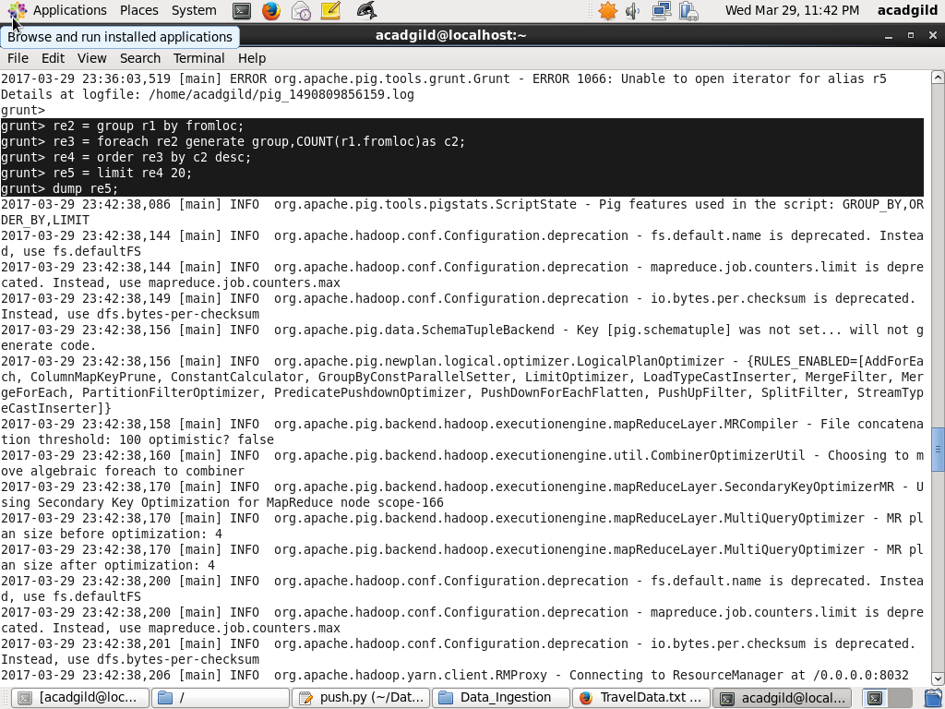

Apply the counting operation:



Apply the descending operation to get the top most destinations:



Limit the top 20 destinations:



Dumping operation:



Final Result:

