**Write a program to implement wordcount using Pig.**

Load the file wordcount into wordcount_load

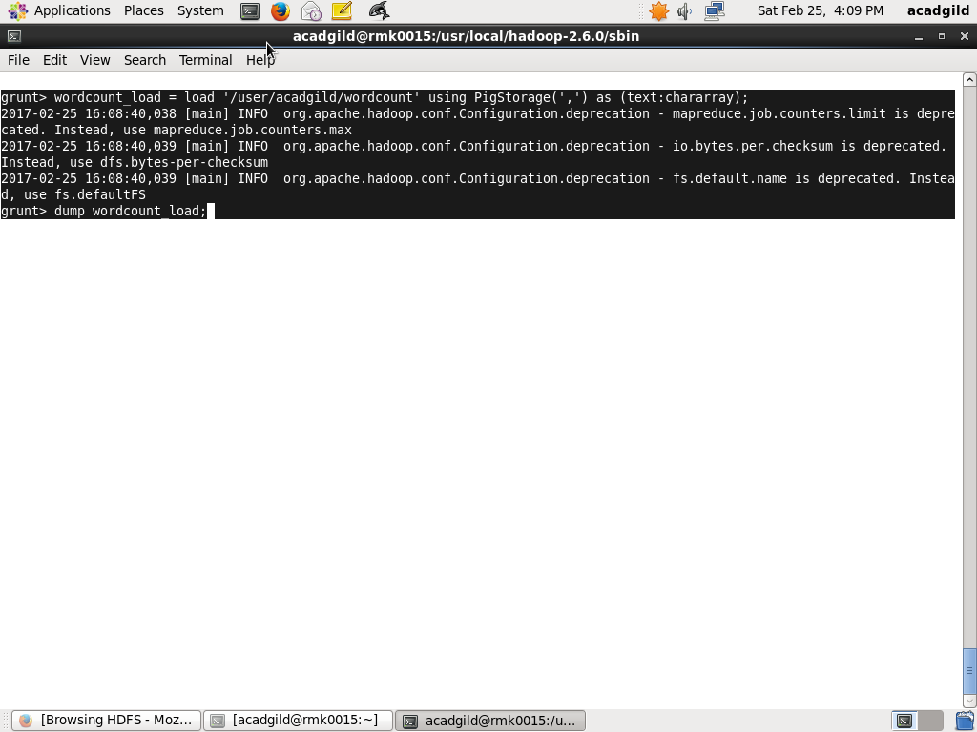

Dump the wordcount_load

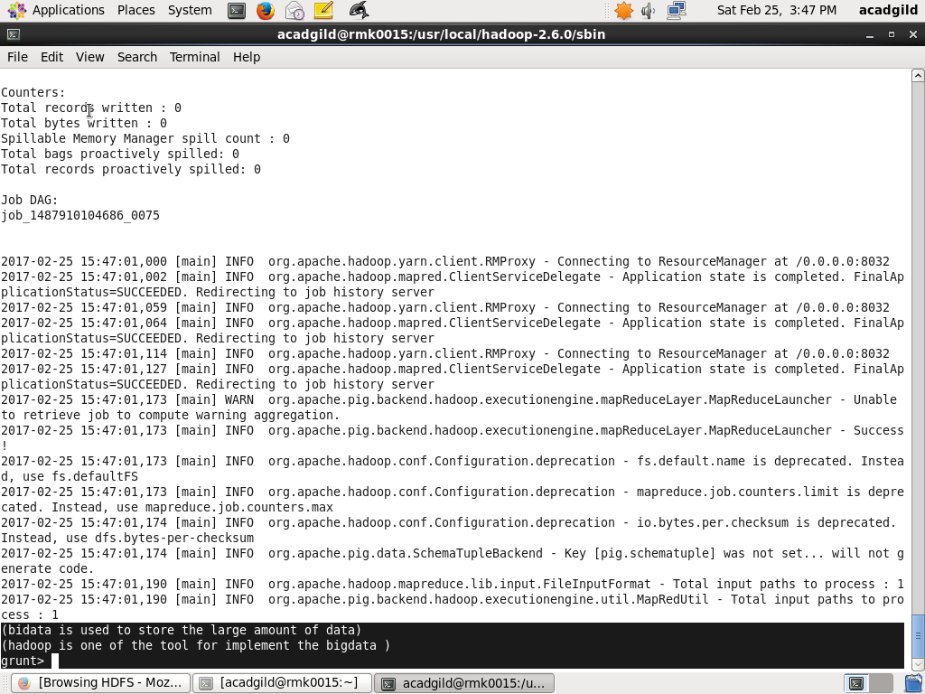

Tokenize the data and then apply the flatten command to seperate the word

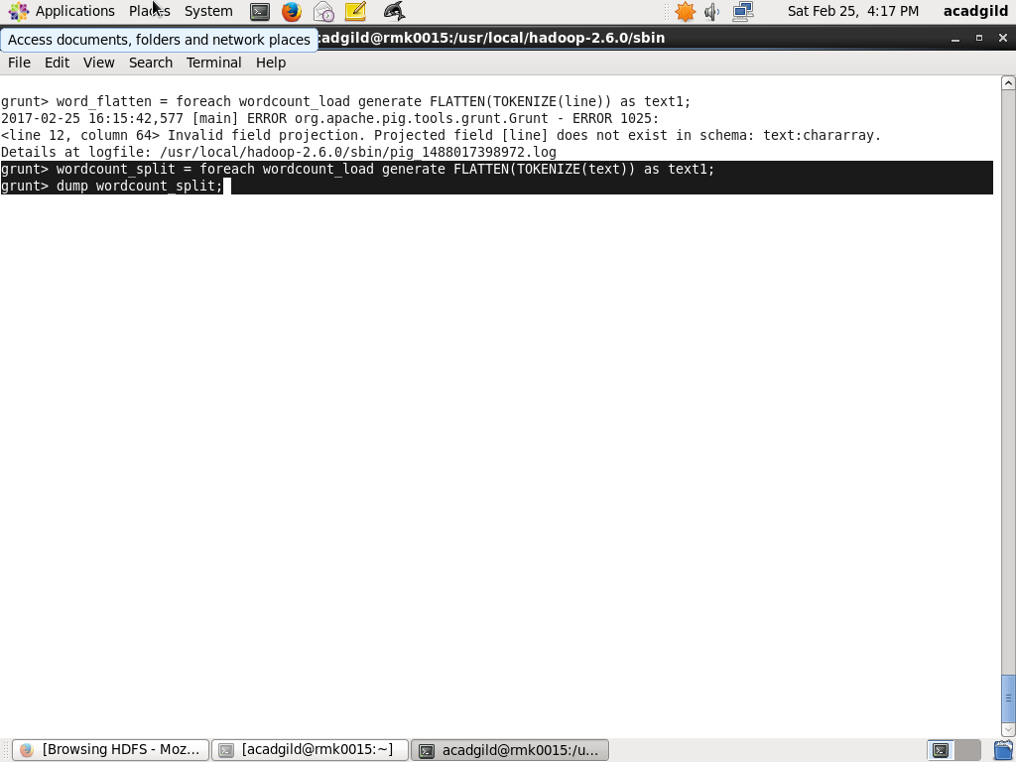

Dump the wordcount_split

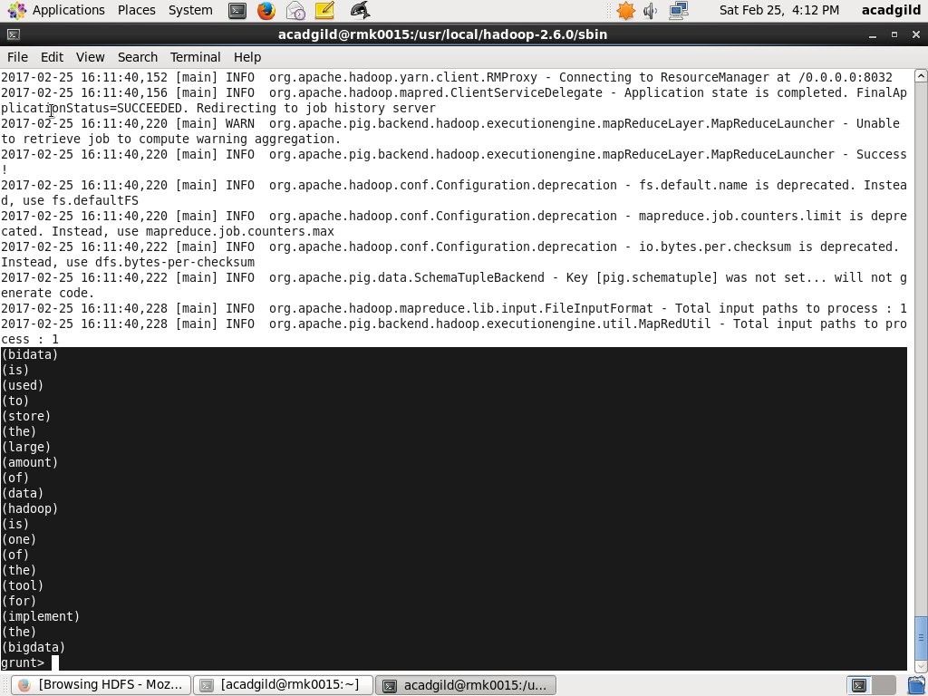

Group the words by GROUP command

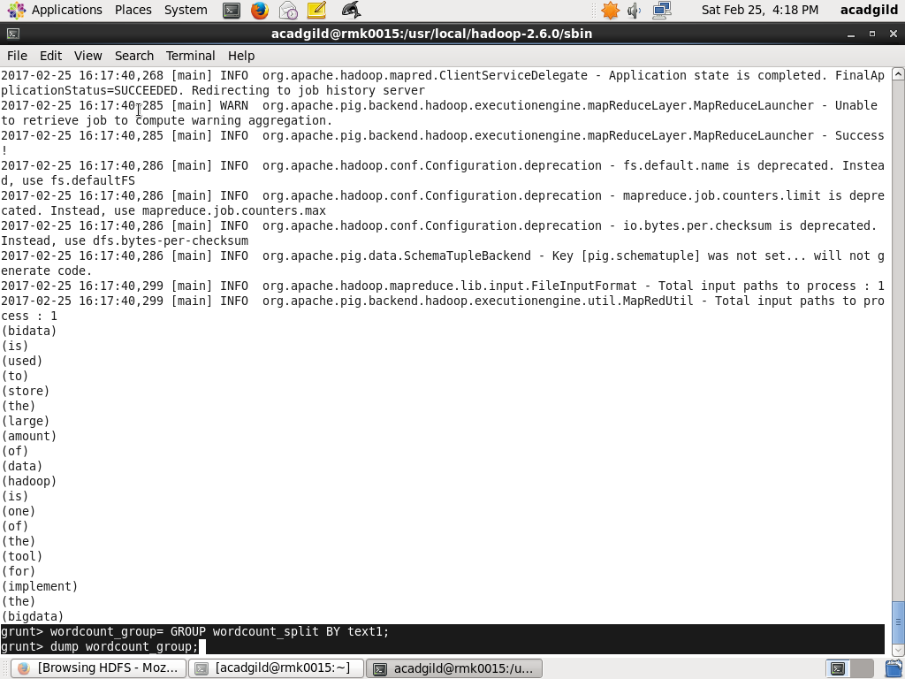

Dump the GROUP command

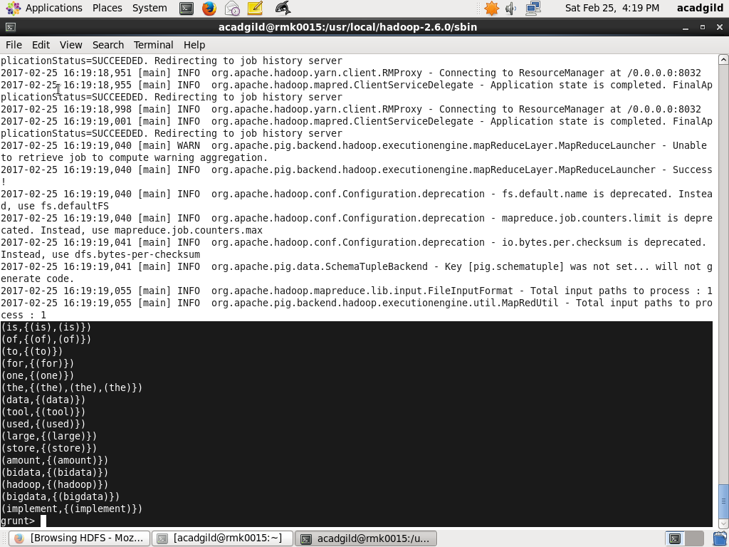

Apply the COUNT command in wordcount_group

