Assignment-7.3
(a) Top 5 employees (employee id and employee name) with highest rating:
Loading the data from employee_details.txt:
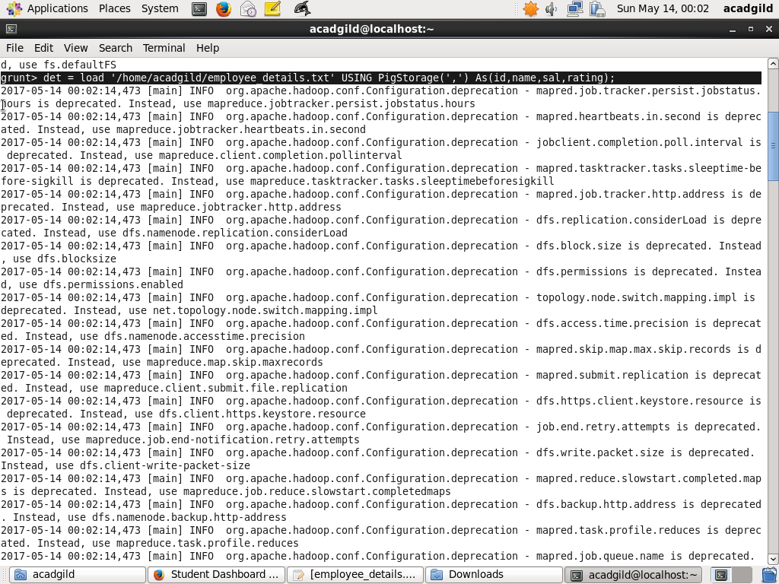
Query for Top 5 employees (employee id and employee name) with highest rating:
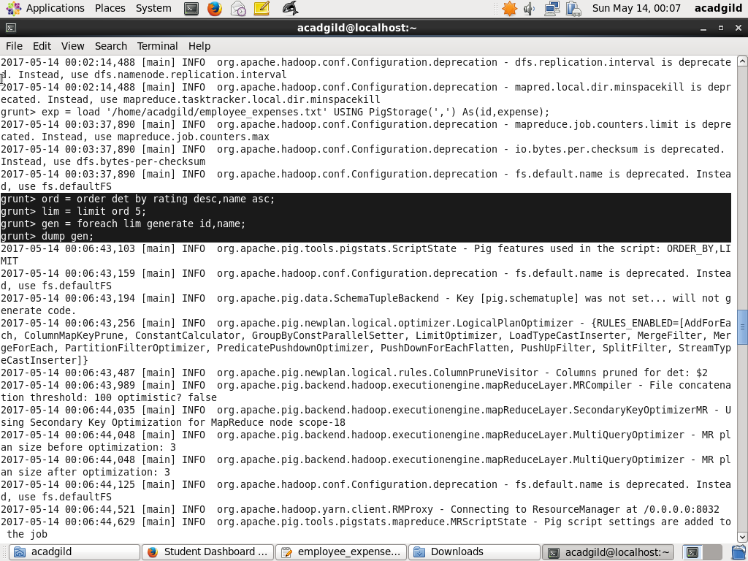
Result for the above query:
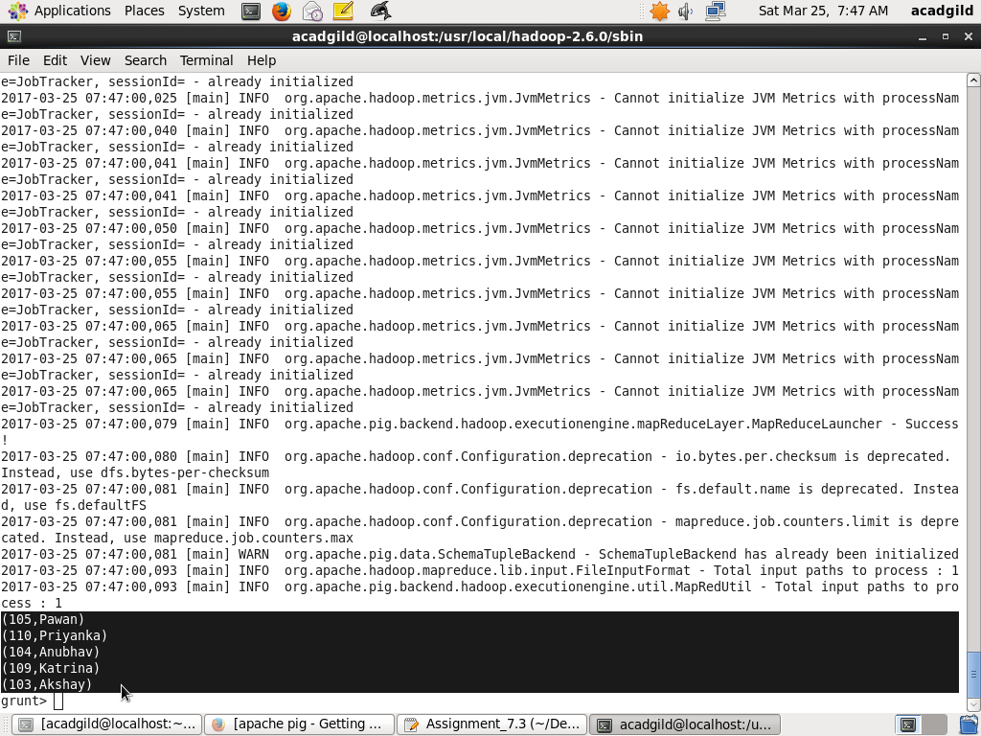
(b) Top 3 employees (employee id and employee name) with highest salary, whose employee id is an odd number.
Loading the data from employee_details.txt:
Query for Top 3 employees (employee id and employee name) with highest salary, whose employee id is an odd number:
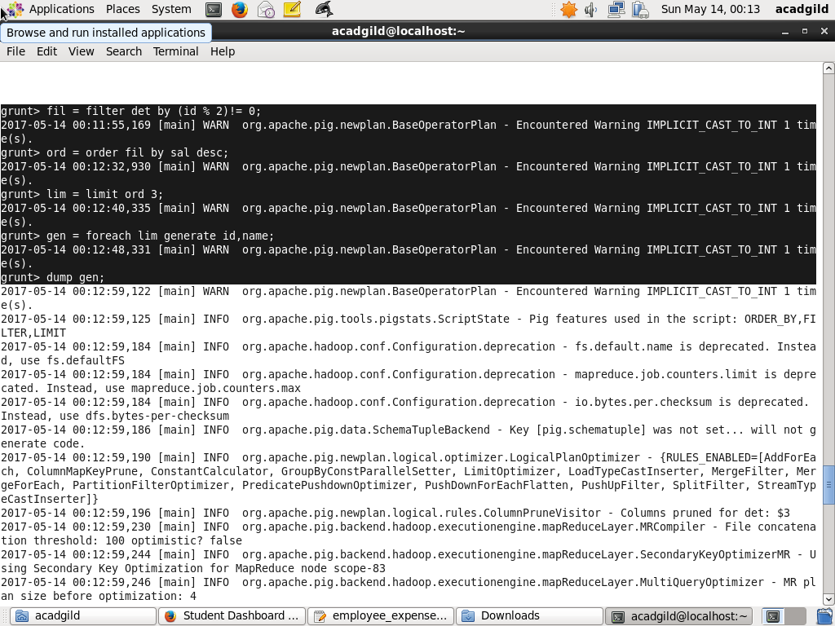
Result for the above query:
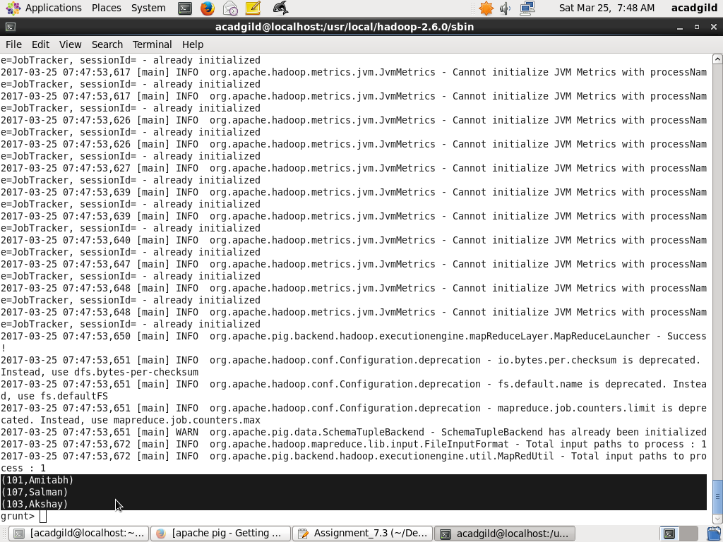

(c) Employee (employee id and employee name) with maximum expense
Loading the data from employee_details.txt:
Loading the data employee_expenses.txt:
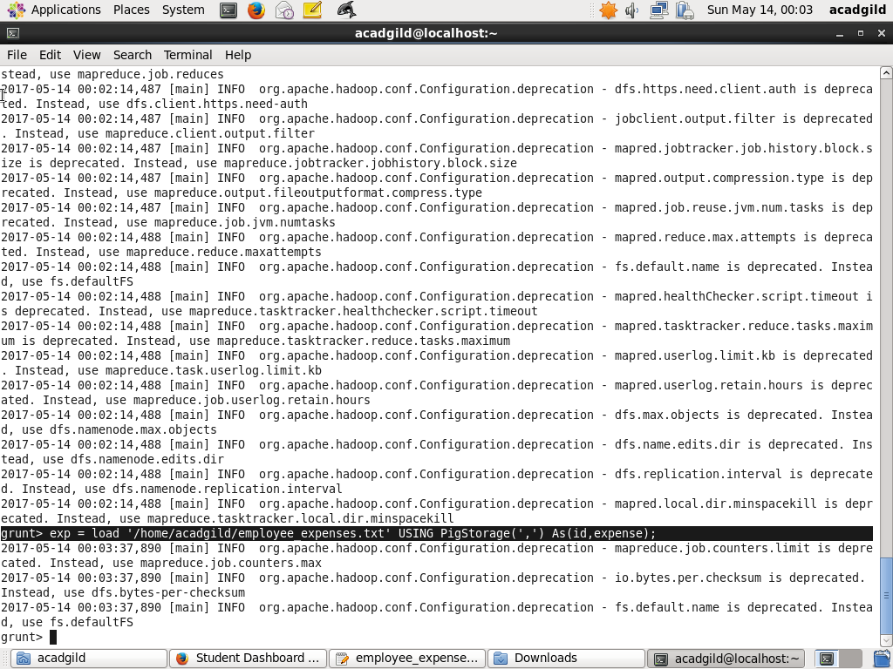

Query for Employee (employee id and employee name) with maximum expense:
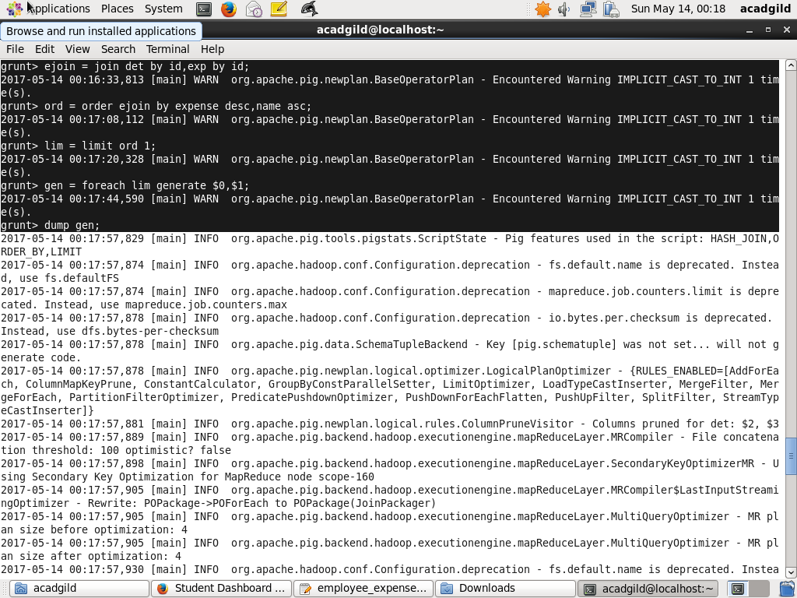
Result for the above query:
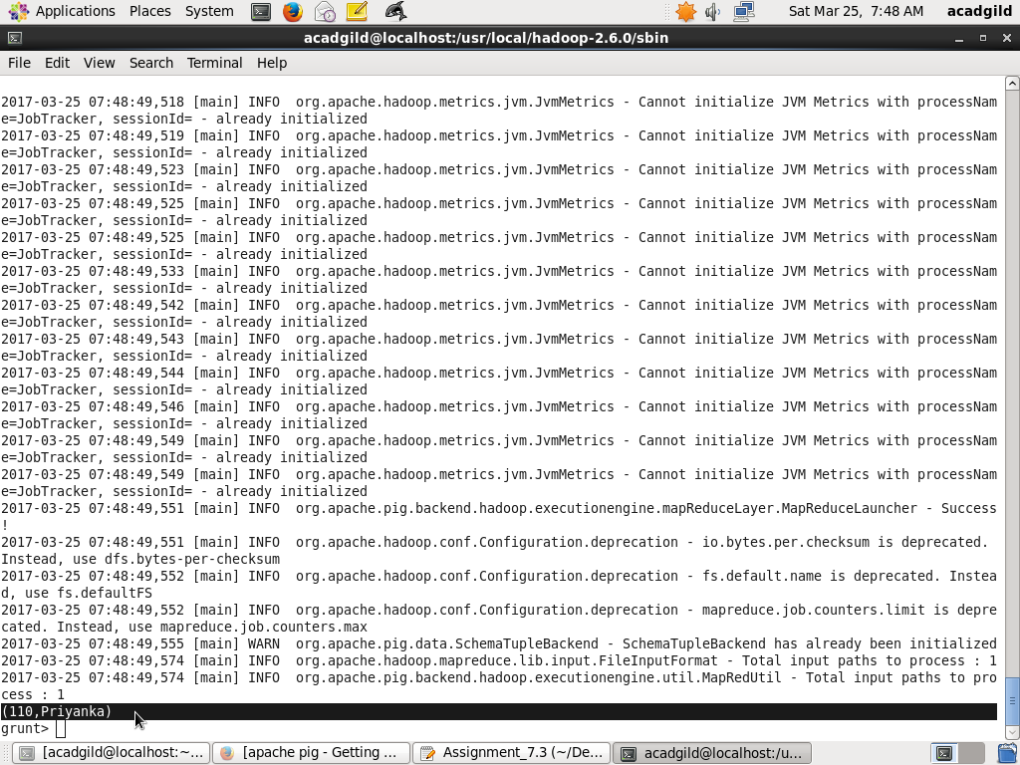
(d) List of employees (employee id and employee name) having entries in employee_expenses file.
Loading the data from employee_details.txt:

Loading the data employee_expenses.txt:
Query for List of employees (employee id and employee name) having entries in employee_expenses file:
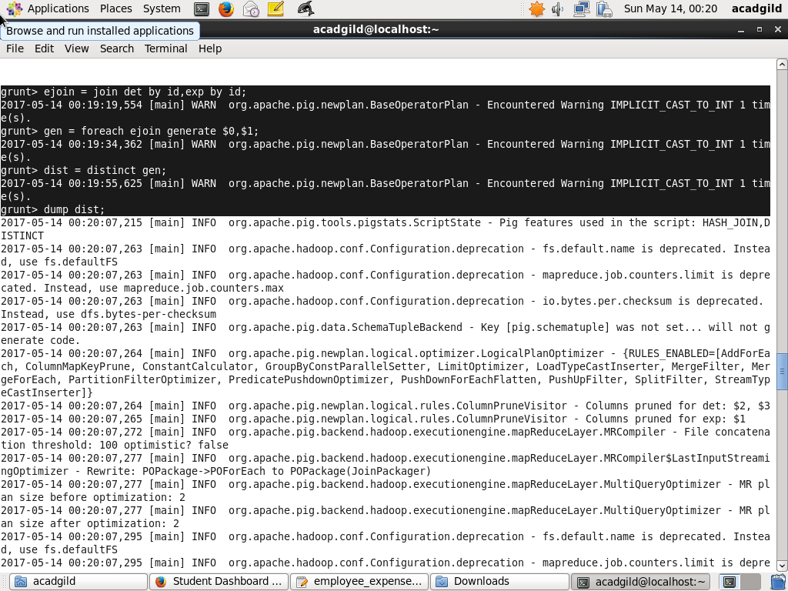
Result for the above query:
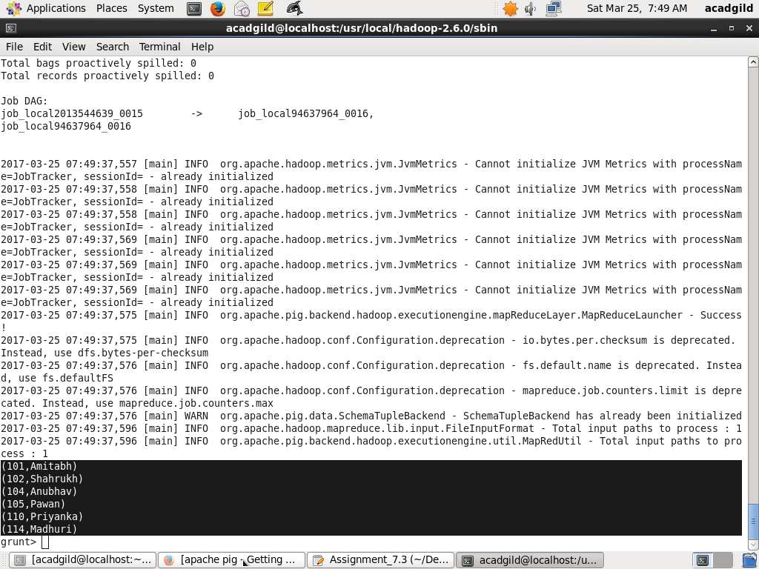
(e) List of employees (employee id and employee name) having no entry in employee_expenses file.
Loading the data from employee_details.txt:
Loading the data employee_expenses.txt:
Query for List of employees (employee id and employee name) having no entry in employee_expenses file.
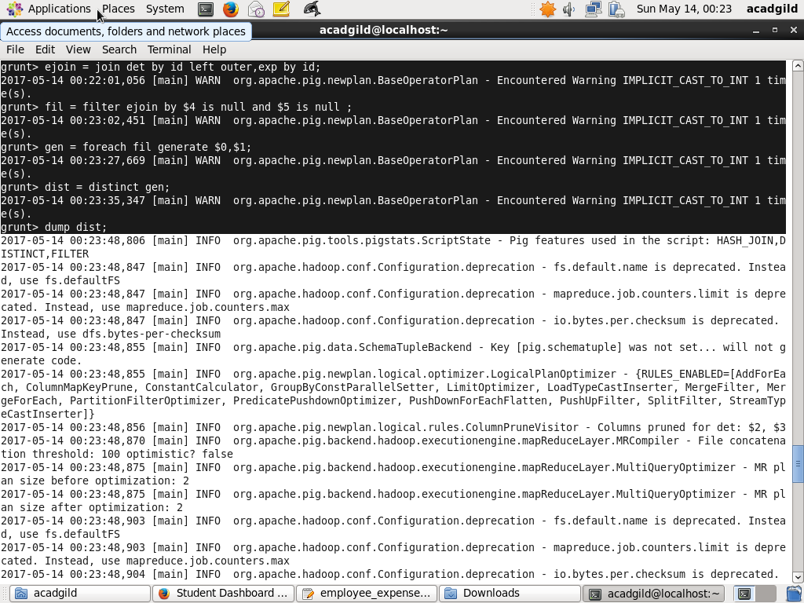
Result for the above query: