**ASSIGNMENT-8.1**

1. **What is the total amount of petrol in volume sold by every distributor?**

Loading the data set into p1 relation:

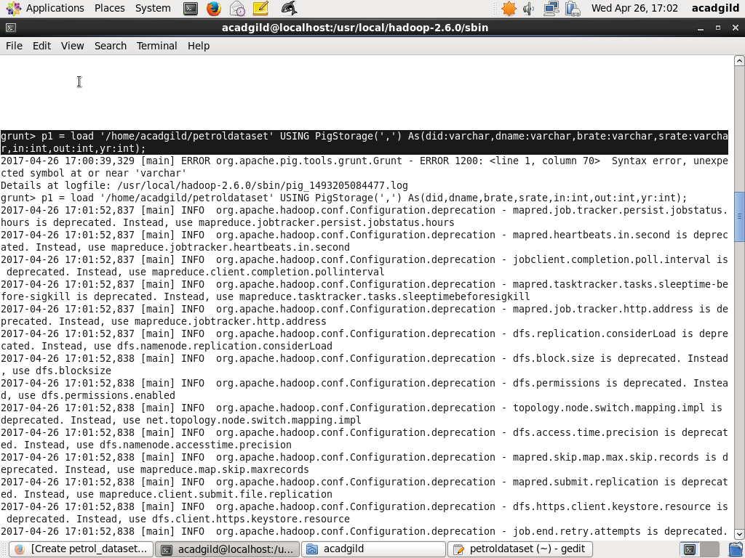

Apply the grouping relation on p1 and calculate the total sell amount for each distributor:

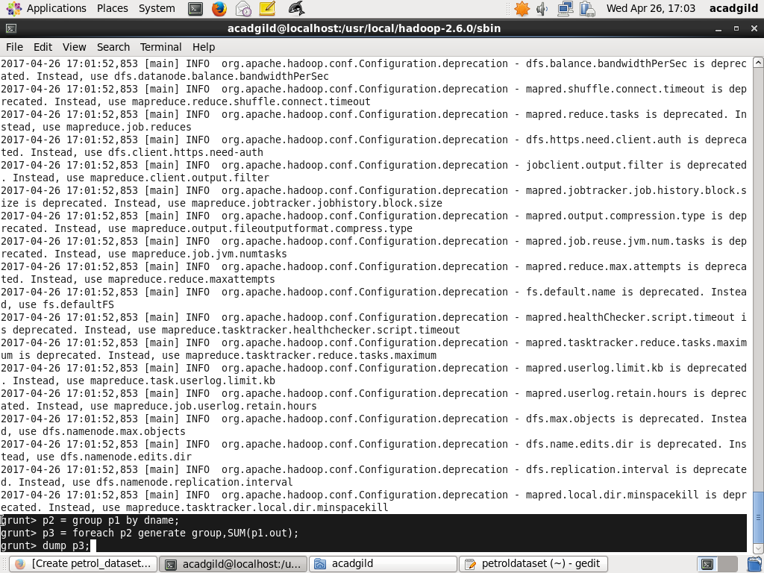

Result:

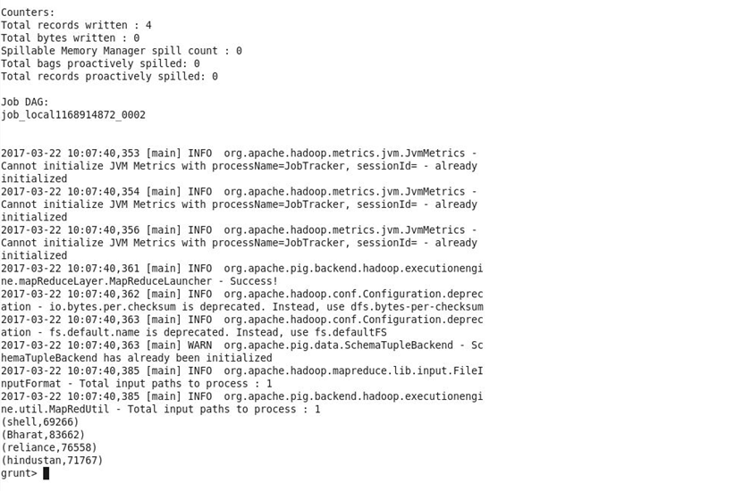

**2.Which are the top 10 distributors ID's for selling petrol? Also display the amount of petrol sold in volume.**

Loading the data set into p1 relation:



Apply the grouping relation on p1 , calculate the total sell amount for each distributor and apply the order by condition :

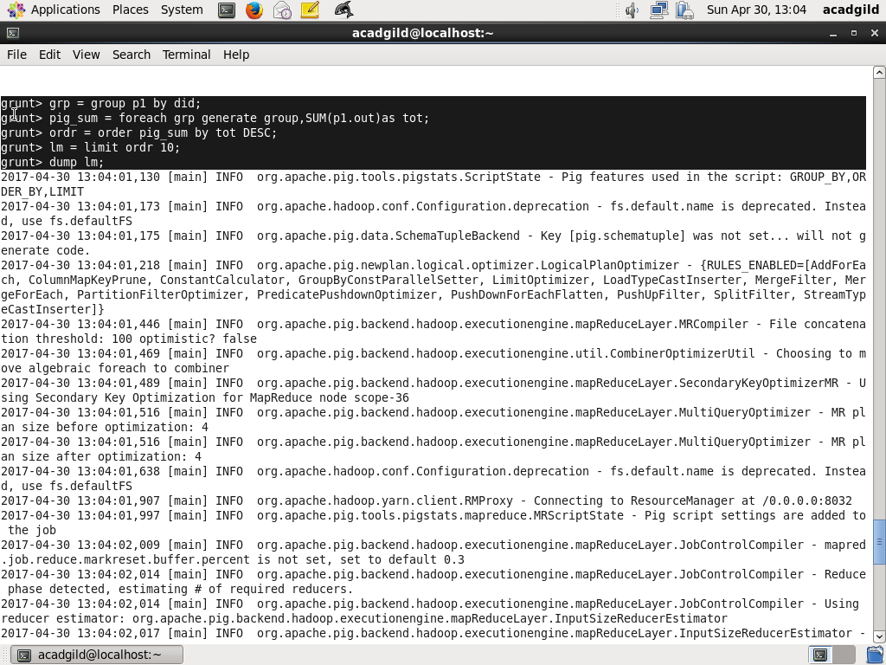

Result:

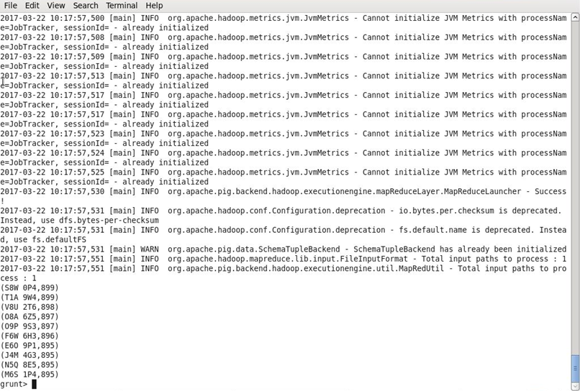

**3.List 10 years where consumption of petrol is more with the distributer id who sold it?**

Loading the data set into p1 relation:



Apply the grouping relation on p1 , calculate the total sell amount for each distributor and apply the order by condition :

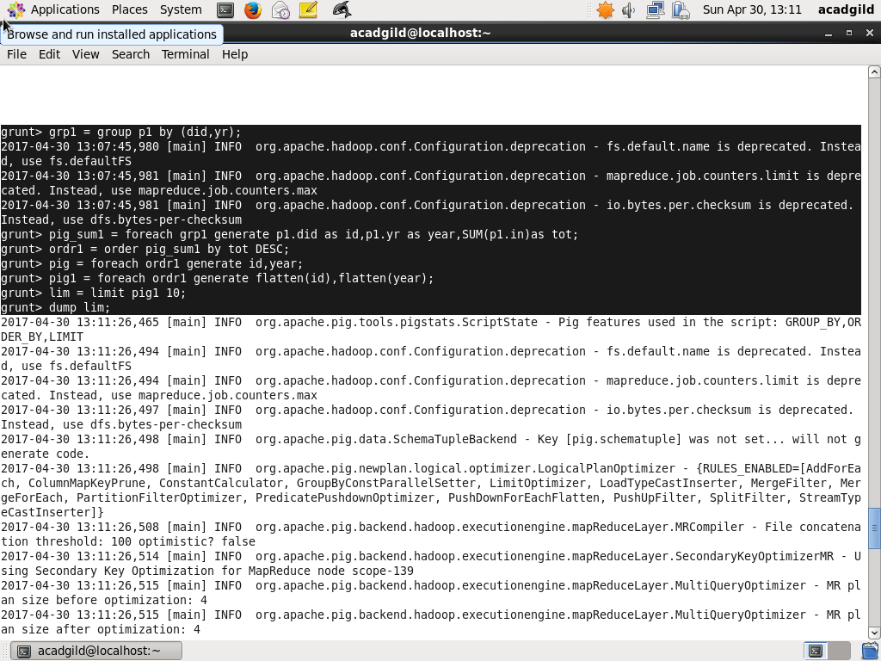

Result:

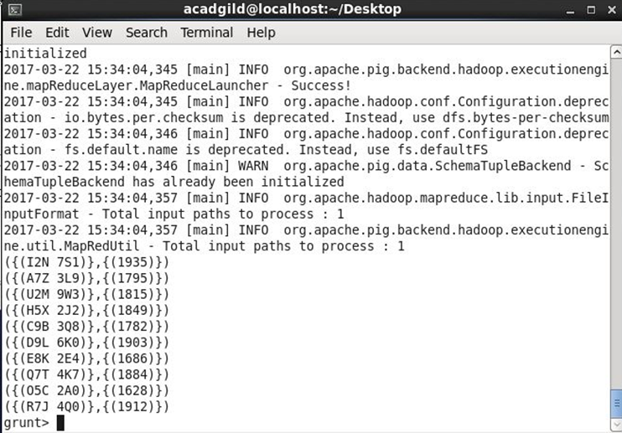

**4.Find the distributer name who sold petrol in least amount**?

Loading the data set into p1 relation:



Apply the grouping relation on p1 , calculate the total sell amount for each distributor and apply the order by condition :

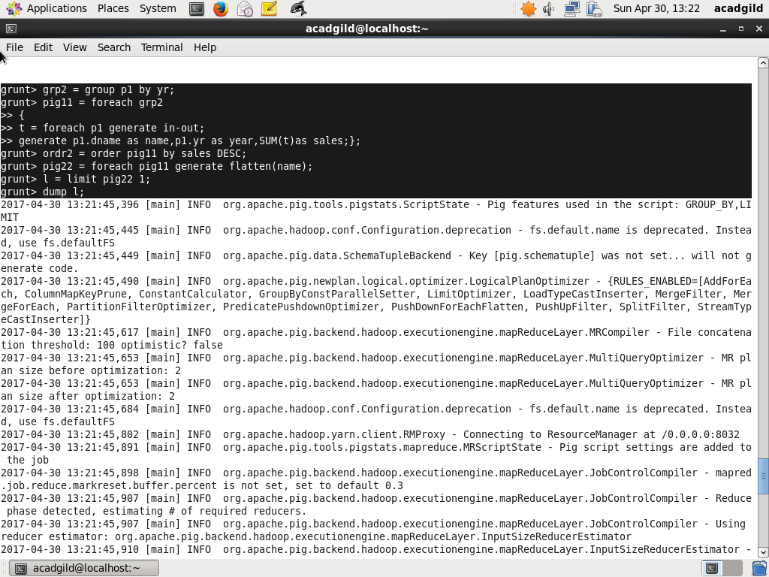

Result:

