**ASSIGNMENT-8.2**

**1.Find the number of students who scored less than 5(50%).**

Loading the data from dataset:

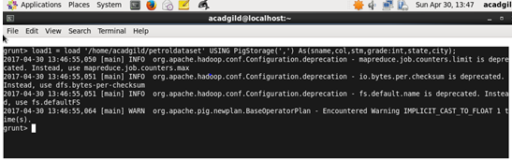

Pig code for find the number of students who scored less than 5:

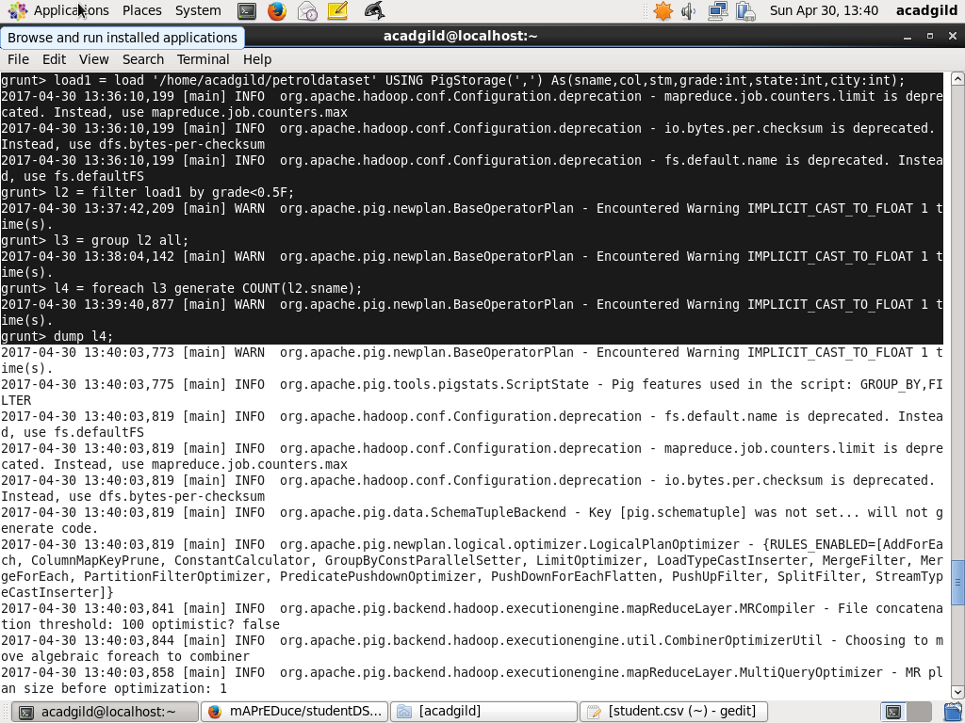

Result:

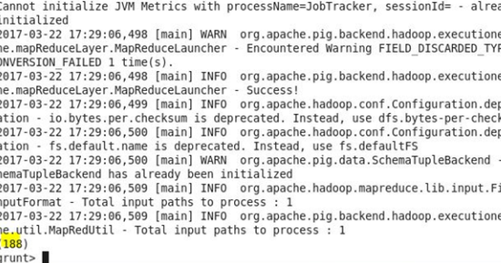

2**.List the name of students who are from Alaska.**

Loading the data from dataset:

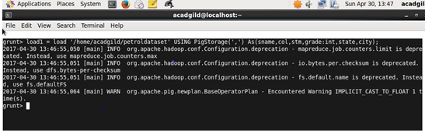

Pig code for list the name of students who are from Alaska: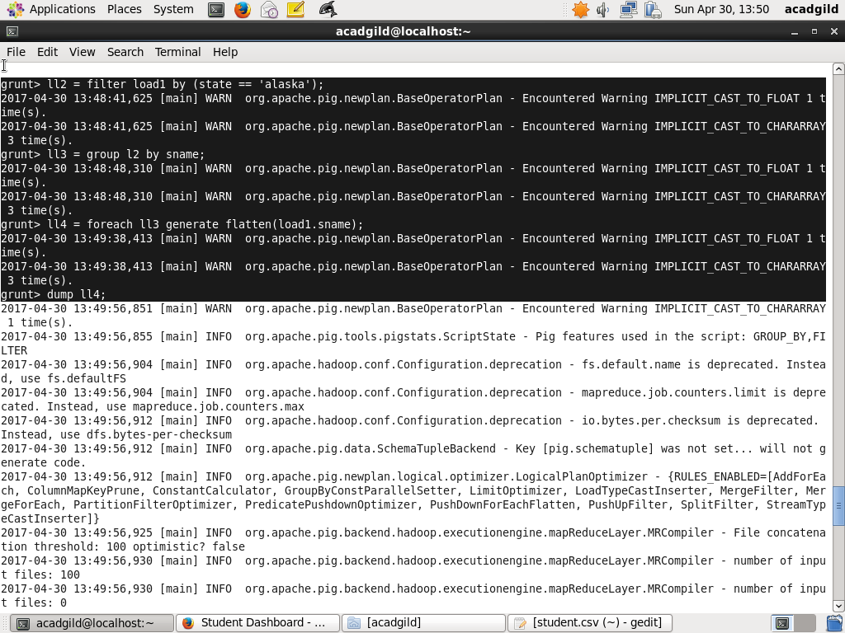

Result:

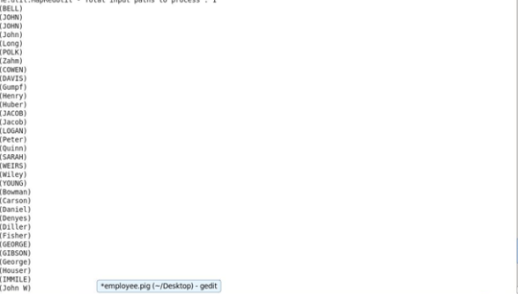

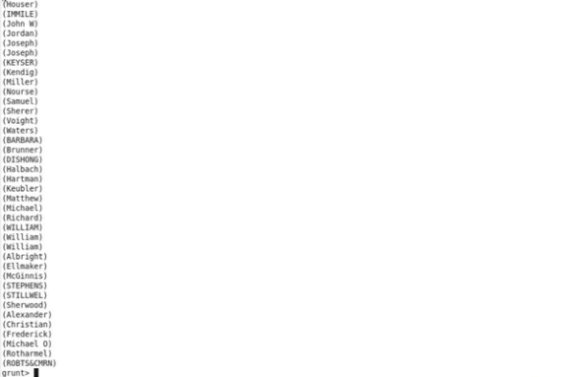

**3.How many government colleges are there in Alabama**?

Loading the data from dataset:



Pig code for how many government colleges are there in Alabama :

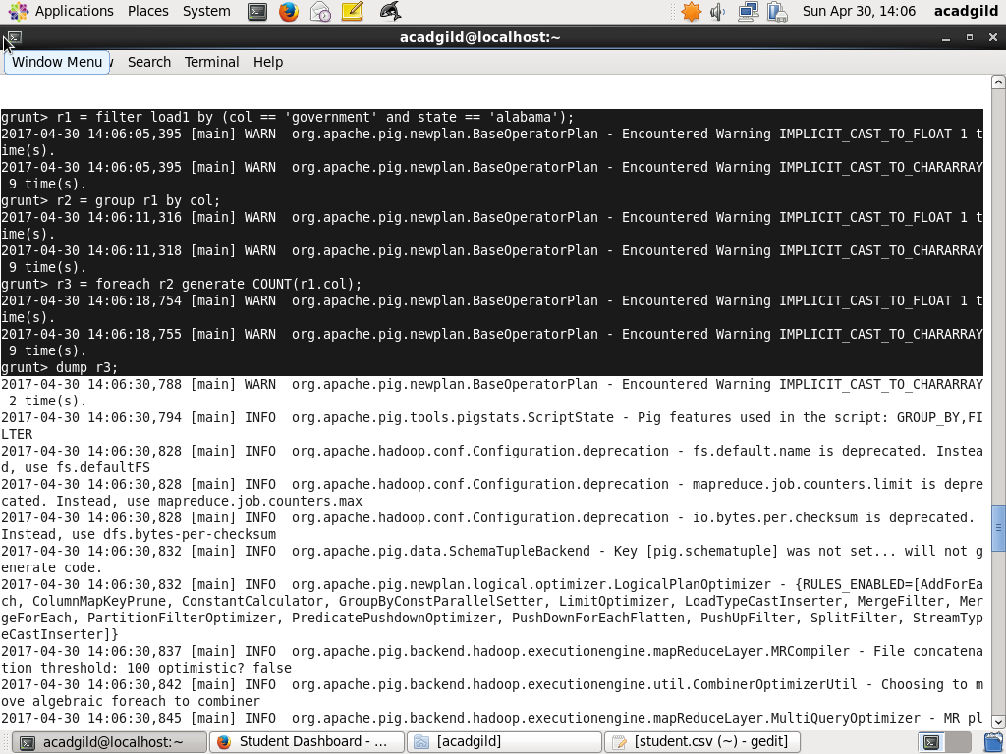

Result:

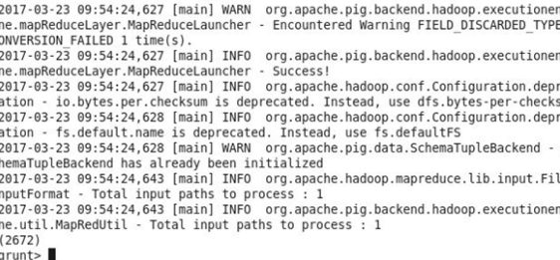

**4.List the name of students who are from Oregon and pursuing BE.**

Loading the data from dataset:

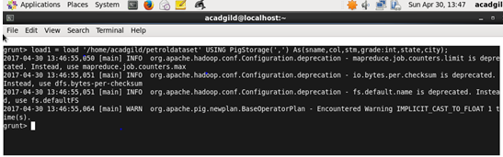

Pig code for list the name of students who are from Oregon and pursuing BE:

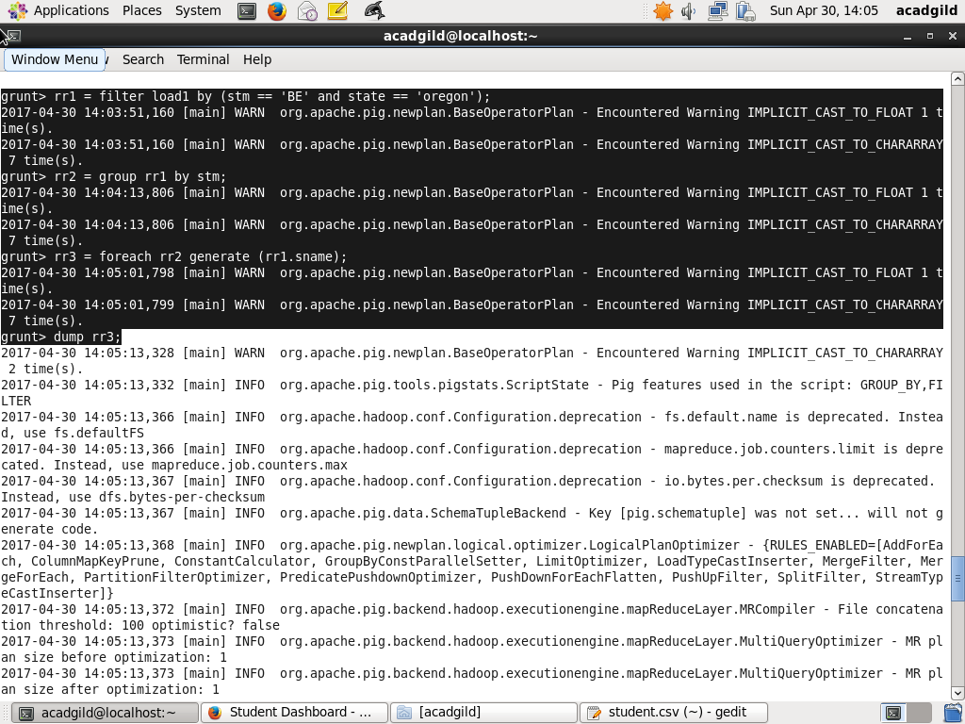

Result:

