**Assignment 8.6**

1.Find the top five kinds of GoogleKnowlege_Occupation people who were guests in the show, in a particular time period i.e., between '1/11/99' and 6/11/99. You need to write an UDF to compare the dates.

Udf

Used Date to filter date between '1/11/99' and 6/11/99 by using date.after and date.before function

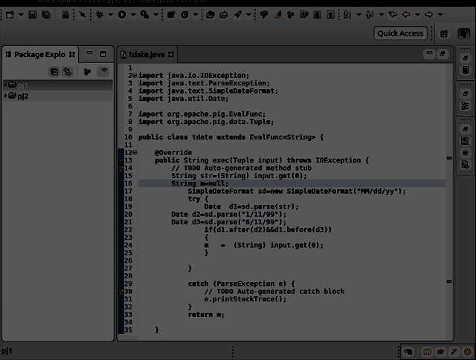

Pig Steps:

Step 1:REGISTERING UDF

Step2:Generating google knowledge column and used tdate(date column);

Step3:filter it for not null condition

Step4:made group by google knowledge occupation

Step5:made count

Step6:order by count desc

Step7:made limit of 5

Output:

