**ASSIGNMENT-9.1**

**Create a flume agent that streams data from Twitter and stores it in the HDFS cluster**.

download and include the snapshot.jar:

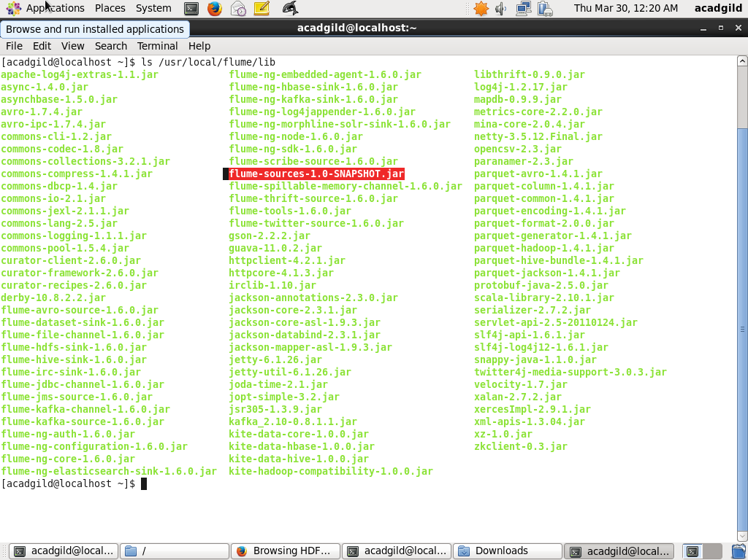

set flume class path:

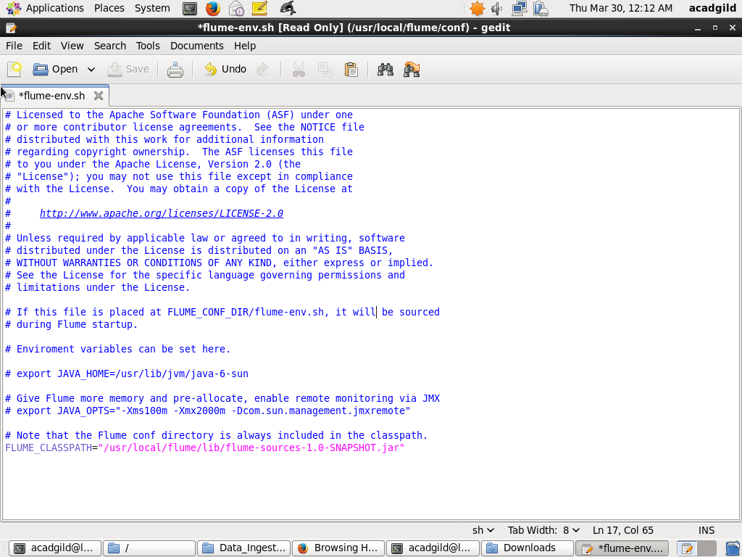

Editing the .conf file with our credentials:

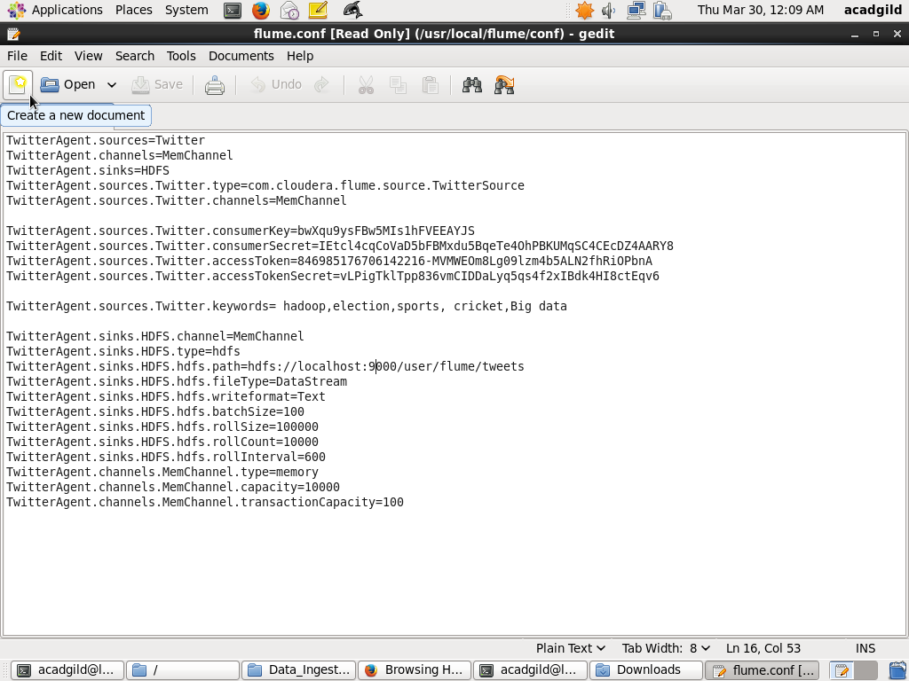

Changing the permissions:

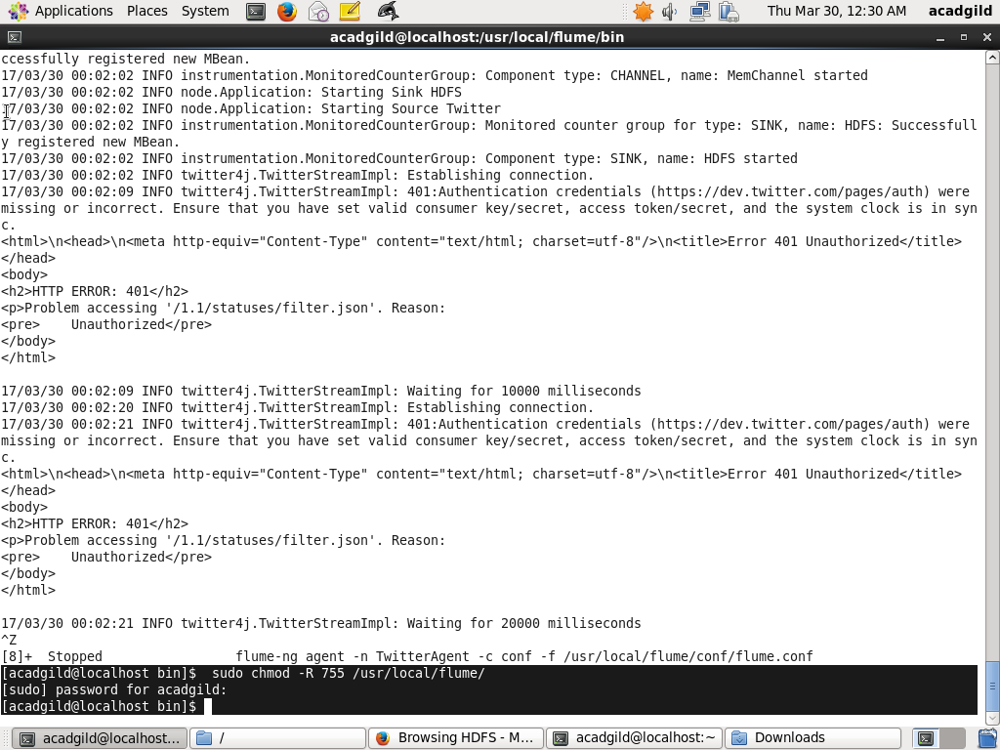

Fetching the data from twitter:

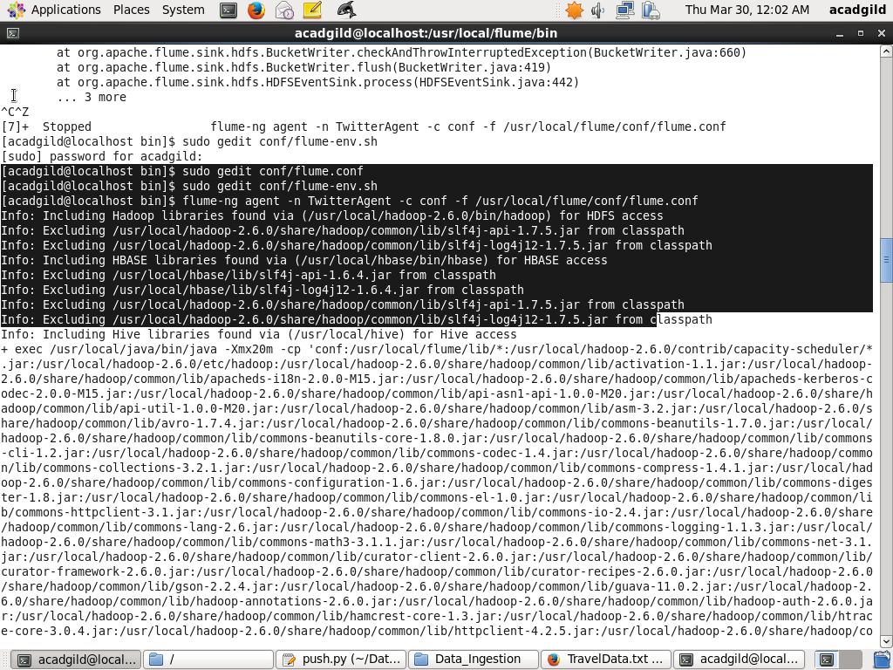

Resultant directory created in hdfs:

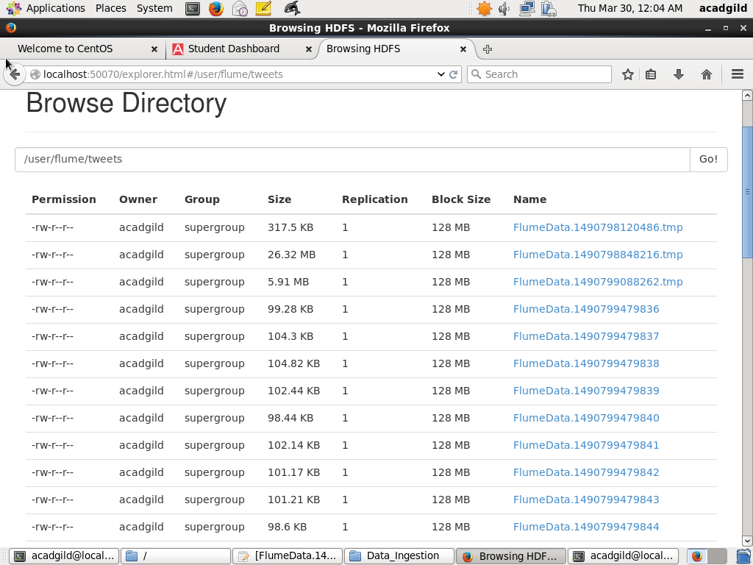

The streaming data inside the .tmp file:

