**ASSIGNMENT-9.4**

**Transfer streaming data from your local file system to HDFS using flume spool directory**.

Creation of a folder spool with 2 files say sample1 and sample2:

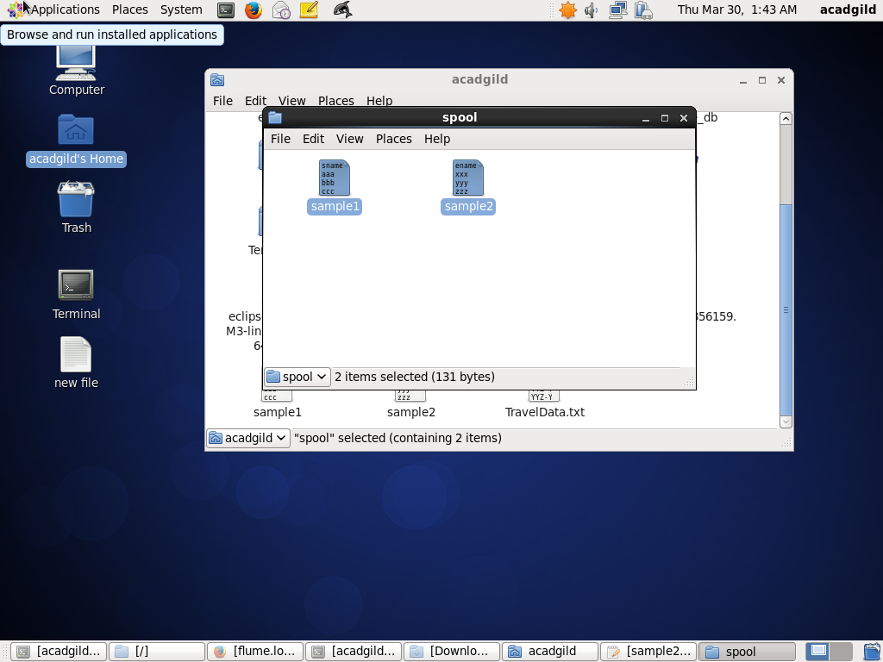

Moving the configuration file into conf folder of flume:

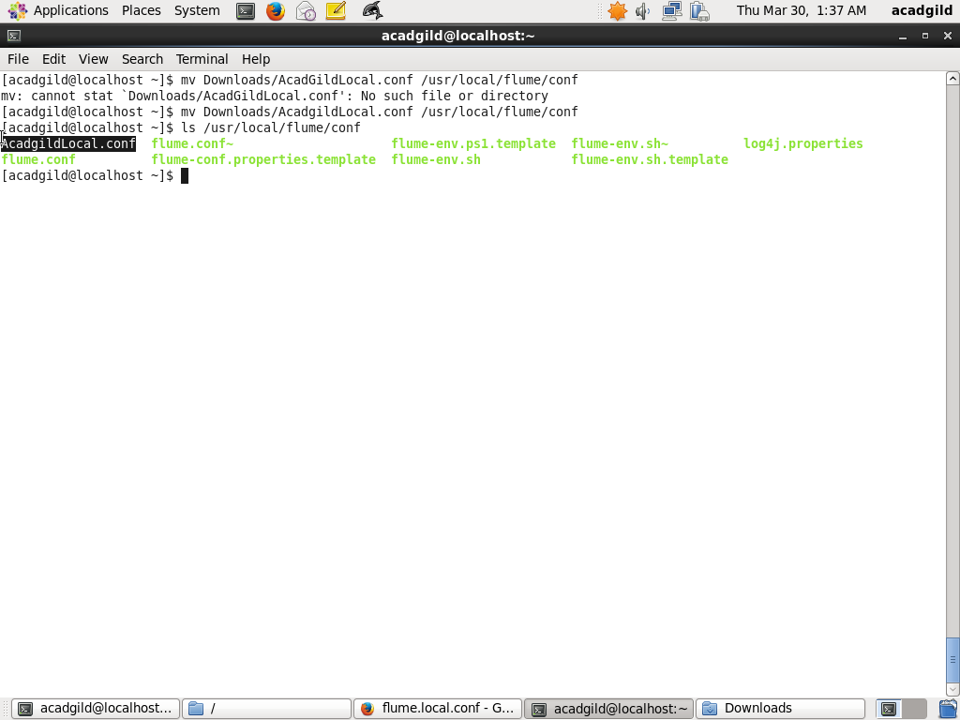

Creation of the output directory:

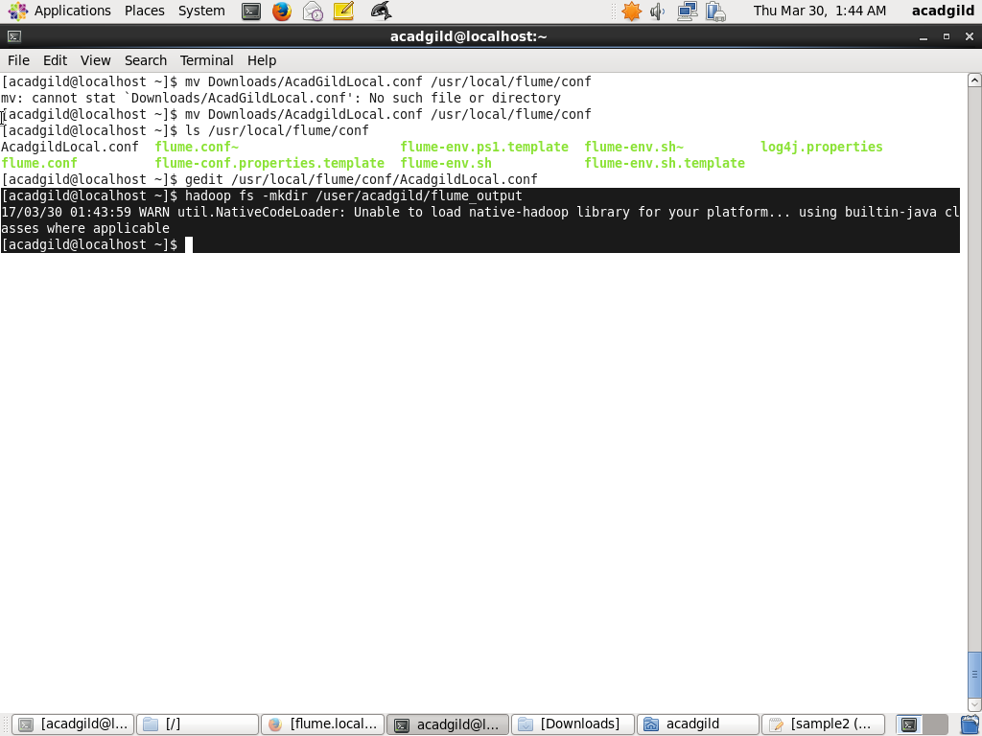

Modification of .conf file according to my path:

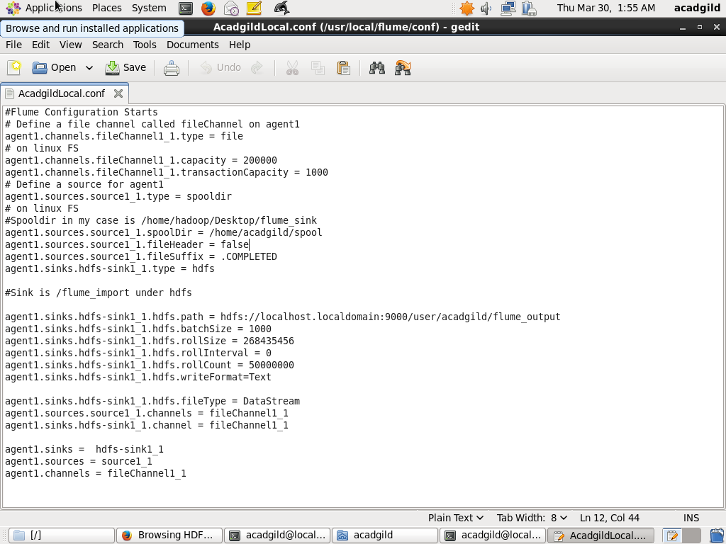

Running the flume agent:

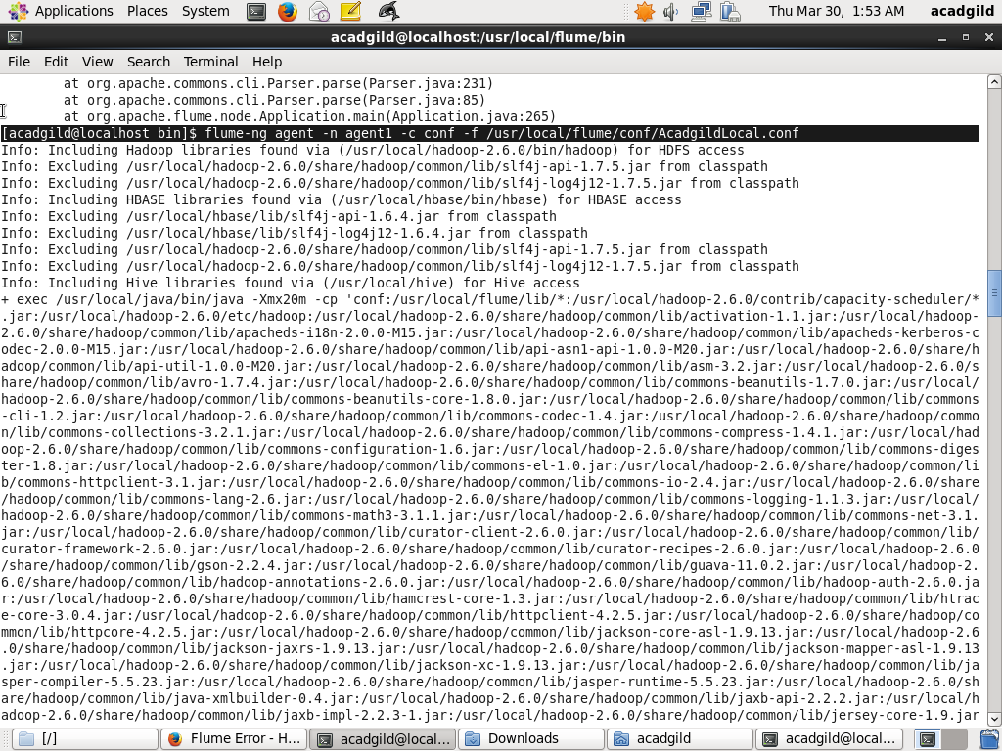

Result:

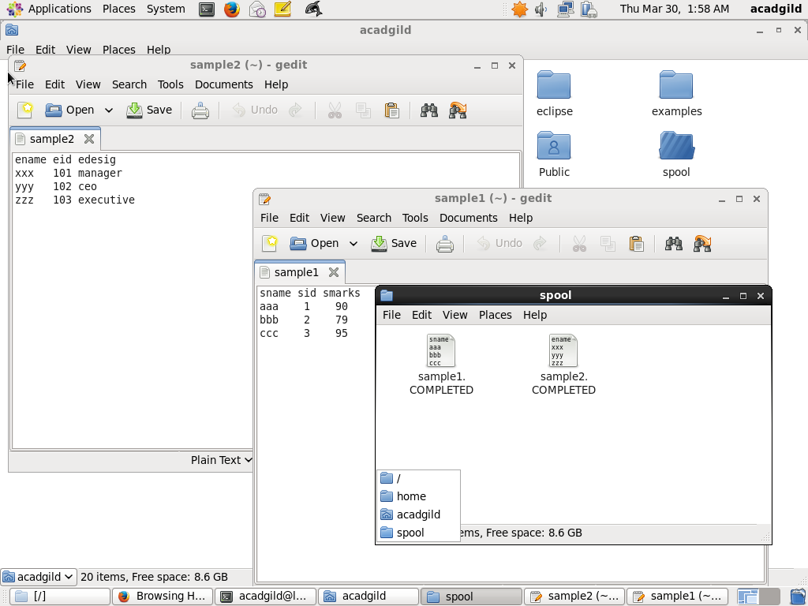

Output stored on hdfs:

