**ASSIGNMENT-9.6**

Data Load

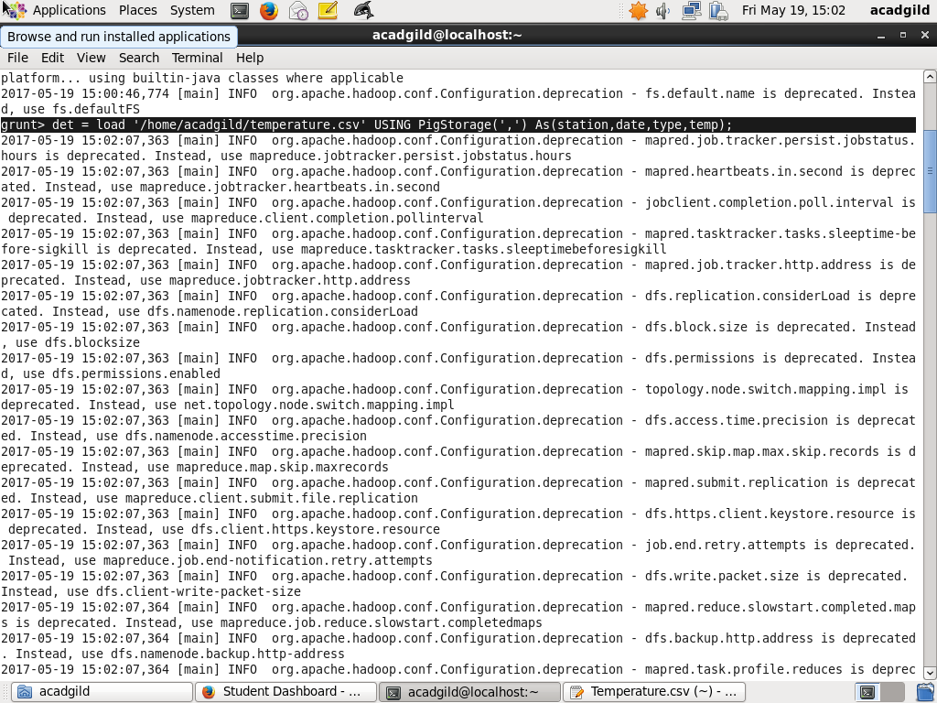

1. Write a pig script to find the minimum temperature observed in a given weather station in a particular year

Filter Operation

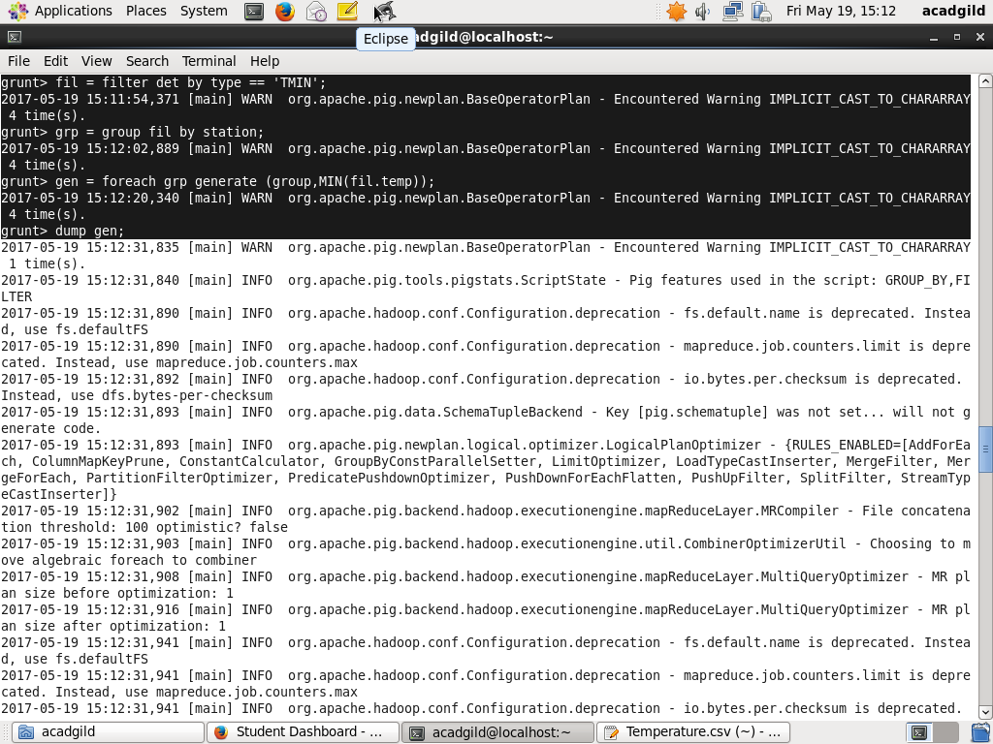

Group Operation



Min Temperature



1. Write a pig script to find the maximum temperature observed in a given weather station in a particular year

Filter Operation

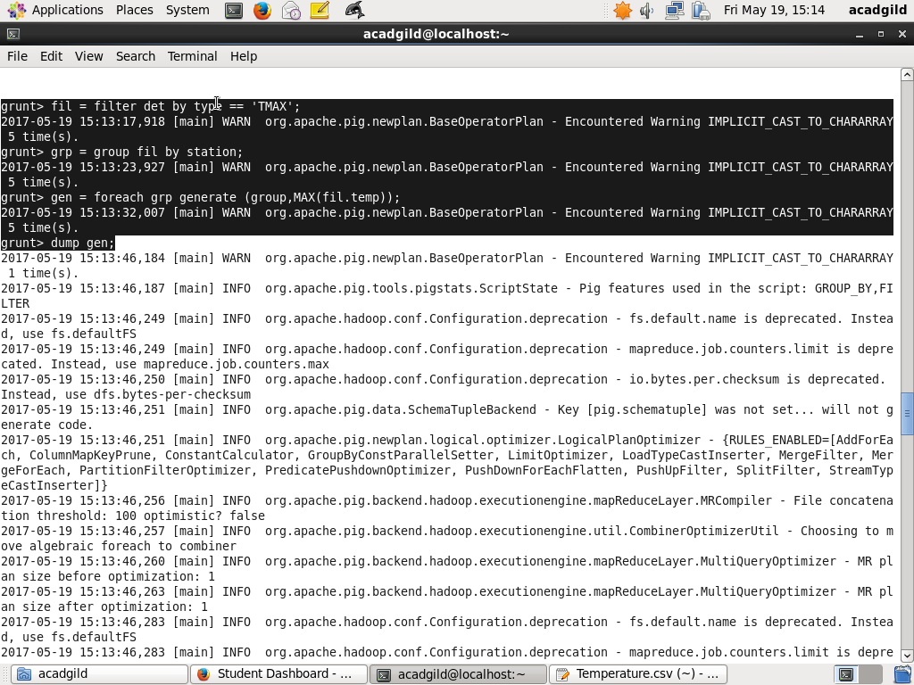

Group Operation



Max Temperature



1. Write a pig script to find the number of readings given by each weather station according to the dataset.

Group Operation

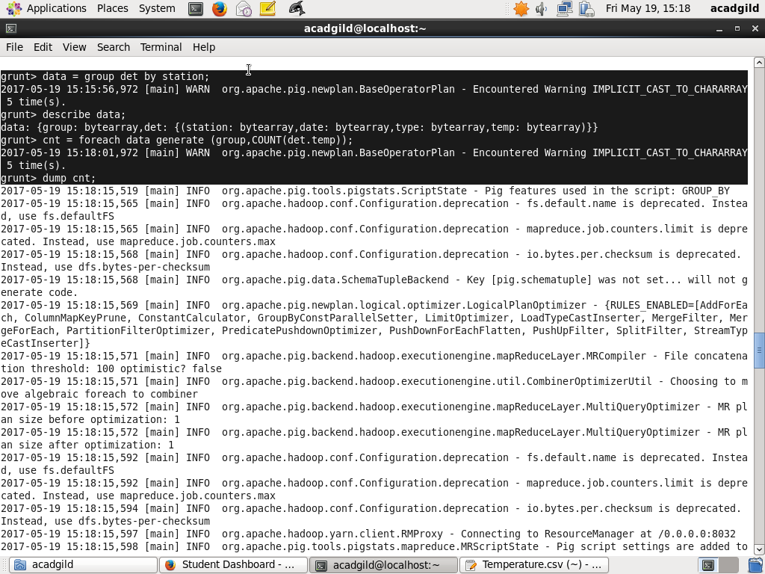

Count Operation

