PES UNIVERSITY
Department of Computer Science & Engineering



UE22CS342BA5 – BlockChain

Mini Project Report

GasTrackPay - Gas Tracking System

Team Number: 16

Submitted to: Submitted By:
Dr. Geetha Dayalan Raahithya Jayaram Swathi C G Swetha Ranganathan
Associate Professor PES2UG22CS421 PES2UG22CS610 PES2UG22CS611
VI Semester VI Semester VI Semester

Table of Contents

Sl.No | Title | Page No
1 | Introduction
2 | Problem Statement
3 | Blockchain Implementation Details
4 | Screenshots of the working application
5 | Conclusion
6 | Future Enhancements
7 | GitHub Repository Link

Introduction

In the fast-changing digital world, the need for systems that ensure transparency, traceability, and decentralization is more and more essential—especially in the field of financial transactions. Centralized systems tend to have limitations like poor visibility, possible tampering, and reliance on third-party intermediaries. Blockchain technology, with its decentralized and unalterable structure, presents a strong alternative to overcome these limitations.

This project covers the design and development of a Blockchain Transaction Tracker, a decentralized application (DApp) implemented using Ethereum smart contracts and a React.js-based frontend. The main purpose of this DApp is to allow users to make Ethereum (ETH) transactions safely and see a complete history of all previous transactions.

By leveraging smart contracts written in Solidity and interacting with the blockchain via Ethers.js, the application ensures that all transaction data is recorded in an immutable and transparent manner. This project not only demonstrates the potential of blockchain for secure and accountable financial operations but also serves as a foundational prototype for more complex decentralized financial solutions (DeFi).

Through this implementation, users are empowered with full control over their transactions while benefiting from the trustless and decentralized nature of the Ethereum blockchain.

Problem Statement

In traditional financial systems, transaction processing is typically controlled by centralized entities such as banks or payment gateways. These systems, while widely used, suffer from several inherent limitations:

Lack of Transparency: Users have limited visibility into how transactions are processed, stored, or audited.

Centralized Control: A single point of failure can disrupt services or lead to data manipulation.

High Transaction Costs: Intermediaries often impose fees for verification, processing, and record-keeping.

Limited Accessibility: Not all users, particularly in underbanked regions, have equal access to financial infrastructure.

In the context of digital payments and peer-to-peer value transfer, there is a pressing need for a solution that ensures verifiable transparency, decentralization, and tamper-proof record keeping without relying on centralized third parties.

This project aims to address these challenges by developing a Blockchain-based Transaction Tracker. The core problem it solves is providing users with a trustworthy, user-friendly platform to:

Record ETH transactions securely on the Ethereum blockchain.

View past transactions with complete details such as recipient address, transferred amount, gas used, and transaction hash.

Eliminate reliance on centralized systems for transaction tracking and history management.

The proposed system offers a decentralized, immutable, and transparent alternative to conventional methods, ensuring that all transaction data is publicly verifiable and resistant to unauthorized modification.

BlockChain Implementation Details

This project utilizes the Ethereum blockchain to create a decentralized transaction tracking system. The system architecture of the project consists of two primary components:
A. Smart Contract(Solidity):

The backbone of the application is a smart contract written in Solidity (version 0.8.0). This contract is responsible for:

Recording Transactions: Each transaction initiated by a user is stored on the blockchain along with metadata such as the sender address, recipient address, amount in ETH, gas used, and a unique transaction hash.

Retrieving Transactions: A public function allows retrieval of all recorded transactions for display on the frontend.

Gas Optimization: The contract is optimized to minimize gas usage, ensuring cost-effective execution of transaction functions.

The smart contract is deployed using the Truffle framework on a local Ganache blockchain during development. The deployment logs and addresses are maintained for reproducibility.

Frontend Interference(React.js):

The user interface is built using React.js and serves as the interactive layer between users and the Ethereum network via MetaMask. Key features include:

Wallet Integration: Users can connect their MetaMask wallet to interact with the contract.

Transaction Execution: A form allows users to specify the recipient address and the amount of ETH to transfer.

Transaction Feedback: Real-time alerts show the transaction hash and a link to view it on Etherscan.

Transaction History: A dynamic table displays all past transactions recorded by the contract, including recipient address, amount, gas used, and transaction hash.

Libraries & Tools Used:

ethers.js: Used for smart contract interaction and sending transactions from the frontend.

MetaMask: Browser extension wallet used for signing and sending transactions.

Truffle & Ganache: For compiling, testing, and deploying contracts on a local blockchain.

Screenshots of the working application

Tracker Interface:

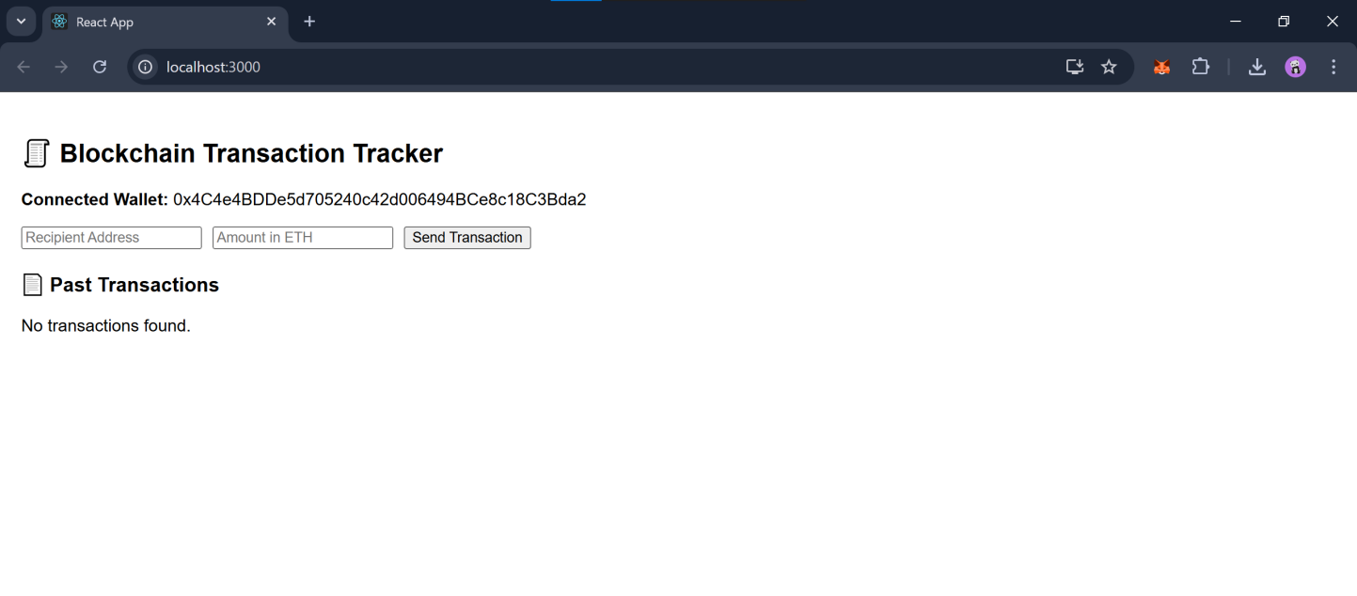

Sender’s account balance before transaction (Ganache):

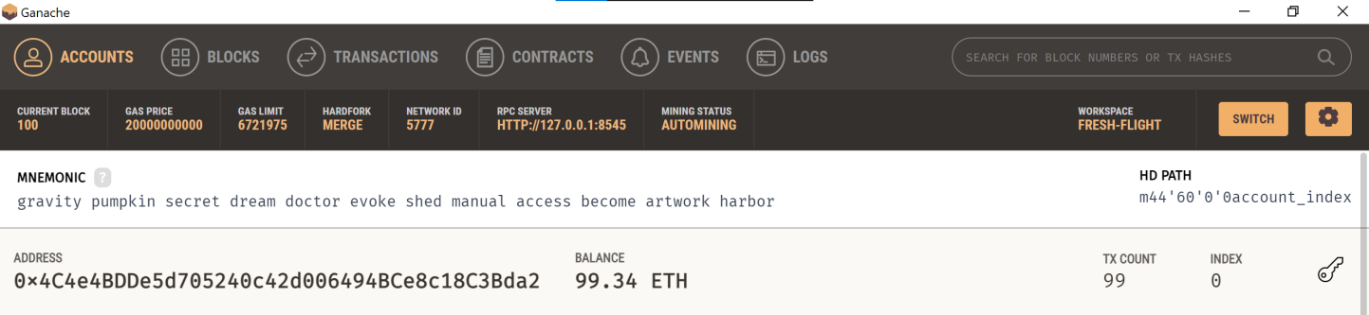

Transaction Triggered:

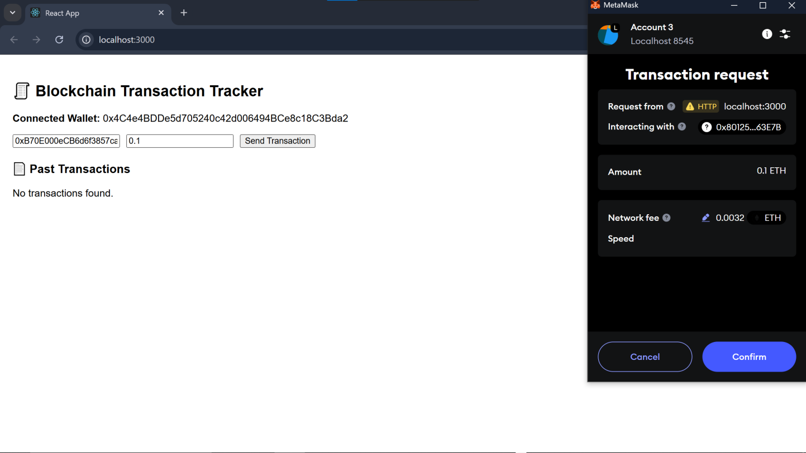

Successful Transaction:

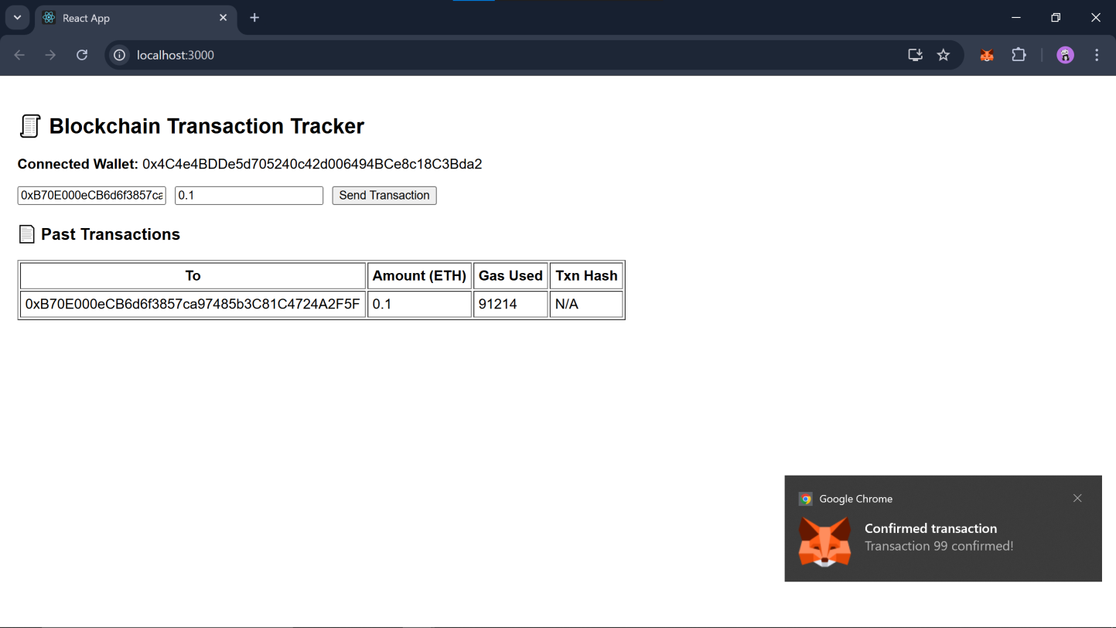

Sender’s account balance after transaction (Ganache):

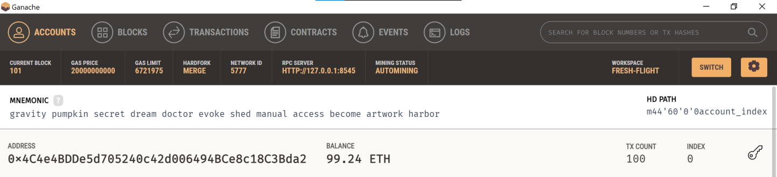

Conclusion
The GasTrackPay project represents a significant step forward in digitizing and securing the gas distribution and payment process using blockchain technology. In traditional gas supply chains, issues such as lack of transparency, manual record-keeping, delayed payments, and tampering often hinder efficiency and trust among stakeholders. GasTrackPay addresses these challenges by introducing a decentralized and immutable ledger system that automates transactions, ensures data integrity, and fosters transparency.
Through the use of smart contracts, the system enables automatic enforcement of business rules, such as payment releases upon delivery confirmation, eliminating the need for intermediaries. This not only accelerates the transaction process but also reduces operational costs and the chances of human error or fraud. Additionally, by recording every transaction on a tamper-proof blockchain, all stakeholders—from gas suppliers to end-users—can verify the authenticity and status of each cylinder and payment, in real time.
The project also highlights the potential for blockchain to transform supply chain management in utilities and public services, offering a scalable and secure foundation for future digital infrastructure. While the current implementation lays the groundwork, it also opens the door for further innovation, such as IoT integration, analytics, and mobile accessibility.
In conclusion, GasTrackPay validates the practical application of blockchain for real-world problems and sets the stage for a more transparent, efficient, and secure gas distribution network.

Future Enhancements
- Mobile Application Support: Development of user-friendly mobile apps for end-users to track cylinder status, receive alerts, and make payments.
- Multi-Currency Support: Enabling payments via multiple cryptocurrencies or fiat gateways for wider user adoption.
- Scalability Upgrades: Implementing Layer 2 solutions like sidechains or rollups to handle high transaction volumes efficiently.
- Advanced Access Control: Role-based smart contracts with dynamic permissioning to accommodate more complex supply chain interactions.
- Data Analytics Dashboard: Building analytical tools to visualize gas usage trends, delivery performance, and payment statistics.

