Product demand prediction with machine learning

Name:Swathi.T

Reg.no:912421104048

Phase 5 submission document

**INTRODUCTION:**

A product company plans to offer discounts on its product during the upcoming holiday season. The company wants to find the price at which its product can be a better deal compared to its competitors. For this task, the company provided a dataset of past changes in sales based on price changes. You need to train a model that can predict the demand for the product in the market with different price segments.

**Data source:**

**DatasetLink:** [**https://www.kaggle.com/datasets/chakradharmattapalli/product-demand-prediction-with-machine-learning**](https://www.kaggle.com/datasets/chakradharmattapalli/product-demand-prediction-with-machine-learning)

**Given data set:**

|  |  |  |  |  |  |
| --- | --- | --- | --- | --- | --- |
| ID |  | Store ID | Total Price | Base Price | Units Sold |
|  | 1 | 8091 | 99.0375 | 111.8625 | 20 |
|  | 2 | 8091 | 99.0375 | 99.0375 | 28 |
|  | 3 | 8091 | 133.95 | 133.95 | 19 |
|  | 4 | 8091 | 133.95 | 133.95 | 44 |
|  | 5 | 8091 | 141.075 | 141.075 | 52 |
|  | 9 | 8091 | 227.2875 | 227.2875 | 18 |
|  | 10 | 8091 | 327.0375 | 327.0375 | 47 |
|  | 13 | 8091 | 210.9 | 210.9 | 50 |
|  | 14 | 8091 | 190.2375 | 234.4125 | 82 |
|  | 17 | 8095 | 99.0375 | 99.0375 | 99 |
|  | 18 | 8095 | 97.6125 | 97.6125 | 120 |
|  | 19 | 8095 | 98.325 | 98.325 | 40 |
|  | 22 | 8095 | 133.2375 | 133.2375 | 68 |
|  | 23 | 8095 | 133.95 | 133.95 | 87 |
|  | 24 | 8095 | 139.65 | 139.65 | 186 |
|  | 27 | 8095 | 236.55 | 280.0125 | 54 |
|  | 28 | 8095 | 214.4625 | 214.4625 | 74 |
|  | 29 | 8095 | 266.475 | 296.4 | 102 |
|  | 30 | 8095 | 173.85 | 192.375 | 214 |
|  | 31 | 8095 | 205.9125 | 205.9125 | 28 |
|  | 32 | 8095 | 205.9125 | 205.9125 | 7 |
|  | 33 | 8095 | 248.6625 | 248.6625 | 48 |
|  | 34 | 8095 | 200.925 | 200.925 | 78 |
|  | 35 | 8095 | 190.2375 | 240.825 | 57 |
|  | 37 | 8095 | 427.5 | 448.1625 | 50 |
|  | 38 | 8095 | 429.6375 | 458.1375 | 62 |
|  | 39 | 8095 | 177.4125 | 177.4125 | 22 |
|  | 42 | 8094 | 87.6375 | 87.6375 | 109 |
|  | 43 | 8094 | 88.35 | 88.35 | 133 |
|  | 44 | 8094 | 85.5 | 85.5 | 11 |
|  | 45 | 8094 | 128.25 | 180.975 | 9 |
|  | 47 | 8094 | 127.5375 | 127.5375 | 19 |
|  | 48 | 8094 | 123.975 | 123.975 | 33 |
|  | 49 | 8094 | 139.65 | 164.5875 | 49 |
|  | 50 | 8094 | 235.8375 | 235.8375 | 32 |
|  | 51 | 8094 | 234.4125 | 234.4125 | 47 |
|  | 52 | 8094 | 235.125 | 235.125 | 27 |
|  | 53 | 8094 | 227.2875 | 227.2875 | 69 |
|  | 54 | 8094 | 312.7875 | 312.7875 | 49 |
|  | 55 | 8094 | 210.9 | 210.9 | 60 |

ID Store ID Total Price Base Price Units Sold

1 8091 99.0375 111.8625 20

2 8091 99.0375 99.0375 28

3 8091 133.95 133.95 19

4 8091 133.95 133.95 44

5 8091 141.075 141.075 52

9 8091 227.2875 227.2875 18

10 8091 327.0375 327.0375 47

13 8091 210.9 210.9 50

14 8091 190.2375 234.4125 82

17 8095 99.0375 99.0375 99

18 8095 97.6125 97.6125 120

19 8095 98.325 98.325 40

22 8095 133.2375 133.2375 68

23 8095 133.95 133.95 87

24 8095 139.65 139.65 186

27 8095 236.55 280.0125 54

28 8095 214.4625 214.4625 74

29 8095 266.475 296.4 102

30 8095 173.85 192.375 214

31 8095 205.9125 205.9125 28

32 8095 205.9125 205.9125 7

33 8095 248.6625 248.6625 48

34 8095 200.925 200.925 78

35 8095 190.2375 240.825 57

37 8095 427.5 448.1625 50

38 8095 429.6375 458.1375 62

39 8095 177.4125 177.4125 22

42 8094 87.6375 87.6375 109

43 8094 88.35 88.35 133

44 8094 85.5 85.5 11

45 8094 128.25 180.975 9

47 8094 127.5375 127.5375 19

48 8094 123.975 123.975 33

49 8094 139.65 164.5875 49

50 8094 235.8375 235.8375 32

51 8094 234.4125 234.4125 47

52 8094 235.125 235.125 27

53 8094 227.2875 227.2875 69

54 8094 312.7875 312.7875 49

Demand forecasting:

Demand forecasting is the process of predicting what customers’ appetite will be for existing products or services, determining what adjustment you should make and what new offerings will spark interest. But predicting what people will want, in what quantities and when is no small feat.

Design thinking:

* Data collection
* Data preparation
* Feature engineering
* Model selection
* Model training
* Evaluation

Data about natural disaster:

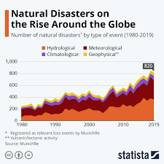

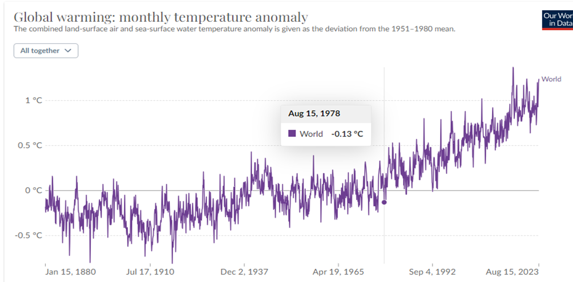

Data preprocessing:

**Data preprocessing** can refer to manipulation or dropping of data before it is used in order to ensure or enhance performance,[[1]](https://en.wikipedia.org/wiki/Data_Preprocessing) and is an important step in the [data mining](https://en.wikipedia.org/wiki/Data_mining) process. The phrase ["garbage in, garbage out"](https://en.wikipedia.org/wiki/GIGO) is particularly applicable to [data mining](https://en.wikipedia.org/wiki/Data_mining) and [machine learning](https://en.wikipedia.org/wiki/Machine_learning) projects. [Data collection](https://en.wikipedia.org/wiki/Data_collection) methods are often loosely controlled, resulting in out-of-range values, impossible data combinations, and [missing values](https://en.wikipedia.org/wiki/Missing_values), amongst other issues.

1. **Data Preprocessing:**

Cleaning, formatting, and organizing the collected data to make it suitable for analysis. This involves handling missing values, removing outliers, and converting data into a format that machine learning algorithms can process.

1. **Data Preprocessing:**

Cleaning, formatting, and organizing the collected data to make it suitable for analysis. This involves handling missing values, removing outliers, and converting data into a format that machine learning algorithms can process.

Process Overview:

The process involves several key stages:

1. **Data Collection:**

Gathering historical data, which may include sales records, customer profiles, market trends, economic indicators, promotional activities, and any other relevant information that could impact demand.

2.Data Preprocessing in Machine learning

Data preprocessing is a process of preparing the raw data and making it suitable for a machine learning model. It is the first and crucial step while creating a machine learning model.

When creating a machine learning project, it is not always a case that we come across clean and formatted data. And while doing any operation with data, it is mandatory to clean it and put it in a formatted way. So, for this, we use data preprocessing tasks.

Cleaning, formatting, and organizing the collected data to make it suitable for analysis. This involves handling missing values, removing outliers, and converting data into a format that machine learning algorithms can process.

Steps involved :

* **Getting the dataset**
* **Importing libraries**
* **Importing datasets**
* **Finding Missing Data**
* **Encoding Categorical Data**
* **Splitting dataset into training and test set**
* **Feature scaling**

**3.Feature Engineering:**

* Creating meaningful features or variables from the data that might influence demand, such as seasonality, trends, customer behavior, and external factors. Feature engineering is crucial to the model's ability to learn and predict accurately.

**4.Model Selection:**

* Choosing appropriate machine learning models suited to the nature of the data and the specific demand forecasting problem. Common models include linear regression, time series models (like ARIMA or SARIMA), decision trees, random forests, gradient boosting, and neural networks.

**5.Model Training:**

* Utilizing historical data, the chosen model is trained to learn patterns and relationships between different variables and the demand for the product.

**6.Model Evaluation:**

* Assessing the model's performance using metrics such as mean absolute error (MAE), mean squared error (MSE), root mean squared error (RMSE), or others. This step determines the model's accuracy and effectiveness.

**7.Hyperparameter Tuning:**

* Optimizing the model's parameters to improve its performance and accuracy. This step involves adjusting settings that are external to the model and impact its learning process.

**8.Forecasting and Prediction:**

* Applying the trained model to new data inputs to forecast future demand.

**9.Deployment and Monitoring:**

* Implementing the model within business operations for real-time predictions. Continual monitoring and updates are vital to ensure the model remains accurate as demand patterns evolve due to changing market conditions.

**10.Decision Making:**

Using the predicted demand to make informed decisions regarding inventory management, production planning, pricing strategies, and overall business operations.

**Tools used:**

1. Python: Python is the most popular programming language for machine learning. It offers a wide range of libraries and frameworks for data analysis and model development.

1. Jupyter Notebooks: Jupyter Notebooks are widely used for data exploration, analysis, and sharing of code and results. They support various programming languages, but Python is the most common choice.
2. Pandas: Pandas is a Python library for data manipulation and analysis. It is used for cleaning, transforming, and organizing data

4. NumPy: NumPy is a fundamental library for numerical operations in Python. It provides support for arrays and matrices, which are essential for machine learning.

5.Scikit-Learn: Scikit-Learn is a popular Python machine learning library that provides tools for data preprocessing, model selection, and model evaluation.

6.TensorFlow and PyTorch: These deep learning frameworks are used for building neural network models, especially for complex demand prediction tasks.

7.XGBoost and LightGBM: These are gradient boosting libraries that are often used for regression and classification problems, including demand prediction.

8.Prophet: Developed by Facebook, Prophet is a forecasting tool that is particularly useful for time series data, making it relevant for demand prediction.

9.SQL Databases: Databases like MySQL, PostgreSQL, or NoSQL databases like MongoDB are used for data storage and retrieval.

10.Apache Spark: For handling large-scale data processing and distributed computing.

11.Tableau or Power BI: Data visualization tools to create interactive dashboards and reports for exploring and presenting predictions.

1. Docker and Kubernetes: Containerization tools that help in packaging and deploying machine learning models in a consistent and reproducible manner.

1. Version Control Systems: Tools like Git and GitHub are used to track changes in code and collaborate on projects.

Methods:

* Clean and preprocess the data
* Handle missing values
* Convert categorical features into numerical representation

Linear regression:

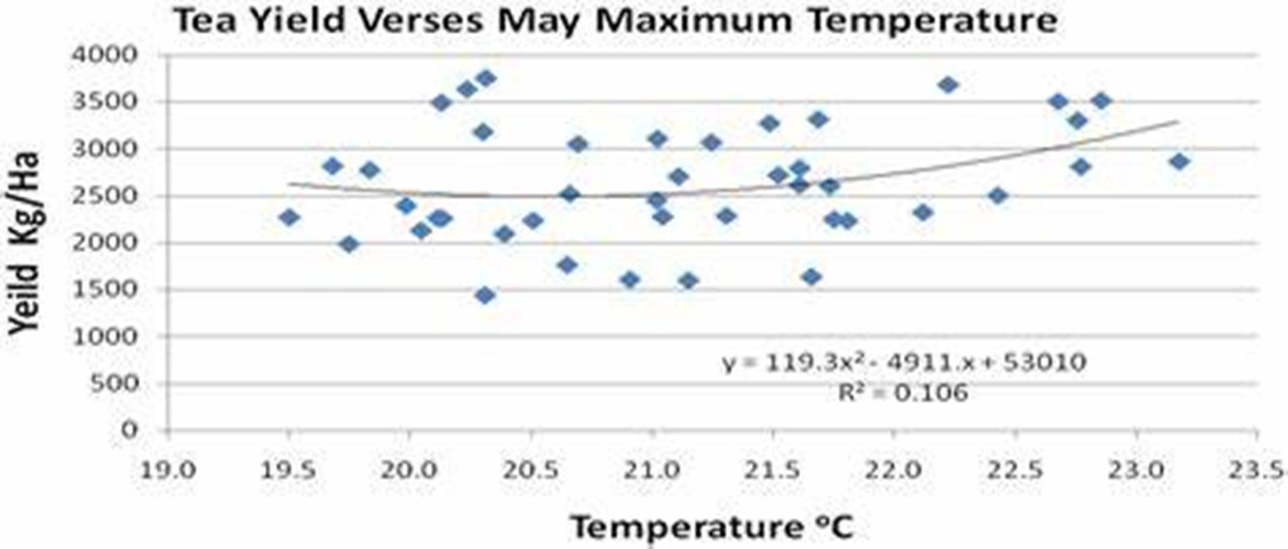

ARIMA

ARIMA is a method for forecasting or predicting future outcomes based on a historical time series.

Data wrangling technique:

* Merging several data sources into one data-set for analysis.
* Identifying gaps or empty cells in data and either filling or removing them.
* Deleting irrelevant or unnecessary data.
* Identifying severe outliers in data and either explaining the inconsistencies or deleting them to facilitate analysis.

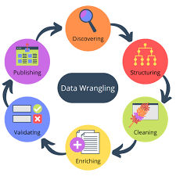

EXAMPLE PROGRAM:

import pandas as pd

import numpy as np

import plotly.express as px

import seaborn as sns

import matplotlib.pyplot as plt

from sklearn.model_selection import train_test_split

from sklearn.tree import DecisionTreeRegressor

data = pd.read_csv("https://raw.githubusercontent.com/amankharwal/Website-data/master/demand.csv")

data.head()

OUTPUT:

**ID Store ID Total Price Base Price Units Sold**  
**0 1 8091 99.0375 111.8625 20**  
**1 2 8091 99.0375 99.0375 28**  
**2 3 8091 133.9500 133.9500 19**  
**3 4 8091 133.9500 133.9500 44**  
**4 5 8091 141.0750 141.0750 52**

**fig = px.scatter(data, x="Units Sold", y="Total Price",**

**size='Units Sold')**

**fig.show()**

**OUTPUT:**

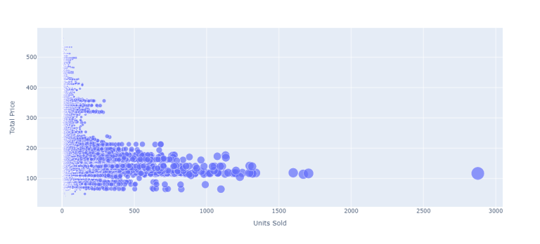

features = np.array([[133.00, 140.00]])

model.predict(features)

OUTPUT:

**array([27.])**

Prophet:

# make an in-sample forecast

from pandas import read_csv

from pandas import to_datetime

from pandas import DataFrame

from fbprophet import Prophet

from matplotlib import pyplot

# load data

path = '<https://raw.githubusercontent.com/jbrownlee/Datasets/master/monthly-car-sales.csv>'

df = read_csv(path, header=0)

# prepare expected column names

df.columns = ['ds', 'y']

df['ds']= to_datetime(df['ds'])

# define the model

model = Prophet()

# fit the model

model.fit(df)

# define the period for which we want a prediction

future = list()

for i in range(1, 13):

date = '1968-%02d' % i

future.append([date])

future = DataFrame(future)

future.columns = ['ds']

future['ds']= to_datetime(future['ds'])

# use the model to make a forecast

forecast = model.predict(future)

# summarize the forecast

print(forecast[['ds', 'yhat', 'yhat_lower', 'yhat_upper']].head())

# plot forecast

model.plot(forecast)

pyplot.show()

Output:

ds yhat yhat_lower yhat_upper

0 1968-01-01 14364.866157 12816.266184 15956.555409

1 1968-02-01 14940.687225 13299.473640 16463.811658

2 1968-03-01 20858.282598 19439.403787 22345.747821

3 1968-04-01 22893.610396 21417.399440 24454.642588

4 1968-05-01 24212.079727 22667.146433 25816.191457

**FEATURE ENGINEERING:**

Create new features or transform existing ones to capture valuable information.

* **Enhanced Model Performance**
* **Improved Interpretability**
* **Handling Non-linearity**

**Enhanced Model Performance:**

Model health monitoring is a critical aspect of maintaining the performance and reliability of machine learning models in production. It involves continuous observation and evaluation of the model's behavior and outcomes to ensure its accuracy and effectiveness over time.

**1.Importance of Monitoring:** Regularly monitoring model health helps detect issues such as data drift, concept drift, and performance degradation early on.

**2.Metrics Tracking:** Keep an eye on metrics like accuracy, precision, recall, and F1-score to assess the model's performance against defined benchmarks.

**3.Data Quality Monitoring:** Ensure the quality and consistency of input data to prevent biased or inaccurate predictions.

**4.Model Drift Detection:** Detect concept drift or changes in data patterns that might affect the model's performance.

**5.Alerts and Notifications:** Implement alerting mechanisms to notify stakeholders when the model's performance deviates from the expected.

**6.Feedback Loop:** Use monitoring insights to continuously improve the model by retraining or fine-tuning based on real-world observations.

**7.Best Practices:** Follow industry best practices and leverage tools like A/B testing and statistical techniques for effective monitoring.

**Improved Interpretability:**

**Methods:**

### 1.Data

### **BM Pre-Processing**

#### **Sign-Flipping to Maximize SM Alignment**

#### **Quality Control and De-Confounding**

#### **Grouping of SM and BM Into Sub-Domains**

### 2. Domain-Driven Dimension Reduction

#### **Two-Way CV**

### 3.Evaluating the Stability of DDR

### 4. CCA on Brain Imaging and Behavioral Data

#### **DDR CCA Pipeline**

#### *5.* **DDR CCA Pipeline**

### 6. Comparison Between PCA and DDR

**Handling Non-linearity:**

* Nonlinearity issues in control practice
* Setpoint scheduling/feedforward

– path planning replay - linear interpolation

* Nonlinear maps

– B-splines

– Multivariable interpolation: polynomials/splines/RBF

– Neural Networks

– Fuzzy logic

• Gain scheduling • Local modeling

**Model Training:**

Train the selected time series forecasting model using historical demand data. This involves estimating model parameters and seasonal components, if applicable.

Unsupervised learning:

Unsupervised learning, also known as unsupervised machine learning, uses machine learning algorithms to analyze and cluster unlabeled datasets. These algorithms discover hidden patterns or data groupings without the need for human intervention.

What is Mean Squared Error or MSE

•The Mean Absolute Error is the squared mean of the difference between the actual values and predictable values.

PROGRAM:

Product Demand Prediction:

Import pandas as pd

Import numpy as np

Import plotly.express as px

Import seaborn as sns

Import matplotlib.pyplot as plt

From sklearn.model_selection import train_test_split

From sklearn.tree import DecisionTreeRegressor

Data=pd.read_csv(“C:\Users\mabir\AppData\Local\Microsoft\Windows\INetCache\IE\AHLGJQP8\archive[1].zip “)

Data.head()

Relationship between price and demand for the product:

Fig = px.scatter(data, x=”Units Sold”, y=”Total Price”,

Size=’Units Sold’)

Fig.show()

Output:

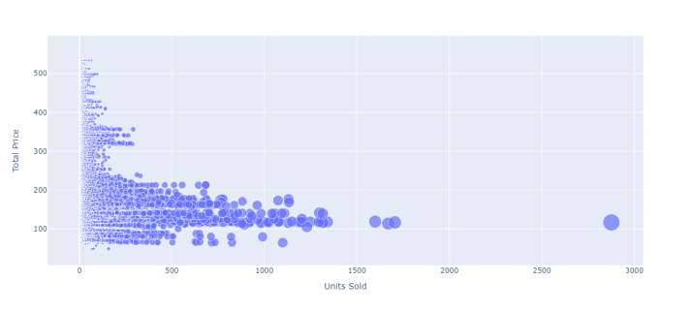

Correlation between the features of the dataset:

Print(data.corr())

Output:

ID Store ID Total Price Base Price Units Sold

ID 1.000000 0.007464 0.008473 0.018932 -0.010616

Store ID 0.007464 1.000000 -0.038315 -0.038848 -0.004372

Total Price 0.008473 -0.038315 1.000000 0.958885 -0.235625

Base Price 0.018932 -0.038848 0.958885 1.000000 -0.140032

Units Sold -0.010616 -0.004372 -0.235625 -0.140032 1.000000

1

Correlations = data.corr(method=’pearson’)

2

Plt.figure(figsize=(15, 12))

3

Sns.heatmap(correlations, cmap=”coolwarm”, annot=True)

4

Plt.show()

Output:

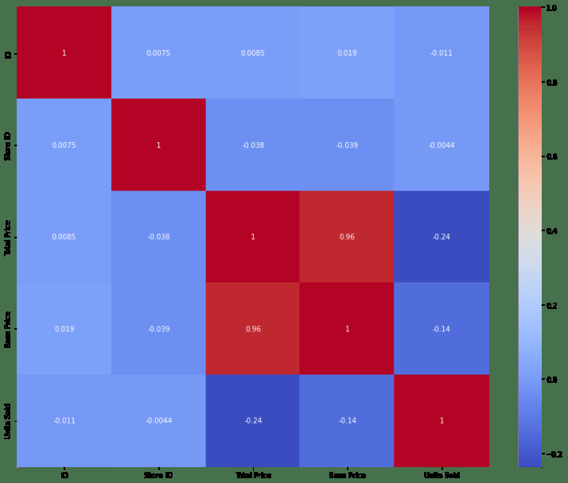  
# fit an ARIMA model and plot residual errors

From pandas import datetime

From pandas import read_csv

From pandas import DataFrame

From statsmodels.tsa.arima.model import ARIMA

From matplotlib import pyplot

# load dataset

Def parser(x):

Return datetime.strptime(‘190’+x, ‘%Y-%m’)

Series = read_csv(‘shampoo-sales.csv’, header=0, index_col=0, parse_dates=True, squeeze=True, date_parser=parser)

Series.index = series.index.to_period(‘M’)

# fit model

Model = ARIMA(series, order=(5,1,0))

Model_fit = model.fit()

# summary of fit model

Print(model_fit.summary())

# line plot of residuals

Residuals = DataFrame(model_fit.resid)

Residuals.plot()

Pyplot.show()

# density plot of residuals

Residuals.plot(kind=’kde’)

Pyplot.show()

# summary stats of residuals

Print(residuals.describe())

Output:

SARIMAX Results

Dep. Variable: Sales No. Observations: 36

Model: ARIMA(5, 1, 0) Log Likelihood -198.485

Date: Thu, 10 Dec 2020 AIC 408.969

Time: 09:15:01 BIC 418.301

Sample: 01-31-1901 HQIC 412.191

* 12-31-1903

Covariance Type: opg

Coef std err z P>|z| [0.025 0.975]

Ar.L1 -0.9014 0.247 -3.647 0.000 -1.386 -0.417

Ar.L2 -0.2284 0.268 -0.851 0.395 -0.754 0.298

Ar.L3 0.0747 0.291 0.256 0.798 -0.497 0.646

Ar.L4 0.2519 0.340 0.742 0.458 -0.414 0.918

Ar.L5 0.3344 0.210 1.593 0.111 -0.077 0.746

Sigma2 4728.9608 1316.021 3.593 0.000 2149.607 7308.314

Ljung-Box (L1) (Q): 0.61 Jarque-Bera (JB): 0.96

Prob(Q): 0.44 Prob(JB): 0.62

Heteroskedasticity (H): 1.07 Skew: 0.28

Prob(H) (two-sided): 0.90 Kurtosis: 2.41

Prophet:

# make an in-sample forecast

from pandas import read_csv

from pandas import to_datetime

from pandas import DataFrame

from fbprophet import Prophet

from matplotlib import pyplot

# load data

path = '<https://raw.githubusercontent.com/jbrownlee/Datasets/master/monthly-car-sales.csv>'

df = read_csv(path, header=0)

# prepare expected column names

df.columns = ['ds', 'y']

df['ds']= to_datetime(df['ds'])

# define the model

model = Prophet()

# fit the model

model.fit(df)

# define the period for which we want a prediction

future = list()

for i in range(1, 13):

date = '1968-%02d' % i

future.append([date])

future = DataFrame(future)

future.columns = ['ds']

future['ds']= to_datetime(future['ds'])

# use the model to make a forecast

forecast = model.predict(future)

# summarize the forecast

print(forecast[['ds', 'yhat', 'yhat_lower', 'yhat_upper']].head())

# plot forecast

model.plot(forecast)

pyplot.show()

Running the example forecasts the last 12 months of the dataset.

OUTPUT:

ds yhat yhat_lower yhat_upper

0 1968-01-01 14364.866157 12816.266184 15956.555409

1 1968-02-01 14940.687225 13299.473640 16463.811658

2 1968-03-01 20858.282598 19439.403787 22345.747821

3 1968-04-01 22893.610396 21417.399440 24454.642588

4 1968-05-01 24212.079727 22667.146433 25816.191457

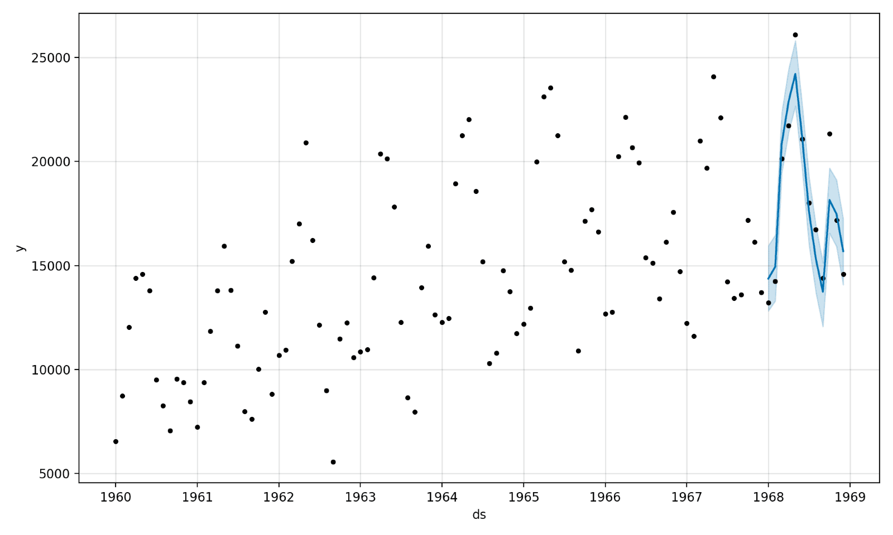

EVALUATION:

Demand forecasting is formulated as a regression problem. Evaluation metrics in regression problems can be split into bias and variation (accuracy) classes, where bias indicates signed deviation from actual values (location), and accuracy evaluates unsigned average deviation (variance of data)

3.BUILD LOADING AND PRE-PROCESSING THE DATASET:

STEPS:

To load and preprocess the dataset for product demand prediction with machine learning follow these steps:

* Data Collection:

Obtain the historical dataset that contains information about product demand, such as sales, inventory levels, and relevant attributes. Ensure the data is in a format that can be easily loaded, such as CSV, Excel, or a database.

Import Libraries:

- Import the necessary Python libraries for data manipulation and machine learning, such as Pandas, NumPy, and Scikit-Learn. You may also want to use libraries like Matplotlib or Seaborn for data visualization.

Data Exploration:

* Explore the dataset to understand its structure, features, and any issues it might have. Check for missing values, data types, and initial data statistics.

4.PERFORMING DIFFERENT ACTIVITIES LIKE FEATURE ENGINEERING, MODEL TRAINING, EVALUATION,ETC.

* **Overview of the process:**
* The following is an overview of the process of building a product demand prediction model by feature selection, model training, evaluation:

**Define the Problem:**

* + Clearly define the problem you want to solve. What product or products are you trying to predict demand for? What are your specific goals and objectives?

**Data Collection:**  Gather historical data related to the product's sales, including sales volume, price, and any other relevant variables. Additional data sources may include marketing activities, seasonality, economic indicators, and external factors.

* **Data Preprocessing:** 
  + Clean and preprocess the collected data. This may involve handling missing data, outliers, and ensuring data consistency.

**Feature Engineering:**

* + Create meaningful features from the raw data. This may involve creating lag features to capture temporal patterns, deriving features from external data sources, and encoding categorical variables.

**Data Splitting:**

* + Split your dataset into training, validation, and testing sets. The training set is used to train the model, the validation set helps fine- tune model parameters, and the testing set is used to evaluate the model's performance.

**Model training:**

* Train your chosen model on the training dataset. This involves optimizing model parameters to minimize the prediction error.

**Model Selection:**

* + Choose an appropriate modeling technique for demand prediction. Common approaches include time series forecasting methods (e.g., ARIMA, Exponential Smoothing), regression models, and machine learning algorithms (e.g., linear regression, decision trees, neural networks).

**Model Evaluation:**

* + Assess the model's performance using the validation dataset.
* Common evaluation metrics for demand prediction include Mean Absolute Error (MAE), Mean Squared Error (MSE), Root Mean Squared Error (RMSE), and R-squared.

**Hyperparameter Tuning:**

* + Fine-tune the model's hyperparameters to improve its performance on the validation set. Techniques like grid search or random search can be used for this purpose.

**Model Validation:**

* + Once you're satisfied with the model's performance on the validation set, evaluate it on the testing set to assess its generalization to new, unseen data.

**Deployment:**

* + Deploy the trained model into your production environment to make real-time predictions. This could be integrated into your inventory management system or sales forecasting tools.

**Monitoring and Maintenance:**

* Continuously monitor the model's performance in the production environment. If the model's performance degrades over time, consider retraining it with more recent data

**Feature engineering:**

**Domain Knowledge:**

* + Leverage domain expertise to identify potential features that could impact product demand. Speak to subject matter experts or conduct a literature review to gather insights.

**Feature Selection:**

* + Decide which features you will use in your model. Select those that are relevant to demand prediction and have a reasonable expectation of influencing demand. Features could include:
  + Historical sales data
  + Price and discount information
  + Marketing campaigns and promotions
  + Seasonal information
  + Economic indicators (e.g., GDP, inflation)
  + External factors (e.g., weather data)

**Lag Features:**

* + Create lag features to capture temporal dependencies. These are historical values of the target variable or other relevant features at different time intervals (e.g., daily, weekly, monthly). Lag features help the model capture trends and seasonality.
  + **ADVANTAGES:**
* **Accurate Forecasts:** 
  + Machine learning models can analyze vast amounts of historical and real-time data to generate more accurate demand forecasts. This accuracy aids in better inventory management and reduces stockouts or overstock situations.
* **Real-time Insights:**
  + With the ability to process and adapt to new data quickly, machine learning models provide real-time insights, enabling businesses to make rapid decisions based on the latest information.
* **Improved Inventory Management:** 
  + Accurate demand prediction leads to optimized inventory levels. It minimizes holding costs by ensuring that products are available when needed, preventing overstock situations, and reducing excess inventory.
  + **DISADVANTAGES:**
  + **1.Data Quality Dependency:**
  + Machine learning models heavily rely on the quality and relevance of the data used for training. Inaccurate, incomplete, or biased data can lead to flawed predictions, emphasizing the need for clean, representative, and high-quality datasets.
  + Benefits:
  + **1.Complex Implementation:**
  + Developing, training, and maintaining machine learning models for demand prediction can be complex. It requires expertise in data science and machine learning, which might not be readily available within all organizations.
* **Enhanced Forecasting:** 
  + By considering multiple variables such as seasonality, market trends, economic indicators, and consumer behavior, machine learning models improve the accuracy of demand forecasts, aiding in better inventory management.
* **Real-time Insights:**
  + Machine learning models can be updated with new data in real-time, providing up-to-date insights for more responsive decision-making. This adaptability is particularly beneficial in rapidly changing markets.
* **Optimized Inventory Management:** 
  + Accurate demand predictions lead to optimized inventory levels, reducing excess stock and minimizing the risk of stockouts. This results in cost savings by improving inventory turnover and reducing carrying costs.
* **Customized Solutions:**
  + Machine learning algorithms can be tailored to specific products, markets, or consumer segments, allowing for more personalized and adaptive demand forecasts.
* **Strategic Decision-making:** 
  + Data-driven predictions enable businesses to make informed decisions. Predictive insights help in planning marketing strategies, pricing, and resource allocation effectively.
* **Cost Reduction:** 
  + Accurate demand forecasts mitigate the need for excessive inventory, reducing costs associated with surplus goods and optimizing resources, ultimately improving the bottom line.

**Conclusion:**

* + In conclusion, product demand prediction using machine learning offers a promising approach for businesses seeking to optimize inventory management, enhance forecasting accuracy, and make data-driven decisions. The advantages of employing machine learning for demand prediction include improved accuracy, realtime insights, optimized inventory management, customization, and cost savings. These benefits empower companies to respond swiftly to market changes, allocate resources efficiently, and gain a competitive edge.