**Phishing Detection Model Deployment with IBM Watson Studio.**

**Design and Innovation**

|  |  |
| --- | --- |
| **Date** | **04-10-2023** |
| **Team ID** | **671** |
| **Project Name** | **Machine Learning Model Deployment using IBM Cloud Watson Studio** |

**Table of Contents**

|  |  |
| --- | --- |
| 1 | Introduction |
| 2 | Problem Statement |
| 3 | Design and Innovation Strategies |
| 3.1 | Data pre-processing and Feature Engineering |
| 3.2 | Model Selection and Development |
| 3.3 | Integration with Security Systems |
| 3.4 | Real-time Analysis and Monitoring |
| 3.5 | Integration of Threat Intelligence |
| 3.6 | Scalability and Deployment |
| 3.7 | Continuous Learning and Model Updates |
| 4 | Conclusion |

**1. Introduction**

The purpose of this document is to offer a comprehensive analysis of the design and innovation strategies employed in the deployment of a machine learning model for phishing detection using IBM Cloud Watson Studio. Phishing detection is a vital component of digital security, and this project seeks to leverage innovative techniques to improve detection accuracy and dependability.

**2. Problem Statement**

The primary challenge of this project is to effectively deploy a machine learning model for phishing detection using IBM Cloud Watson Studio, ensuring the accurate identification of fraudulent and malicious activities in real-time while optimizing the model's performance, scalability, and integration with existing security systems.

**3. Design and Innovation Strategies**

**3.1. Data Preprocessing and Feature Engineering**

Innovation: Comprehensive Data Gathering and NLP(Natural Language Processing )

Start by collecting and preprocessing a diverse and representative dataset of both legitimate and phishing emails.

Engage in feature engineering to extract relevant information from email headers, content, and URLs.

Consider using techniques like TF-IDF, word embeddings, and domain analysis to enhance feature quality.

**3.2.** **Model Selection and Development**

Innovation: Ensemble Learning and Deep Learning Integration

Employ ensemble learning techniques, including Random Forests, Gradient Boosting, and Stacking, to combine the strengths of multiple models and enhance prediction accuracy.

Incorporate deep learning models, such as neural networks, to capture complex nonlinear relationships within the data.

Innovate by exploring ensemble methods, transfer learning, or custom model architectures tailored to phishing characteristics.

**3.3. Integration with Security Systems**

Innovation: Security Protocols**( OAuth** -Open Authorization, **SSH** -Secure Shell)

Integrating the phishing detection model seamlessly into existing security systems and workflows is a paramount aspect of deploying an effective defense against phishing threats.

Innovate by developing APIs and connectors that act as bridges between the phishing detection model and existing security systems. These APIs allow for smooth communication and data exchange.

Collaborate with firewall systems to enhance network security. Use the model's predictions to dynamically update firewall rules, blocking access to known phishing sites and sources.

**3.4. Real-time Analysis and Monitoring**

Innovation: Statistical methods(Standard Deviation)and Distance based methods(K-Means Clustering)

Implement real-time email analysis for rapid identification of potential phishing threats, enabling immediate detection and response to safeguard digital security**.**

Drive innovation by integrating anomaly detection algorithms, enabling the detection of new and evolving phishing tactics that traditional methods may miss.

Ensure model reliability through continuous monitoring, promptly identifying model drift and performance deterioration, allowing for timely adjustments and improvements.

**3.5. Integration of Threat Intelligence:**

Innovation: ETL (Extract, Transform, Load) processes

Integrating threat intelligence into your phishing detection system provides a proactive defense against known threats and enhances your ability to detect and respond to emerging ones.

IBM Cloud Watson Studio can facilitate this integration by providing tools for data ingestion, processing, and machine learning model deployment, making it easier to incorporate threat intelligence feeds into your detection workflow.

**3.6. Scalability and Deployment**

Innovation: Containerization (Docker) for deployment and Serverless Computing(AWS Lambda) for enhancing scalability.

Scalability involves designing the system to handle increased workloads, accommodating a growing volume of incoming data and email traffic using IBM Cloud Watson Studio.

Deployment involves the process of making the phishing detection model and associated components available in a production environment.

IBM Cloud Watson Studio facilitates deployment by providing tools for containerization and orchestration of machine learning models.

**3.7. Continuous Learning and Model Updates**

Innovation: Model Maintenance and Improvement

Continuously incorporate new data sources and samples of phishing attempts to keep the model updated with the latest threats and tactics.

Implement incremental training techniques to retrain the model periodically, adapting to evolving phishing patterns while avoiding full retraining.

Establish a feedback loop with end-users and security analysts to gather insights and reports on false positives/negatives, using this feedback to fine-tune and improve the model's performance.

Note: In the diagram below, we've depicted the key components and interactions described in sections 3.1 to 3.7, offering a clear and concise overview of our solution architecture. This visualization simplifies the complex concepts and relationships discussed in those sections, making it easier for the reader to grasp the overall design and innovation strategies at a glance.

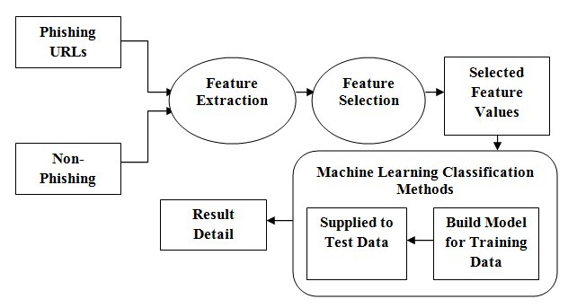

**4. Conclusion**

In summary, we have presented a comprehensive design and innovation strategy for deploying a machine learning model for phishing detection using IBM Cloud Watson Studio. These strategies encompass data processing, model development, continuous learning, scalability, real-time analysis, interpretability, integration with security systems, user education, ethical considerations, and compliance. By implementing these strategies, organizations can establish a resilient and adaptive phishing detection system within the IBM Cloud Watson Studio framework to safeguard against evolving cybersecurity threats.