SUPPLY CHAIN VISIBILITY SYSTEM
WITH OPTIMIZATION ANALYTICS

POWER BI PROJECT DOCUMENTATION
Name: | Bogireddy Swathi
Project Title: | E-commerce Dashboard
Mentor Name: | Kalaiyarasi N
Batch Number: | 1
TABLE OF CONTENTS
1. Introduction 3
2. Project Objective 3
3. Tools and Technologies 4
Milestone 1 – Data Modelling & KPI Foundation 5
4.1 Milestone 1 Introduction 5
4.2 Data Import and Cleaning 5
4.3 Data Modelling 5
4.4 KPI Creation 6
4.5 Milestone 1 Dashboard 7
Milestone 2 – Inventory & Delivery Analytics 8
5.1 Milestone 2 Introduction 8
5.2 Inventory Performance Analysis 8
5.3 Delivery Performance Analysis 9
5.4 Regional and Product-Level Analysis 10
5.5 Trend and Variance Analysis 10
Milestone 3 – Supplier & Transportation Analytics 12
6.1 Milestone 3 Introduction 12
6.2 Supplier Analysis 12
6.3 Transportation Analysis 13
6.4 KPI and DAX Measures 13
6.5 Transportation Dashboard Screenshots 14
Milestone 4 – Warehouse Analytics & Final Dashboard 15
7.1 Warehouse Efficiency Report 15
7.2 Executive Overview Dashboard 16
7.3 Dashboard Performance Optimization 17
7.4 Final Testing and Documentation 18
7.5 Deployment 19
8. Key Insights 19
9. References 19

1. INTRODUCTION
This document presents the Power BI project titled Supply Chain Visibility System with Optimization Analytics. The project is built in Microsoft Power BI Desktop on a relational retail and logistics dataset and brings orders, customers, products, inventory, shipments and suppliers together in a single reporting solution. The report is organised as a set of dashboards named Page 1, Page 2, Supplier Scorecard, Warehouse Efficiency Report, Executive Overview and Performance Optimization.
The purpose of the project is to give decision makers a clear and consistent view of how goods and orders move through the supply chain. Supply chain visibility means that the current state of orders, stock and shipments can be seen in one place instead of being spread across separate files and tables. The dashboards in this project make this possible through KPI cards, charts, slicers and tables that update together when a filter is applied.
The project covers the following analytical areas:
- Logistics analytics – order counts by month, city and product category, together with shipment status analysis.
- Inventory monitoring – total inventory, inventory turnover, product counts and inventory views by category, city and time.
- Delivery monitoring – on-time versus delayed deliveries and delivery performance by city and over time.
- Supplier performance – supplier-wise inventory value, products by supplier country and shipment status.
- Transportation analysis – shipment-level information available in the dataset.
- Warehouse efficiency – orders, shipped quantity and on-time delivery, supported by slicers for city, category, date and status.
- Executive-level reporting – a summary page showing revenue, orders, customers, average order value and inventory turnover.
All values quoted in this document are taken from the Power BI report screenshots. Where information is not visible in the report, this is stated explicitly.

2. PROJECT OBJECTIVE
The overall objectives of the project are:
- Build a centralised Power BI analytics solution for supply chain and logistics data.
- Analyse supply chain and logistics data drawn from the related tables of the data model.
- Create meaningful KPIs and DAX measures such as Total Orders, Total Revenue, Total Customers, Average Order Value and Inventory Turnover.
- Monitor inventory performance by category, city and time.
- Analyse delivery performance using shipment status and order counts.
- Evaluate supplier performance through supplier-wise and country-wise views.
- Analyse transportation activity using the available shipment data.
- Monitor warehouse efficiency using orders, shipped quantity and delivery indicators.
- Provide executive-level visibility through a consolidated overview dashboard.
- Improve dashboard usability and performance through consistent design, slicers and a clean layout.

3. TOOLS AND TECHNOLOGIES
The technologies listed below are those evidenced in the project screenshots.
Technology | Use in the Project
Microsoft Power BI Desktop | Report authoring environment. The report file is named “relation tables” and contains six report pages.
Power Query | To be updated from the Power BI report.
DAX | Used to create the report measures (for example Total Orders, Total Revenue, AOV and Inventory Turnover). Exact formulas: To be updated from the Power BI report.
Power BI Data Model | The Data pane lists twelve tables: categories, customers, employees, order_items, orders, payments, products, promotions, returns, shipments, stores and suppliers.
Power BI Visualizations | KPI cards, donut charts, line charts, bar and column charts, tables and slicers (list and date-range slicers).

MILESTONE – 1
Data Modelling & KPI Foundation

Milestone 1 Deliverables
- Import and clean logistics datasets.
- Design the supply chain data model.
- Create core KPIs and DAX measures.
- Build the inventory turnover dashboard.

4.1 Milestone 1 Introduction
Milestone 1 establishes the foundation of the project. It covers the preparation of the source tables, the design of the data model that connects them, and the creation of the core measures that are reused in every later dashboard. The first report page, titled “Supply Chain Visibility and Inventory Dashboard”, presents these core measures together with basic order, shipment, category, city and revenue views.

4.2 Data Import and Cleaning
The Data pane of the report shows that twelve tables were imported into the Power BI model. The table below records what can be confirmed from the report and what still needs to be completed from the Power BI file.
Preparation Area | Observation from the Project
Data import | Twelve tables are loaded: categories, customers, employees, order_items, orders, payments, products, promotions, returns, shipments, stores and suppliers.
Data types | To be updated from the Power BI report.
Missing / blank values | A “(Blank)” entry appears in the city slicer of the Warehouse Efficiency Report, and the city-level table on the Performance Optimization page contains one row with a blank city. Treatment of these values: To be updated from the Power BI report.
Data transformation | To be updated from the Power BI report.
Column preparation | Columns used in the report include city, category_name, order_date, status, order_id, shipment_id, product_id, qty, supplier_id and country. Any calculated or renamed columns: To be updated from the Power BI report.
Relationship preparation | To be updated from the Power BI report.

4.3 Data Modelling
The Power BI data model consists of twelve tables. The table below lists each table together with how it is used in the report dashboards, as far as this is visible in the screenshots. Tables that are not used in any visible visual are marked accordingly.
Table | Usage Evident in the Report
orders | Order counts (Total Orders 300K); order_id and order_date fields used in charts and slicers.
order_items | Order item count (Total Order Items 600K).
customers | Customer count (Total Customers 50K).
products | Product counts (Total Products 10K) and product_id in the Inventory Details Table.
categories | category_name used for category-wise orders, inventory and revenue.
shipments | Shipment status (shipped, delivered, late) and shipment_id used in shipment and delivery visuals.
suppliers | supplier_id and country used in the Supplier Scorecard.
stores | City-level analysis (Bangalore, Delhi, Mumbai, Pune) is used throughout; the source table of the city field: To be updated from the Power BI report.
payments, employees, promotions, returns | Not used in any visual shown in the screenshots. Role in the model: To be updated from the Power BI report.

Relationships, key fields and fact/dimension roles: To be updated from the Power BI report. The Power BI Model view screenshot was not included with the material provided, so the diagram is left as a placeholder below.

4.4 KPI Creation
The core KPI measures visible in the Milestone 1 dashboard and the later dashboards are listed below. The values are read directly from the report cards.
KPI / Measure | Value Shown | DAX Formula
Total Order Items | 600K | To be updated from the Power BI report.
Total Customers | 50K | To be updated from the Power BI report.
Total Orders | 300K | To be updated from the Power BI report.
Total Revenue | 4bn (3,827,746,136 in the city table) | To be updated from the Power BI report.
AOV (Average Order Value) | 12,759.15 | To be updated from the Power BI report.
Inventory Turnover (Proxy) | 150.05 | To be updated from the Power BI report.
Total Inventory | 2M | To be updated from the Power BI report.
Total Products | 10K | To be updated from the Power BI report.
Slow-Moving Products | 0 | To be updated from the Power BI report.

As a consistency observation, the total revenue of 3,827,746,136 divided by the 300,000 orders gives 12,759.15, which matches the AOV value displayed in the report.

4.5 Milestone 1 Dashboard
The Milestone 1 dashboard is titled Supply Chain Visibility and Inventory Dashboard and is shown on Page 1 of the report. It is built on a dark theme with a green title banner. Its components are described below.

KPI Cards
Five cards are placed across the top of the page: Total Order Items (600K), Total Customers (50K), Total Orders (300K), Total Revenue (4bn) and AOV (12,759.15). A larger sixth card titled Inventory Turnover (Proxy) shows the value 150.05.

Charts
- Shipment Status Analysis – donut chart of order count by status (shipped, delivered, late) with 300K at the centre. Each status holds about 100K orders, shown as 33.29%, 33.43% and 33.29%.
- Monthly Order – line chart of order count by month from January to December.
- Category-wise Orders – horizontal bar chart of order count by category_name (Cat_1, Cat_10, Cat_11 and so on, with a scroll bar for the remaining categories).
- City-wise Orders – bar chart of order count by city: Mumbai 76K, Pune 75K, Bangalore 75K and Delhi 74K.
- Monthly Revenue – line chart of Total Revenue by year and month for 2020 to 2024, with a vertical axis from 0M to 100M.

Filters, Slicers and Tables
No slicers or tables are placed on this page. The Filters pane of Power BI is available on the right side of the report canvas. Inventory turnover analysis is presented through the Inventory Turnover (Proxy) card; a detailed product-level view is provided in Milestone 2.
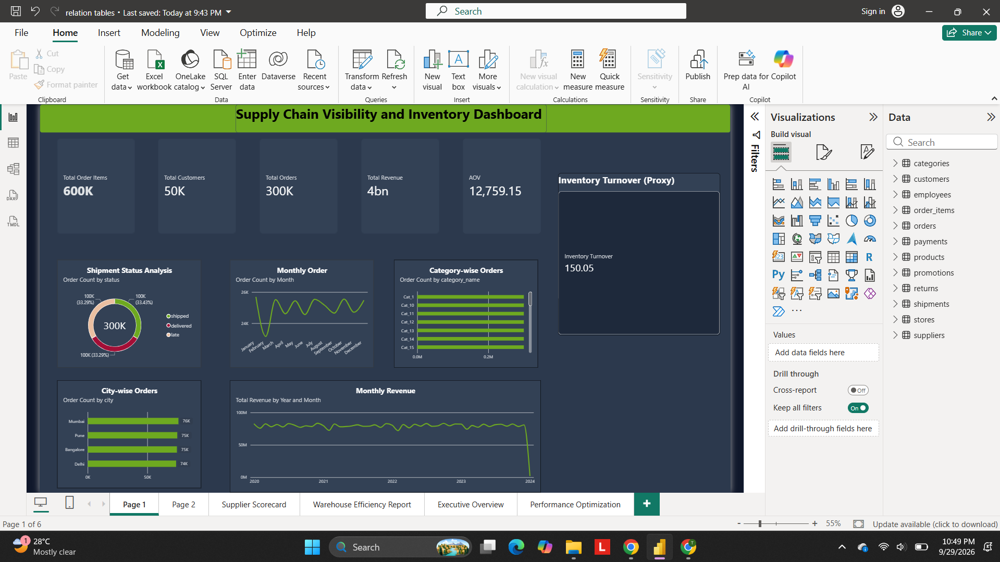
Figure 2: Milestone 1 Dashboard – KPI Foundation

MILESTONE – 2
Inventory & Delivery Analytics

Milestone 2 Deliverables
- Develop inventory performance reports.
- Create delivery performance dashboards.
- Implement regional and product-level drill-downs.
- Add trend and variance analysis.

5.1 Milestone 2 Introduction
Milestone 2 extends the foundation with inventory and delivery reporting. Page 2 of the report combines inventory KPIs, inventory charts by category, city and time, delivery status visuals, and a product-level Inventory Details Table. Together these views allow stock levels and delivery outcomes to be compared across cities and product categories.

5.2 Inventory Performance Analysis

Inventory KPIs
KPI | Value Shown
Total Inventory | 2M
Inventory Turnover | 150.05
Total Products | 10K
Slow-Moving Products | 0

Inventory Charts
- Inventory by Product Category – bar chart of Sum of qty by category_name; Cat_5 and Cat_3 are visible in the displayed portion, and a scroll bar gives access to the remaining categories.
- Inventory by City – column chart of Sum of qty by city, with the vertical axis from 0.0M to 0.4M.
- Inventory Trend Over Time – line chart of Sum of qty by year, with the vertical axis from 0.0M to 0.4M.

Inventory Details Table
The table lists product_id, category_name, city, Sum of qty and Inventory Turnover. The total row shows a Sum of qty of 1,500,518 and an Inventory Turnover of 150.05. Product-level and category-level analysis is provided by this table together with the category chart above.
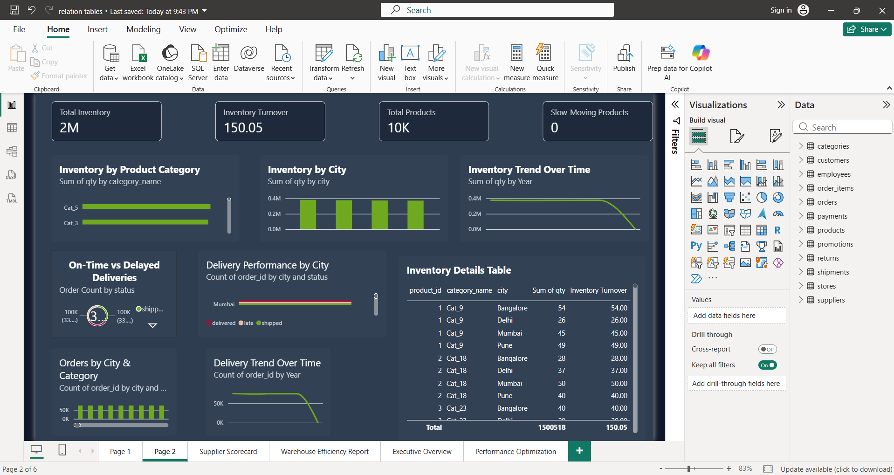
Figure 3: Inventory Performance Dashboard

5.3 Delivery Performance Analysis
The lower section of Page 2 contains the delivery-related visuals:
- On-Time vs Delayed Deliveries – donut chart of order count by status. The segments are labelled 100K each, and the legend lists shipped, delivered and late.
- Delivery Performance by City – bar chart of order count by city and status (delivered, late, shipped); Mumbai is visible in the displayed portion, with a scroll bar for the other cities.
- Orders by City & Category – column chart of order count by city and category.
- Delivery Trend Over Time – line chart of order count by year, with the vertical axis from 0K to 50K.
Shipment status values used in the report are shipped, delivered and late. Delivery-related KPIs on the Supplier Scorecard page show 300K Total Shipments, 99.862K Delivered Shipments and 100K Late Shipments (see Figure 5). Regional analysis is available through the city fields of the visuals above.
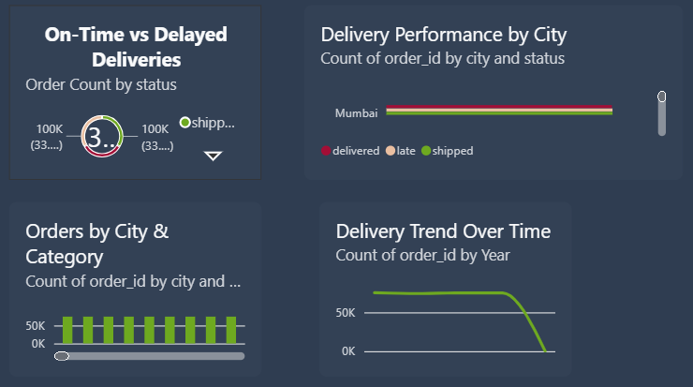
Figure 4: Delivery Performance Analysis
Figure 4 is an enlarged view of the delivery section of the Page 2 screenshot shown in Figure 3.

5.4 Regional and Product-Level Analysis
Regional and product-level views are created by combining the following real fields of the report:
Level | Fields Used | Visuals
Regional | city (Bangalore, Delhi, Mumbai, Pune) | Inventory by City, Delivery Performance by City, Orders by City & Category, City-wise Orders
Category | category_name | Inventory by Product Category, Category-wise Orders, Inventory Details Table
Product | product_id | Inventory Details Table

In the Inventory Details Table, product 1 (Cat_9) is listed for Bangalore, Delhi, Mumbai and Pune with quantities 54, 26, 45 and 49; product 2 (Cat_18) is listed for the same four cities with quantities 28, 37, 50 and 40; and product 3 (Cat_23) appears with 40 units for Bangalore. The Drill through well in the Visualizations pane is empty in the captured screenshots. Configured drill-down hierarchies: To be updated from the Power BI report.

5.5 Trend and Variance Analysis
The following trend visuals are present in the report:
- Inventory Trend Over Time (Page 2) – Sum of qty by year.
- Delivery Trend Over Time (Page 2) – order count by year.
- Monthly Order (Page 1) and Total Orders by Month (Warehouse Efficiency Report) – order count by month from January to December.
- Monthly Revenue (Page 1) – Total Revenue by year and month, 2020 to 2024.
In the Inventory Trend, Delivery Trend and Monthly Revenue charts the plotted line falls sharply towards the last period on the horizontal axis. The Monthly Order line shows a visible dip in the early months of the year before recovering. Dedicated variance measures (for example year-over-year change) are not visible in the screenshots: To be updated from the Power BI report.

MILESTONE – 3
Supplier & Transportation Analytics

Milestone 3 Deliverables
- Build supplier scorecards.
- Develop transportation cost dashboards.
- Create route and carrier performance analysis.
- Implement advanced KPI visualizations.

6.1 Milestone 3 Introduction
Milestone 3 focuses on the supplier and shipment side of the supply chain. The Supplier Scorecard page brings supplier-level product and inventory figures together with shipment KPIs and a country slicer. Transportation-specific information such as route, carrier and cost is described in Section 6.3.

6.2 Supplier Analysis

Supplier Comparison Cards
Three groups of KPI cards on the left of the page compare suppliers by Total Products, Total Inventory and Inventory Value. The groups are labelled China 5, China 7 and China 11 in the screenshot.
Supplier Label | Total Products | Total Inventory | Inventory Value
China 5 | 45 | 7K | 46M
China 7 | 42 | 6K | 63M
China 11 | 67 | 10K | 82M

Supplier Charts and Slicer
- Supplier-wise Inventory Value – column chart of Inventory Value by supplier_id (axis 0 to 200), with data labels such as 91M, 98M, 101M, 103M and 104M.
- Products by Supplier Country – bar chart of Total Products by country: USA 3.8K, China 3.2K and India 3.1K.
- Inventory Value by Supplier Country – column chart of Inventory Value by country: USA 5.3bn, India 4.3bn and China 4.3bn.
- Shipment Status Distribution – column chart of Total Shipments by status; shipped, delivered and late are each about 100K.
- Country slicer – list slicer with the options China, India and USA.
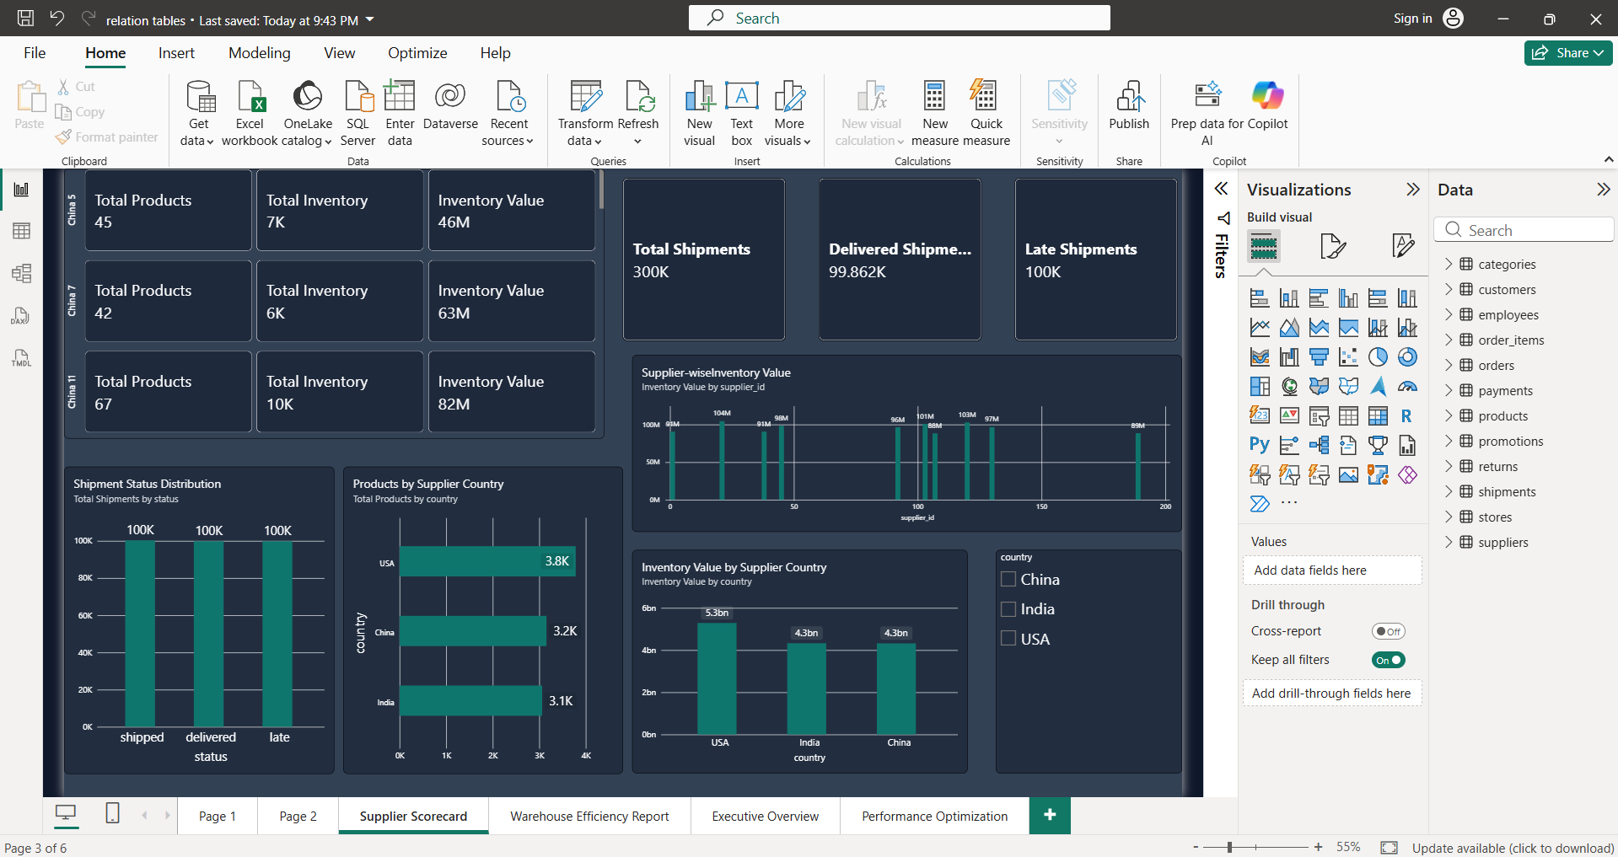
Figure 5: Supplier Performance Scorecard

6.3 Transportation Analysis
Shipment information is available in the report through the shipments table. Three shipment KPI cards are shown on the Supplier Scorecard page (Figure 5), and shipment status is also shown on Page 1, Page 2 and the Warehouse Efficiency Report. The availability of the remaining transportation analyses is summarised below.
Analysis | Availability in the Report
Shipment information | Total Shipments 300K, Delivered Shipments 99.862K, Late Shipments 100K; Total Shipped Quantity 501K on the Warehouse Efficiency Report.
Shipment status | Shipped, delivered and late, each about one-third of the orders.
Route analysis | To be updated from the Power BI report.
Carrier analysis | To be updated from the Power BI report.
Cost analysis | To be updated from the Power BI report.

6.4 KPI and DAX Measures
Measure | Value Shown | Where Shown | DAX Formula
Total Shipments | 300K | Supplier Scorecard | To be updated from the Power BI report.
Delivered Shipments | 99.862K | Supplier Scorecard | To be updated from the Power BI report.
Late Shipments | 100K | Supplier Scorecard | To be updated from the Power BI report.
Total Products (per supplier) | 45 / 42 / 67 | Supplier Scorecard | To be updated from the Power BI report.
Total Inventory (per supplier) | 7K / 6K / 10K | Supplier Scorecard | To be updated from the Power BI report.
Inventory Value (per supplier) | 46M / 63M / 82M | Supplier Scorecard | To be updated from the Power BI report.

6.5 Transportation Dashboard Screenshots
Dedicated transportation cost, route and carrier screenshots were not included in the material provided. The shipment-related dashboard content that exists in the report is shown in Figure 5 above. The two figures below are therefore left as placeholders.

MILESTONE – 4
Warehouse Analytics & Final Dashboard

Milestone 4 Deliverables
- Develop warehouse efficiency reports.
- Create the executive overview dashboard.
- Optimize dashboard performance.
- Final testing, documentation and deployment.

7.1 Warehouse Efficiency Report
The Warehouse Efficiency Report page combines four slicers, three KPI cards, four charts and a detail table. Each visual is described below.

Slicers
Visual | Field | Purpose and Business Relevance
City slicer (list) | city – (Blank), Bangalore, Delhi, Mumbai, Pune | Filters the whole page by location so that warehouse activity can be compared city by city.
Category slicer (list) | category_name – Cat_1, Cat_10, Cat_11, Cat_12, Cat_13 and more | Restricts the analysis to selected product categories.
Date slicer (range) | order_date – 1/1/2020 to 1/1/2024 | Limits the report to a chosen period.
Status slicer (list) | status – delivered, late, shipped | Isolates orders by shipment status.

KPI Cards
Visual | Value Shown | Purpose and Business Relevance
Total Orders | 300K | Overall order volume handled, responding to the slicers.
Total Shipped Qu… (label truncated in the screenshot) | 501K | Quantity shipped, an indicator of outbound warehouse activity.
On-Time Delivery | 7.01E-5 | Delivery punctuality indicator. The value is displayed in scientific notation; its number format and calculation: To be updated from the Power BI report.

Charts and Table
Visual | Type | Fields / Measures | What It Represents
Total Orders by category_name | Column chart | Total Orders by category_name (axis 0.0M to 0.3M) | Order volume for each product category.
Shipment Count by status | Donut chart | Shipment count by status; 300K at the centre; 100K each (33.2% and 33.4% labelled) | Split of shipments into shipped, delivered and late.
Total Orders by city | Bar chart | Total Orders by city (Mumbai, Pune, Delhi, Bangalore) | Order volume handled per city.
Total Orders by Month | Line chart | Total Orders by month, January to December (axis 23K to 26K) | Monthly movement of order volume.
Order detail table | Table | order_id, Sum of shipment_id, status, city, Sum of qty; total row 45000150000 and 1500518 | Order-level detail linking orders to shipment status, city and quantity.

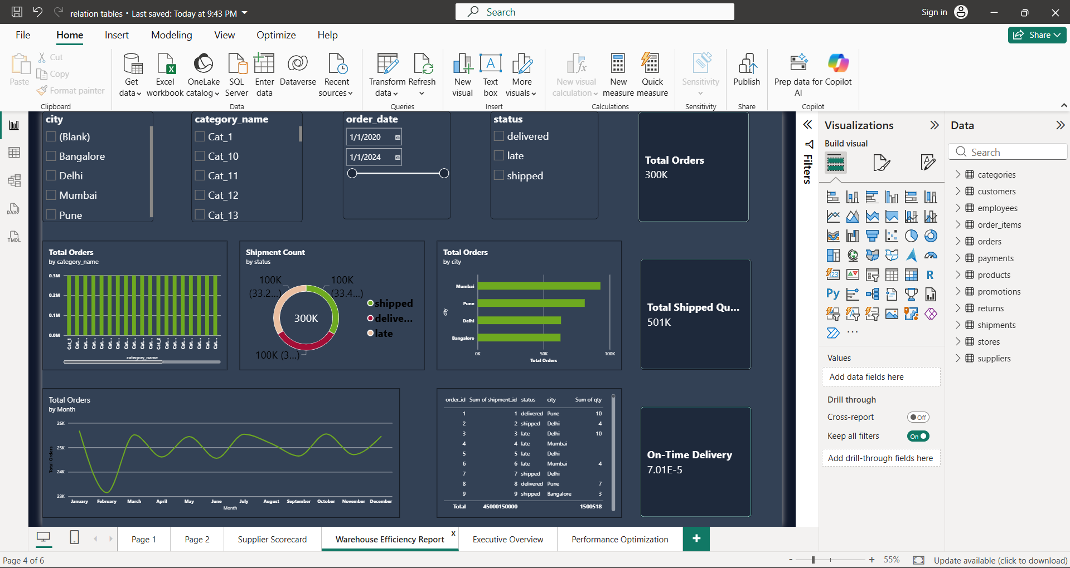
Figure 8: Warehouse Efficiency Report Dashboard

7.2 Executive Overview Dashboard
The Executive Overview page summarises the main indicators of the project on a single screen.
Visual | Value / Content Shown
Total Revenue (card) | 4bn
Total Orders (card) | 300K
Total Customers (card) | 50K
AOV (card) | 12.76K
Inventory Turnover (card) | 150.05
City-wise Revenue Performance | Bar chart of Total Revenue by city: Mumbai, Pune, Delhi and Bangalore in descending order of bar length; axis from 0.0bn to 1.0bn.
Total Revenue by category_name | Column chart with a vertical axis from 0M to 140M; bars fall gradually from left to right across the categories.
order_date slicer | Date-range slicer from 1/1/2020 to 1/1/2024.

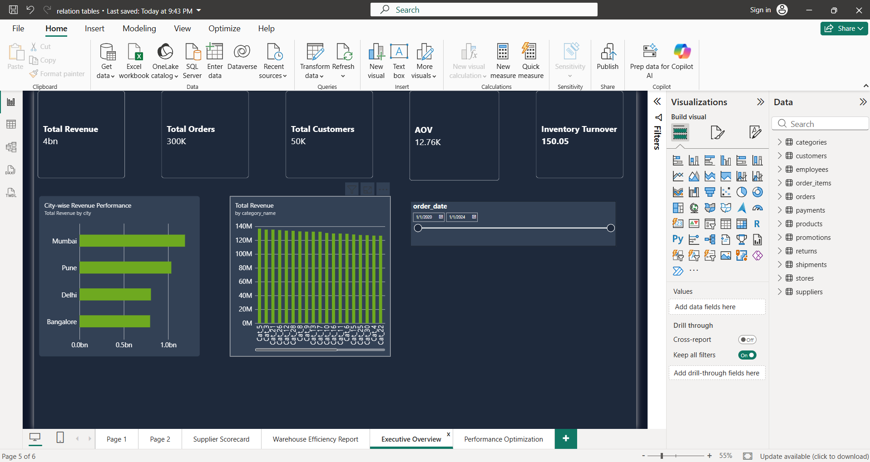
Figure 9: Executive Overview Dashboard

7.3 Dashboard Performance Optimization
The Performance Optimization page contains a single table visual that consolidates the main measures by city. It presents the key figures in one compact view without additional charts.
City | Total Revenue | Total Orders | Total Customers | AOV | Inventory Turnover
(Blank) | – | – | 50000 | – | –
Bangalore | 796,283,132 | 62,755 | 50000 | 12,688.76 | 31.19
Delhi | 805,723,746 | 63,157 | 50000 | 12,757.47 | 31.61
Mumbai | 1,189,994,536 | 92,971 | 50000 | 12,799.63 | 46.63
Pune | 1,035,744,722 | 81,117 | 50000 | 12,768.53 | 40.62
Total | 3,827,746,136 | 300,000 | 50000 | 12,759.15 | 150.05

The optimisation aspects that can be confirmed from the screenshots, and those that still need to be completed, are listed below.
Optimisation Aspect | Status
Consistent formatting and clean layout | All pages share the same dark theme, card style and green/teal colour palette.
Improved navigation | Named page tabs are provided: Page 1, Page 2, Supplier Scorecard, Warehouse Efficiency Report, Executive Overview and Performance Optimization.
Slicer / filter optimisation | Slicers are used on the Warehouse Efficiency Report (city, category, date, status), the Executive Overview (date) and the Supplier Scorecard (country).
Using appropriate measures | The same named measures (Total Orders, Total Revenue, Total Customers, AOV, Inventory Turnover) are reused across pages and in the summary table.
Removing unnecessary visuals / fields | To be updated from the Power BI report.
Optimising visual interactions | To be updated from the Power BI report.
Reducing unnecessary calculations | To be updated from the Power BI report.
Improving report performance (e.g. Performance Analyzer results) | To be updated from the Power BI report.

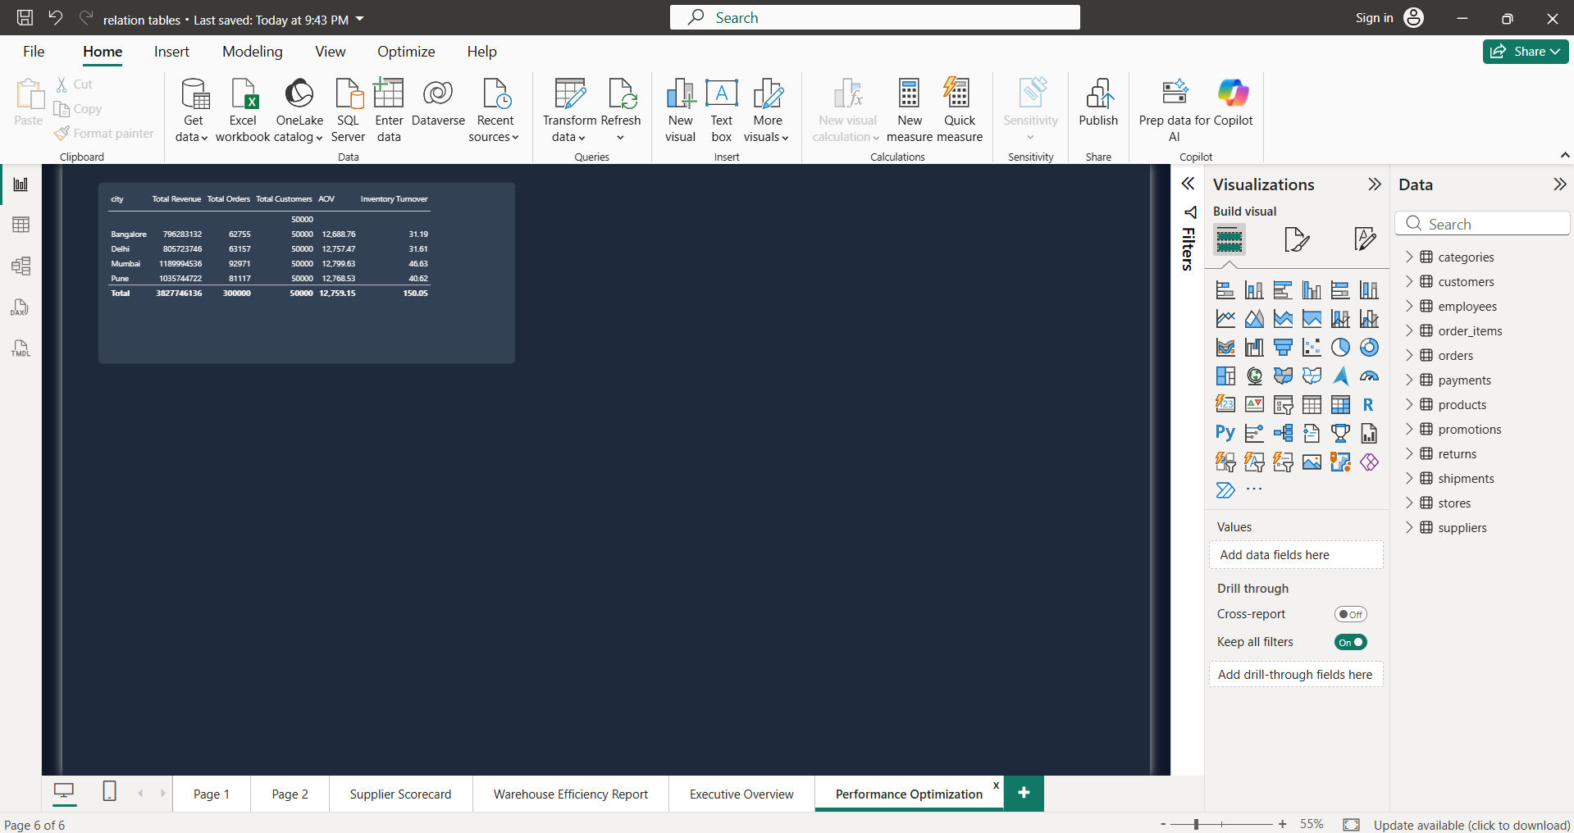
Figure 10: Dashboard Performance Optimization

7.4 Final Testing and Documentation
A detailed testing record was not included in the material provided, so the table below lists the verification areas together with what can be observed from the screenshots. No testing is claimed beyond this.
Verification Area | Observation from the Screenshots | Test Record
KPI verification | Total Orders (300K), Total Customers (50K) and Inventory Turnover (150.05) are the same on every page where they appear. Total Revenue divided by Total Orders equals the displayed AOV of 12,759.15. City orders in the summary table add up to 300,000. | To be updated from the Power BI report.
Visual verification | The visuals render on all six report pages in the captured screenshots. | To be updated from the Power BI report.
Filter and slicer testing | Slicers for city, category, date, status and country are present. | To be updated from the Power BI report.
Relationship verification | – | To be updated from the Power BI report.
Dashboard navigation | Six named page tabs are present. | To be updated from the Power BI report.
Formatting consistency | Consistent theme across pages. | To be updated from the Power BI report.

7.5 Deployment
Information about publishing the report to the Power BI Service or sharing it with other users was not provided. To be updated from the Power BI report.

8. KEY INSIGHTS
The observations below are taken only from values visible in the dashboards and screenshots.
- Order distribution: The report shows 300K orders in total. Shipment status is split almost evenly, with shipped, delivered and late each at about 100K orders (33.29%, 33.43% and 33.29% on Page 1).
- Revenue distribution: Total Revenue is 3,827,746,136 in the city summary table. Mumbai contributes the highest revenue (1,189,994,536), followed by Pune (1,035,744,722), Delhi (805,723,746) and Bangalore (796,283,132).
- City-wise performance: Mumbai also records the highest number of orders (92,971) in the city summary table, followed by Pune (81,117), Delhi (63,157) and Bangalore (62,755).
- Average order value: AOV is 12,759.15 overall, and the city values are close to one another, ranging from 12,688.76 (Bangalore) to 12,799.63 (Mumbai).
- Inventory turnover: The overall value is 150.05. By city it is highest for Mumbai (46.63) and Pune (40.62), and lower for Delhi (31.61) and Bangalore (31.19).
- Inventory position: Total Inventory is 2M across 10K products, and the Slow-Moving Products card shows 0. The Inventory Details Table shows a total quantity of 1,500,518.
- Category-level performance: In the Executive Overview, category revenue bars lie between about 125M and 140M, with a gradual decline across the categories shown.
- Supplier performance: By supplier country, USA has the most products (3.8K) and the highest inventory value (5.3bn), while China (3.2K, 4.3bn) and India (3.1K, 4.3bn) are close to each other.
- Shipments: Of 300K shipments, 99.862K are shown as delivered and 100K as late.
- Trends: Monthly order volume varies between about 23K and 26K with a dip in the early months, and the yearly inventory, delivery and revenue trend lines fall sharply at the end of the plotted period.
- Warehouse efficiency: Total Shipped Quantity is 501K, and the On-Time Delivery card displays 7.01E-5; the calculation and number format of this measure should be confirmed in the Power BI file.

9. REFERENCES
- Microsoft. Power BI Documentation. Microsoft Learn. https://learn.microsoft.com/power-bi/

