DESKTOP-65L0E04\SQLEXPRESS

1.Total Revenue

SELECT SUM(total_price) AS Total_Revenue from pizza_sales

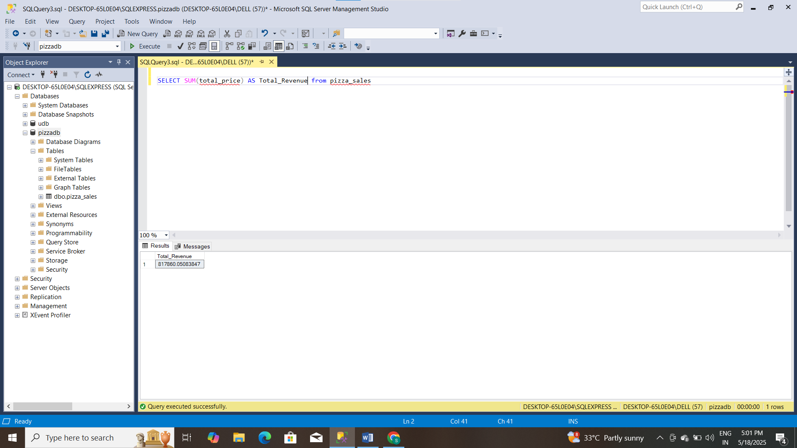

2.Average Order Value

SELECT SUM(total_price)/COUNT(DISTINCT order_id) AS Avg_Order_Value from pizza_sales

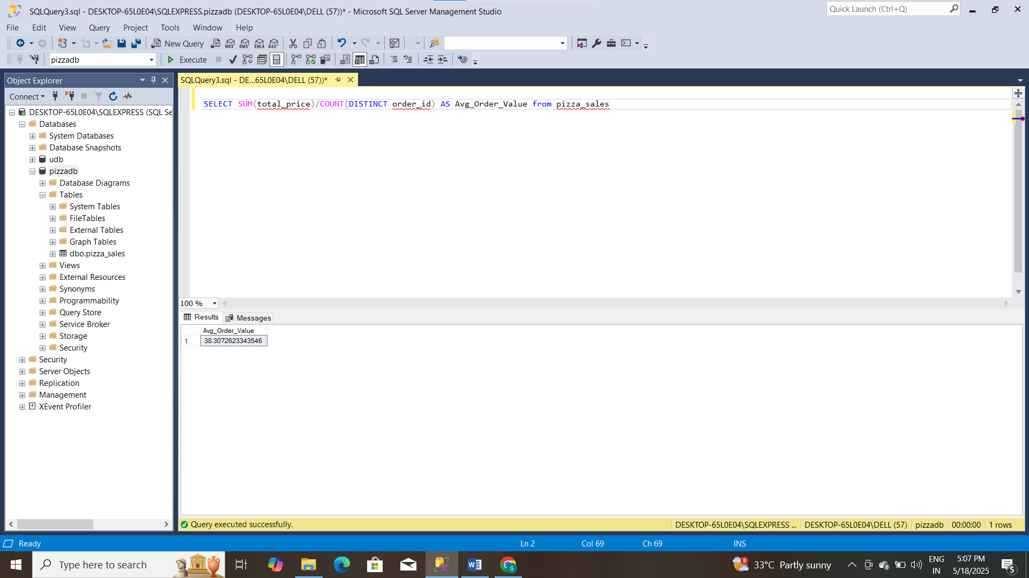

3.Total Pizzas Sold

SELECT SUM(quantity) AS TotalPizzasSold FROM pizza_sales

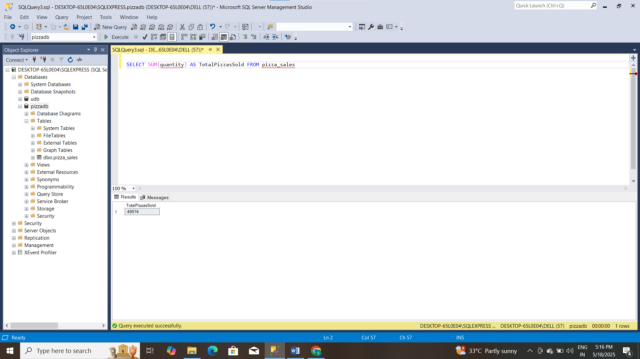

4.Total Orders

SELECT COUNT(DISTINCT order_id) AS TotalOrders FROM pizza_sales

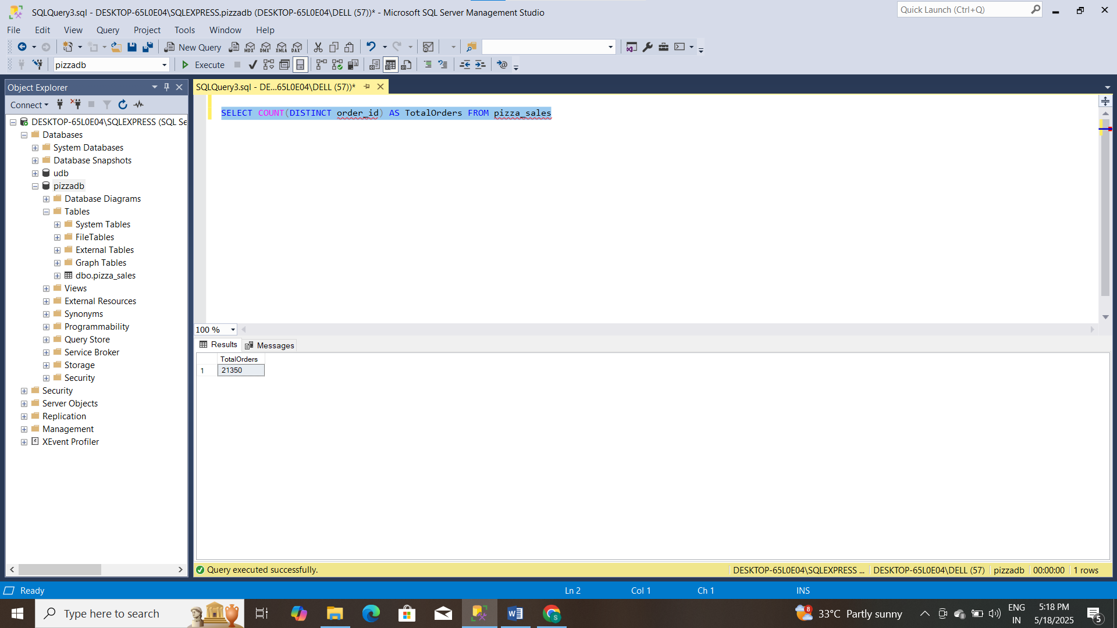

5.Average Pizzas Per Order

SELECT CAST(SUM(quantity) AS DECIMAL(10,2))/COUNT(DISTINCT order_id) AS AveragePizzasPerOrder FROM pizza_sales

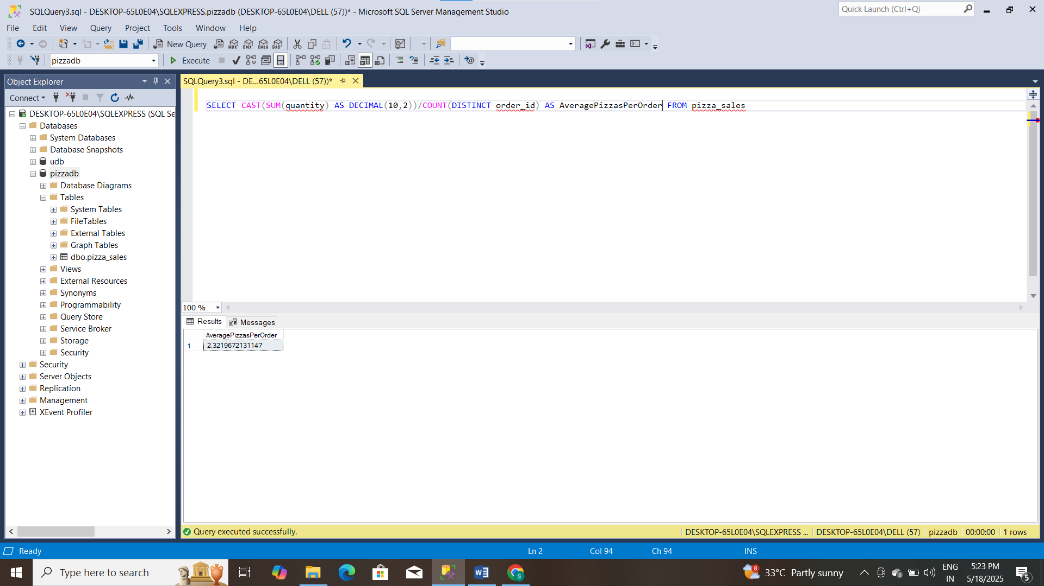

6.Daily Trend For Total Orders

SELECT DATENAME(Dw, Order_date) AS order_day, COUNT(DISTINCT order_id) AS Total_Orders

FROM pizza_sales

GROUP BY DATENAME(Dw, order_date)

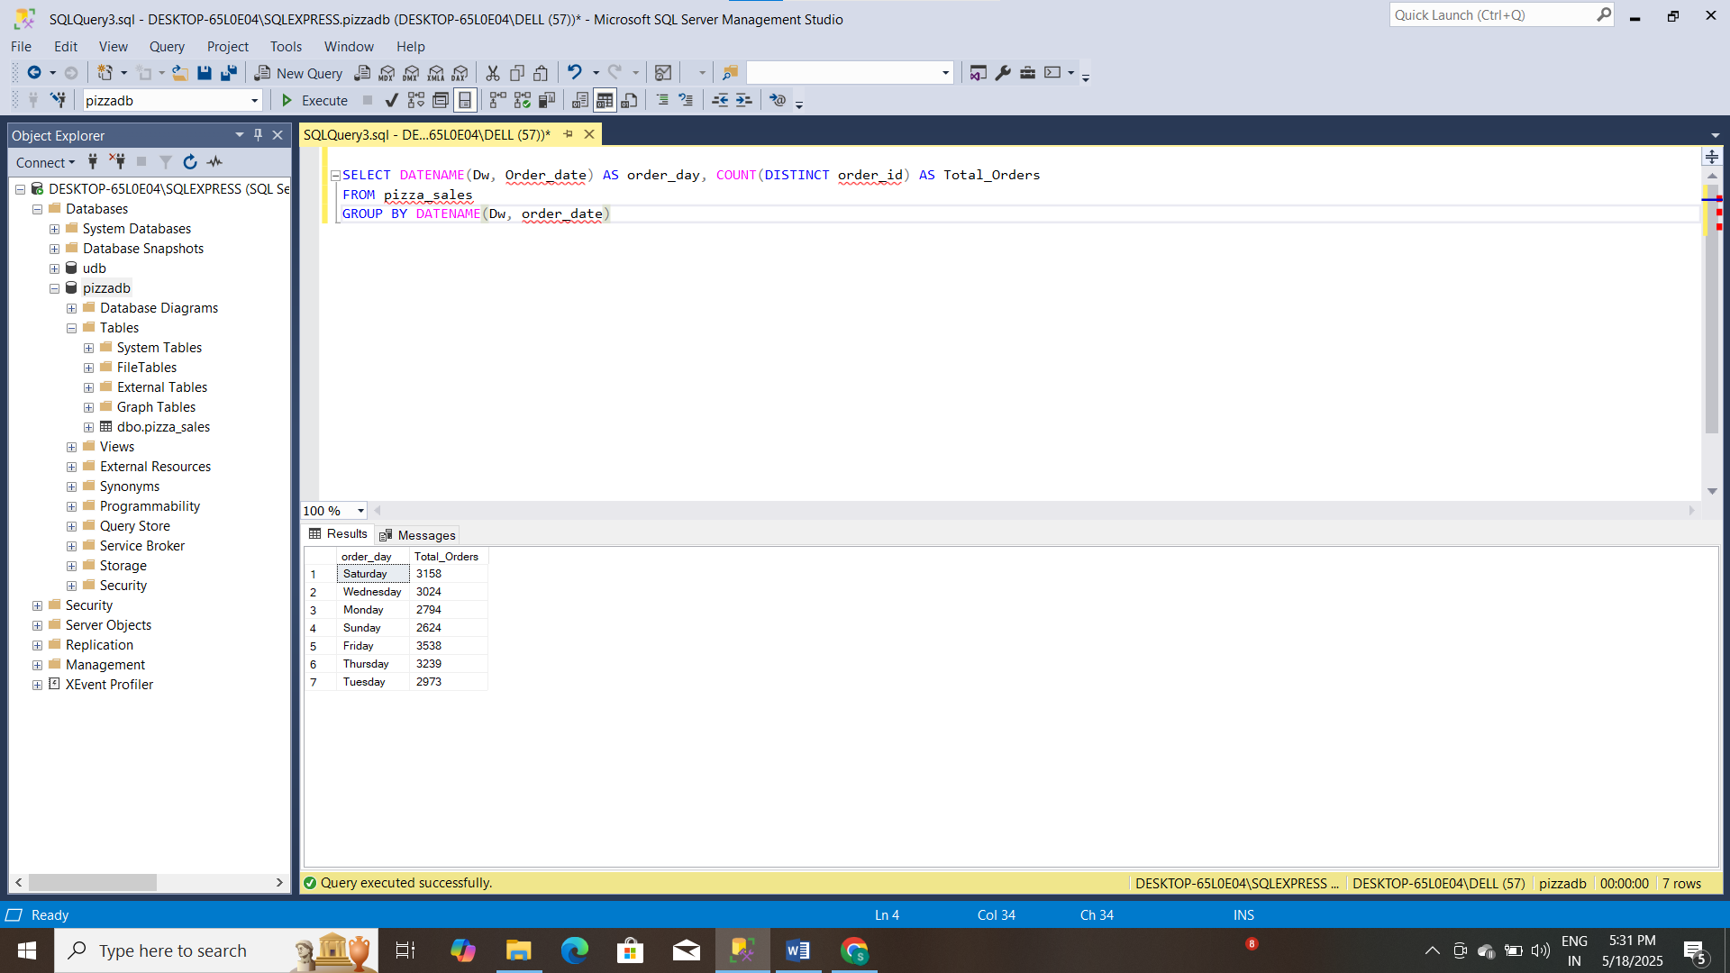

7. Order Hourly Trend

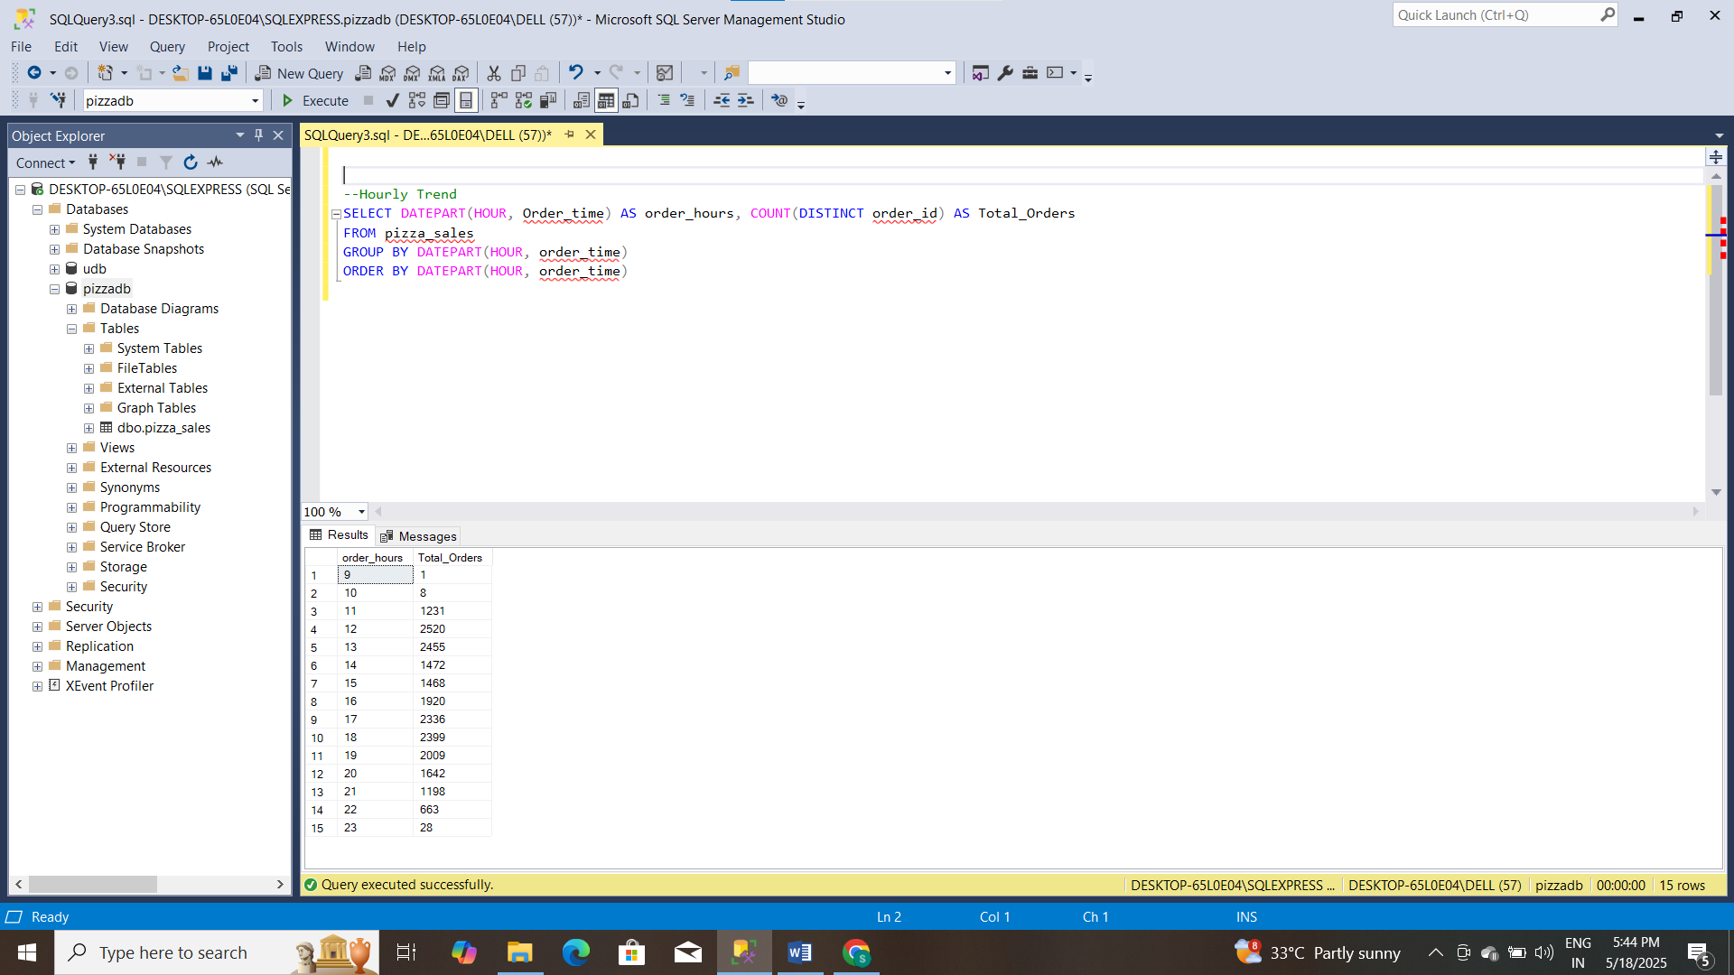

8. % of Sales by pizza_category

SELECT pizza_category, CAST(SUM(total_price) AS DECIMAL(10,2)) as total_revenue,

CAST(SUM(total_price) * 100 / (SELECT SUM(total_price) from pizza_sales) AS DECIMAL(10,2)) AS PCT

FROM pizza_sales

GROUP BY pizza_category

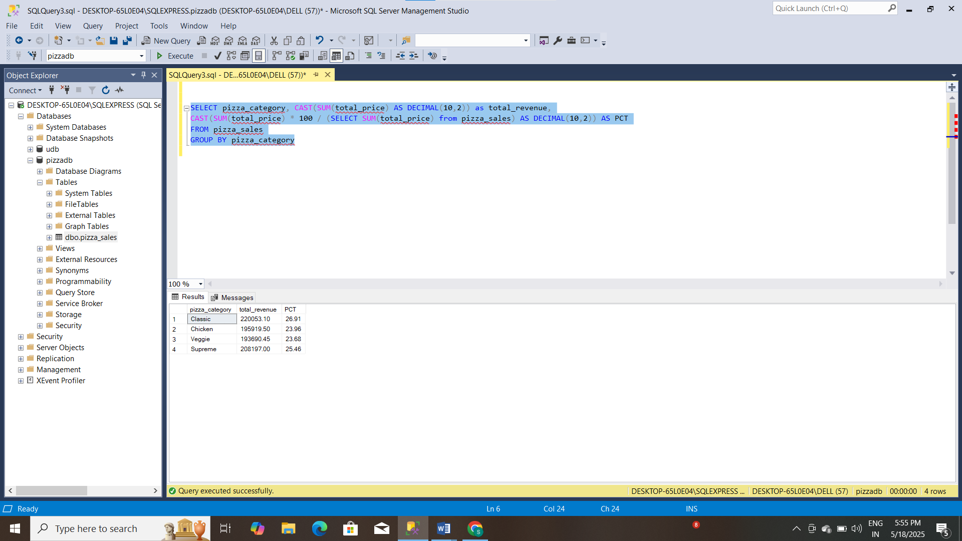

9. % of sales by pizza size

SELECT pizza_size, CAST(SUM(total_price) AS DECIMAL(10,2)) as total_revenue,

CAST(SUM(total_price) * 100 / (SELECT SUM(total_price) from pizza_sales) AS DECIMAL(10,2)) AS PCT

FROM pizza_sales

GROUP BY pizza_size

ORDER BY pizza_size

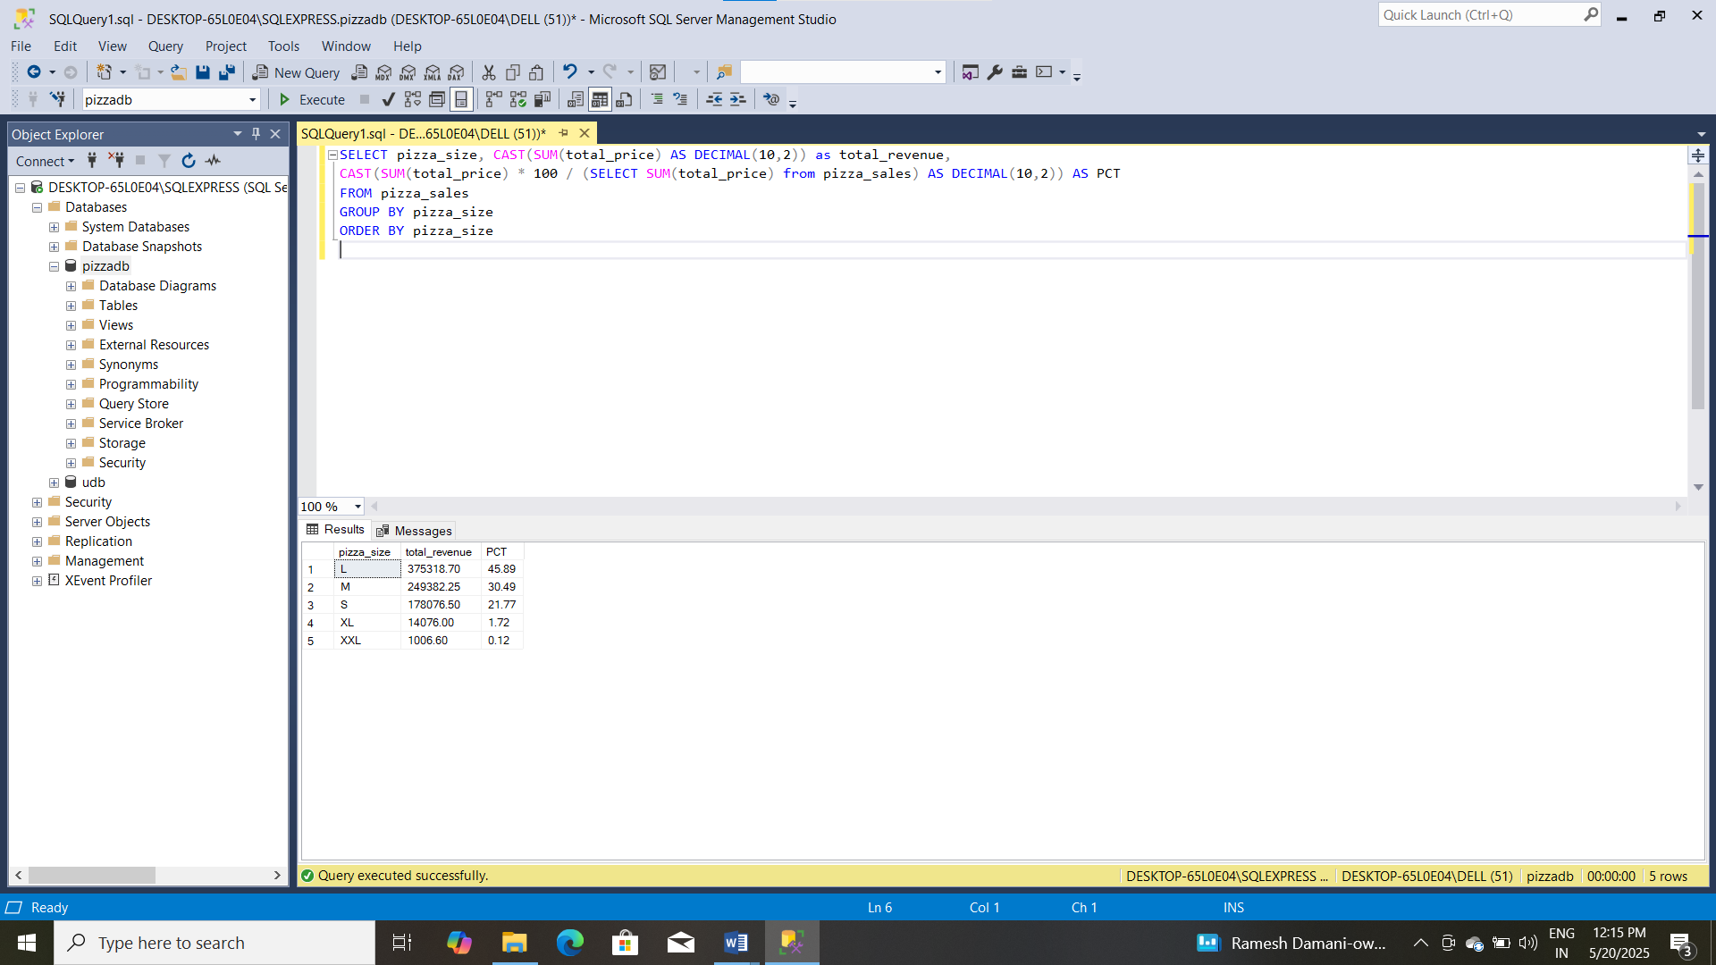

10. Total pizzas sold by pizza category

SELECT pizza_category, SUM(quantity) as Total_Quantity_Sold

FROM pizza_sales

WHERE MONTH(order_date) = 2

GROUP BY pizza_category

ORDER BY Total_Quantity_Sold DESC

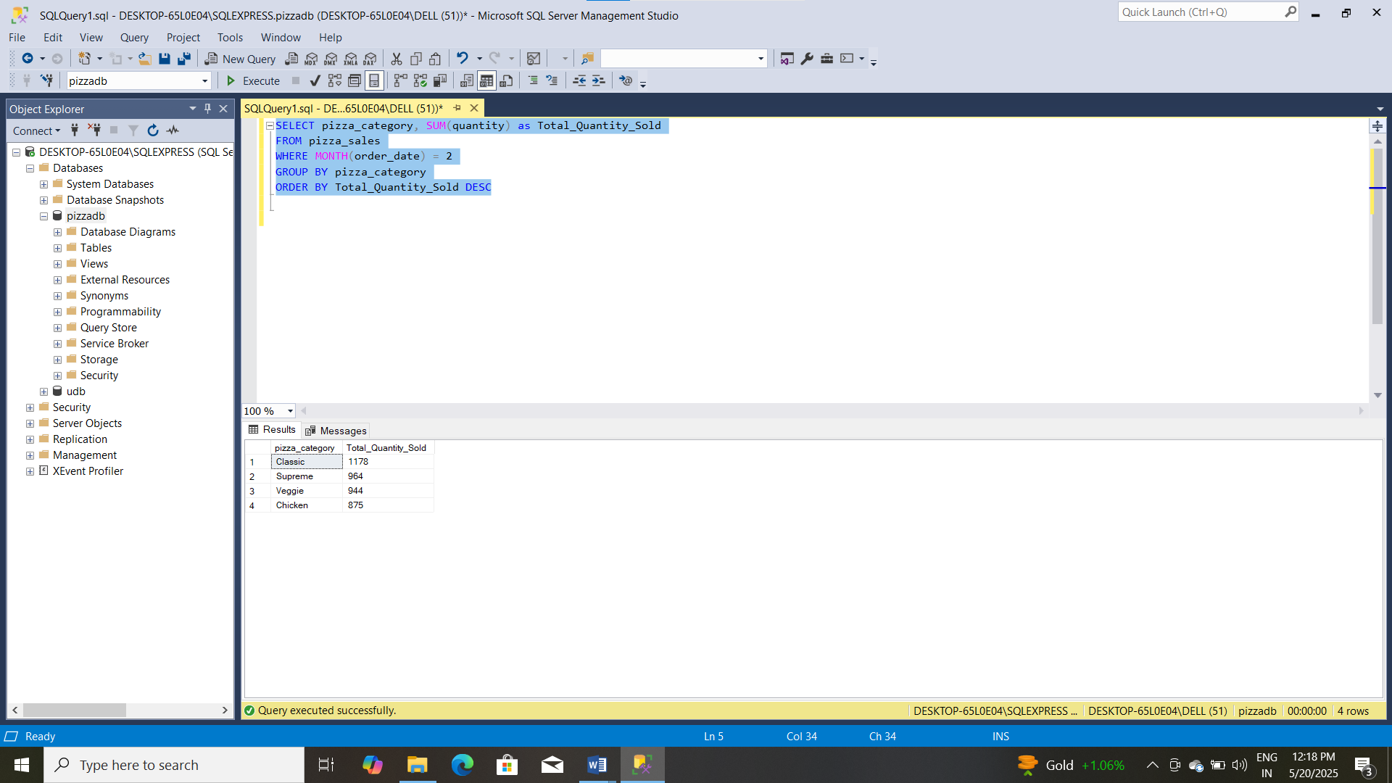

11. Top 5 sellers by pizza sold

SELECT Top 5 pizza_name, SUM(quantity) AS Total_Pizza_Sold

FROM pizza_sales

GROUP BY pizza_name

ORDER BY Total_Pizza_Sold DESC

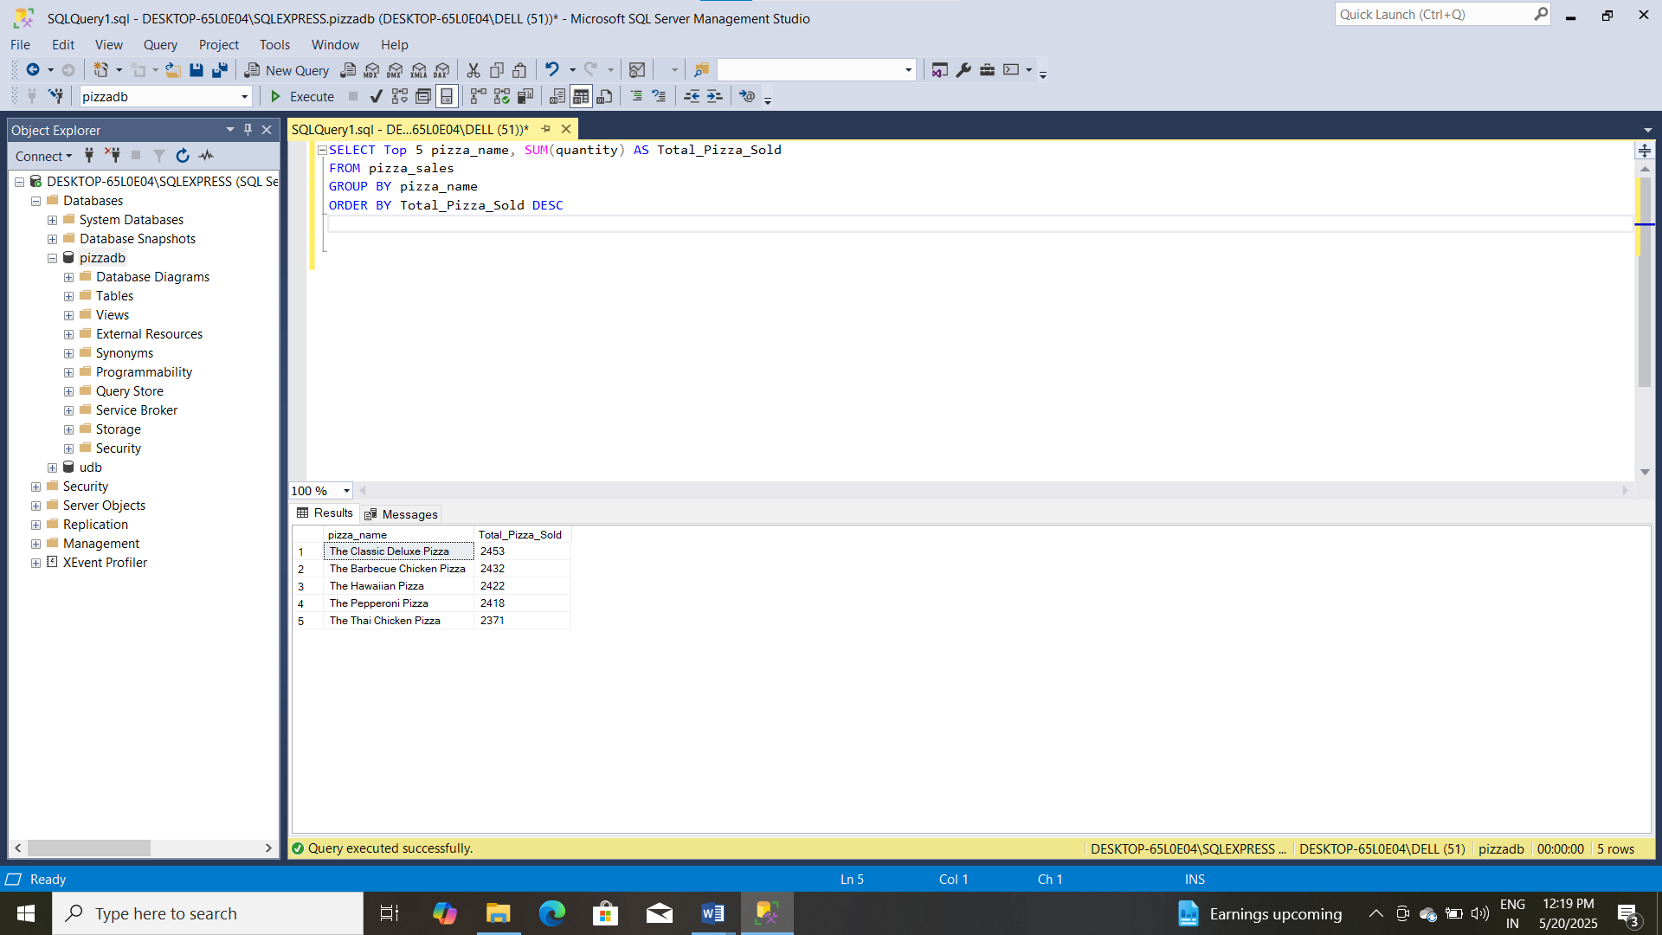

12. Bottom 5 best sellers by total pizzas sold

SELECT TOP 5 pizza_name, SUM(quantity) AS Total_Pizza_Sold

FROM pizza_sales

GROUP BY pizza_name

ORDER BY Total_Pizza_Sold ASC

