1. Where can one find the information with regards to Testing Standards and Defect Management guidelines?

Business Requirement Specification

Project Initiation Document

**Quality Assurance Plan**

Project Engineering Guidelines

2. Sumathy is performing a configuration audit for a project. From where can she find information regarding individuals authorized for change approval

Team Score Card

Change Request Log

**Configuration Management Plan**

Project Structure Document

3). Identify what will NOT be considered as innovation

Initiatives involved with Significant gains

Initiatives with Organizational Impact

**Initiatives with High cost of definition and implementation**

New practices brought in to comply with a new model or standard to cater to the business

4) What does the term "Living" indicate when it is associated with an Artifact?

Artifact that is going to be reviewed and enhanced

**Artifact that is going to be updated throughout the project lifecycle**

Artifact that provides the framework for execution

Artifact related to Project Management

5) What is NOT a key criteria for evaluating adequacy of a requirement statement

Complete

**Secure**

Accurate

Simple

6) Identify what is NOT tracked normally as a part of Project Status Reviews

**Team Score Card**

Risks and Issues

Work Completion

Variation of effort and schedule

7) Which document contains the naming conventions for the database tables to be used in the project?

Detailed Software Technical Design Document

**Project Engineering Guideline**

Technology Standards at Virtusa

Project Approach Document

8) Identify who is responsible for the activity "Facilitate Process Institutionalization"

Senior Management

Project Manager

Account Quality Partner

**Everyone in the project staff**

9) Sudha is to lead a project for a client in Japan. Language constraint is identified as a key challenge in the requirement gathering phase. What is the MOST effective method to be adopted

Configure extra time for gathering requirements

**Usage of "Use Case Diagramming Method"**

Japanese Language training for her key team members

Recruit a local business analyst

10) Identify the attribute that is measured to evaluate the Knowledge Management process within a project

Effort Variation

Client Satisfaction

Schedule Variation

**Extent of reusable artifacts and methods**

11) Deployment Plan is BEST prepared in

**Early Elaboration Phase**

Transition Phase

After Construction Phase

Early Construction Phase

12) The QATP needs to be approved by

Client

Test Analyst

**Project Manager and Test Analyst**

Project Manager and PQA

13) Sumathy is performing a Code Review of Surjit's work. What would be of LEAST consideration

Error Handling routines

Simplicity

Readability

**Coding Effort**

14) Shyam is the technical architect for developing a configuration management system. The system will store identified CI and track their lifecycle. System features are heavily dependent on the state of the CI at any point in time. What would BEST help Shyam in detailing the system design

**State Chart Diagram**

Use Case Modeling

Entity Relationship diagrams

Data Flow Diagrams

15) What is NOT an input for an Account Delivery Review

Account Status Report

Project Quality Indicators

Client Satisfaction Score Card

**Change Request Log**

16) What is TRUE about tailoring a PTR?

All Disciplines must be included

PTR is approved by the Delivery Head

**PTR can be modified during the course of the project**

PTR is not applicable when Client templates are being followed

17). Shyam is the technical architect at Virtusa for an online assessment system. For encryption of the questionnaire, he decides to opt for a tool developed by the popular vendor AES. What is the MOST important activity that shyam is to do next?

He should ensure AES incorporation does not have any legal liability

**He should obtain approval to use the tool from the Project Manager**

He should enter into an escrow arrangement with AES

He should ensure skills are available for integration of this tool in the project

18) According to GIP, there are _______ number of severity levels assigned to defects.

2

5

**4**

3

19) Identify what is NOT a direct intent of Change Management Process

Prevent implementation of unauthorized changes

Consistent implementation of approved change

**Control of effort variance**

Ascertaining impact of change

20) Identify what is NOT a prerequisite for the "Integrate System" activity

**Approved Deployment Plan**

Component availability in configuration management system

Integration Build Plan

Completion of unit testing for the sub components

21) According to GIP, "Remark" is a status assigned to the QA Test Defect when

**The defect is raised by the QA Test team**

The defect is fixed by the Development team

The defect is rejected as "not reproducible" by the Development team

The defect is rejected as "duplicate" by the Development team

22) For projects with large code base, what is the recommended sampling % for work product audit

15-20%

25-30%

10-15%

**5-10%**

(23) Identify what is NOT an activity of the Process Management Discipline

Establish Process Performance Model

Monitor Project Audit Results

Monitor and Control SPI

**Deploy Process**

24) What is the PRIMARY consideration while deciding on the build or buy option

Availability of open source utilities

Time available to cater to the requirement

**Cost Benefit Analysis**

Competency within organization

25) In a typical acceptance plan, with who should Execution of acceptance test reside?

Client

**Project Manager**

Test Lead

Business Quality partner

26) Identify the CORRECT statement with respect to Physical Configuration Audits

Conducted prior to the release of a baseline

Optional for small development projects

**Mandatory for all projects.**

Normally conducted by the tech lead

27) Suyash is new to Virtusa. He has to choose the process framework for execution of his project. What would help him in arriving at the MOST appropriate framework for his project

Contract document

GIP PTR template

PTR of similar projects

**Project Approach Document**

28) Success of the acceptance test is PRIMARILY dependent on

Good Supporting documentation

Well trained user community

**Base lined Acceptance Plan**

Strong deployment Manager

29) What is NOT the intent of the Program Management discipline

To provide management attention to delivery

To provide necessary trainings

**Conflict resolution within project team members**

To manage resource utilization

30) Management of Acceptance tests is the activity performed by

**Client**

36) Preparation of Configuration Management Plan is the responsibility of:

38) All these are valid expectation from an implementation model EXCEPT---

**Unnecessary dependencies on lower-layer subsystems have been eliminated**

39) Test report is developed by:

**Test lead**

40) What is the BEST method for preparation of User Manual

**user side operator**

41) What is the PRIMARY intent of an account delivery review?-----

**To review and provide management support to meet delivery**

42) Identify the PRIMARY benefit of a DAR process?

43) A customer comes back to the project manager informing that the product delivered is not acceptable. The project manager goes back to the acceptance plan but notices that the plan was not signed off by the customer, due to which there was rework on the delivered product to meet client expectations. Which process has failed? Requirements Management Requirements Development Communication Management Stakeholder Management?

44) Suyash is the Project Manager. His project contains a large code base. He is selecting the codes that would be subjected to code review. Which is the BEST method for selecting the candidate codes?

Atleast one code per module Codes which pose a significant risk on not getting reviewed Atleast one code per developer Atleast one code per category (maintenance/report etc)

45) Where are the reuse area identified for a project?

While performing code review, the OUTPUT can be

(1). Conventions to be used in her project?

Requirements Management Plan

**Technology Standards**

Configuration Status Report

2) Baselining criteria for a Business Requirement Document is

**Sign off by Client**

Review by Project Leadership team

Acceptance by Delivery Head

Acceptance by Project Leadership team

(3).What is incorrect about Contract Compliance Checklist?

The minimum prescribed frequency is fortnightly

The process is owned by Account Owner

It is prepared by Project Manager

**It is published at agreed intervals to the Client**

(4). Requirements Management Plan is to be signed off by

**Client**

BU Quality Partner

Business Analyst

Change Control Board

5). Sumathy is to lead the QA testing of a system. Where can she find the acceptance criteria for Testing?

Project Approach Document

Requirements Management Plan

**QATP**

Release Management Plan

6) What is the primary intent of an architectural POC?

**Prove feasibility of the system to architecturally significant requirements**

To explore best option for system design

To identify major risks in designing of the system

Evaluate effort involved in system realization

(7).The scope functionality traceability matrix holds which of the following information:

a) Active requirements

b) Requirements Dropped

c) Approved Changes to Requirement

d) Rejected Changes

C and D

A, B and C

A and B

**A, C and D**

8) What does ETVX imply in terms of a process description

Explore Task Verify and Explain

Explore Task Verify and Explain

Entry Task Version and Example

**Entry Task Verification and Exit**

9) On Development and Maintenance Projects, Quality Effort Index DOES NOT include

Coding Effort

Estimation Effort

**System Testing Effort**

Code Review Effort

(10) If the Project Manager prepares the PTR. Who needs to maintain it?

Account Quality Partner

BU Quality Partner

**Project Manager**

SEPG

(11)What does a PCI indicate?

Project Capability Index

Process Capability Index

**Process Compliance Index**

Project Compliance Index

**12**) Out of these identify the MOST critical aspect to be recorded in the Test log against a defect?

Tester Details

**Cause of the Defect**

Defect Categorization

Details for error simulation

13) What will NOT usually be included in a Deployment Plan?

Training requirements for End Users

Process of Remediation

**Time Lines related to deployment**

Key Software Features

14) Who should approve the Project Approach Note?

**Account Owner, as he is the senior management representative**

Delivery Head, as he is the management representative

PQA, as he has to facilitate process implementation

Quality Partner, as he is responsible for the process framework

15) "Perform Architectural Analysis and Design" is NOT required for

Small Enhancement Projects

Technology Migration Projects

For Maintenance Projects

**Systems with existing well-defined architecture**

16) Approving Authority for User Manual is

Delivery Head

Deployment Manager

Business Quality Partner

**Client**

17) What will NOT be normally discussed in a team kick off meeting?

Project Overview

**Detailed Project WBS**

Acceptance Criteria

Project Vision

18) What is the main intent of an Engineering Rigor Audit?

**To evaluate the maturity of engineering practices within a project**

To identify instances in code where GIP standards have not be followed

To evaluate the technical skills of the project team

To evaluate the ability of the project team to meet the non-functional requirements

19) Identify the approving authority for a PTR

PQA

Delivery Head

**Account Owner**

Business Quality Partner

20) What is NOT an accurate statement about the GIP component ROLE?

Roles are NOT individuals but represent how they behave in the business environment

**Roles are restricted to people within the organization**

A role is an abstract definition of a set of activities performed and artifacts owned.

Roles perform activities

21. With regards to GIP process components, what is NOT a valid relationship?

An activity is performed by a role

A role is responsible for an artifact creation, maintenance and update

An activity refers to a template

**Software Engineering Process is organized into Disciplines**

22. Identify what is NOT intent of the Assurance Discipline?

To provide early indicators with regards to process risks

**To define organizational processes**

Facilitate Process Implementation

Provide Support to Project Leadership

23. What is "Workload analysis" Used for?

Arriving at leveling of work allocated to team members

**Arriving At the Framework For Performance Testing**

Arriving at Database size

Arriving at acceptance criteria

24. When should the project risks be identified and managed?

On milestone completion

Transition Phase

Construction Phase

**Throughout the project**

25. Identify what is NOT an appropriate status during change approval?

Rejected

Duplicate

**Hold**

Accepted

26. All units have been tested and integration activities have been completed. The team now prepares the developer release note. Identify the PRIMARY intent of the Developer Release Notes

**Provides key information on the current release to QA**

Provides the deployment manger information about known defects

Provides insight to the deployment manager on limitations of the system

Provides the Client an insight into limitation of the system

27. Against what would a POC be evaluated?

**Against identified Architecturally Significant Requirements**

Against acceptance Criteria in Project Acceptance document

As defined in the Project Approach Document

Against Criteria in Project Engineering Guidelines

28) As per the PTR template in GIP, what are the Mandatory activities for a maintenance project?

Project Effort Estimate

None of the options

Deployment Plan

**QATP**

29) Rework Effort Index DOES NOT include

Code Fixes

Correction to the Design components

Writing the test cases for the functionality not covered which is identified during testing

**Re-estimation**

30) Identify the condition which will NOT normally be tested in a developer test case?

**Stress Testing**

Coverage Testing

Negative Testing

Boundary Condition behavior

1).What is normally NOT included in a deployment package?

**Review Reports**

Installation Manual

Operations Manual

User Manual

2). What BEST describes the principle of classification of a nonconformance into Major or a Minor NC?

If the discipline to which it is attributed is a delivery related discipline, it is a Major NC

**Classification is based on the potential risk the lapse can cause to the project's success**

If there are multiple occurrence of the same lapse the finding is classified as a Major NC

Any finding against the performance of a process (Activity) is classified as a Major NC

(3).What will NOT be described in a Configuration Management Plan?

UAT Environment Details

**Control Test Environment Details**

Development Environment Details

Integration Testing Environment Details

4).As per the GIP guidelines what is the thumb rule for affixing the size of the lowest node in a WBS?

The task should at least be 40 hours of duration

The task should NOT be in the critical path

**The task should result in a measurable deliverable**

The task should not have any dependency

5) What is NOT normally done during an interim Build Process?

Preparing build release note

Checking out code from repository

**Deployment on test machine**

Logging Build defects

(7) During Detailed Design how does one address non functional requirements?

Through traceability Matrix

By mapping Design elements to State Chart Diagram

**By associating core technical service to individual class**

By mapping design to POC

(8) Identify what will NOT influence the Quality Plan for a project?

Audit Summary Results

Feed from other Quality Partners

**None**

Areas of improvements for the project

9) What is normally NOT discussed in an Account Business Review?

New Business Opportunities

Score Card Trends

CDI

**SARB Comments**

10).What is the PRIMARY intent of bi-directional traceability

To provide inputs for configuration management

**To identify all requirements are translated into implementation, to verify all features implemented can be traced to an approved source and traceability between requirements is maintained for ensuring integrity**

To identify features in the deliverable those are not mapped to any user specified or design driven requirement

To identify features in the deliverable those are aligned to requirements specified by users

11) The assertion that is true in its completeness with respect to work product audit is

As DSTD is subjected to SARB review, work product review is optional

Review of artifacts by the process consultant is considered as work product review

**Every work product needs to be audited atleast once**

Project Manager provides waiver in case of non-closure of findings

12) Where do you find the list of Business Objectives of Virtusa?

Metrics Description Document (MDD)

QI Sheet

**Organizational Objectives Document**

Metrics Profile Document

13) A SARB review will be LEAST concerned with:

Adherence to Requirement

Scalability

**Requirement Detailing**

Performance

14) Of the given below identify which will be considered in preparation of Quality Plan for PQA activities

Consolidated Reports for improvements areas in implementation rigor

**All the options**

Areas of improvements as identified by Senior Management

Audit Summary Results

15) Which artifact holds the list of "To be Decided" requirements

Traceability Matrix

Business Requirement Document

**Business Requirement Log**

Issue Log

16) Identify what is NOT an input for "Planning the Integration"

Project Engineering Guidelines

Approved Change Requests

Implementation Model

**Developer Release Notes**

17) Who is authorized to "Close" an implemented CR?

**Member of the CCB**

Owner of the change request

Project Manager

Configuration Manager

18) Which is the Group that is responsible for maintaining GIP Quality?

**Champions OCM**

Project Leadership

SPI

Team Lead

(19). Identify what will NOT normally give raise to a change request?

**Requirements Change to SARB**

Review Changes to code due to QA

Review Changes due to Client requirement during design review

Code Change following Unit Testing

20. What is the main intent of an Engineering Rigor Audit??

22. Identify what will NOT influence the Quality Plan for a project?

**None**

Audit Summary Results

Areas of improvements for the project

Feed from other Quality Partners

23. Sujatha is a developer and she attended a technical discussion session with the Onsite / Client Tech Lead. Which Pulse category should she log this effort to?

**Implementation - Others** (because it is a meeting)

Construction

Virtusa - Admin project (as there is no Pulse category called technical discussions in the project's pulse categories)

Project Management (because it is a meeting)

24. What is accurate about the activity "Designing of Core Technical Services"?

**This activity involves planning for non-functional requirements**

This activity need not maintain DAR

This activity is initiated in the Inception phase

This activity is performed on completion of POC

25. Identify the activity FIRST leads to the creation of Scope-Traceability Matrix

Handle Changes

**Manage Requirements**

Develop Plan

Perform System Analysis

26. Identify the situation which mandates a formal Decision Analysis and Resolution Process

**Evaluation of Tools**

Approving Change Implementation

Deciding Mitigation

27. What is the prescribed frequency for Account Delivery Review for a Strategic Account with AHI 5?

**Fortnightly**

Weekly

Monthly

Once in two months

Under: work guidelines->Account delivery review

28.What is NOT a key criteria for evaluating adequacy of a requirement statement?

* 1. Verifiable
  2. Simple
  3. Accurate
  4. Secure

29.What is NOT a prerequisite for initiating test at client site?

* 1. Agreed upon Test Environment Configuration
  2. Availability of relevant infrastructure
  3. Availability of relevant support software
  4. Automated Defect tracking mechanism

30.Risk Mitigation must be performed for:

* 1. High Risks
  2. Direct and Indirect Risks
  3. Only Direct Risks
  4. High and Medium Risks

32.When can the CM Plan available for the team,

* 1. Beginning of Elaboration phase
  2. During the Elaboration phase
  3. Beginning of Construction phase
  4. During of Construction phase

33.When will happen the Account Review meeting

34.What is TRUE about Tailoring a project

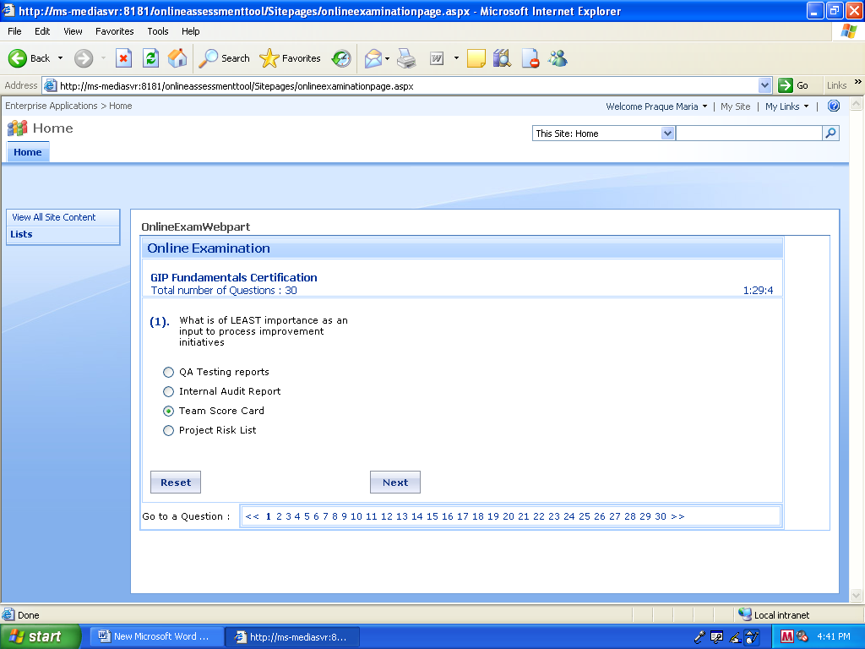

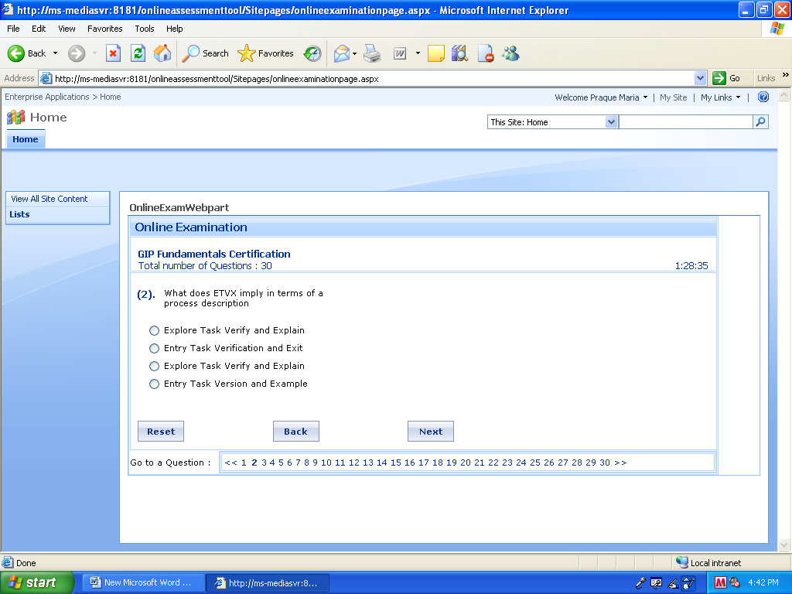

b)

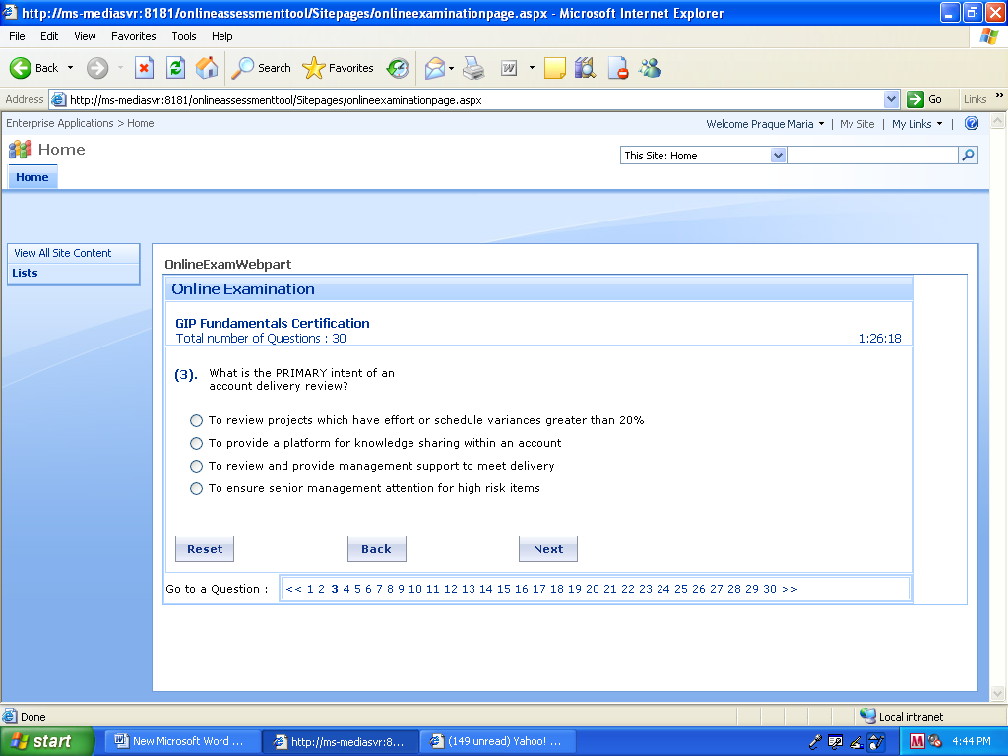

c)

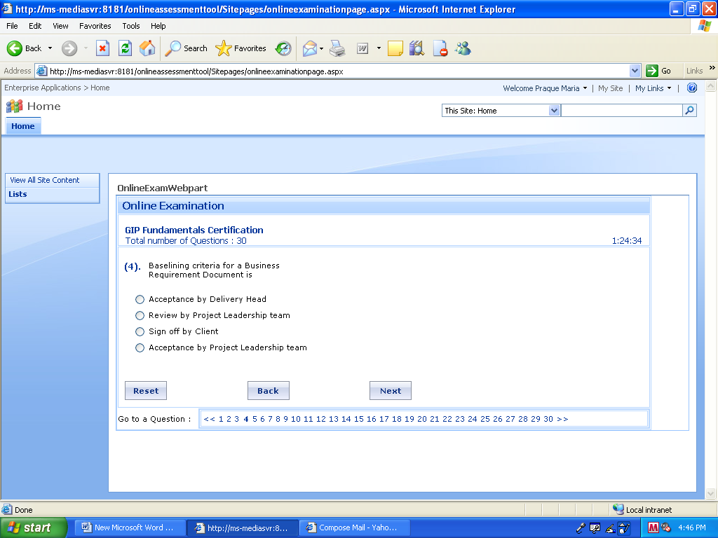

c)

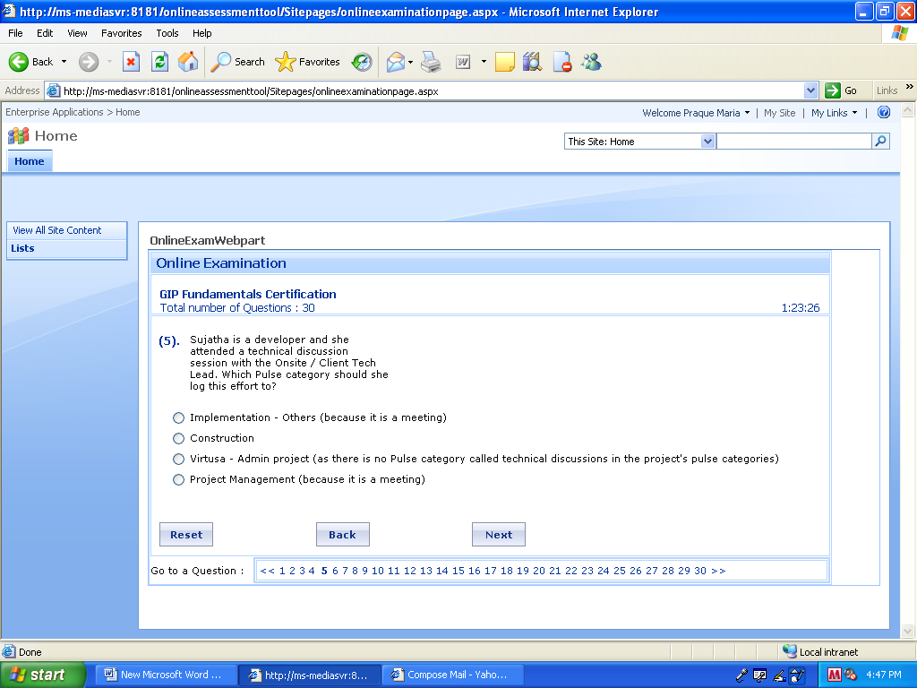

a)

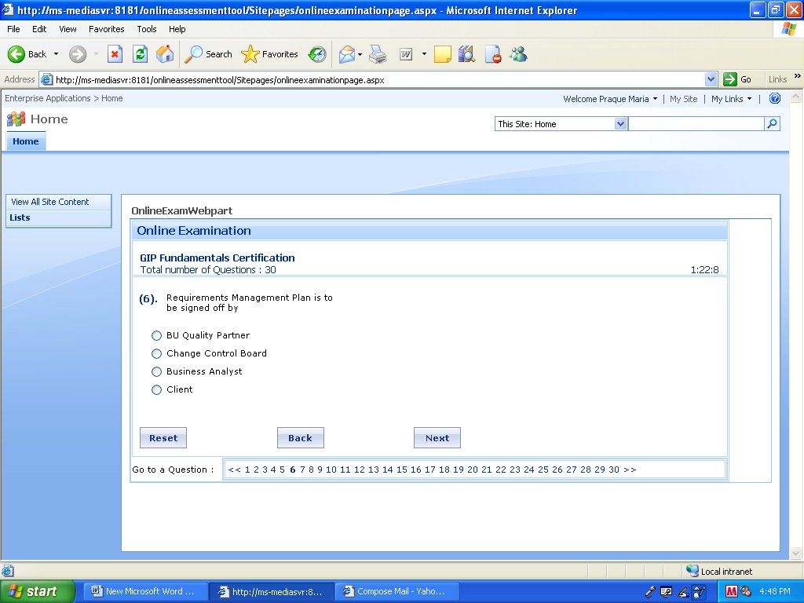

d)

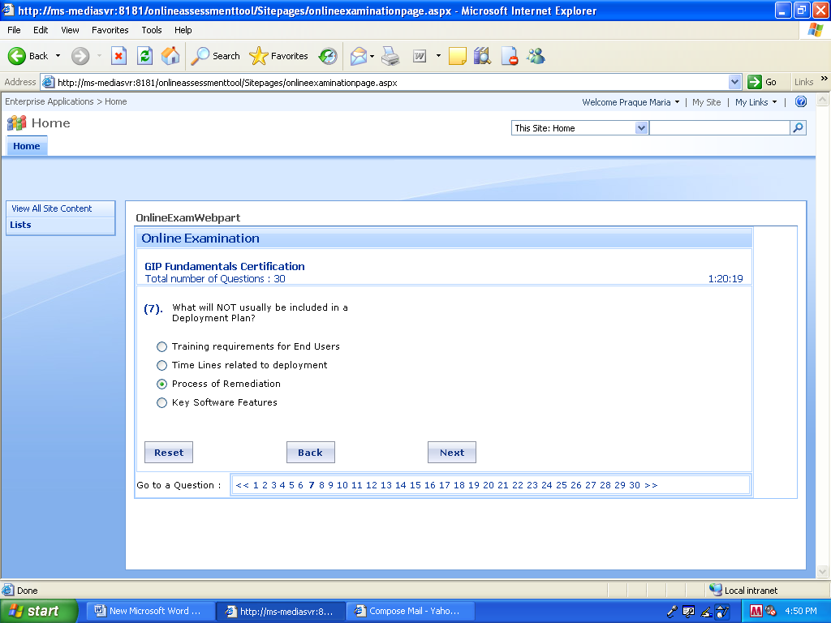

b)

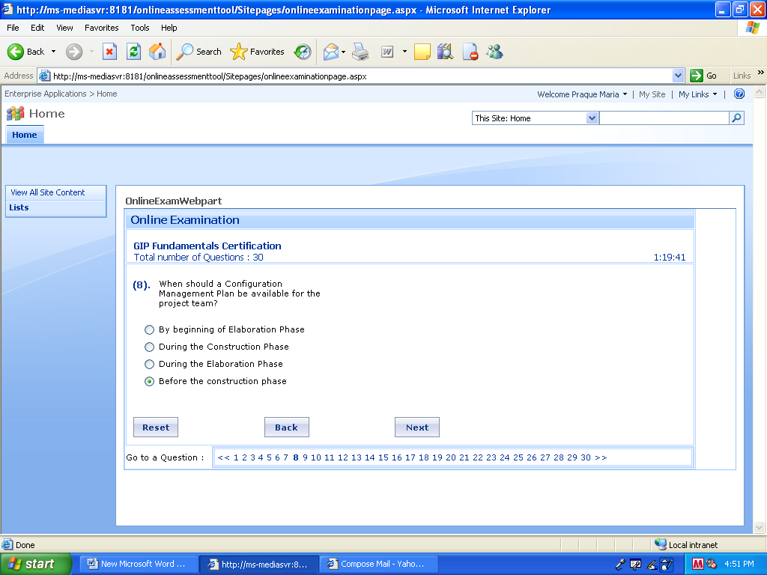

a)

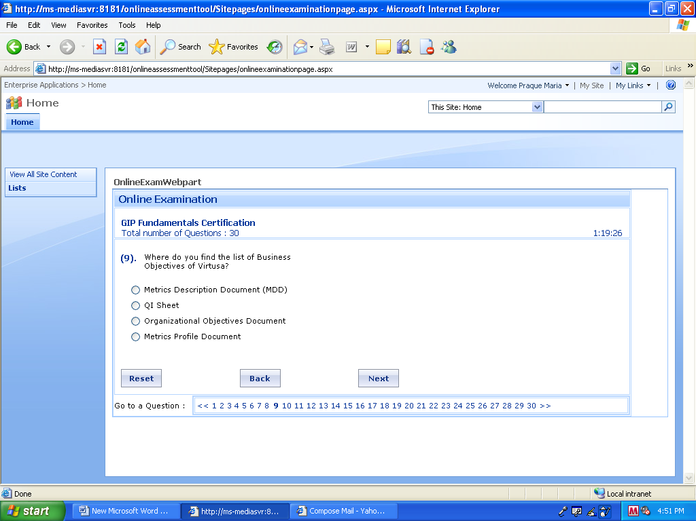

c)

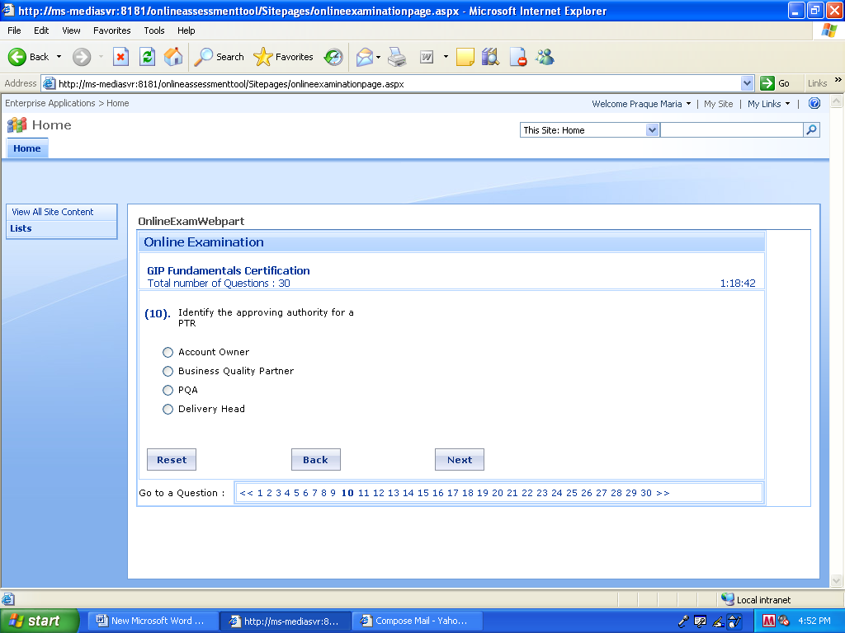

Ans: Account owner

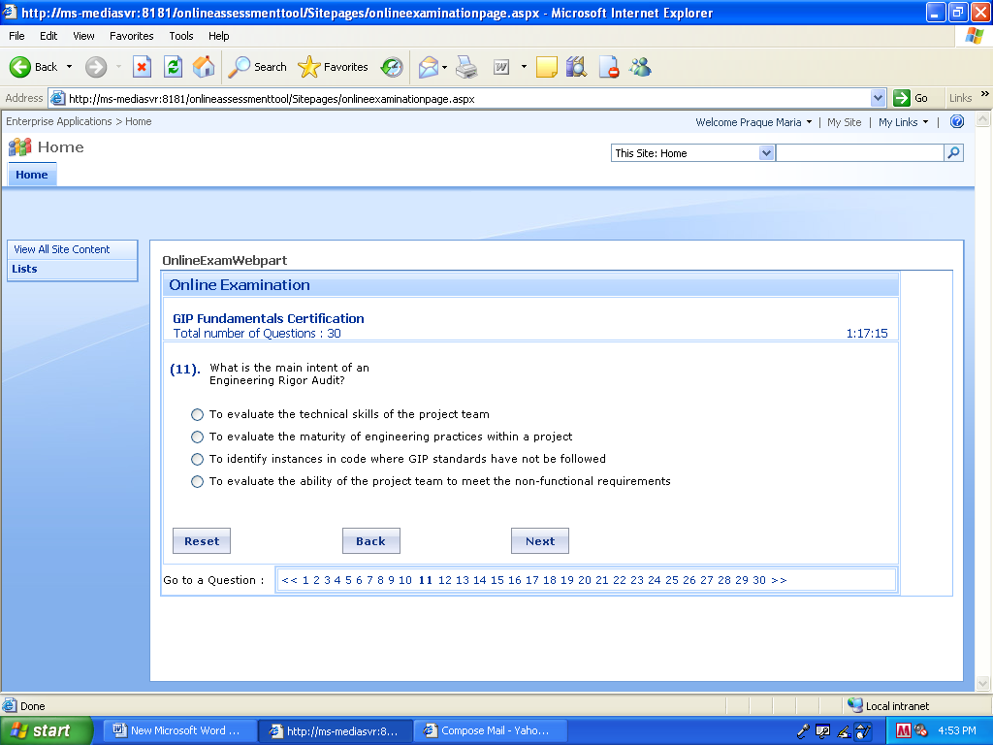

b)

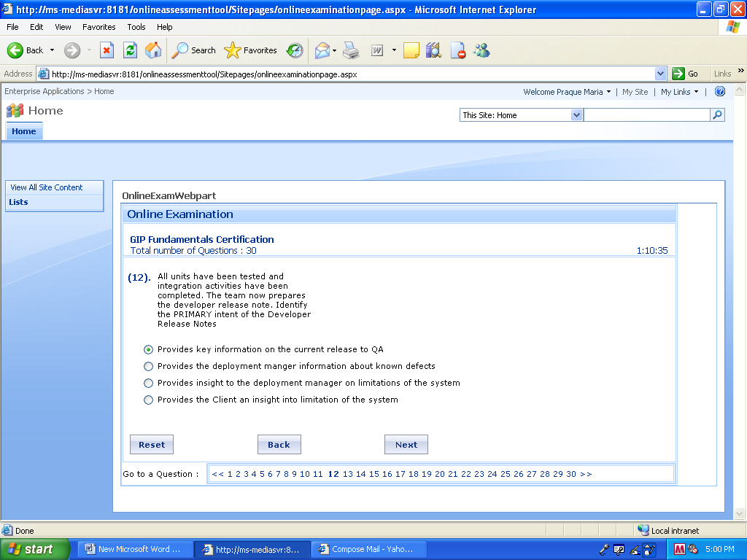

a)

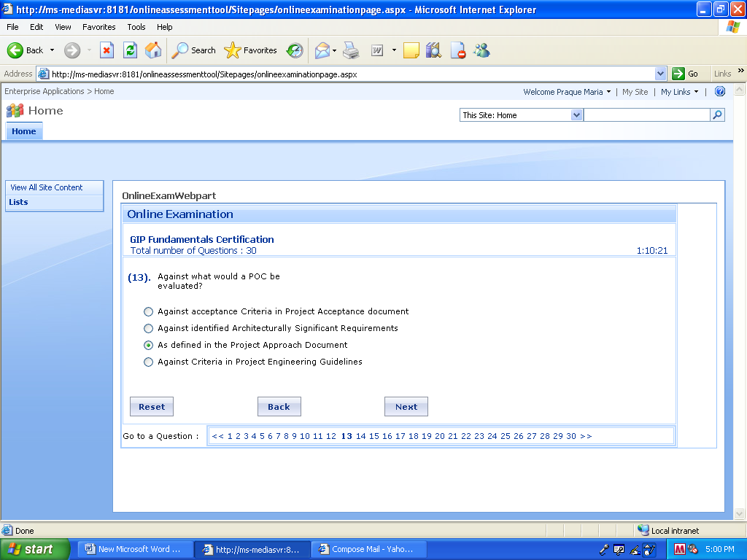

b)

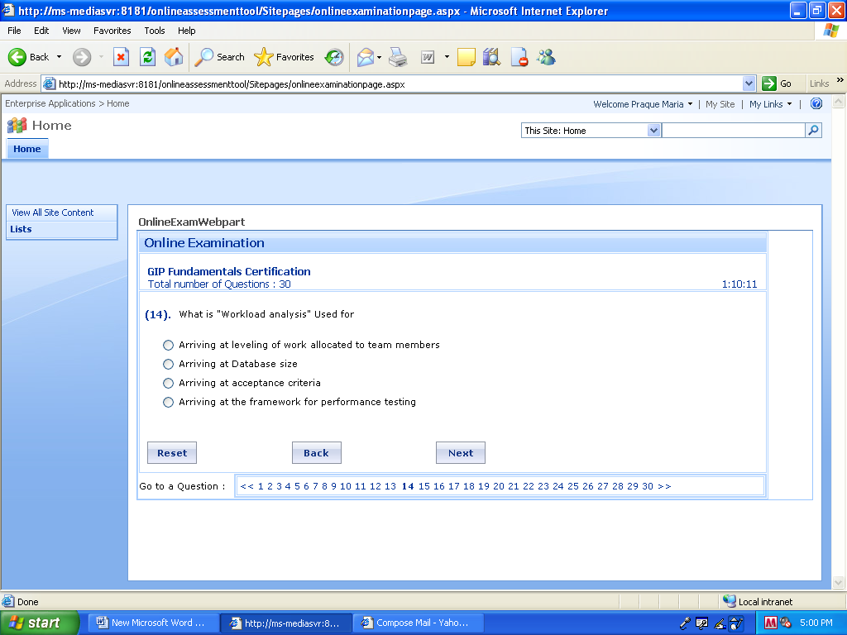

d)

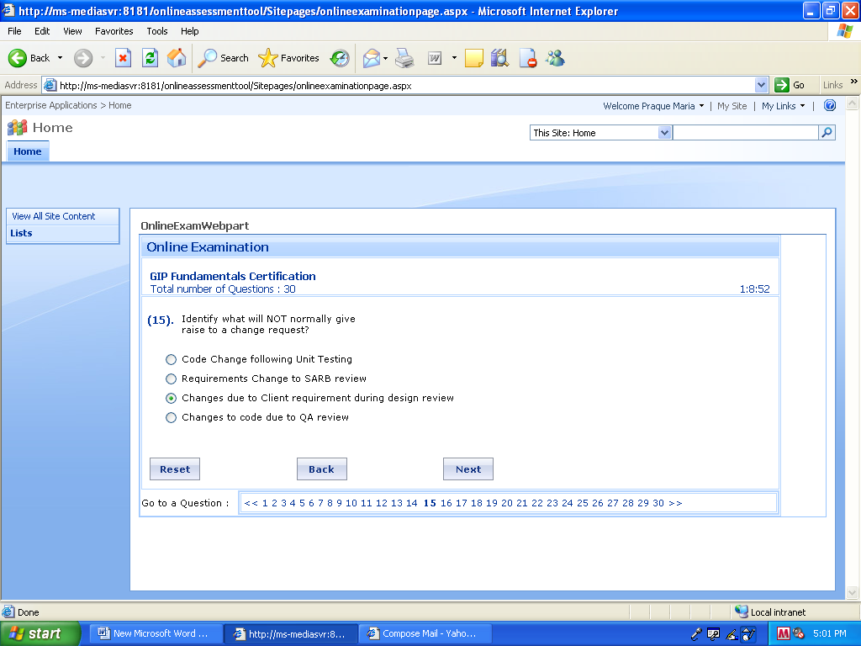

b)

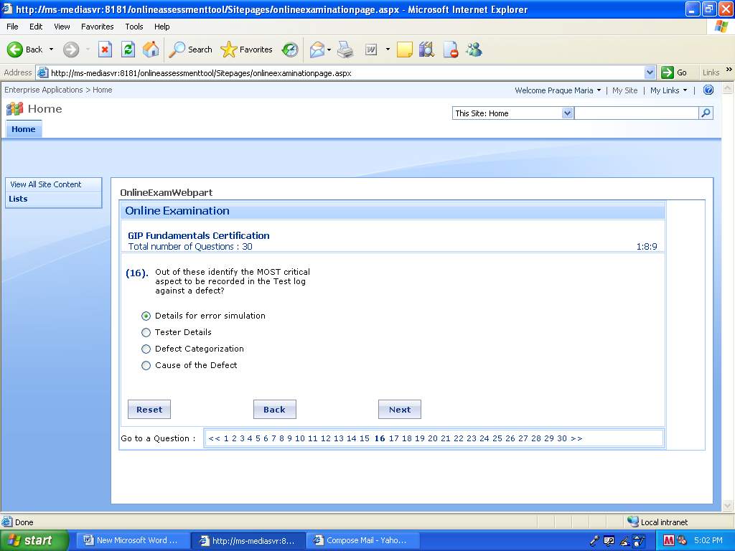

a) (not sure)

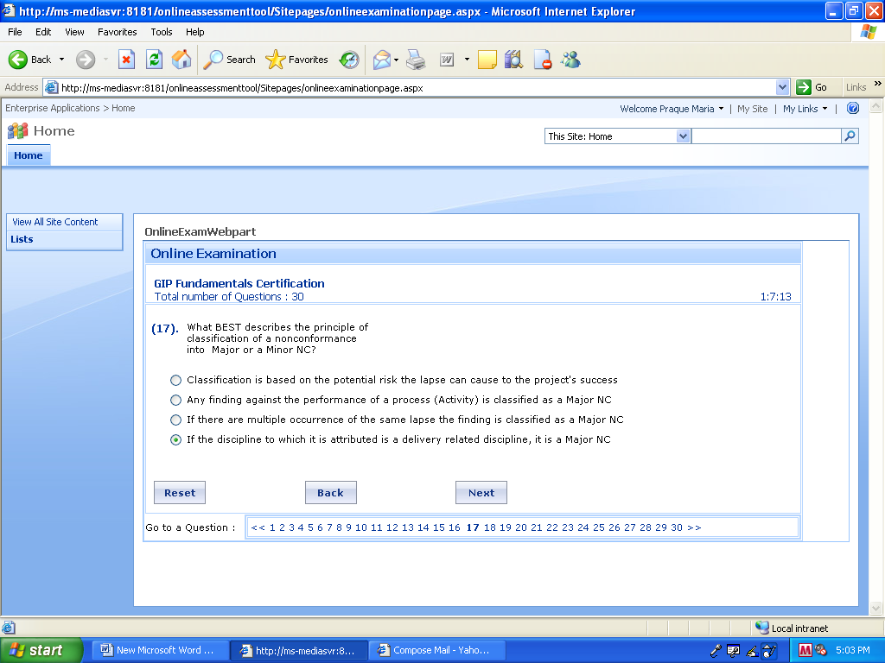

a)

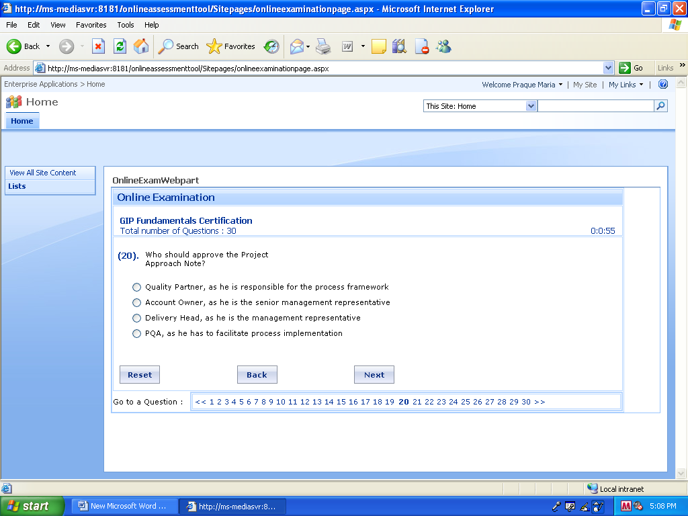

b)

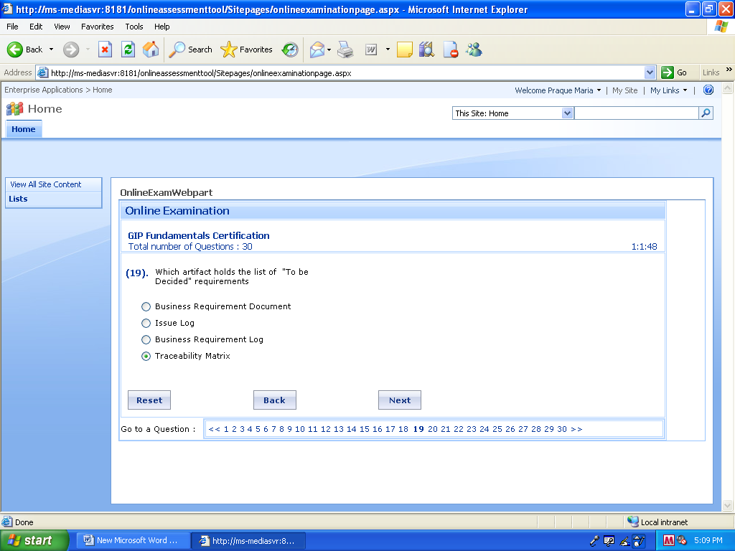

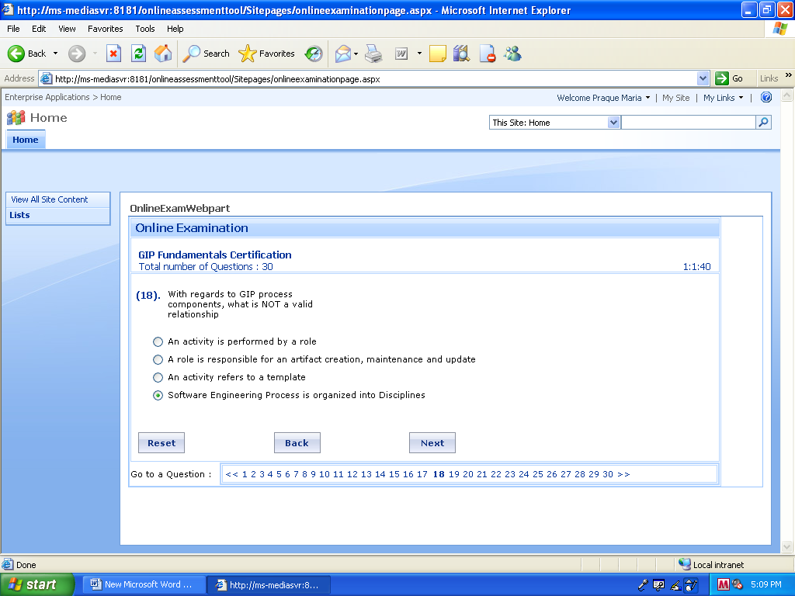

c) (not sure)

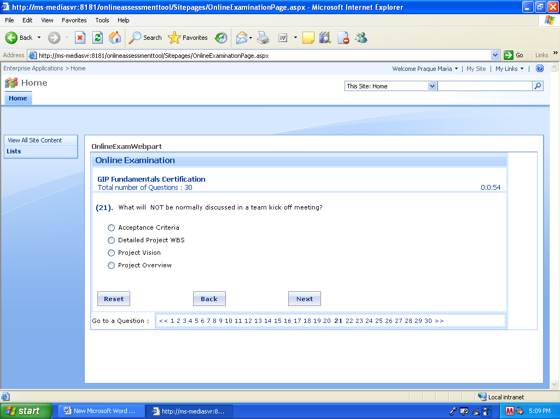

3. Which is not an input for the Inception Phase?

Skill gap Analysis Report

4. When will the Inception Review Occur?

10 day after the Project start.

5. What is the Living Artifact?

DSRS.

6. If a PM is going to review the code, which part of the code the PM choose to review.

1. The code which is considered to be critical without review.
2. The code from any category.
3. The code from each Module.

8. Which is the following is True.

1. PTR is approved by Delivery manager.
2. PTR can be changed throughout the project.

8. Who is authorized to raise the Change Request for the Project?

Anyone in the Team.

9. Which is true related to the Metrics Council?

1. Metric council lead is a dedicated person.

10. If a person is going to develop a Online assessment and he is going to use the Encryption tool. What he should do next?

He should get the approval of the tool from the PM.

11. Which is not true with respect to Program management?

* To provide and manage support to meet delivery
* To identify, plan and facilitate to provide necessary training to project teams
* To manage resource utilization of Projects
* Conflict resolution within Project team members.

12. Acceptence test plan run by client.

13. If the test is be happen in the client system which of the following is not necessary

1. Good Infrastructure.

2. Agreed Test Environment configuration.

3. **Automated Defect tracking mechanism.**

4. Supporting software’s available.

14. Configuration Manual does not contain which of the following.

1. FAQ

2. Contact Details

3. Troubleshooting details

4 **User side operator details**

15. **Getting so many change requests. What could have done best to avoid this?**

.Could have done proper design review

**.Could have used SARB comments as input**

16 **Least imp input to process initiation improvement initiative**

.QA Testing report

**.Team Score card**

.Internal Audit report

.Project risk list

20- **Decision to build/buy, as per what criteria**?

.Related to Cost

**.Timelines for requirement**

22. **Change requests NOT dependant on –**

.QA testing report

. Client requests

**. Code review**

21. **Code Refactoring can be done to –**

.Readability

Simplification

Error removal/handling

**All above**

22. Which is considered to be least important criteria in code review?

1. **Coding effort**

2. Simplicity

.Verifiable/Complete

24. What is the relation between the Quality partner and PTR?

**Quality partner will review the PTR**

25 Person found the four defects during Unit testing, after fixing it what will be her next step?

1. Retest by peer.
2. she will do her own one round of developer testing(She will retest all the four defects to ensure the defect closure)

log the defect log and close the defect

26. The Highest level of the Configuration Item--- Baseline Configuration

27. **Defect to Review ratio – indicates?**

Efficiency of the testing team

28. If u want to integrate a system where do u find the CI?

1. Provided the PM,
2. Got from the Previous Audit.
3. Fetched from Project configuration repository

29. Which is true for the Physical configuration audit?

It will be frozen in the Inception phase.

Mandatory for all the Projects.

30. Where can we find the Coding standards?

Project Engineering Guidelines.

32. Which is not true related to Defect Density?

Greater the defect Density, more rework.

Have impact on the Productivity team size

Greater the Defect density, larger is the size of the system.

1. **Primary source of CI** 
   * Prev Audit results///not answer
   * Raised by Team
   * **Configuration Repositary**
2. **PTR is applicant for  - (Different Question)**
   * all through the project

**What is not an activity of process mgmt(Different Question)**

**-** Monitor and control SPI

                 - Manage performance model

                 - Deploy Process

1. **Where to find Db naming conventions(Different Question)**

**-** DSTD

                       - Project Approach doc

- Project Engineering Guidelines

1. **n QA Testing  when QA will mark ' Remark' in the QA test Log**

.when the defect is Not reproducible, by developer

.when the defect is Duplicate

.When developer fixes the defect

1. **What is the primary intent of account delivery review?** **(Different Question)**

.To review projects, which have effort or schedule variances >20

.To provide platform for knowledge sharing within acct.

.To review and manage support to meet delivery

.To ensure senior management attention for high risk items

1. **What is NOT true about PTR?** 
   * **it is frozen after inception phase and used as a guideline in the project**
2. **Relationship to Program mgmt- Project mgmt**

- **Program mgmt oversees project management**

1. **Attribute to check the knowledge mgmt activities-** 
   * Extent to artifacts and
   * Client satisfaction
   * **Effort variation**
2. **He is a technical architect for one configuration management system. The CI state is most important in the system- which to use to detail the system design.**
   * DFD
   * **State chart**
   * Usecase
   * ER diagram
3. **‘Integration in ‘Integrating system ‘ is primarily dependant on which discipline**
   * **Implementation**
   * Analysis & Design

8) **Success of acceptance Test is because**

* + **Baselined Acceptance plan**
  + Strong Deplyment manager
  + Well trained user team

**11) What is not considered as Innovation?**

- Initiative with Organizational Impact

-New methodologies found....

-**Initiative with high cost and implementation**

1. **DAR should be used in which phase**(not sure abt the ans)

.Elaboration

.Contrunction,

**Throughout the project**

2. **DAR - helps for –(**not sure abt ans )

.Compliance to CMM I

.Cost Analysis

3. **Project Initiation note – when, who**

.**After kick-off by client , by Senior management**

.Client sends

.PM sends

5- **As part of audit, one PM gets one NC, saying some review documents missing.**

**He does the follow-up and gets the documents. This caution can be best categorized as**

.Prevention.

.Closure

**.Correction**

6. **During unit testing, one dev finds 4 errors. She fixes it. What is the best next step?**

.One round of developer testing

**. Unit Test and verify, all the 4 errors are closed.**

.Log in Test Log and close

13. **After Audit, issues found should be closed by**

.PM

Internal Auditor and PM

**AQP**

16. **Project goals, depends on**

.Service agreements

**.Project approach**

17- **When to do Project /phase closure**

.As per PM’s decision

.**End of each phase**

.On Baselining the phase

.After 2 weeks of phase completion

Qns :

1. Least intent of config mgmt.
2. Least intent of project mgmt.
3. When should inception review take place
4. DAR – benefit
5. A new lead, where will he find the reference for execution plan.
6. Which is the best plan for requirements gathering from a client of foreign language?
7. Developer found 4 new bugs. Fixed it. What should be done next?
8. Least required doc for deployment.
9. Which gives primary integrity for integration?
10. Which is not discussed in account delivery team meeting?
    1. Team morale
    2. Config mgmt.
11. Which is primary source for project goals to fill in QI sheet?
12. Which is the best time to make the deployment plan?
13. Where do you find the naming convention for db tables?
14. PTR
15. What is living artifact?
16. Which is not a part of project initiation?
17. What does defect to review ration indicate?
18. How can large no. of changes be avoided in a project?

Qns

1) Innovation

Initiative with Org Impact

New process found....

**Initiative with high cost and implementation**

Initiative with gain

3) Acceptance test is done best when

good documentation

Project reports are prepared

**Baselined acceptance plan**

4) Physical Configuration Audit

9) More detailed design. So many change reqts coming what’s the reason? **What could have done best to avoid this?)**

.**Could have used SARB comments as input**

Reqmts should be reviewed by tech arch

Non-functional reqmts should be addressed

10) Who will differentiate the NC major and minor after audit

PQA

PM and above

**PM, Account Quality partner, Auditor collectively**

Internal Audit

11) Config Management plan has all available for BUT

12) Config Mgmt Plan should be made available when

**By beginning of elaboration**

inception

during elaboration

15) Account Review meeting include

**project status**

client score card

16) Project status review include

**Project completion**

Variation of effort and schedule

Client satisfaction

18) Where a person can find the process framework for his project(not sure abt ans)

GIP PTR

PTR of similar projects

Project Engineering Guidelines

1. Which of the following situations does the GIP recommend but does NOT mandate the usage of Decision Analysis process?

**A. Deciding the distribution and team composition of the project**

B. Evaluation of Vendors

C. Arriving at critical design decisions involving High Level Design and Architecture

D. Procurement of Tools

2. Based on the above chart indicating the Quality Effort Index (QEI) for a development project currently in testing phase, which of the following is the most appropriate inference?

A. The chart indicates that project is in code RED since the Quality Effort Index is around the 100 % mark.

**B. The chart indicates that the last few weeks the only activity performed was testing which is shown as high Quality Effort Index.**

C. The chart indicates incorrect data entered in the time sheets since Quality Effort Index can never be as high as 100%.

D. The chart indicates that the project planning was done incorrectly.

3. A Project Team is in the implementation phase of the project. They find an Open Source component on the net which exactly matches the project requirements. What should they do?

**A. Seek client’s approval If the contract allows usage of open source components, document the same in the IP Usage Register before using it**

B. Since it is open source and the IP usage is not restricted by the component owner, go ahead use it in the code

C. Seek Client’s approval and upon getting the approval, use the component

D. **Seek the approval from the PM and use it accordingly**

4. Which of the following approaches is/are recommended for use when estimating for high risk projects?(Don’t know)

A. use a "rolling wave" or "moving window" approach – initially estimate in detail for what is known and elaborate the rest as the work progresses

B. Provide an estimate with a high amount of buffer

C. Do an initial assessment followed by a pilot project or a POC take the result as the basis for detailed estimation of the rest of the project

D. Make assumptions and provide a ballpark effort estimate

5. Identify the INCORRECT statement from the below as per GIP

**A. ROUTE MAP is an artifact that contains the information on what updates are planned to be brought in to GIP**

B. DISCIPLINE is a collection of activities that are related to a major 'area of concern' within the overall project

C. WORKFLOW is a sequence of activities that produces a result of observable value

D. ACTIVITY is something that is performed by a ROLE and results in one or more ARTIFACTS in part or in full

6. Which of the following does the Environment discipline of GIP NOT deal with?(Not sure)

A. Defining the life cycle for the project

B. Developing bridge documents for the client supplied templates

**C. Setting up the development environment for the project**

D. Documenting the Project Engineering Guidelines

7. Which of the following is NOT TRUE about performing Project Closure Activities?

A. Should gather information on what worked well and what did not

B. The customer should acknowledge that all deliverables been completed according to the contract

C. Prepare Project Case Study

**D. Need not be conducted for the projects that are terminated mid way through the execution**

8. While performing the decision analysis, is it necessary to identify the evaluation criteria before identifying the alternatives? What is the reason?

A. No, there is no need for a specific order as such

**B. Yes because otherwise the criteria may be so developed as to favor your preferred solution which may lead to lack of objectivity**

C. No, actually the alternatives should be identified before developing the evaluation criteria because it then gives a better understanding of the criteria to look for

D. Yes because only then will you understand what your problem statement is and hence it enables identification of alternatives

9. Which of the following is the highest level of control exercised on the Configuration Items (CIs) in a project?

A. Managed and Controlled

**B. Baseline Controlled**

C. Configuration Controlled

D. All are of equal level of control, but classified differently for convenience

10. As per Virtusa Document Classification Policy, which of the following is the correct arrangement of increasing order of confidentiality?

A. Unclassified, Internal Use Only, Virtusa Confidential, Virtusa Confidential Restricted and Client Confidential

B. Unclassified, Internal Use Only, Virtusa Confidential Restricted, Virtusa Confidential and Client Confidential

**C. Unclassified, Internal Use Only, Client Confidential, Virtusa Confidential and Virtusa Confidential Restricted**

D. Unclassified, Client Confidential, Internal Use Only, Virtusa Confidential and Virtusa Confidential Restricted

11. As per GIP, what do you mean by “Collegial Review”?

A. A group of reviewers provide comments on the work products, whose implementation is subject to agreement of the author with the reviewers' views

**B. A review by a peer of the Author of a product for the purpose of identifying defects and improvements**

C. A review in which the author walks the reviewers through the artifact and the reviewers ask questions and make suggestions for the improvement of the work product

D. A rigorous review technique in which an artifact is examined in complete detail

12. During the Client Kickoff Meeting, the Client stated that according to the regulations in connection with their business domain, it is mandatory to use the templates defined by their organization only. Because of this clause, Virtusa is required to use client specified templates though GIP has the templates defined for this purpose. What should the Project Team do in this situation?

A. Refuse to use client specified templates because GIP mandates the use of GIP defined templates

B. Go ahead and use the client specified templates as it is mandated by client

C. Mention the use of client templates in the PTR and get a signoff from AQP and Account Owner and then use the client specified templates

**D. In addition to Option C above, the PM should perform**

**i. gap analysis between the GIP and client specified templates,**

**ii. Assess the impact of gaps if any and**

**iii. Create bridge documents to supplement the information / sections missing in the client templates, as may be needed**

13. Answer and Rationale for the question posted on 13 August 2008:

Answer is **D. Regular status reporting on project progress.**

**GIP Questions with Answers:**

(1). Preparation of Configuration Management Plan is the responsibility of:

1. All the options
2. Project Manager
3. Configuration Auditor
4. Configuration Manager

(2). While performing code review, the OUTPUT(S) can be

1. Defect Log
2. Change Request
3. Change Request and Defect Log
4. None of the options

(3). Identify what is NOT a prerequisite for the "Integrate System" activity

1. Integration Build Plan
2. Completion of unit testing for the sub components
3. Component availability in configuration management system
4. Approved Deployment Plan

(4). A website is developed and delivered to a retail client. The customer comes back informing that the website is as per the functional requirements agreed upon but the website crashes when more than 500 users login at the same time. This issue could have been prevented if:

1. There is no issue as the client did not specify this requirement
2. Product was tested exhaustively
3. Requirements development was detailed with complete information on non functional requirements (NFRs)
4. Allocated requirements adhered to the design

(5). What is NOT a required input for designing of User Interface?

1. Project Engineering Guidelines
2. Business Requirement Specification
3. UI requirement specification
4. Detailed Software Requirement Specification

(6). what is of LEAST priority while designing QATP test cases

1. Requirement Validation
2. Boundary Value Analysis
3. UI validation
4. Performance Analysis

(9). The effort estimate is derived by

1. Applying productivity value to the size estimates of the project
2. Applying effort to Size estimates of the project
3. Using the formula – Total resource*Hours of planned work+ (Buffer)
4. Using any of the above choices

(10). The Process Tailoring Record, an artifact of the Environment Discipline is optional for which type of Project

a) Small Enhancement Project

b) Maintenance Project

c) Development Projects

d) SQA Projects

* Only A
* A, B and D
* All client project require PTR
* B and C

(11). Who is responsible for verifying closure of all the configuration audit findings and action points?

1. Project Manager
2. All the options
3. Configuration Auditor
4. Configuration Manager

(13). A PM is regularly tracking the work performed through planned reviews as stated in the Project Approach Document. The PM also ensures regular customer reporting on the work performed. Which activity is the PM performing?

1. Initiate Project
2. Execute project
3. Monitor Project Status
4. Project Closure

(14). your project receives requirements from the client. As a part of understanding of those requirements you or the project team seek clarifications for doubts/queries on the requirements. Which of the following is applicable?

1. Develop Q&A document
2. Develop BRS (Business Requirement Specification)
3. Develop DSRS (Detail Software Requirement Specification)
4. Tailor out BRS and DSRS from PTR

(15). Tailoring of GIP to project needs is the ownership of

1. Project Manager
2. Account Manager
3. Project Manager and Project Quality Partner
4. Project Quality Partner

(17). Risk tracking during project execution is done using:

1. All of the options
2. Risk database
3. Project risk list
4. Risk Management Plan

(19). Select the valid statement regarding the Project Initiation Note:

1. It is issued by the Client on approval of Project Approach Note
2. It is issued by the Account Owner after the client kick off meeting
3. It issued by the Marketing team communicating sign off on the contract
4. It is issued by the Senior Management intimating of Project Start

(20). The QA testing report indicates certain critical errors which have been agreed to by the Project Team as requiring closure. What is the FIRST step to be undertaken now?

1. Client should be updated on impact if any on schedule
2. The report and its finding should be discussed in the ATC review
3. Change Request should be raised for the agreed defects
4. Client must be updated of these critical issues

(22). what is the purpose of Refactoring the code

1. Add Flexibility
2. Simplify the Code
3. All the options
4. Improve Communication

(24). “Defect to Remark Ratio" metric is a DIRECT indicator of

1. Efficiency of the QA Test Team
2. Effectiveness of defect fixing by the development team
3. Efficiency of the requirements review
4. Capability of the designer / architect

(25). which of the following is NOT a data integrity check?

1. Verifying that the tasks have correct standard codes
2. Verifying if corresponding rework effort is entered for defects captured
3. Verifying that defects are categorized correctly
4. Verifying that the current weeks value is within the specification limit

(26). which of the following are FALSE?

1. Specification limits are set by the organization
2. Specification limits can be changed based on appropriate approvals
3. Control limits are set by the project
4. Changing control limits require approvals

(27). what is the source of CI for configuration audits

1. As contained in the project configuration repository
2. As submitted by the team members
3. Source used in prior internal audit
4. As indicated by the Project Manager

(28). A project manager is reviewing risks and issues in a project in one of the status reviews. Which activity is he performing and in which project management phase

1. Manage communication, Plan the Project
2. Manage Risks and Issues, Execute the Project
3. Manage risks, Initiate project
4. Manage Risks and Issues, Project Monitoring and control

(29). Sumathy is testing her unit. She is using her peer reviewed Developer Test Plan to check her program. She finds that a critical test mentioned in her test case is not being met by her unit. She fears this will involve a lot of rework and hence a delay in delivery. What Sumathy should FIRST do

1. Sumathy should understand the impact of this test defect
2. Sumathy should continue to complete the testing
3. Sumathy should proceed with the defect closure
4. Sumathy should raise a change request

(30). The final product to be validated is identified and recorded in

1. PTW
2. QATC
3. QATP
4. PAD

(31). Identify what is NOT a direct intent of Change Management Process

1. Prevent implementation of unauthorized changes
2. Consistent implementation of approved change
3. Control of effort variance
4. Ascertaining impact of change

(32). A configuration management plan will provide for all information BUT

1. Change Management policies and directives
2. CCB authorities
3. Configuration audit schedule
4. Details of change requests

(33). While performing the Detailed Design of a system, significant number of requirement related changes arise. What could have BEST avoided this situation

1. Non-functional requirements should have been captured better
2. System Analysis should have considered preliminary design implication
3. SARB review should have been done on requirements
4. Requirements should have been reviewed by the technical architect

(36). When is the developer test case BEST written?

1. On completion of detailed design
2. Before unit testing
3. Before Coding of the Unit
4. As planned in the project schedule

(37). which of the following are FALSE?

1. Specification limits can be changed based on appropriate approvals
2. Changing control limits require approvals
3. Specification limits are set by the organization
4. Control limits are set by the project

(38). Identify what is NOT an activity of the Process Management Discipline

1. Monitor Project Audit Results
2. Deploy Process
3. Establish Process Performance Model
4. Monitor and Control SPI

(44). which of the following is NOT a data integrity check?

1. Verifying that defects are categorized correctly
2. Verifying that the tasks have correct standard codes
3. Verifying that the current weeks value is within the specification limit
4. Verifying if corresponding rework effort is entered for defects captured

(45). what is NOT normally contained in an installation guide?

1. FAQ
2. User Side Operator Details
3. Contact id for queries
4. Troubleshooting information

(47). “Defect to Remark Ratio" metric is a DIRECT indicator of

1. Effectiveness of defect fixing by the development team
2. Efficiency of the requirements review
3. Capability of the designer / architect
4. Efficiency of the QA Test Team

(48). what is verification and validation?

1. “Build the product right” and “Build the right product”
2. Verification is “Reviews” and Validation is “Testing”
3. Both are reviews/testing but Validation is internal and verification is external
4. “Build the right product” and “Build the product right”

(50). The Team kickoff Meeting:

1. Can be tailored if Client Kickoff is conducted
2. Is not mandatory for testing projects
3. Is not mandatory for development projects
4. Is mandatory for all projects

(52). A project has just developed a Requirement review log along with a Business requirement document. Which activity has been performed?

1. Manage requirements
2. Gather and analyze business requirements
3. None of the options
4. Perform system analysis

(56). A project manager is identifying the criteria to select solutions during design with respect to Technologies, COTS products, Reusable components and/or Design approaches etc. The project manager is

1. Selecting alternative solutions
2. Establishing design interfaces
3. Performing Decision Analysis
4. Developing a design
5. What is NOT a prerequisite for initiating test at client site?

Automated Defect tracking mechanism

1. What is TRUE about tailoring a PTR?

PTR can be modified during the course of the project

1. What is the PRIMARY intent of an account delivery review?

To review and provide management support to meet delivery

1. Risk Mitigation must be performed for:

High Risks

1. The QATP needs to be approved by

Project Manager and Test Analyst

1. What is NOT a key criteria for evaluating adequacy of a requirement statement

Secure

1. What is of LEAST importance as an input to process improvement initiatives

Team Score Card

1. At the end of an audit, who is responsible for classification of the findings as Major NC / Minor NC and AFI

The Auditors as per guidelines provided in the GIP

1. For projects with large code base, what is the recommended sampling % for work product audit

5-10%

1. As per GIP, inception review is to take place

By the 10th working day of the project start

1. Due to time constraint the team  has only limited time to close comments arising out of the work product audit. What should be the BEST consideration to identify the subset of comments for closure?

All comments whose impact on non-implementation is high needs to be closed

1. Identify who is responsible for the activity "Facilitate Process Institutionalization

Account Quality Partner

1. Suyash is the Project Manager. A minor NC is recorded in the project audit regarding absence of certain review report documentation. Suyash contacts the reviewer and gets the documents prepared. What is this response best categorized as

Correction

1. Which document contains the naming conventions for the database tables to be used in the project?

Project Engineering Guideline

1. What is NOT a required input for designing of User Interface?

UI requirement specification

1. Shyam is the technical architect for developing a configuration management system. The system will store identified CI and track their lifecycle. System features are heavily dependent on the state of the CI at any point in time. What would BEST help Shyam in detailing the system design

State Chart Diagram

1. Shyam is a technical architect at Virtusa. He has been given some documents by his project manager as input documents to design. Which document should he refer for restriction if any on design and technical aspect?

Project Engineering Guideline

1. Shyam is the technical architect at Virtusa for an online assessment system. For encryption of the questionnaire, he decides to opt for a tool developed by the popular vendor AES. What is the MOST important activity that shyam is to do next?

He should obtain approval to use the tool from the Project Manager

1. What is the PRIMARY consideration while deciding on the build or buy option

Cost Benefit Analysis

1. While performing the Detailed Design of a system, significant number of requirement related changes arise. What could have BEST avoided this situation

System Analysis should have considered preliminary design implication

1. Identify who is authorized to raise a change request in a project?

Any Project Staff

1. Identify the CORRECT statement with respect to Physical Configuration Audits

Mandatory for all projects.

1. What is the source of CI for configuration audits

As contained in the project configuration repository

1. A configuration management plan will provide for all information BUT

Details of change requests

1. Sumathy is performing a configuration audit for a project. From where can she find information regarding individuals authorized for change approval

Configuration Management Plan

1. Identify the activity that will NOT lead to a change request

None of the Options

1. Identify what is NOT a direct intent of Change Management Process

Control of effort variance

1. Deployment Plan is BEST prepared in

Early Construction Phase

1. What is the BEST method for preparation of User Manual

Prepared by the technical writer with inputs from the team

1. Success of the acceptance test is PRIMARILY dependent on

Baselined Acceptance Plan

1. What is NOT normally contained in an installation guide?

User Side Operator Details

1. Client Release Note is mandated for which Client releases?

For all Client releases

1. Decision Analysis and Resolution is a MUST HAVE activity in which phase

Elaboration

1. The Process Tailoring Record, an artifact of the Environment Discipline is optional for which type of Project

a) Small Enhancement Project  
b) Maintenance Project  
c) Development Projects  
d) SQA Projects

All client project require PTR

1. Identify the statement that is NOT correct with respect to PTR

PTR is frozen at inception phase and used subsequently as guiding principle

1. Sumathi is the Quality Partner for a Project. What is Sumathi's role in developing the PTR for the project

Review PTR

1. Suyash is new to Virtusa. He has to choose the process framework for execution of his project. What would help him in arriving at the MOST appropriate framework for his project

PTR of similar projects

1. Sumathy is testing her unit. She is using her peer reviewed Developer Test Plan to check her program. She finds that a critical test mentioned in her test case is not being met by her unit. She fears this will involve a lot of rework and hence a delay in delivery. What Sumathy should FIRST do

Sumathy should understand the impact of this test defect

1. Sumathy is testing her unit. She has detected four errors in the first round of testing. She has completed the defect fixing. What should be the appropriate action to be taken now

Sumathy should subject her unit to another round of developer testing

1. What is the purpose of Refactoring the code

All the options

1. Identify what is NOT a prerequisite for the "Integrate System" activity

Approved Deployment Plan

1. Identify the discipline on which the integrity of the "Integrate System" is PRIMARILY dependent on

Configuration Management

1. When is the developer test case BEST written?

Before Coding of the Unit

1. Suyash is peer reviewing a Developer Test Plan for a user profile maintenance screen. What would be of LEAST concern to Suyash

Business Continuity Requirement

1. Sumathy is performing a Code Review of Surjit's work. What would be of LEAST consideration

Coding Effort

1. All these are valid expectation from an implementation model EXCEPT:

Number of implementation layers is less than ten

1. Suyash is the Project Manager. His project contains a large code base. He is selecting the codes that would be subjected to code review. Which is the BEST method for selecting the candidate codes?

Codes which pose a significant risk on not getting reviewed

1. What is normally NOT discussed in an Account Delivery Review

Project Account Receivable status

1. What is NOT an input for an Account Delivery Review

Change Request Log

1. Who is responsible for conducting Contract Compliance review

Account Owner

1. What is NOT the intent of the Program Management discipline

Conflict resolution within project team members

1. What is the applicability of the program management discipline

All

1. What can BEST describe the relationship of Program Management discipline to Project Management?

Program Management Oversees Project Management

1. What is the GIP recommended time frame for conducting phase/project closure for the project

Within 2 weeks of completion of the phase or project

1. In a typical acceptance plan, with whom should Execution of acceptance test reside?

Client

1. A task has an optimistic value of 12 days, pessimistic value of 20 days. What would be its most likely estimate?

Unknown

1. Select the valid statement regarding the Project Initiation Note:

It is issued by the Senior Management intimating of Project Start

1. Identify the artifact that is NOT an input for project initiation

Skill Gap Analysis Report

1. Identify what is NOT tracked normally as a part of Project Status Reviews

Team Score Card

1. Identify the statement that is NOT true with respect to GIP recommendation for RCA

For Maintenance Project RCA is not required

1. Identify the attribute that is measured to evaluate the Knowledge Management process within a project

Extent of reusable artifacts and methods

1. Where can one find the information with regards to Testing Standards and Defect Management guidelines?

Project Engineering Guidelines

1. All of the following about Defect Density is true EXCEPT

Could have an impact on the size of the system, the higher the defect density, the greater the size

1. Which among the list below is the PRIMARY source of the project goals in the QI Sheet?

Process Performance Baseline (PPB)

According to GIP, there are __4_____ number of severity levels assigned to defects.

1. According to GIP, "Remark" is a status assigned to the QA Test Defect when

The defect is raised by the QA Test team

1. What does the term "Living"  indicate when it is associated with an Artifact?

Artifact that is going to be updated throughout the project lifecycle

1. Identify the PRIMARY benefit of a DAR process

Provides a framework for option analysis and removes bias

1. What is NOT a key criteria for evaluating adequacy of a requirement statement

Secure

1. Sudha is to lead a project for a client in Japan. Language constraint is identified as a key challenge in the requirement gathering phase. What is the MOST effective method to be adopted

Usage of "Use Case Diagramming Method"

1. What is NOT true with respect to Metrics Council

Metrics Council lead is a dedicated person

1. Identify what is NOT an activity of the Process Management Discipline

Monitor Project Audit Results

1. Identify what will NOT be considered as innovation

New practices brought in to comply with a new model or standard to cater to the business

1. "Defect to Remark Ratio" metric is a DIRECT indicator of

Efficiency of the QA Test Team

Q). Shyam is a technical architect at Virtusa. He has been given some documents by his project manager as input documents to design. Which document should he refer for restriction if any on design and technical aspect?

1. Detailed Software Technical design document
2. **Architecture Document**
3. Detailed Software Requirement Specification
4. Project Engineering Guideline

Q). Identify what is NOT a direct intent of Change Management Process ---1

1. Prevent implementation of unauthorized changes
2. Consistent implementation of approved change
3. **Control of effort variance**
4. Ascertaining impact of change

Q). While performing the Detailed Design of a system, significant number of requirement related changes arise. What could have BEST avoided this situation ---2

1. Non-functional requirements should have been captured better
2. System Analysis should have considered preliminary design implication
3. SARB review should have been done on requirements
4. **Requirements should have been reviewed by the technical architect**

^^^^^^^^^^^^^^^^^^^^^^^^^^^^^^^^^^^^^^^^^^^^^^^^^^^^^^^^^^^^

Q). Sumathy is testing her unit. She has detected four errors in the first round of testing. She has completed the defect fixing. What should be the appropriate action to be taken now ---3

1. **Sumathy should subject her unit to another round of developer testing**
2. Sumathy should request a peer to perform defect closure testing
3. Sumathy should test the four test cases to ensure defects are closed
4. Sumathy should update the test log for tracking of defect closure

Q) All these are valid expectation from an implementation model EXCEPT:

**Number of implementation layers is less than ten**

Unnecessary dependencies on lower-layer subsystems have been eliminated

The amount of source code is consistent with the expectation based on the number

of design classes

The workload for the Implementation Team is balanced

Q) Sumathy is testing her unit. She is using her peer reviewed Developer Test Plan to check her program. She finds that a critical test mentioned in her test case is not being met by her unit. She fears this will involve a lot of rework and hence a delay in delivery. What Sumathy should FIRST do -----4

**Sumathy should understand the impact of this test defect**

Sumathy should proceed with the defect closure

Sumathy should continue to complete the testing

Sumathy should raise a change request

Q) What is the PRIMARY consideration while deciding on the build or buy option ---5

Availability of open source utilities

Time available to cater to the requirement

Competency within organization

**Cost Benefit Analysis**

Q) Identify what will NOT be considered as innovation ---6

**New practices brought in to comply with a new model or standard to cater to the   
 business**

**Initiatives with High cost of definition and implementation**

Initiatives with Organizational Impact

Initiatives involved with significant gains

Q) Success of the acceptance test is PRIMARILY dependent on ---7

Good Supporting documentation

Well trained user community

**Baselined Acceptance Plan**

Strong deployment Manager

Q) Suyash is the Project Manager. A minor NC is recorded in the project audit regarding absence of certain review report documentation. Suyash contacts the reviewer and gets the documents prepared. What is this response best categorized as ----8

a) Preventive Action b) Improvement c) **Correction** **d) Closure**

PM recognizes there is a training required for the resources…..

What could have done to avoid client dissatisfaction?

**Training to employees before dev phase**

Skill assessment approach during dev phase(During Inception Phase)

^^^^^^^^^^^^^^^^^^^^^^^^^^^^^^^^^^^^^^^^^^^^^^^^^^^^^^^^^^^^

#####In Account Delivery meeting, which one of the following is not discussed -----9

Cdi , change request log

a) **Client satisfaction** b) Acct review status c) Team Score Card d)Project Risks (I gave this option)

^^^^^^^^^^^^^^^^^^^^^^^^^^^^^^^^^^^^^^^^^^^^^^^^^^^^^^^^^^^^

#####Q) What is NOT a key criteria for evaluating adequacy of a requirement statement -----10

a) Simple b) Accurate c) Complete d) **Secure**

Q) Identify the attribute that is measured to evaluate the Knowledge Management process within a project -----14

**a**) **Extent of reusable artifacts and methods**

b) Schedule Variation c) Effort Variation d) Client Satisfaction

Q) Sudha is to lead a project for a client in Japan. Language constraint is identified as a key challenge in the requirement gathering phase. What is the MOST effective method to be adopted?

Recruit a local business analyst

Japanese Language training for her key team members

**Usage of "Use Case Diagramming Method"**

Configure extra time for gathering requirements

^^^^^^^^^^^^^^^^^^^^^^^^^^^^^^^^^^^^^^^^^^^^^^^^^^^^^^^^^^^^

#####Q) Where can one find the information with regards to Testing Standards and Defect Management guidelines?

a) Project Initiation Document

**b)** Quality Assurance Plan

**c) Project Engineering Guidelines** d) Business Requirement Specification

Q) What can BEST describe the relationship of Program Management discipline to Project Management?

Program Management is Project Management on larger scope

Program Management is Project Management when applied to large projects

Program Management Supports Project Management

**Program Management Oversees Project Management**

Program Management oversees the Project Management discipline and interactions with other disciplines within GIP occur while performing activities associated with Program Management

Q) As per GIP, inception review is to take place

**By the 10th working day of the project start**

There is no fixed time frame for inception review

Along with occurrence of the first milestone

Along with the internal kick off meeting

Q) A task has an optimistic value of 12 days, pessimistic value of 20 days. What would be its most likely estimate?

a) 13 b) 18 c) **15** d) Unknown

Q) When should a Configuration Management Plan be available for the project team?

**Early of Elaboration Phase**

During the Construction Phase

During the Elaboration Phase

Before the construction phase

(1). Preparation of Configuration Management Plan is the responsibility of:

a) All the options **b)** Project Manager

c) Configuration Auditor d) **Configuration Manager**

(11). Who is responsible for verifying closure of all the configuration audit findings and action points?

a) Project Manager b) All the options

c) **Configuration Auditor** d) Configuration Manager

(2). While performing code review, the OUTPUT(S) can be

a) **Defect Log** b) Change Request

c) Change Request and Defect Log d) None of the options

(3). Identify what is NOT a prerequisite for the "Integrate System" activity -----15

1. Integration Build Plan
2. Completion of unit testing for the sub components
3. Component availability in configuration management system
4. **Approved Deployment Plan**

(4). A website is developed and delivered to a retail client. The customer comes back informing that the website is as per the functional requirements agreed upon but the website crashes when more than 500 users login at the same time. This issue could have been prevented if: ----16

1. There is no issue as the client did not specify this requirement
2. Product was tested exhaustively
3. **Requirements development was detailed with complete information on non functional requirements (NFRs)**
4. Allocated requirements adhered to the design

(5). What is NOT a required input for designing of User Interface?

1. Project Engineering Guidelines
2. Business Requirement Specification
3. **UI requirement specification**
4. Detailed Software Requirement Specification

(6). What is of LEAST priority while designing QATP test cases

a) Requirement Validation b) Boundary Value Analysis

c) UI validation d) **Performance Analysis**

(7). What is "Workload analysis" Used for ----17

1. **Arriving at the framework for performance testing**
2. Arriving at level 3 estimation
3. Arriving at leveling of work allocated to team members
4. Arriving at design of the system for handling transaction size

(8). Shyam is the technical architect for developing a configuration management system. The system will store identified CI and track their lifecycle. System features are heavily dependent on the state of the CI at any point in time. What would BEST help Shyam in detailing the system design

a) Use Case Modeling b) Entity Relationship diagrams

c**) State Chart Diagram** d) Data Flow Diagrams

(9). The effort estimate is derived by

1. **Applying productivity value to the size estimates of the project**
2. Using any of the above choices
3. Applying effort to Size estimates of the project
4. Using the formula – Total resource*Hours of planned work+ (Buffer)

(10). The Process Tailoring Record, an artifact of the Environment Discipline is optional for which type of Project-------18

a) Small Enhancement Project b) Maintenance Project c) Development Projects d) SQA Projects

1) **Only A** 2) A, B and D 3) All client project require PTR 4) B and C

^^^^^^^^^^^^^^^^^^^^^^^^^^^^^^^^^^^^^^^^^^^^^^^^^^^^^^^^^^^^

######(12). Sumathy is performing a Code Review of Surjit's work. What would be of LEAST consideration

a) Readability b) Error Handling routines c) **Coding Effort** d) Simplicity

^^^^^^^^^^^^^^^^^^^^^^^^^^^^^^^^^^^^^^^^^^^^^^^^^^^^^^^^^^^^

######(13). A PM is regularly tracking the work performed through planned reviews as stated in the Project Approach Document. The PM also ensures regular customer reporting on the work performed. Which activity is the PM performing?

a) Initiate Project b) Execute project c) **Monitor Project Status** d)Project Closure

^^^^^^^^^^^^^^^^^^^^^^^^^^^^^^^^^^^^^^^^^^^^^^^^^^^^^^^^^^^^##### (14). your project receives requirements from the client. As a part of understanding of those requirements you or the project team seek clarifications for doubts/queries on the requirements. Which of the following is applicable? ---19

1. **Develop Q&A document**
2. Develop BRS (Business Requirement Specification)
3. Develop DSRS (Detail Software Requirement Specification)
4. Tailor out BRS and DSRS from PTR

(15). Tailoring of GIP to project needs is the ownership of

a) **Project Manager b**)Account Manager

c) Project Manager and Project Quality Partner d)Project Quality Partner

Review and approval of PTR by Quality Partner and Senior Management

(16). Shyam is the technical architect at Virtusa for an online assessment system. For encryption of the questionnaire, he decides to opt for a tool developed by the popular vendor AES. What is the MOST important activity that shyam is to do next?

1. He should enter into an escrow arrangement with AES
2. He should ensure skills are available for integration of this tool in the project
3. He should obtain approval to use the tool from the Project Manager
4. **He should ensure AES incorporation does not have any legal liability**

(17). Risk tracking during project execution is done using:

1. All of the options b)Risk database c**)Project risk list** d)Risk Management Plan

(19**). Select the valid statement regarding the Project Initiation Note**:

1. It is issued by the Client on approval of Project Approach Note
2. It is issued by the Account Owner after the client kick off meeting
3. It issued by the Marketing team communicating sign off on the contract
4. **It is issued by the Senior Management intimating of Project Start**

(20). The QA testing report indicates certain critical errors which have been agreed to by the Project Team as requiring closure. What is the FIRST step to be undertaken now?

1. Client should be updated on impact if any on schedule
2. The report and its finding should be discussed in the ATC review
3. Change Request should be raised for the agreed defects
4. **Client must be updated of these critical issues**

(21). Test report is developed by:

a**) Test Lead** b) Test Lead and Test Engineer c)Test Engineer d) Design Architect

(22). what is the purpose of Refactoring the code

a) Add Flexibility b) Simplify the Code

c) **All the options** d) Improve Communication

|  |
| --- |
| **Refactor the Code [To top of page](http://dashboard/Process/GIP/GIP50/process/activity/ac_impldevelemnts.htm#Top)** |
| Restructure the code without changing its behavior to remove duplication, improve communication, simplify, or add flexibility. |

^^^^^^^^^^^^^^^^^^^^^^^^^^^^^^^^^^^^^^^^^^^^^^^^^^^^^^^^^^^

#####(23). Deployment Plan is BEST prepared in

a) **Early Elaboration Phase** b) After Construction Phase

c) Transition Phase d) Early Construction Phase .

|  |
| --- |
| Timing [top](http://dashboard/Process/GIP/GIP50/process/artifact/ar_deployplan.htm#top) |
| The Deployment Plan is started in the Elaboration phase and is refined in the Construction phase. |

^^^^^^^^^^^^^^^^^^^^^^^^^^^^^^^^^^^^^^^^^^^^^^^^^^^^^^^^^^^^

#####(24). “Defect to Remark Ratio" metric is a DIRECT indicator of

1. **Efficiency of the QA Test Team**
2. Effectiveness of defect fixing by the development team
3. Efficiency of the requirements review
4. Capability of the designer / architect

(25). Which of the following is NOT a data integrity check?

1. Verifying that the tasks have correct standard codes
2. Verifying if corresponding rework effort is entered for defects captured
3. Verifying that defects are categorized correctly
4. **Verifying that the current weeks value is within the specification limit -----------**

^^^^^^^^^^^^^^^^^^^^^^^^^^^^^^^^^^^^^^^^^^^^^^^^^^^^^^^^^^^

#####(26). which of the following are FALSE?

1. Specification limits are set by the organization
2. Specification limits can be changed based on appropriate approvals
3. Control limits are set by the project
4. **Changing control limits require approvals**

(27). What is the source of CI for configuration audits

1. **As contained in the project configuration repository**
2. As submitted by the team members
3. Source used in prior internal audit
4. As indicated by the Project Manager

(28). A project manager is reviewing risks and issues in a project in one of the status reviews. Which activity is he performing and in which project management phase

1. Manage communication, Plan the Project
2. Manage Risks and Issues, Execute the Project
3. Manage risks, Initiate project
4. **Manage Risks and Issues, Project Monitoring and control**

^^^^^^^^^^^^^^^^^^^^^^^^^^^^^^^^^^^^^^^^^^^^^^^^^^^^^^^^^^^^

#####(30). the final product to be validated is identified and recorded in

a) PTW b) QATC c) **QATP** d) PAD

^^^^^^^^^^^^^^^^^^^^^^^^^^^^^^^^^^^^^^^^^^^^^^^^^^^^^^^^^^^^

#####(29). A configuration management plan will provide for all information BUT ---20

a) Change Management policies and directives b**) Details of change requests**

c) CCB authorities d) Configuration audit schedule

(26). Identify the discipline on which the integrity of the "Integrate System" is PRIMARILY dependent on

a) Project Management b) Analysis and Design

c) **Implementation** d)Configuration Management

^^^^^^^^^^^^^^^^^^^^^^^^^^^^^^^^^^^^^^^^^^^^^^^^^^^^^^^^^^^^

##### 22 In a typical acceptance plan, with whom should Execution of acceptance test reside? a) Project Manager b)Business Quality partner c**) Client** d) Test Lead

^^^^^^^^^^^^^^^^^^^^^^^^^^^^^^^^^^^^^^^^^^^^^^^^^^^^^^^^^^^^

#####(19). Suyash is the Project Manager. His project contains a large code base. He is selecting the codes that would be subjected to code review. Which is the BEST method for selecting the candidate codes?

1. **Codes which pose a significant risk on not getting reviewed**
2. At least one code per module
3. At least one code per category (maintenance/report etc)
4. At least one code per developer

(16). What is NOT normally contained in an installation guide?

a) FAQ b**) User Side Operator Details**

c) Contact id for queries d) Troubleshooting information

(13). What is verification and validation?

1. **“Build the product right” and “Build the right product” - This is correct answer**
2. Verification is “Reviews” and Validation is “Testing”
3. Both are reviews/testing but Validation is internal and verification is external
4. “Build the right product” and “Build the product right” - But I answerd this one – This is wrong

(11). The Team kickoff Meeting:

1. Can be tailored if Client Kickoff is conducted
2. Is not mandatory for testing projects
3. Is not mandatory for development projects
4. **Is mandatory for all projects**

(9). A project has just developed a Requirement review log along with a Business requirement document. Which activity has been performed?

a) Manage requirements b**) Gather and analyze business requirements**

c) None of the options d) Perform system analysis

-------Review plan is placed **in PAD**, Chorus, Review log, none of the above

(7). Identify the statement that is NOT correct with respect to PTR

1. PTR is created in the early inception Phase
2. **PTR is frozen at inception phase and used subsequently as guiding principle**
3. PTR is owned by the Project Manager d) PTR is used for internal audit

(5). A project manager is identifying the criteria to select solutions during design with respect to Technologies, COTS products, Reusable components and/or Design approaches etc. The project manager is

a) **Selecting alternative solutions** b) Establishing design interfaces

**c) Performing Decision Analysis** d) Developing a design

#####(4). Which document contains the naming conventions for the database tables to be used in the project?

1. Detailed Software Technical Design Document
2. **Project Engineering Guideline**
3. Project Approach Document
4. Technology Standards at Virtusa

All the answers given below are not right. Please check the answers once.

What is the BEST method for preparation of User Manual

  Prepared by the Technical Lead in consultation with the project manager

  Prepared by End User with the help of the team

**Prepared by the technical writer with inputs from the team**

  Prepared by Project Sponsor with help of the Business Analyst

**Inception review by – account Quality partner**

^^^^^^^^^^^^^^^^^^^^^^^^^^^^^^^^^^^^^^^^^^^^^^^^^^^^^^^^^^^^

#####What is primary benefit of DAR (Design Analysis and Review) ?

Suyash is new to Virtusa, where he can get the change requests

**Change Request log**, Proj approach plan

####PM recognizes there is a training required for the resources…..

What could have done to avoid client dissatisfaction?

**Training to employees before dev phase**

Skill assessment approach during dev phase

###PM will get requirements and map it. What is the doc name?

**Scope and Traceability matrix**

BRS

(9).  Suyash is peer reviewing a Developer Test cases for a user profile maintenance screen. What would be of LEAST concern to Suyash?

a) Encryption Requirement   b) Traceability of test cases

c**)  Business Continuity Requirement**   d) Audit Trail requirement

process management – 2questions

Risk is not considered?

6. At the end of an audit, who is responsible for classification of the findings as Major NC / Minor NC and AFI

The PQA of the project along with the internal audit team

Project Manager, Account Owner and Auditors collectively

**The Auditors as per guidelines provided in the GIP**

The Auditors in consultation with Account Quality Partner

5 . Defect density is high then which is not true $

**Size of project grows**

Identify the CORRECT statement with respect to Physical Configuration Audits $

  Optional for small development projects

**Conducted prior to the release of a baseline**

  Normally conducted by the tech lead

**Mandatory for all projects.**

PCA is mandatory on all projects. The periodicity can be tailored

Identify the artifact that is NOT an input for project initiation ( ANS SHOULD be skill gap analysis report)

  Project Tailoring Record

  Project Initiation Note

  Presales Documents

**Skill Gap Analysis Report**

* + 25).  All of the following about Defect Density is true EXCEPT $
* One of the most important metrics that determines the state of the project
* **Could have an impact on the size of the system, the higher the defect density, the greater the size**
* The higher the defect density, the more the rework
* Has an impact on Productivity of the team

5. Client Release Note is mandated for which Client releases? --$

For identified major releases

As requested by the Client

**For all Client releases**

Only for the initial release

39). What is normally NOT discussed in an Account Business Review ? --$

New Business Opportunities

Score Card Trends

CDI

**SARB Comments**

5) "Perform Architectural Analysis and Design" is NOT required for --$

Small Enhancement Projects

Technology Migration Projects

**For Maintenance Projects**

**Systems with existing well-defined architecture**

3. Installation guide will not have. – (Installation Guide provides a standard way of installation of software. > Comes under deployment >

|  |  |
| --- | --- |
| Owned By: | Release Engineer |
| Contributing Team: | Integrators |

            User side operator details.

4. QATP approved by

            PM & Test Analyst

5. Defect density is high then which is not true

            Size of project grows

6. Delivery account reviews which is not required

            Change Request log

7. PTR not true about

            Frozen at inception phase

8. Change request can be raised by

            Any project staff

9. Naming conventions for oracle

            Project Eng Guidelines

10. Testing Standards & defect Management guidelines

            Project Eng guidelines

 12. Who writes installation guide

            Technical writer with the help of team members

|  |  |
| --- | --- |
| Owned By: | Release Engineer |

11. Technical architect refers to what while reviewing the architecture

            Architecture document

14. When do we mark defect as "remark" (Doubt)

            Defect not reproducible

**15. Number of defect levels  (Showstopper High Medium Low)**

**3,4,5,6**

**18. In larger organization, how much sample is taken for work product audit?**

**5-10 %**

19. For process improvement what is least important

            Team score card

21. Physical configuration mgt is applicable for

            All projects except presales

22. When should inception phase review conducted

The Inception Review should happen by the 10th working day of project start and the Inception Review Report is shared with the Project Manager after resolving discrepancies, if any.             Before 10th day

23. Japanese language constraint question  (use case modeling)

            Usecase modeling, train Lang to team members, hire local business analyst

24. Which is not included in code review?

            Coding effort

25. Business requirement log is maintained until

            Scope & traceability matrix is created

26. When can code review be done?

**For every module**

27. What is not applicable according to GIP?

            Management process that are customer controlled/

RCA not applicable for maintenance projects (Ans)

Identify the statement that is NOT true with respect to GIP recommendation for RCA   
 At least one RCA meeting is recommended in the "construction" phase   
 **For Maintenance Project RCA is not required**   
 At least one meeting per month is recommended for all kinds of projects.

In Development projects, it is recommended that Root Cause Analysis be performed at least once before the Construction Phase

* RCA is performed at various stages of project life cycle
  + Mandatory for all projects where Virtusa holds Project Management responsibility
  + Projects are required to perform RCA
    - Periodically (planned)
    - Event driven
  + It is recommended that ALL projects conduct RCA at least once a month

28. PTR is reviewed by Quality partner/Senior management

**Approved by account owner**

            Maintained by PM

31. What is least important in code reviews?

            Simple

32. Risk mitigation is followed for what projects

            All projects

33. Primary benefit of DAR

            Analysis & remove bias

34. Restructuring the code

            All the above

|  |
| --- |
| The Engineering Rigor Plan document will contain   * Findings * Root cause analysis * Plans to bridge the gaps * **Tracking notes of progress** |
|  |

The Process Tailor Record is created early in the Inception phase and is updated throughout the project as needed.

Input to Activities:[Conduct Team kickoff](http://dashboard/Process/GIP/GIP50/process/activity/ac_teamkickoff.htm)

* [Conduct Client kickoff](http://dashboard/Process/GIP/GIP50/process/activity/ac_custkickoff.htm)
* [Initiate Project](http://dashboard/Process/GIP/GIP50/process/activity/ac_initproj.htm)
* [Establish Estimates](http://dashboard/Process/GIP/GIP50/process/activity/ac_estblshestm.htm)
* [Tailoring GIP](http://dashboard/Process/GIP/GIP50/process/activity/ac_tailorgip.htm)

This step of the activity shall be executed by the Project Manager in consultation with the Quality Partner.

* Document in the PTR the information identified in the earlier step.
* Review and approval of PTR by Quality Partner and Senior Management
* Risk Mitigation must be performed for: ----
* **High Risks**
* Direct and Indirect Risks
* Only Direct Risks
* High and Medium Risks

|  |
| --- |
| **Identify Risk Mitigation and Contingency Strategies [top](http://dashboard/Process/GIP/GIP50/process/activity/ac_idrisks.htm#top)** |
| Risk Mitigation strategies are identified beforehand and generally deployed if during the course of the project risk items' exposures turn to yellow. However, mitigation strategies need not be identified for the risks, whose impact is likely to be less than the cost of mitigation.   * Determine risk mitigation plans for the high priority risk items. This would involve sufficiently detailing the mitigation plans in the Risk Sheet and including alternative courses of action, transference, avoidance and acceptance strategies as applicable. |

* 17). Identify who is responsible for the activity "Facilitate Process Institutionalization" ( Ans is Quality partner )
* Every one in the project staff
* Senior Management
* **Account Quality Partner**
* Project Manager (Wrong Ans )

|  |
| --- |
| The Account Quality Partner (AQP) is responsible for: (Activity: Facilitate Process Institutionalization)   * Helping the projects to tailor their processes from GIP * Facilitating projects' adherence to the process by guiding them on the usage of artifacts/tools, performing activities, and advising them on Disciplines and Phases * Provding clarifications and feedback to projects and Account Owners and Delivery Heads |

* 14) Who should approve the Project Approach Note?
* Account Owner, as he is the senior management representative
* **Delivery Head, as he is the management representative**
* PQA, as he has to facilitate process implementation
* Quality Partner, as he is responsible for the process framework

Delivery Head will review and approve the document depending on the Nature, Size, Complexity and/or Status of the project. e.g. FP, New Engagement / Customer / Technology, Red / Yellow etc.

* 18) What is the main intent of an Engineering Rigor Audit?
* **To evaluate the maturity of engineering practices within a project**
* To identify instances in code where GIP standards have not be followed
* To evaluate the technical skills of the project team
* To evaluate the ability of the project team to meet the non-functional requirements
* 25.Identify what is NOT an appropriate status during change approval?
* Rejected
* Duplicate
* **Hold**
* Accepted
* 26. All units have been tested and integration activities have been completed. The team now prepares the developer release note. Identify the PRIMARY intent of the Developer Release Notes.
* **Provides key information on the current release to QA**
* Provides the deployment manger information about known defects
* Provides insight to the deployment manager on limitations of the system
* Provides the Client an insight into limitation of the system
* (7). The scope functionality traceability matrix holds which of the following information:
* a) Active requirements
* b) Requirements Dropped
* c) Approved Changes to Requirement
* d) Rejected Changes
* C and D
* **A, B and C**
* A and B
* A,C and D

Program Manager.   
Delivery Head will review and approve the document depending on the Nature, Size, Complexity and/or Status of the project. e.g. FP, New Engagement / Customer / Technology, Red / Yellow etc.

17) What will NOT be normally discussed in a team kick off meeting?

Project Overview

**Detailed Project WBS**

Acceptance Criteria

Project Vision

19) Identify the approving authority for a PTR

PQA

Delivery Head

**Account Owner**

Business Quality Partner

Sumaty is to lead the qa testing of the system where can she find the acceptance criteria for the following

Project approach document

Requirement management plan

**QATP**

Release management plan

20.What is incorrect about Contract Compliance Checklist?

**It is prepared by Project Manager**

The process is owned by Account Owner

It is published at agreed intervals to the Client

The minimum prescribed frequency is fortnightly

15.Identify the activity FIRST leads to the creation of Scope-Traceability Matrix

Handle Changes

Manage Requirements

Develop Plan

**Perform System Analysis**

12. What will NOT be described in a Configuration Management Plan?

**UAT Environment Details**

Integration Testing Environment Details

**Control Test Environment Details doubt**

Development Environment Details

The Project Approach is a comprehensive, composite artifact that gathers all information required to manage the project. It encloses a number of artifacts developed during the Inception phase and is maintained throughout the project.

The project approach includes high level project schedule, resource plan, communication plan, project governance structure and other plans that enable project delivery

19. When is the developer test case BEST written?

Before unit testing

Before Coding of the Unit

**On completion of detailed design**

As planned in the project schedule

22. Identify what is NOT an intent of the Assurance Discipline?

**To provide early indicators with regards to process risks**

To define organizational processes

Facilitate Process Implementation

Provide Support to Project Leadership

(37). During Detailed Design how does one address non functional requirements?

Through traceability Matrix

By mapping Design elements to State Chart Diagram

**By associating core technical service to individual class**

By mapping design to PoC

2) On Development and Maintenance Projects, Quality Effort Index DOES NOT include

System Testing

**Effort Code**

Review Effort Coding Effort

**Estimation Effort**

What is the PRIMARY intent of an account delivery review?

**To review and provide management support to meet delivery**

  To ensure senior management attention for high risk items

  To provide a platform for knowledge sharing within an account

  To review projects which have effort or schedule variances greater than 20%

Physical configuration mgt is applicable for      All projects except presales

(39).  In a typical acceptance plan, with whom should Execution of acceptance test reside?

**1** Project Manager 2 Quality partner  3 **Client** 4 Test Lead

18. the status "living" is assigned to a document. what does it mean? --$

a. project management documents

**b. document that is changed through out the life cycle(b may be)**

c. document which is created and ready to review and enhance

d. process documents

8).  Identify what is NOT an activity of the Process Management Discipline

1. Monitor Project Audit Results
2. **Deploy Process**
3. Establish Process Performance Model
4. Monitor and Control SPI

14. What is NOT a required input for designing of User Interface?

Business Requirement Specification

**UI requirement specification**

Project Engineering Guidelines

Detailed Software Requirement Specification

DAR must have passess through – **elaboration**, construction, transistion, all the options

**Inception reviw is perfomed by acct quality partner**

Identify what will NOT normally give raise to a change request?

**Code Change following Unit Testing**

Requirements Change to SARB review

Changes due to Client requirement during design review

Changes to code due to QA review

(23). Identify the PRIMARY benefit of a DAR process

  Provides Compliance to CMMI requirement

  Demonstrates thought leadership

  Helps justify costs

**Provides a framework for option analysis and removes bias**

12. Decision Analysis and Resolution is a MUST HAVE activity in which phase

All Phases

Transition

**Elaboration (ANS )**

Construction

14. What is the src of CI for Performing Product Audit

A. PM Provides

B. Process Person provides

C. **Found in Configuration Project Repository(Answer)**

D. Taken from Similar project

45) Which artifact holds the list of "To be Decided" requirements

Traceability Matrix

**Business Requirement Document**

*Business Requirement Log*

Issue Log

51. Baselining criteria for a Business Requirement Document is?

**Sign off by Client**

Review by Project Leadership team

Acceptance by Project Leadership team

Acceptance by Delivery Head

7. Identify what is NOT tracked normally as a part of Project Status Reviews

Work Completion

Risks and Issues

**Team Score Card**

Variation of effort and schedule

11. Identify who is authorized to raise a change request in a project?

Project Leadership Team

**Any Project Staff**

Only Client

Change Control Board

(11).  What is of LEAST importance as an input to process improvement initiatives

**Team Score Card**

  QA Testing reports

  Project Risk List

  Internal Audit Report

The Project Approach is Delivery Head will review and approve the document depending on the Nature, Size, Complexity and/or Status of the project. e.g. FP, New Engagement / Customer / Technology, Red / Yellow etc.

Account Owner  
In some instances, the Delivery Head may do the approval of the PTR instead of the Account Owner. In such instances, the Delivery Head will inform the project Team and the Quality Partner

* **Rework effort index DOES NOT include**
  1. Correction to the Design components
  2. **Re-estimation**
  3. Code fixes
  4. Writing the test cases for the functionality not covered which is identified during testing
* When should the project risks be identified and managed
  1. On milestone completion
  2. Construction Phase
  3. **Through the project**
  4. Transition Phase
* If the project manager prepares the PTR. Who needs to maintain it
  1. SEPG
  2. **Project Manager**
  3. Account Quality Partner
  4. BU Quality Partner
* Of the given below, identify which will be considered in preparation of Quality Plan for PQA activities?
  1. Consolidated reports for improvements areas in implementation rigor
  2. Areas of improvement as identified by senior management
  3. Audit summary results
  4. **All the options**
* What is NOT normally included in a deployment package?
  1. **Review reports**
  2. Installation Manual
  3. Operational Manual
  4. User Manual
* What is NOT normally done during an interim build process?
  1. **Deployment on test machine**
  2. Checking out code from repository
  3. Logging build defects
  4. **Preparing build release note**
* Identify what is NOT an intent of the Assurance Discipline
  1. **To provide early indicators with regards to process risks**
  2. Provide support to Project Leadership
  3. Facilitate process Implementation
  4. **To define organizational processes**
* On development and maintenance projects, Quality Effort Index DOES NOT include
  1. Estimation effort
  2. System testing effort
  3. Code review effort
  4. **Coding effort**
* **“Perform Architectural Analysis and Design” is NOT required for**
  1. **Small Enhancement Projects**
  2. **For maintenance projects**
  3. **Technology migration projects**
  4. **Systems with existing well –defined architecture**
* **What is the primary intent of an architectural POC?** 
  1. **Evaluate effort involved in system realization**
  2. **Prove feasibility of the system to architecturally significant requirements**
  3. **To explorer the best option for the system design**
  4. **To identify major risks in designing of the system**
* **What is BEST describes the principle of classification of a nonconformance into Major or a Minor NC?**
  1. **If there are multiple occurrence of the same lapse the finding is classified as a Major NC**
  2. **Classification is based on the potential risk the lapse can cause to the project’s success**
  3. Any finding against the performance of a process (activity) is classified as a Major NC
  4. If the discipline to which it is attributed is a delivery related discipline, it is a Major NC
* **Subadhra is new to Virtusa. From where can she find the code naming conventions to be used in her project?**
  1. **Configuration Management Plan**
  2. Requirement Management Plan
  3. Configuration Status Report
  4. **Technology Standards**
* **A SARB review will be LEAST concerned with:** 
  1. **Performance**
  2. **Scalability**
  3. **Adherence to Requirement**
  4. **Requirement Detailing**
* **who is authorized to “Close” an implemented CR?**
  1. **Owner of the Change Request**
  2. **Configuration Manager**
  3. **Member of the CCB**
  4. Project Manager
* **With regards to GIP process components, what is NOT a valid relationship** 
  1. **An activity is performed by a role**
  2. **Software Engineering Process is organized into Disciplines**
  3. A role is responsible for an artifact creation, maintenance and update
  4. **An activity refers to a template**
* **Identify what will NOT normally give raise to a change request?** 
  1. **Code Change following Unit Testing**
  2. **Changes to code due to QA review**
  3. **Requirements change to SARB review**
  4. **Change due to client requirement during design review**
* **Identify what is NOT an input for “Planning the Integration”** 
  1. **Implementation Model**
  2. **Approved Change Request**
  3. **Project Engineering Guideline**
  4. **Developer Release Notes**
* **Identify the situation which mandates a formal Decision Analysis and Resolution Process** 
  1. **Approving Change Implementation**
  2. **Deciding Mitigation**
  3. **Evaluation of Tools**
  4. **Closure of review comments**
* What is the primary intent of an architectural POC?

1. To identify major risks in designing of the system
2. To explore best option for system design
3. Evaluate effort involved in system realization
4. Prove feasibility of the system to architecturally significant requirements

* Against what would a POC be evaluated?

1. Against identified Architecturally Significant Requirements
2. As defined in the Project Approach Document
3. Against acceptance Criteria in Project Acceptance document
4. Against Criteria in Project Engineering Guidelines

* What will NOT usually be included in a Deployment Plan?

1. Training requirements for End Users
2. **Process of Remediation**
3. **Key Software Features**
4. Time Lines related to deployment

As per the GIP guidelines what is the thumb rule for affixing the size of the lowest node in a WBS ?

1. The task should at least be 40 hours of duration
2. The task should not have any dependency
3. The task should NOT be in the critical path
4. **The task should result in a measurable deliverable**

* The assertion that is true in its completeness with respect to work product audit is

1. **Project Manager provides waiver in case of non-closure of findings**
2. As DSTD is subjected to SARB review, work product review is optional
3. **Review of artifacts by the process consultant is considered as work product review**
4. Every work product needs to be audited at least once

* Who should approve the Project Approach Note?

1. Account Owner, as he is the senior management representative
2. PQA, as he has to facilitate process implementation
3. **Delivery Head, as he is the management representative**
4. Quality Partner, as he is responsible for the process framework

* What is TRUE about tailoring a PTR?

1. PTR is approved by the Delivery Head
2. **PTR can be modified during the course of the project**
3. PTR is not applicable when Client templates are being followed
4. All Disciplines must be included

|  |  |  |  |  |  |  |  |  |  |  |  |  |  |  |
| --- | --- | --- | --- | --- | --- | --- | --- | --- | --- | --- | --- | --- | --- | --- |
| What is NOT a prerequisite for initiating test at client site? | | | | | | | | | | | | | | |
|  | | | | | | | | | | | | | | |
|  | | | | Availability of relevant infrastructure | | | | | | | | | | |
|  | | | | Availability of relevant support software | | | | | | | | | | |
|  | | | | Agreed upon Test Environment Configuration | | | | | | | | | | |
|  | | | | **Automated Defect tracking mechanism** | | | | | | | | | | |
| What is NOT an input for an Account Delivery Review | | | | | | | | | | | | | | | | | | |
|  | | | | | | | | | | | | | | | | | | |
| **Change Request Log** | | | | | | | | | | | | | | | |
| Project Quality Indicators | | | | | | | | | | | | | | | |
| Client Satisfaction Score Card | | | | | | | | | | | | | | | |
| Account Status Report | | | | | | | | | | | | | | | |
| 16). | | | | | Suyash is peer reviewing a Developer Test Plan for a user profile maintenance screen. What would be of LEAST concern to Suyash | | | | | | | | | | | | | |
|  | | | | | | | | | | | | | | | | | | |
|  | | | | | **Business Continuity Requirement** | | | | | | | | | | | | | |
|  | | | | | Audit Trail requirement | | | | | | | | | | | | | |
|  | | | | | **Encryption Requirement** | | | | | | | | | | | | | |
|  | | | | | Traceability of test cases   |  | | --- | | Identify the statement that is NOT true with respect to GIP recommendation for RCA | |  | | | At least one RCA meeting is recommended in the "construction" phase | | In Development projects, it is recommended that Root Cause Analysis be performed at least once before the Construction Phase | | At least one meeting per month is recommended for all kinds of projects. | | **For Maintenance Project RCA is not required** | | | | | | | | | | | | | | |
| According to GIP, "Remark" is a status assigned to the QA Test Defect when | | | | | | | | | | | | | | | | |
|  | | | | | | | | | | | | | | | | | | | |
| The defect is rejected as "duplicate" by the Development team | | | | | | | | | | | | | |
| **The defect is rejected as "not reproducible" by the Development team** | | | | | | | | | | | | | |
| The defect is fixed by the Development team | | | | | | | | | | | | | |
| The defect is raised by the QA Test team | | | | | | | | | | | | | |
| What is the applicability of the program management discipline | | | | | | | | | | | | | | | | | | | | | |
|  | | | | | | | | | | | | | | | | | | | | | | |
|  | | | | | | | | **All the options** | | | | | | | | | | | | | | |
|  | | | | | | | | T&M projects | | | | | | | | | | | | | | |
|  | | | | | | | | Pre sales projects | | | | | | | | | | | | | | |
|  | | | | | | | | Maintenance Projects  **Scope [top](http://dashboard/Process/GIP/GIP50/process/workflow/ovu_progmgnt.htm#Top)**  This is applicable for all the client projects, in-house projects including pre-sales activities. | | | | | | | | | | | | | | |
| A work product auditor is identified and assigned to a project in the: | | | | | | | | | | | | | | | | | | | | | | | |
|  | | | | | | | | | | | | | | | | | | | | | | | | |
|  | | | | | | | **Initiation stage** | | | | | | | | | | | | | | | | | |
|  | | | | | | | None of the options | | | | | | | | | | | | | | | | | |
|  | | | | | | | Monitoring and control stage | | | | | | | | | | | | | | | | | |
|  | | | | | | | Planning stage | | | | | | | | | | | | | | | | | |
| Identify what is NOT tracked normally as a part of Project Status Reviews | | | | | | | |
|  | | | | | | | | |
| **Team Score Card** | | | | | | |
| Variation of effort and schedule | | | | | | |
| Work Completion | | | | | | |
| Risks and Issues | | | | | | |
| A customer comes back to the project manager informing that the product delivered is not acceptable. The project manager goes back to the acceptance plan but notices that the plan was not signed off by the customer, due to which there was rework on the delivered product to meet client expectations. Which process has failed? | | | | | | |
|  | | | | | | |
| Requirements Development | | | | | | |
| Stakeholder Management | | | | | | |
| **Communication Management** | | | | | | |
| Requirements Management  Contract compliance conducted by – account owener, B U quality partner, PM , delivery head | | | | | | |
| Which of the following activities is NOT owned by PM? | | | | | | |
|  | | | | | | |
| **Publish Account Status Report** | | | | | | |
| Perform Root cause analysis | | | | | | |
| Establish estimates | | | | | | |
| Conduct client satisfaction survey | | | | | | |
| Identify what is NOT an activity of the Process Management Discipline | | | | | | |
|  | | | | | | |
| Monitor and Control SPI | | | | | | |
| **Monitor Project Audit Results** | | | | | | |
| **Deploy Process** | | | | | | |
| Establish Process Performance Model | | | | | | |
| According to GIP, there are _______ number of severity levels assigned to defects. | | | | | | |
|  | | | | | | |
|  | | | | **4** | | | | | | | | | | | |
|  | | | | 3 | | | | | | | | | | | |
|  | | | | 2 | | | | | | | | | | | |
|  | | | | 5 | | | | | | | | | | | |
| Where is the reuse area(s) identified for a project? | | | | | | | |
|  | | | | | | | | | | | | | | | | | | | |
| QATP and Reuse database | | | | | | | | | | | |
| QATP | | | | | | | | | | | |
| Reuse database | | | | | | | | | | | |
| **Project Approach Document** | | | | | | | | | | | |

**Identify the activity FIRST leads to the creation of Scope-Traceability Matrix**

Develop Plan

Handle Changes

Manage Requirements

**Perform System Analysis**

 28)As per the PTR template in GIP, what are the Mandatory activity for a maintenance project?

**Project Effort Estimate**   None of the options   Deployment Plan   QATP

**Identify what will NOT normally give raise to a change request?**

**Code Change following Unit Testing**

Requirements Change to SARB review

Changes due to Client requirement during design review

Changes to code due to QA review

Identify the discipline on which the integrity of the "Integrate System" is PRIMARILY dependent on

**Configuration Management**

Implementation

Analysis and Design

Project Management

(28). Out of these identify the MOST critical aspect to be recorded in the Test log against a defect?

Tester Details

Defect Categorization

Cause of the Defect

**Details for error simulation**

(11). What is NOT a prerequisite for initiating test at client site?

**Automated Defect tracking mechanism**

Agreed upon Test Environment Configuration

Availability of relevant support software

Availability of relevant infrastructure

Work product audit is performed in which phase --- planning phase, project inniatiate phase, monitor and control and none of the above

* The Work Product Audit is conducted prior to release to the client
* Work Product Audits need to be performed after completion of the designated peer reviews, and would be a condition for baselining the work product.
* The Auditor submits findings of the Work Product Audit to the project, and closure of the findings is a necessary condition for the work product to move to the next stage. For customer deliverables, Work Product Audits must be conducted prior to delivery.
* For larger code bases, between 5-10% of the Code base may get checked during the Work Product Audits.
* 1. Who facilatates process institutnilization
* 2. What is the primary intent of account delivery
* 3. what is the doc not required for project initiation
* 3. What is the primary intent of DAR
* 4. what will be reviewed in Fornightly reviews.
* 5. who is responsible conducting for Contract compliance -- program manager
* 6. What is wrong in terms of metrics council.
* 7. How will defect density affect the project.
* 8. Dar will be performed on which phase.

|  |
| --- |
| Schedule Audit Meeting [top](http://dashboard/Process/GIP/GIP50/process/activity/ac_perfselfcomplrev.htm#top) |
| • Discuss with identified process consultant and schedule Process Audit. Make sure all the relevant project documents are made up to date and made available to Auditors sufficiently in advance of the Audit meeting (at least 2 working days prior to the meeting) to allow the Auditors adequate time to review it.  • Inform and appraise project team about the audit. |