 Project Report Template

1. **INTRODUCTION**

A subscriber to a channel on the video-sharing YouTube is a user who has chosen to receive the channel’s content by clicking on that channel’s “subscriber” button and each user’s subscription feed consist of video published by channels to which the user is subscribed. The ability to subscribe to users was introduced in October 2005.youtube began publishing a list of its most-subscribed channels in April 2006.an early archive of the list dates to may 2006.the following table lists the 50 most-subscribed YouTube channels as well as the primary language and content category of each channel.The channels are ordered by numbers of subscribers those whose displayed subscriber counts are identical are listed so that the channel whose current growth rate indicates that its displayed subscriber count will exceed that of the other channel is listed first automatically generated channels that lack their own videos(such as music and news) and channels that have been made effectively obsolete as a result of the transferal of their content9such as (Justin Bieber VEVO and Taylor swift VEVO) are excluded.as of february2023, 21 of the 50 channels listed primarily produce content in English while 16 primarily produced content in Hindi. All 50 of the channels have surpassed 40 million subscribers,39 of them have surpassed 50 million subscribers,23 of them have surpassed 60 million subscribers,16 of them have surpassed 70 million subscribers,12 of them have surpassed 80 million subscribers, 10 of them have surpassed 90 million and 7 of them have surpassed 100 million subscribers.Only 1 channel (T-Series) has surpassed 200 million subscribers.

PURPOSE:

The Goal Of The Purpose of Exploring The World Top YouTube Channel.In this field Youtube has just become the most popular video-sharing platform in the world.The main purpose of Youtube is to provide a platform for users to Watch,Share and Creating videos.

**2 Problem Definition &Design Thinking**

**2.1Emapthy Map**

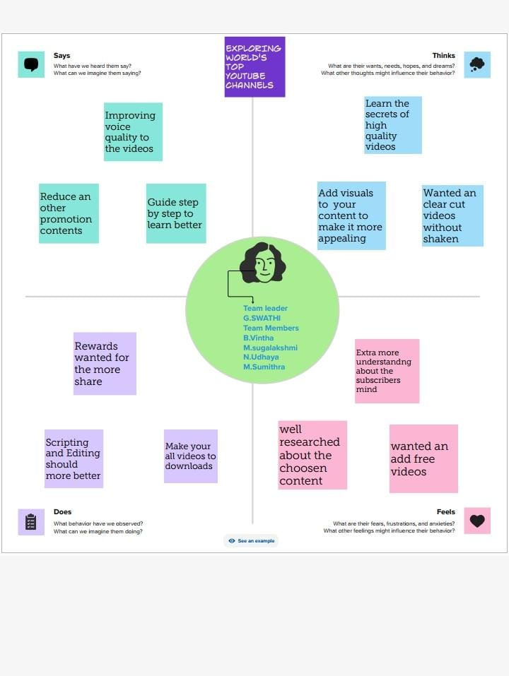

2.2 Ideation &Brainstorming Map

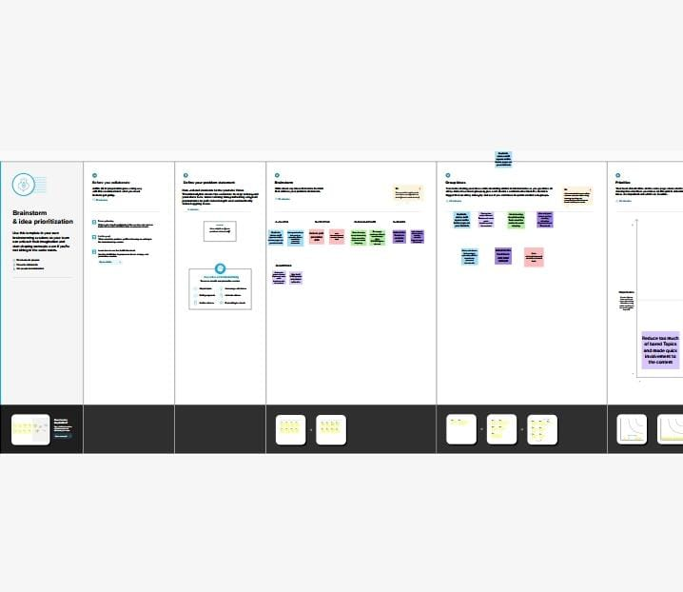BRAINSTORMING

* **RESULT**

* Data Model:

|  |  |
| --- | --- |
| **Object name** | **Fields in the Object** |
| Rank wise Channel | |  |  | | --- | --- | | Field label | Data type | | Rank | Numbers | | channel | Text | |
| No of channel with brand | |  |  | | --- | --- | | Field label | Data type | | Count of rank | Numbers | | Brand channel | graph | |
| Channel Brand | |  |  | | --- | --- | | Field label | Data type | | Name | Text | | Brand channel | Text | |
| Channel name with subscribers | |  |  | | --- | --- | | Field label | Data type | | Channel name | Text | | subscribers | Rank type | | |
| No of Channels of a Language | |  |  | | --- | --- | | Field label | Data type | | Channel | Text | | Language | Text | | |
| Country Wise Subscribers | |  |  | | --- | --- | | Field label | Data type | | Country | Text | | Subscribers | Numbers | | |
| Language Wise Subscribers | |  |  | | --- | --- | | Field label | Data type | | Language | Text | | Subcribers | Numbers | | |
| Category Wish Language | |  |  | | --- | --- | | Field label | Data type | | Category | Text | | Language | Text | | |
| Country wise channel | |  |  | | --- | --- | | Field label | Data type | | Country | Text | | Channel | Text | | |

* **Activity & Screenshot :**
* **HOME :**

RANK WISE CHANNEL:

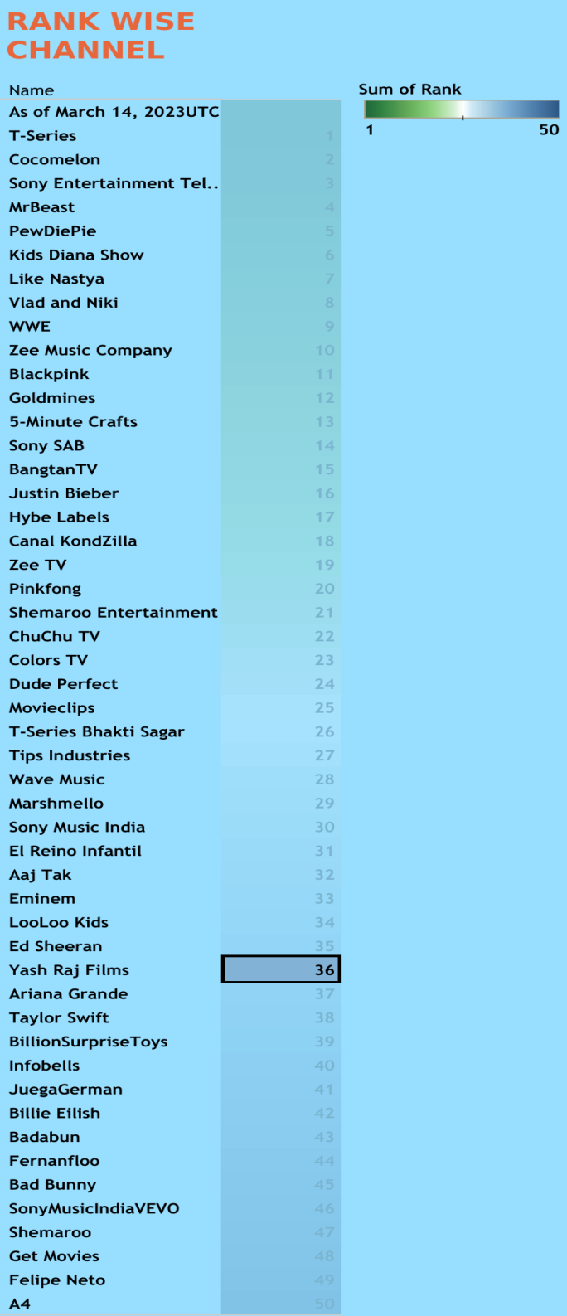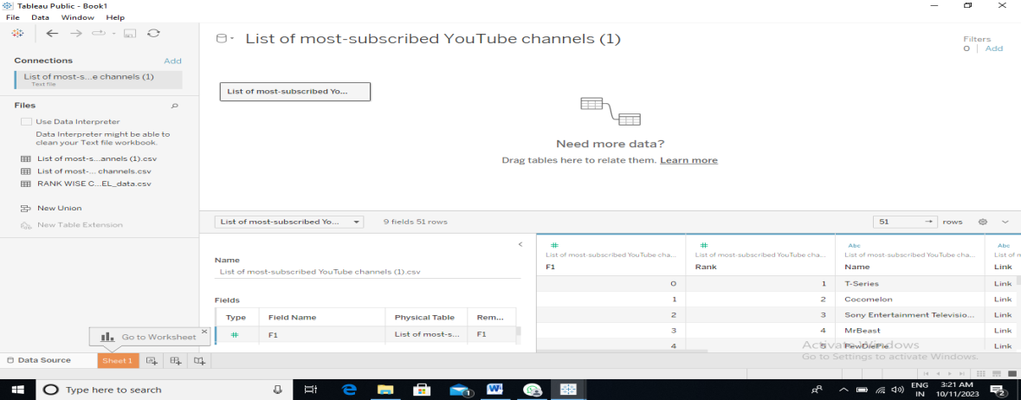

**R**

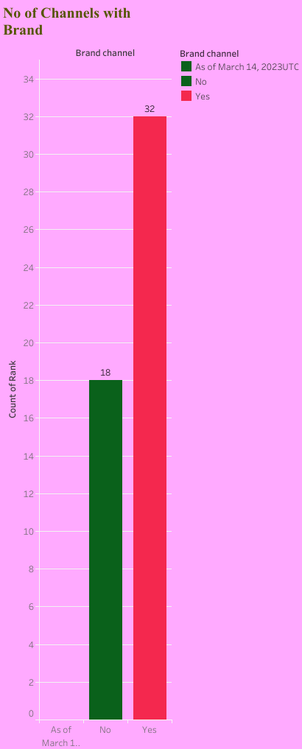

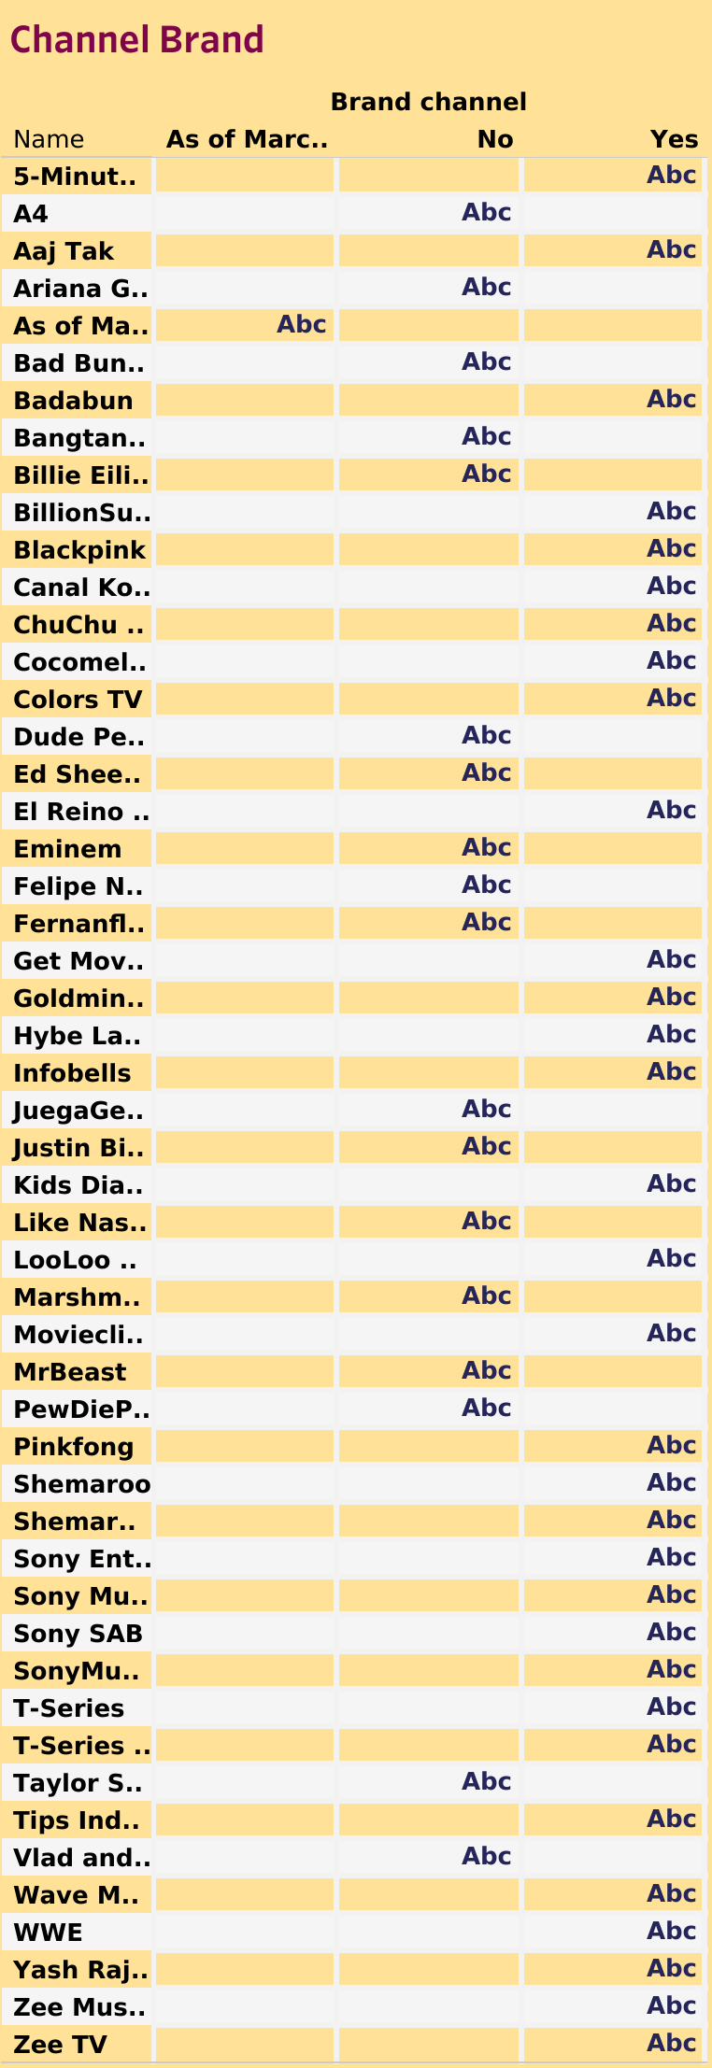

**DASHBOARD1:**

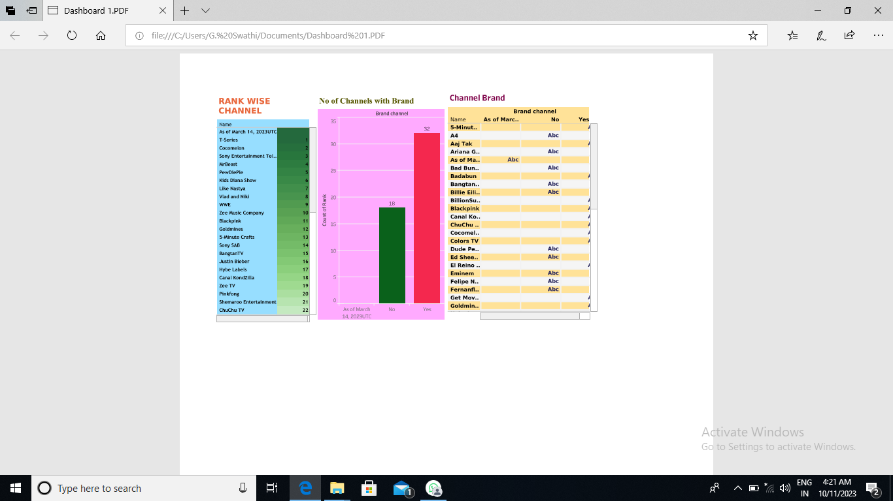

**Channel name with subscribers:**

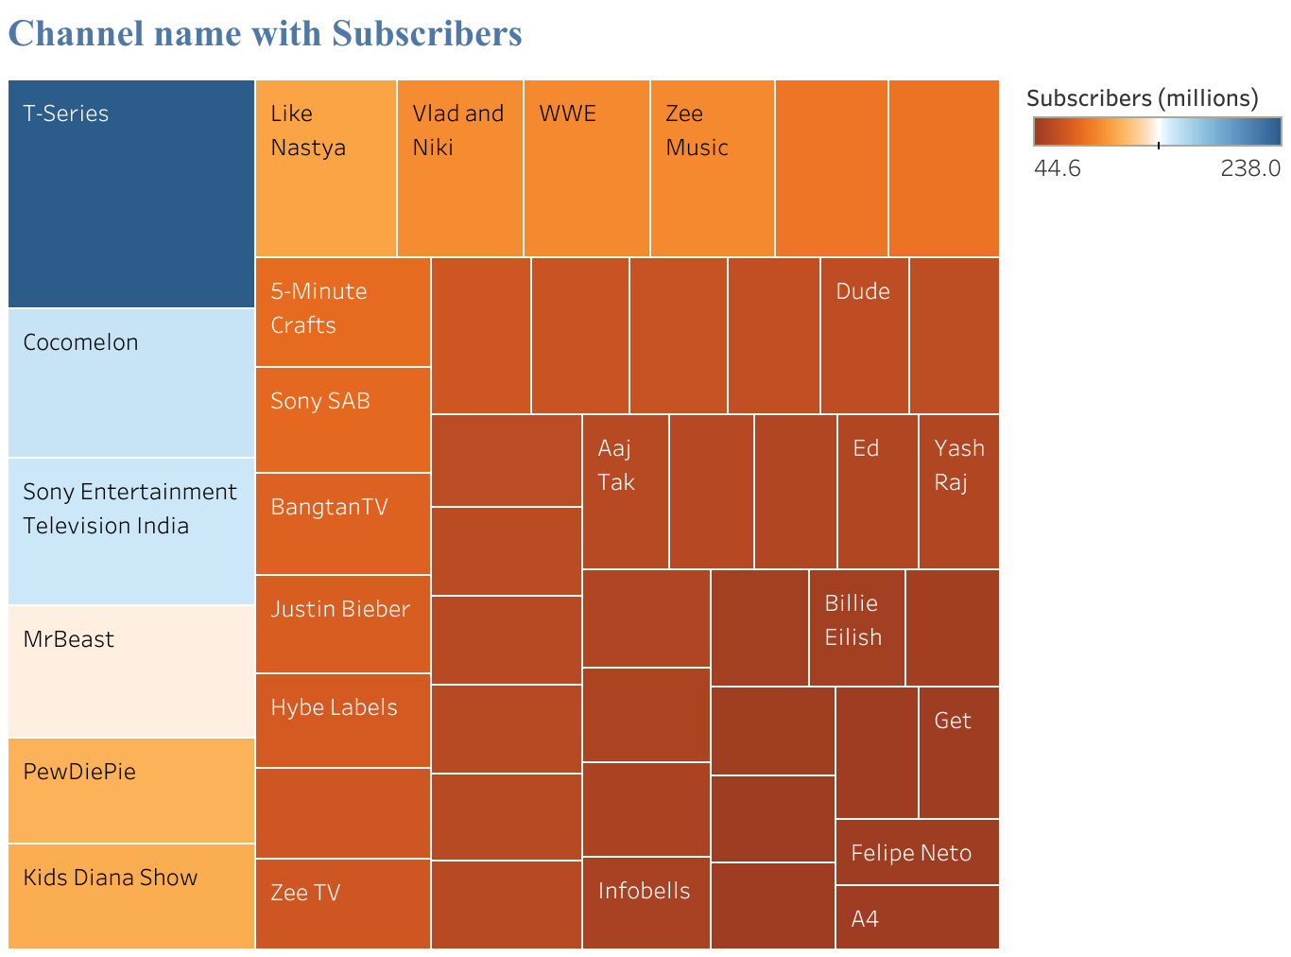

No. of channels of a language:

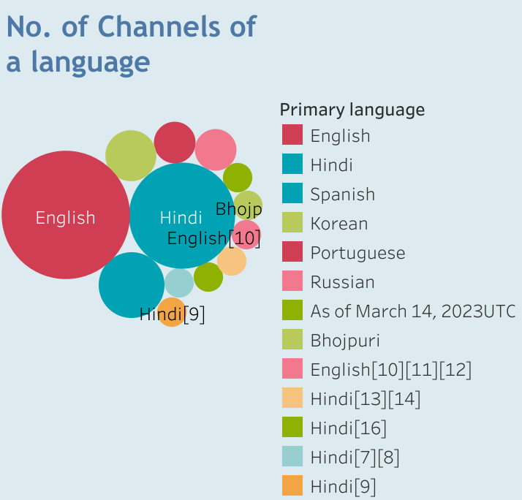

**DASHBOARD 2:**

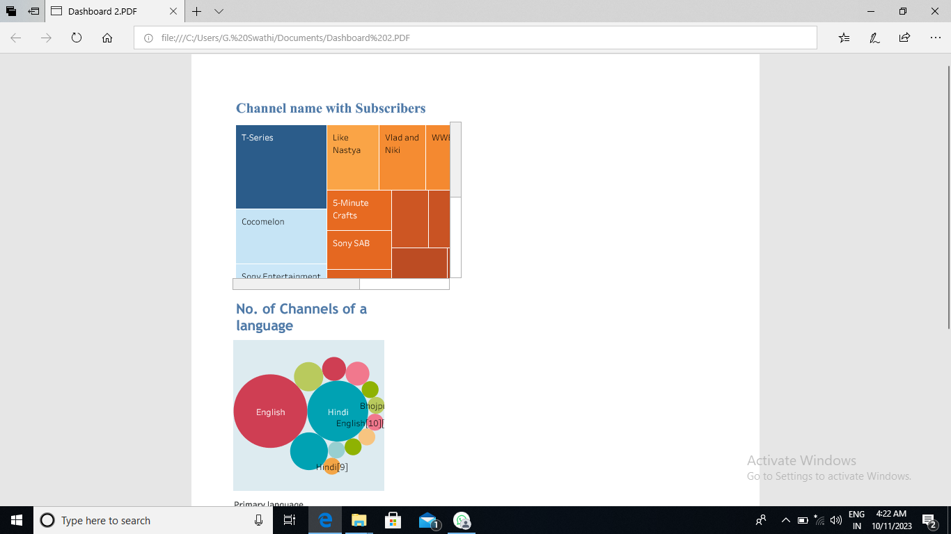

**COUNTRY WISE SUBSCRIBERS:**

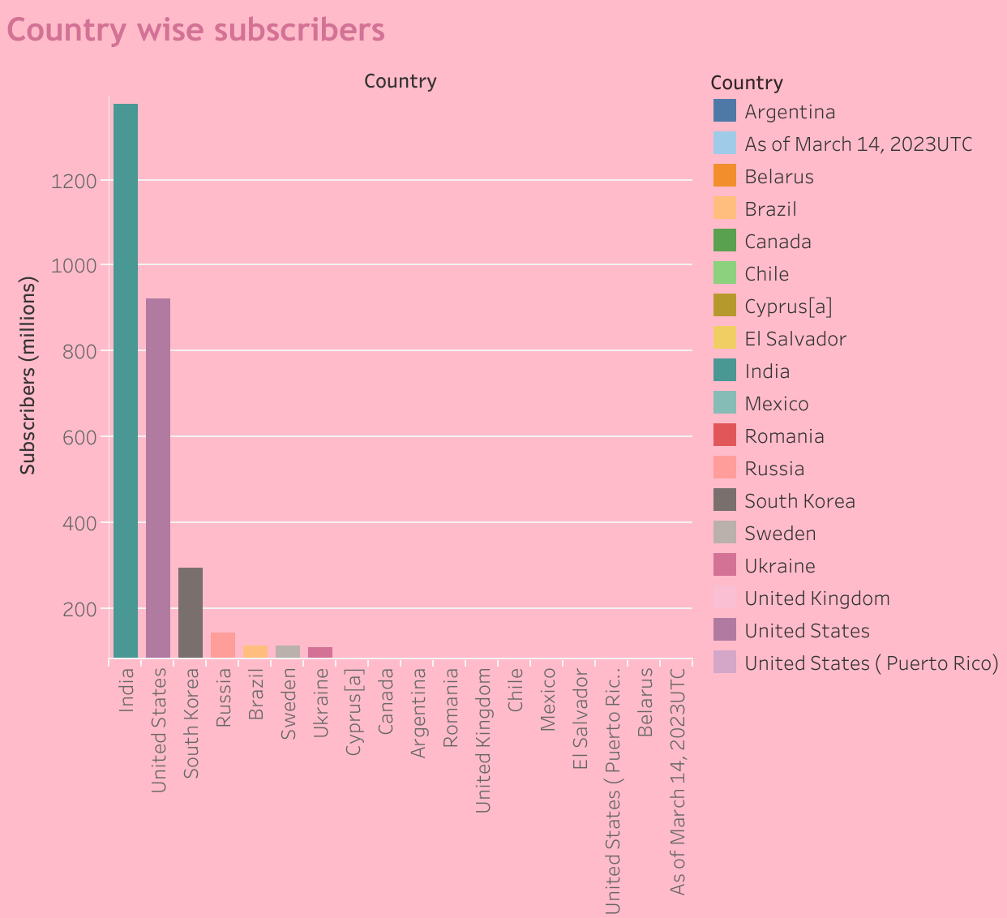

LANGUAGE WITH SUBSCRIBERS:

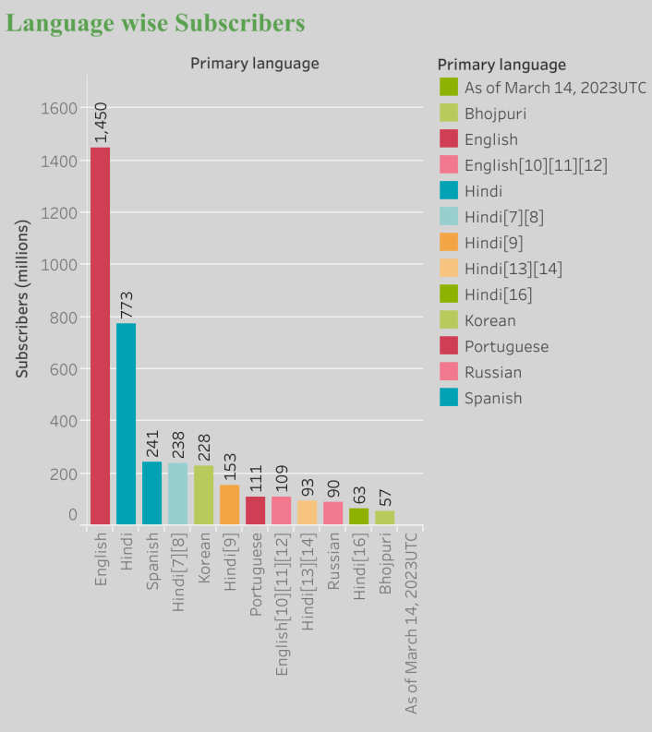

DASHBOARD 3:

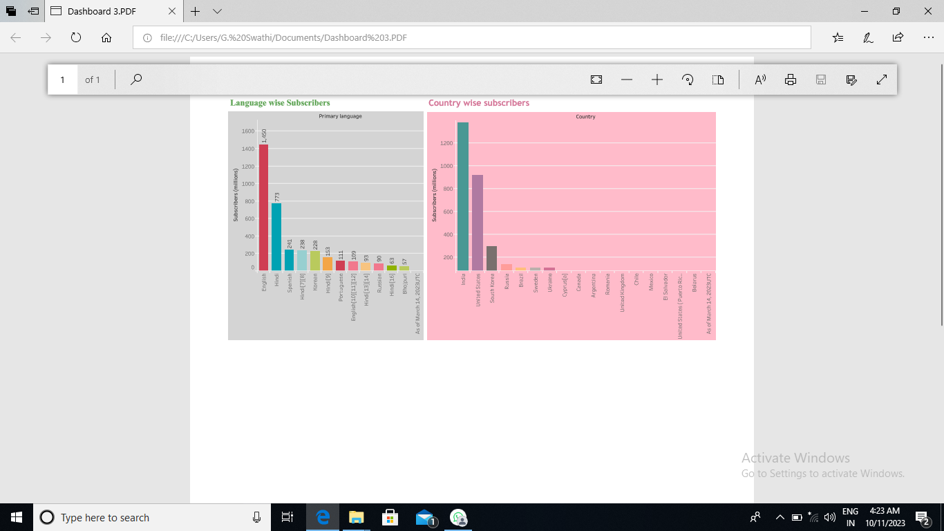

CATEGORY WISH LANGUAGE:

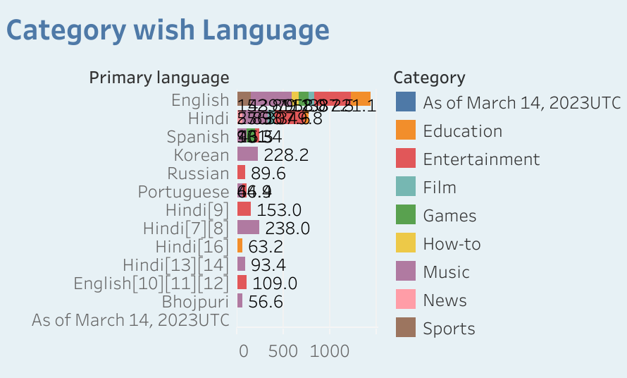

COUNTRY AND LANGUAGE:

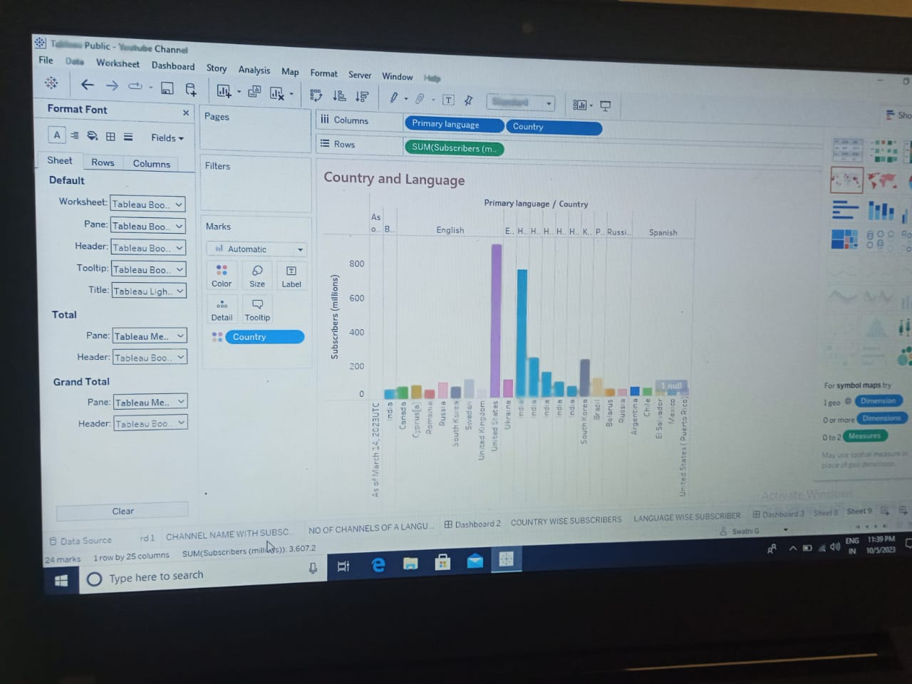

DASHBOARD 4:

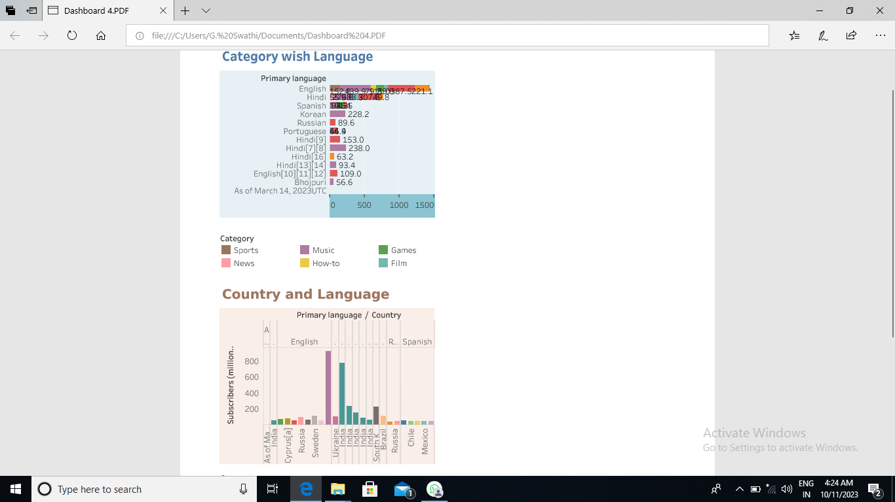

COUNTRY WISE CHANNEL:

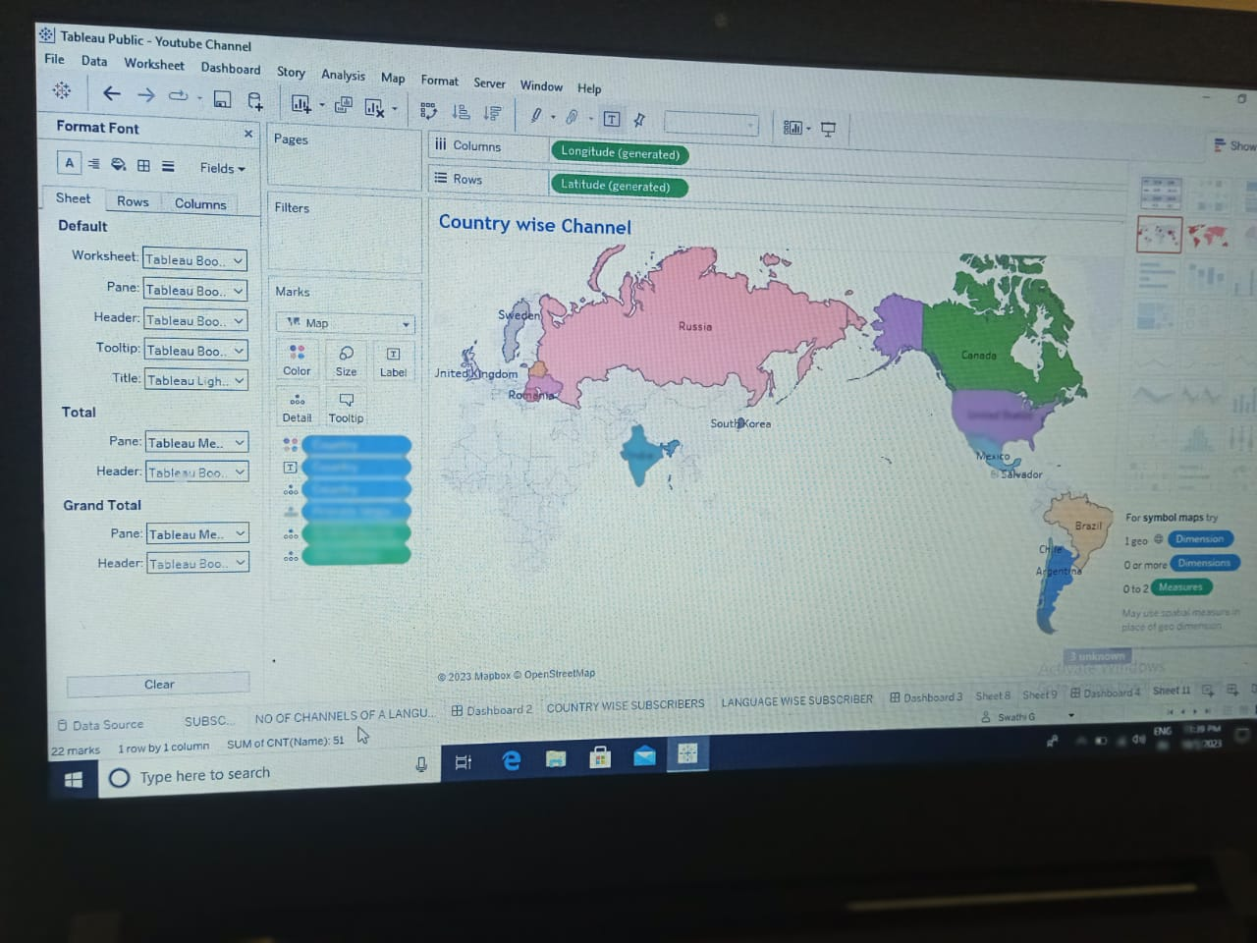

STORY 1:

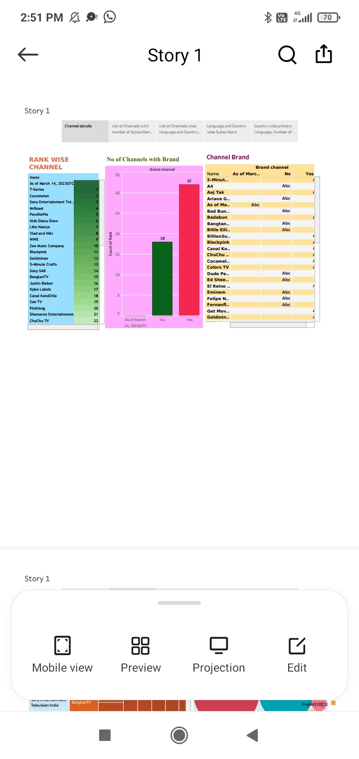

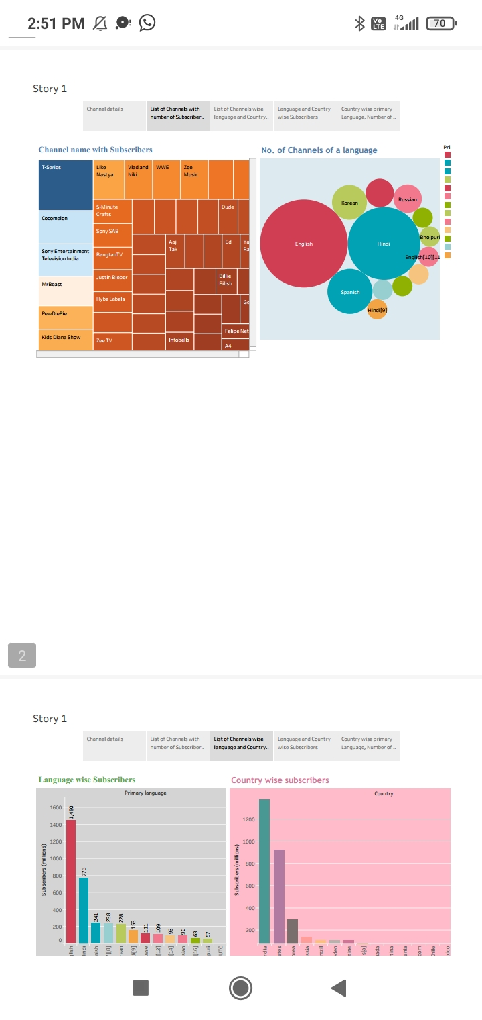

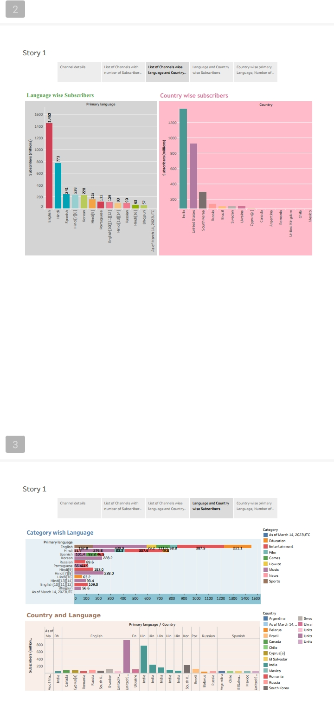

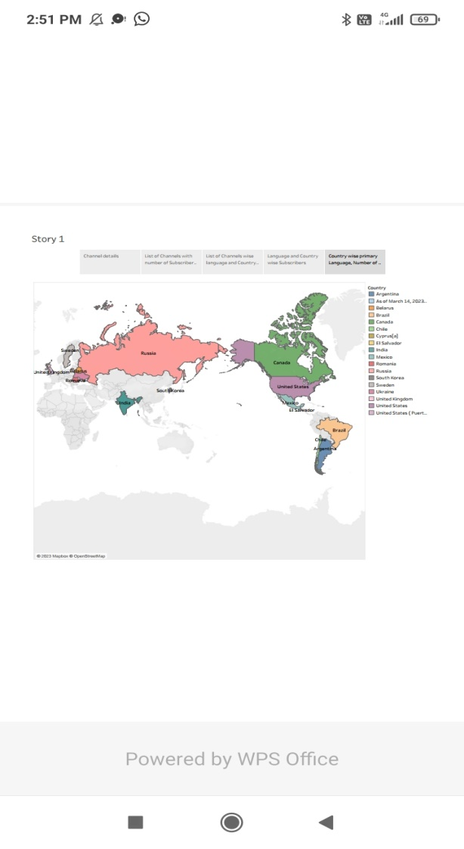

* **Trailhead Profile Public URL**

**TEAM LEADER(G.SWATHI)**

**TEAM MEMBER(M.SUGALAKSHMI)**

**TEAM MEMBER(M.SUMITHRA)**

**TEAM MEMBER(B.VINITHA)**

**TEAM MEMBER(N.UDHAYA)**

 Project Report Template

* **ADVANTAGES & DISADVANTAGE**
* **ADVANTAGES**
* Exposure to a worldwide audience
* Marketing on youtube will help you get found on Google
* Other ways to repurpose your videos
* Chance to reach with diverse clients as a viewers
* Youtube makes a videos great tool for engaging students in learning requirements
* Good platform for Social Transforming
* **DISADVANTAGES**
* Distracting or Harmful Content
* Privacy Concerns and “Creep Factor”
* Quality or Accuracy Issue
* Copyright Issues
* Add and Promoting videos for premium
* **APPLICATIONS**
* Youtube is a video Sharing Service where users can watch,like,share,comment and upload their own videos.It is a free video sharing website that makes it easy to Watch online videos.
* **CONCLUSION**

**Every YouTube helps us to know about the known and unknown things. It is customized with activities related to youtube management .It’s provider a good platform to all the people to show the ability in this big platform.**

* **FUTURE SCOPE**
* The scope of youtube channel as a carry in India is immense. All in all, youtube has a bright future in India but it will have to change a lot of things to not adversely affect the country’s national security.