|  |
| --- |
| **LockedMe.Com**  **(Application Screenshots)** |

**Version History:**

|  |  |
| --- | --- |
| Developer | Swathi Suheal J I |
| Purpose | Application Screenshots |
| Date | 10th August 2021 |
| Version | 1.0 |

Contents

1. Main Menu Screen Shot 3

2. Display Files 4

3. Add a File 5

4. Delete a File 6

5. Search File 7

6. Exit File 8

# Main Menu Screen Shot

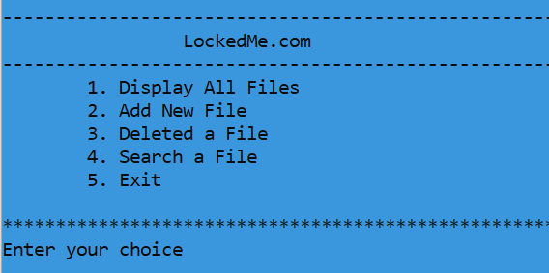

Fig 1.1

# Display Files

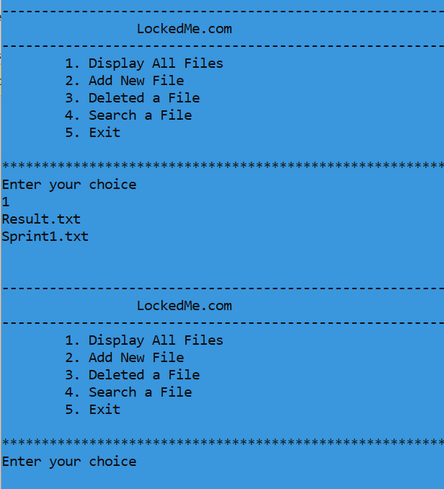

Fig 1.2

# Add a File

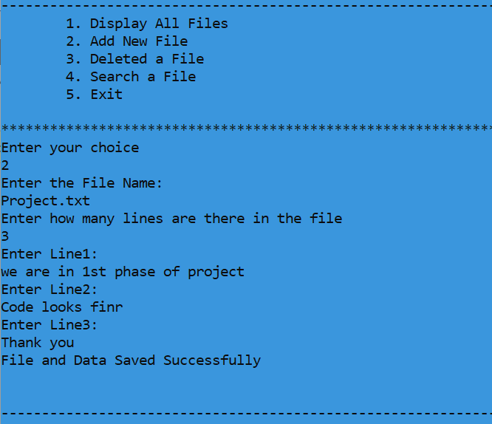

Fig 1.3

# Delete a File

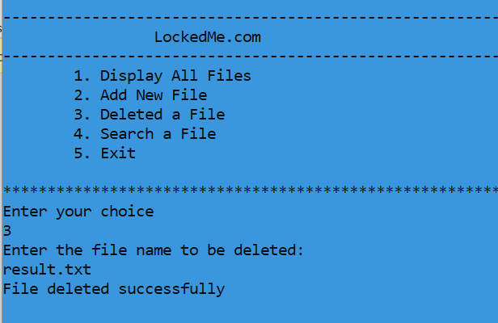

Fig 1.4

# Search File

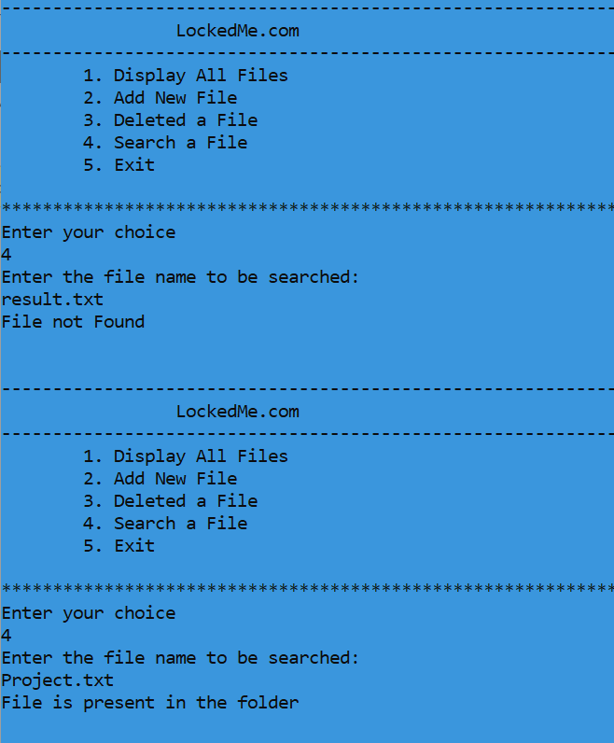

Fig 1.5

# Exit File

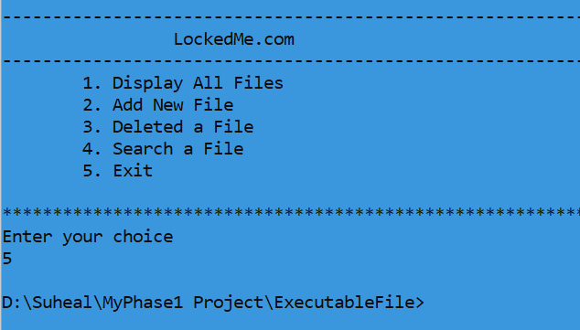

Fig 1.6