DOMAIN:APPLIED DATA SCIENCE
PROJECT TITLE:CREDIT CARD FRAUD DETECTION
TEAM MEMBERS:
D.HARISH
M.MADHUSRI
J.KEERTHIKA
E.REVATHI
R.SWATHI
PROBLEM DEFINITION:
The problem is to develop a machine learning-based system for real-time credit card fraud detection. The goal is to create a solution that can accurately identify fraudulent transactions while minimizing false positives. This project involves data preprocessing, feature engineering, model selection, training, and evaluation to create a robust fraud detection system.Data preprocessing is an important step in the data mining process. It refers to the cleaning, transforming, and integrating of data in order to make it ready for analysis. The goal of data preprocessing is to improve the quality of the data and to make it more suitable for the specific data mining task.Feature engineering involves a set of techniques that enable us to create new features by combining or transforming the existing ones. These techniques help to highlight the most important patterns and relationships in the data, which in turn helps the machine learning model to learn from the data more effectively.In its most basic forms, model selection is one of the fundamental tasks of scientific inquiry. Determining the principle that explains a series of observations is often linked directly to a mathematical model predicting those observations. For example, when Galileo performed his inclined plane experiments, he demonstrated that the motion of the balls fitted the parabola predicted by his model.
DESIGN THINKING:
DATA SOURCE:

A data source is simply the source of the data. It can be a file, a particular database on a DBMS, or even a live data feed. The data might be located on the same computer as the program, or on another computer somewhere on a network.
TRANSACTION DATASET:
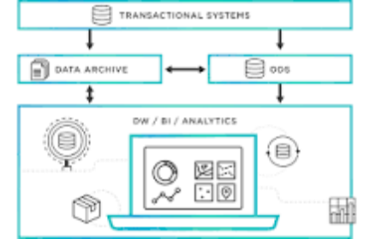
Transactional data is information that is captured from transactions. It records the time of the transaction, the place where it occurred, the price points of the items bought, the payment method employed, discounts if any, and other quantities and qualities associated with the transaction.
TRANSACTION AMOUNT:


A data source is the location where data that is being used originates from. A data source may be the initial location where data is born or where physical information is first digitized, however even the most refined data may serve as a source, as long as another process accesses and utilizes it.
TIMESTAM:
SQL Server timestamps are a data type used to store a date and time value. The timestamp data type stores a date and time value in the format YYYY-MM-DD HH:MM:SS. The timestamp data type is an 8-byte value representing a date and time value in the YYYY-MM-DD HH:MM:SS format.
MERCHANT INFORMATION:
The details about your products that you submit to the Google Merchant Centre. Your product data is used to show dynamic ads, free product listings and Shopping ads when you run a Google Ads campaign.
CARD DETAILS:
Ultimately, data sources are intended to help users and applications connect to and move data to where it needs to be. They gather relevant technical information in one place and hide it so data consumers can focus on processing and identify how to best utilize their data.
DATA PREPROCESSING:
Data preprocessing is an important step in the data mining process. It refers to the cleaning, transforming, and integrating of data in order to make it ready for analysis. The goal of data preprocessing is to improve the quality of the data and to make it more suitable for the specific data mining task.
PREPROCESS THE DATA:
Ultimately, data sources are intended to help users and applications connect to and move data to where it needs to be. They gather relevant technical information in one place and hide it so data consumers can focus on processing and identify how to best utilize their data. information in one place.
HANDEL MISSING VALUES:rs can focus on p
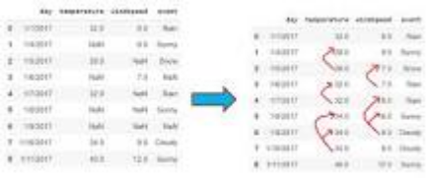
the deletion of the rows or columns having null values. If any columns have more than half of the values as null then you can drop the entire column. In the same way, rows can also be dropped if having one or more columns values as null.utilize their data.
NORMAIZE FEATURES:
Normalization is a data preprocessing technique used to transform features in a dataset to a common scale, improving the performance and accuracy of machine learning algorithms. The main goal of normalization is to eliminate the potential biases and distortions caused by the different scales of features.
FEATURE ENGINEERING :
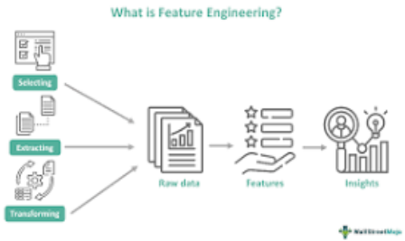
Feature engineering involves a set of techniques that enable us to create new features by combining or transforming the existing ones. These techniques help to highlight the most important patterns and relationships in the data, which in turn helps the machine learning model to learn from the data more effectively.
ENHANCE FRAUDE DETECTION :

Feature engineering is the key to success in modeling. Good feature engineering can capture the nature of the problem, thus rendering a better outcome. What is a feature? A feature is a variable that describes the latent patterns. In this article, I will survey feature engineering in the literature on credit card fraud. Readers will learn how other data scientists create features to attach fraud in different industries. In Feature Engineering for Healthcare Fraud Detection, I show you how to create features for the healthcare industry.
TRANSACTION FREQUENCY:
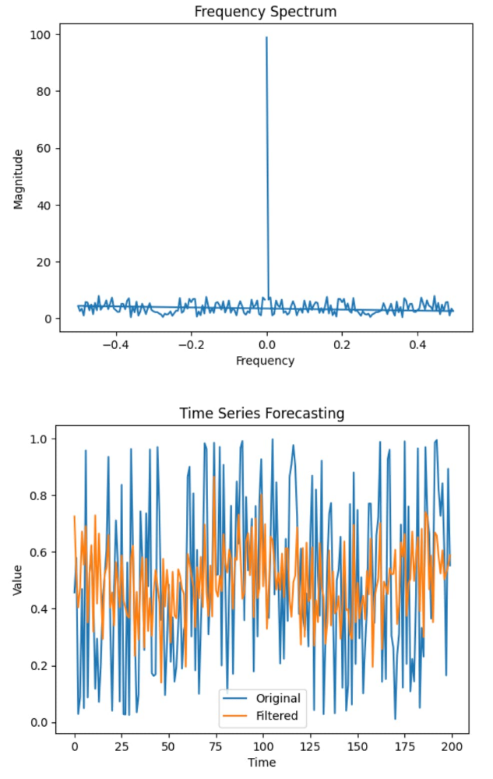
In this blog post, I would like to focus on feature engineering to predict customer transactions for the next month. As a data scientist working in marketing, I find it quite important to understand why I am doing some work and how it can solve a business problem. I think feature engineering is a part of an analysis where the domain knowledge and hard skills are equally important and blended to find a better solution to a problem.
AMOUNT DEVIATIONS:
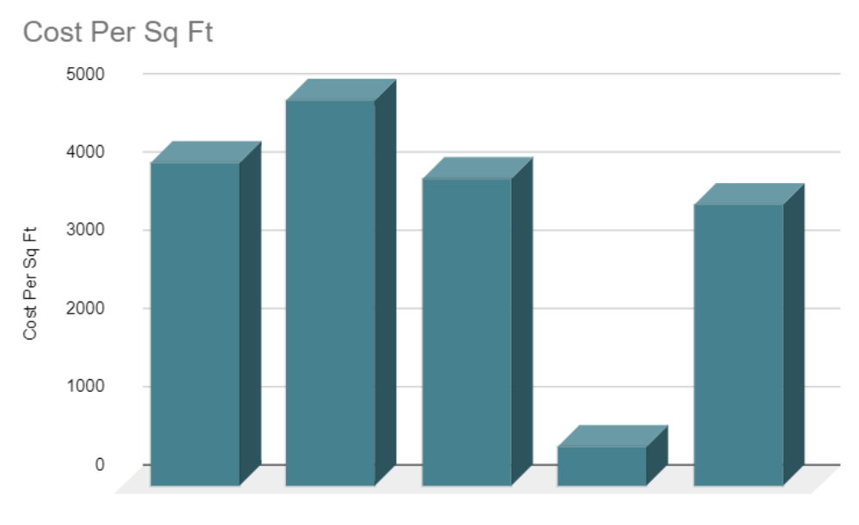
When you plot the data, youll notice that one price is significantly different from the rest. In the visualisation method, you can readily notice the problem. The third way is to use Statistics to analyze your data and find any problem. Feature engineering consists of various process.
MODEL SELECTION:
In its most basic forms, model selection is one of the fundamental tasks of scientific inquiry. Determining the principle that explains a series of observations is often linked directly to a mathematical model predicting those observations. For example, when Galileo performed his inclined plane experiments, he demonstrated that the motion of the balls fitted the parabola predicted by his model.
MACHINE LEARNING ALGORITHMS FOR FRAUD DETECTION:
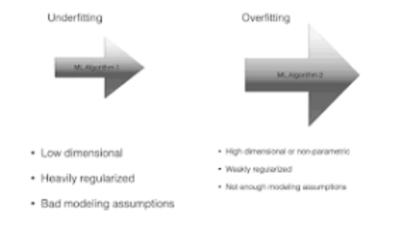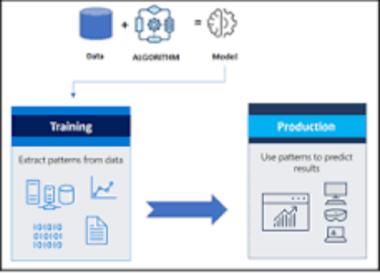
Model selection is the process of deciding which algorithm and model architecture is best suited for a particular task or dataset. It entails contrasting various models, assessing their efficacy, and choosing the one that most effectively addresses the issue at hand.
e.g.
Logistic Regression:
select all the variables whose p-value < 0.25 along with the variables of known clinical importance. Step 2: Fit a multiple logistic regression model using the variables selected in step 1. Verify the importance of each variable in this multiple model using Wald statistic.
MODEL TRAINING:
Model training is the phase in the data science development lifecycle where practitioners try to fit the best combination of weights and bias to a machine learning algorithm to minimize a loss function over the prediction range.
TRAIN THE SELECTED MODEL USING THE PREPROCESSED DATA:
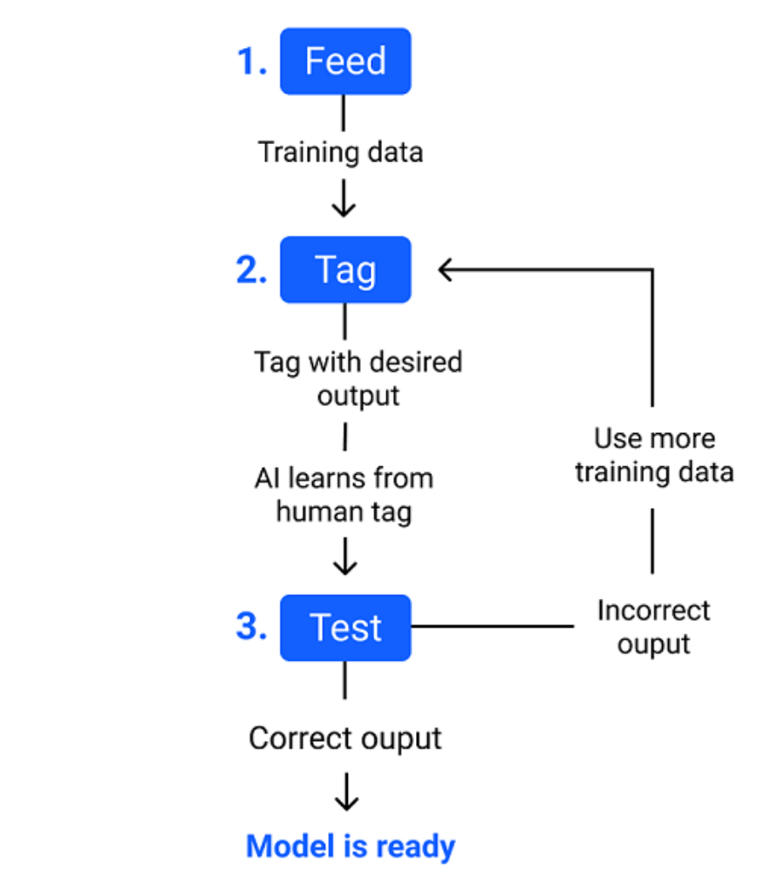

The main difference between training data and testing data is that training data is the subset of original data that is used to train the machine learning model, whereas testing data is used to check the accuracy of the model. The training dataset is generally larger in size compared to the testing dataset.
EVALUATION:
Evaluation is the structured interpretation and giving of meaning to predicted or actual impacts of proposals or results. It looks at original objectives, and at what is either predicted or what was accomplished and how it was accomplished. So evaluation can be formative, that is taking place during the development of a concept or proposal, project or organization, with the intention of improving the value or effectiveness of the proposal, project, or organisation.
EVALUATE THE MODEL'S PERFORMANCE USING MATRICS LIKE ACCURANCY:
Therefore evaluating a model plays a vital role so that we can judge the performance of our model. The evaluation also helps to analyze a model's key weaknesses. There are many metrics like Accuracy, Precision, Recall, F1 score, Area under Curve, Confusion Matrix, and Mean Square Error.What is the evaluation metrics for accuracy?
Accuracy means that how many data points are predicted correctly. It is one of the simplest form of evaluation metrics. The accuracy score is # of correct points / # total = (30 + 35 + 50) / 200 = 0.575.
PRECISION:
Precision evaluates how precise a model is in predicting positive labels. Precision answers the question, out of the number of times a model predicted positive, how often was it correct? Precision is the percentage of your results which are relevant.
RECALL:
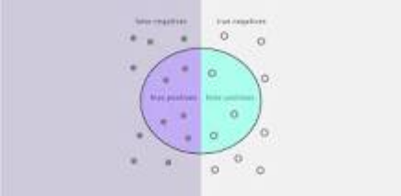

Recall in this context is defined as the number of true positives divided by the total number of elements that actually belong to the positive class (i.e. the sum of true positives and false negatives, which are items which were not labelled as belonging to the positive class but should have been).
F1-score :
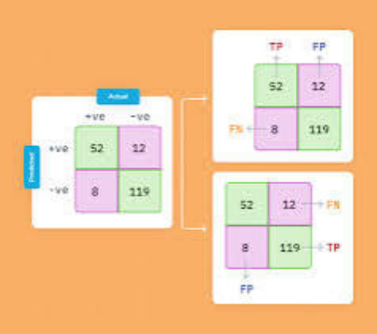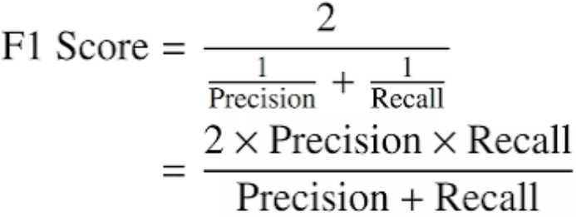
F1-score is the evaluation matrix that combines two matrices: Precision and Recall, into a single metric by taking their harmonic mean. In simple terms, the f1 score is the weighted average mean of Precision and Recall. It is also used in Natural Language Processing.
ROC-AUC:
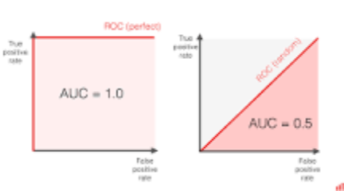

To get the score, you must measure the area under the ROC curve. ROC AUC score shows how well the classifier distinguishes positive and negative classes. It can take values from 0 to 1. A higher ROC AUC indicates better performance.

