**WEEK 7 REACT JS**

**Ex 9 :**

**ListofPlayers.js**

import React from 'react';

const ListofPlayers = () => {

const players = [

{ name: 'Dhawan', score: 60 },

{ name: 'Shreyas', score: 95 },

{ name: 'Pant', score: 35 },

{ name: 'Kishan', score: 82 },

{ name: 'Sanju', score: 40 },

{ name: 'Washington', score: 78 },

{ name: 'Axar', score: 90 },

{ name: 'Ashwin', score: 55 },

{ name: 'Chahal', score: 33 },

{ name: 'Arshdeep', score: 68 },

{ name: 'Thakur', score: 74 },

];

const underPerformers = players.filter(p => p.score < 70);

return (

<div>

<h2>Team Lineup</h2>

<ul>

{players.map((p, index) => (

<li key={index}>{p.name} - {p.score} runs</li>

))}

</ul>

<h3>Underperformers (Below 70)</h3>

<ul>

{underPerformers.map((p, index) => (

<li key={index}>{p.name} - {p.score} runs</li>

))}

</ul>

</div>

);

};

export default ListofPlayers;

**IndianPlayers.js**

import React from 'react';

const IndianPlayers = () => {

const oddTeam = ['Dhawan', 'Pant', 'Washington', 'Ashwin', 'Thakur'];

const evenTeam = ['Shreyas', 'Kishan', 'Sanju', 'Axar', 'Chahal', 'Arshdeep'];

const [skipper, deputy, ...rest] = evenTeam;

const t20List = ['Tilak Varma', 'Jitesh Sharma', 'Ravi Bishnoi'];

const ranjiList = ['Rahane', 'Pujara', 'Manoj Tiwary'];

const combinedSquad = [...t20List, ...ranjiList];

return (

<div>

<h2>Odd Team Members</h2>

<p>{oddTeam.join(', ')}</p>

<h2>Even Team Roles</h2>

<p>Skipper: {skipper}</p>

<p>Deputy: {deputy}</p>

<p>Rest: {rest.join(', ')}</p>

<h2>Combined T20 & Ranji Players</h2>

<ul>

{combinedSquad.map((player, idx) => (

<li key={idx}>{player}</li>

))}

</ul>

</div>

);

};

export default IndianPlayers;

**App.js**

import React from 'react';

import ListofPlayers from './ListofPlayers';

import IndianPlayers from './IndianPlayers';

function App() {

const flag = false;

return (

<div style={{ padding: '2rem' }}>

<h1>Cricket Player Stats Dashboard</h1>

{flag ? <ListofPlayers /> : <IndianPlayers />}

</div>

);

}

export default App;

**Output :**

**Flag = true**

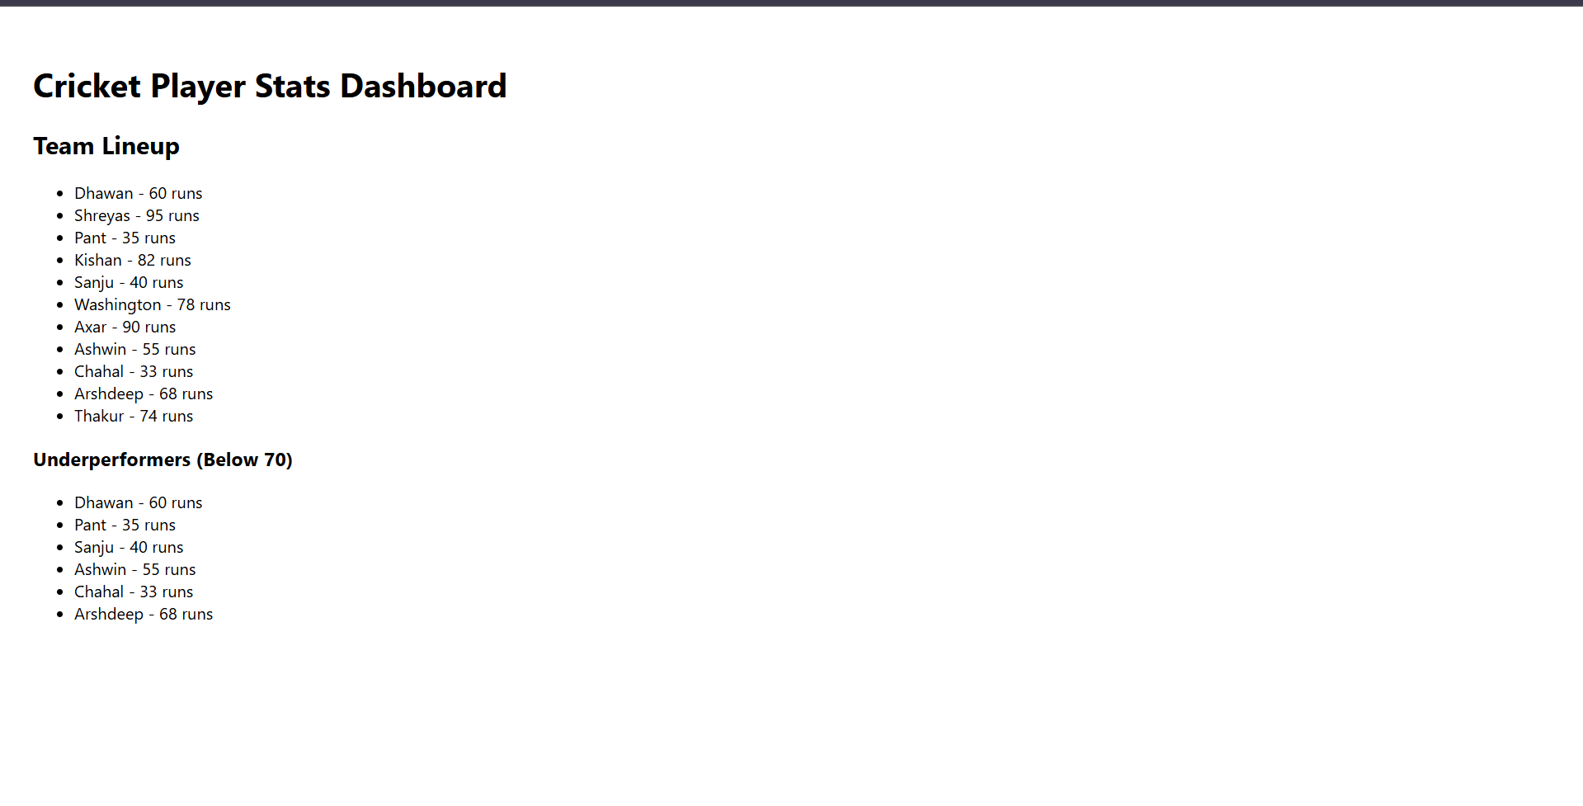

**Flag = false**

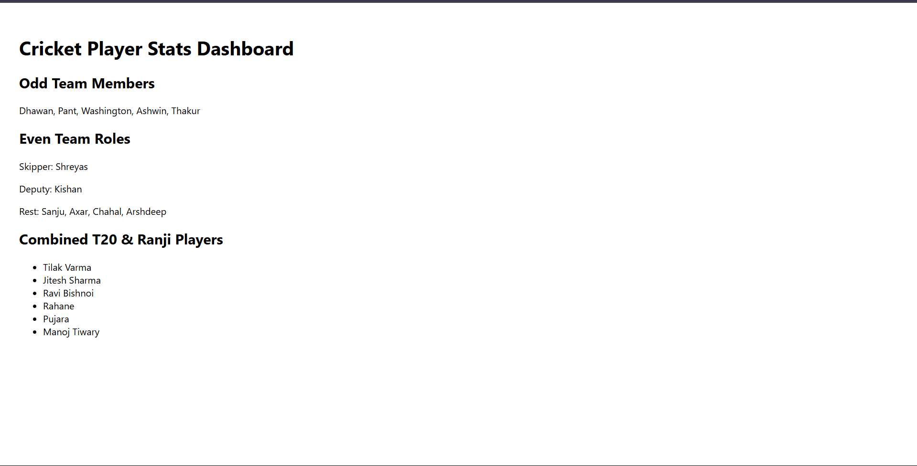

**Ex 10**

**App.js**

import React from 'react';

const App = () => {

const heading = <h1 style={{ textAlign: 'center', margin: '25px 0', color: '#333' }}>Workplace Rental Dashboard</h1>;

const officeBanner = "https://images.unsplash.com/photo-1562183241-b937f5810650";

const featuredOffice = {

name: "AlphaWork Hub",

rent: 68000,

address: "45 Anna Salai, Chennai"

};

const allOffices = [

{ id: 101, name: "BrightSpace", rent: 59000, address: "OMR, Chennai" },

{ id: 102, name: "CubeNest", rent: 73000, address: "Velachery, Chennai" },

{ id: 103, name: "GrowthBay", rent: 61000, address: "T Nagar, Chennai" },

{ id: 104, name: "FocusRooms", rent: 54000, address: "Guindy, Chennai" }

];

const rentColorStyle = (rent) => ({

color: rent > 60000 ? "#008000" : "#C62828",

fontWeight: "600"

});

return (

<div style={{ padding: "35px", fontFamily: "Segoe UI" }}>

{heading}

<div style={{ textAlign: 'center' }}>

<img

src={officeBanner}

alt="Office Space"

style={{ width: "85%", height: "320px", objectFit: "cover", borderRadius: "12px" }}

/>

</div>

<h2 style={{ marginTop: "30px" }}>Top Pick</h2>

<p><strong>Name:</strong> {featuredOffice.name}</p>

<p><strong>Location:</strong> {featuredOffice.address}</p>

<p><strong>Rent:</strong> <span style={rentColorStyle(featuredOffice.rent)}>{featuredOffice.rent}</span></p>

<h2 style={{ marginTop: "30px" }}>More Workspaces</h2>

{allOffices.map((office) => (

<div key={office.id} style={{ borderBottom: "1px dashed #aaa", paddingBottom: "10px", marginBottom: "15px" }}>

<p><strong>Name:</strong> {office.name}</p>

<p><strong>Address:</strong> {office.address}</p>

<p><strong>Rent:</strong> <span style={rentColorStyle(office.rent)}>{office.rent}</span></p>

</div>

))}

</div>

);

};

export default App;

**Output :**

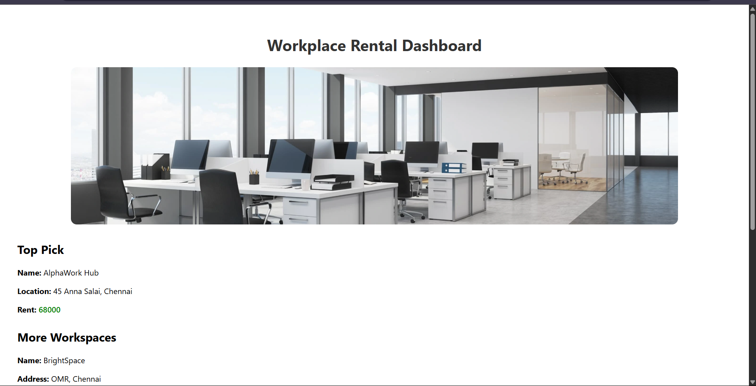

**Ex 11**

**App.js**

import React, { useState } from 'react';

import CurrencyConvertor from './CurrencyConvertor';

const App = () => {

const [count, setCount] = useState(0);

const increaseCounter = () => {

setCount(prev => prev + 1);

greetUser();

};

const decreaseCounter = () => {

setCount(prev => prev - 1);

};

const greetUser = () => {

console.log("Hi Poshika! You're increasing the count");

};

const welcomeMessage = (msg) => {

alert(msg);

};

const syntheticEventHandler = (e) => {

alert("Poshika clicked this button!");

console.log("Synthetic event triggered by Poshika:", e);

};

return (

<div style={{ padding: "40px", fontFamily: "Segoe UI" }}>

<h1>React Events Practice - Poshika</h1>

<h2>Current Value: {count}</h2>

<button onClick={increaseCounter}>Add Count</button>

<button onClick={decreaseCounter} style={{ marginLeft: "10px" }}>Reduce Count</button>

<div style={{ marginTop: "20px" }}>

<button onClick={() => welcomeMessage("Welcome to React Events, Poshika!")}>Show Welcome</button>

</div>

<div style={{ marginTop: "20px" }}>

<button onClick={syntheticEventHandler}>Synthetic Click Event</button>

</div>

<hr style={{ margin: "30px 0" }} />

<CurrencyConvertor />

</div>

);

};

export default App;

**CurrencyConvertor.js**

import React, { useState } from 'react';

const CurrencyConvertor = () => {

const [inr, setInr] = useState('');

const [convertedEuro, setConvertedEuro] = useState(null);

const convertCurrency = (e) => {

e.preventDefault();

const rate = 0.011;

const euro = (parseFloat(inr) * rate).toFixed(2);

setConvertedEuro(euro);

};

return (

<div>

<h2>INR to Euro Converter</h2>

<form onSubmit={convertCurrency}>

<input

type="number"

value={inr}

onChange={(e) => setInr(e.target.value)}

placeholder="Amount in INR"

/>

<button type="submit" style={{ marginLeft: "10px" }}>Convert to EUR</button>

</form>

{convertedEuro && (

<p style={{ marginTop: "15px" }}>

₹{inr} = <strong>€{convertedEuro}</strong>

</p>

)}

</div>

);

};

export default CurrencyConvertor;

**Output :**

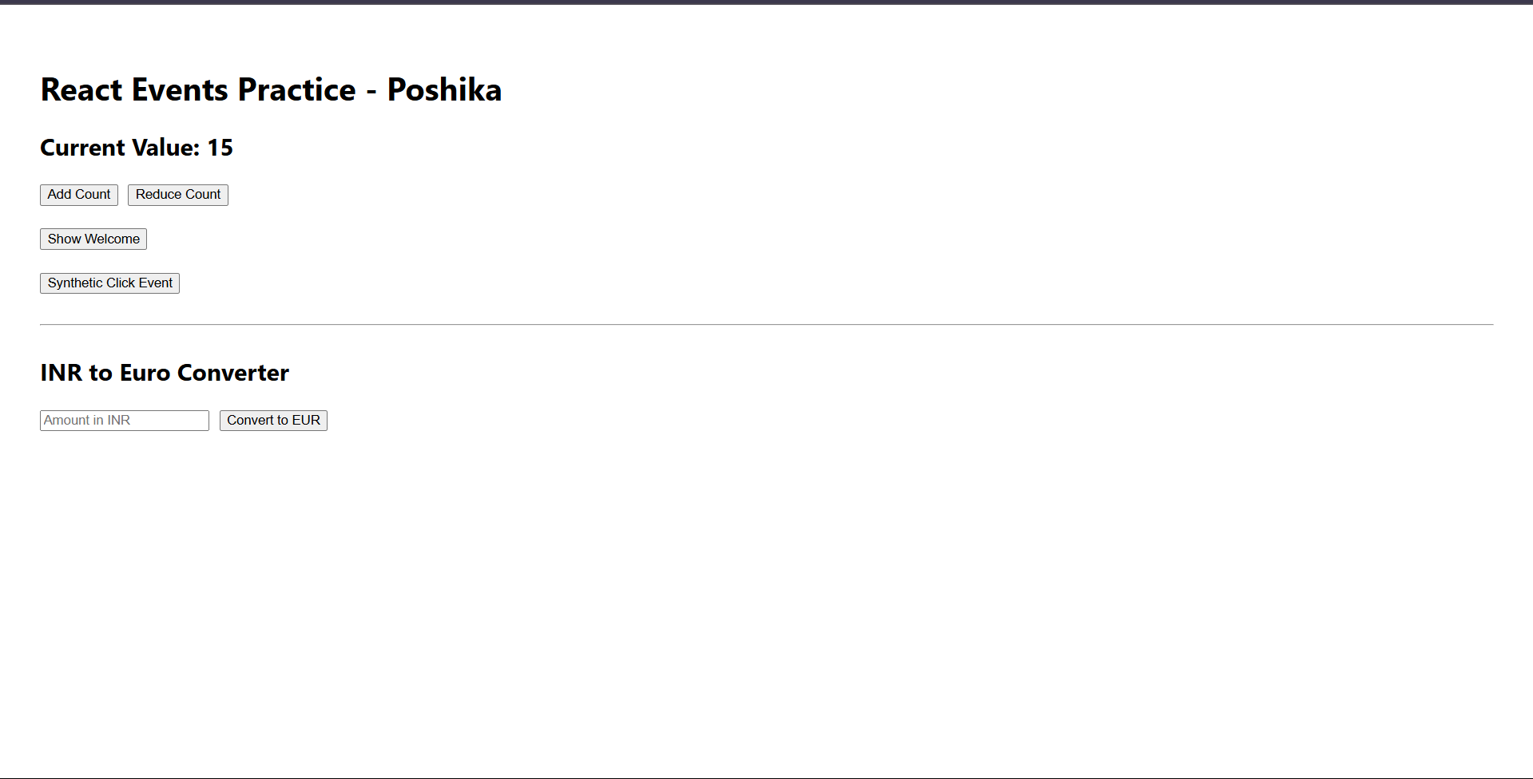

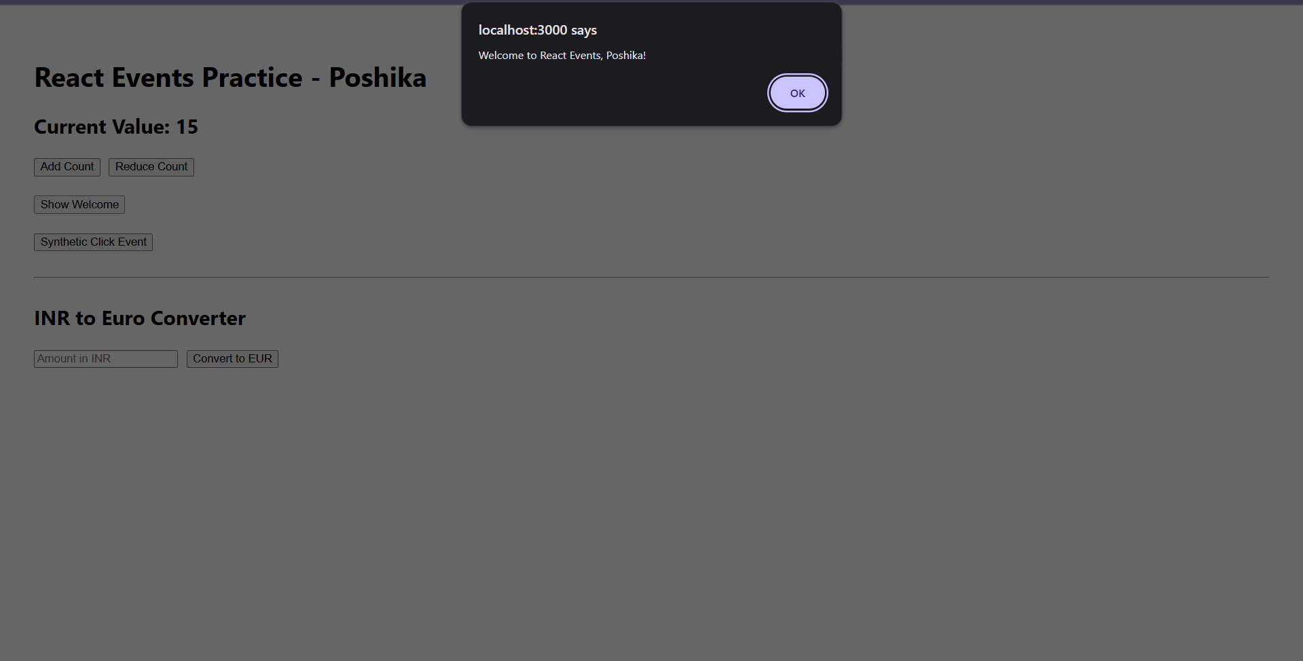

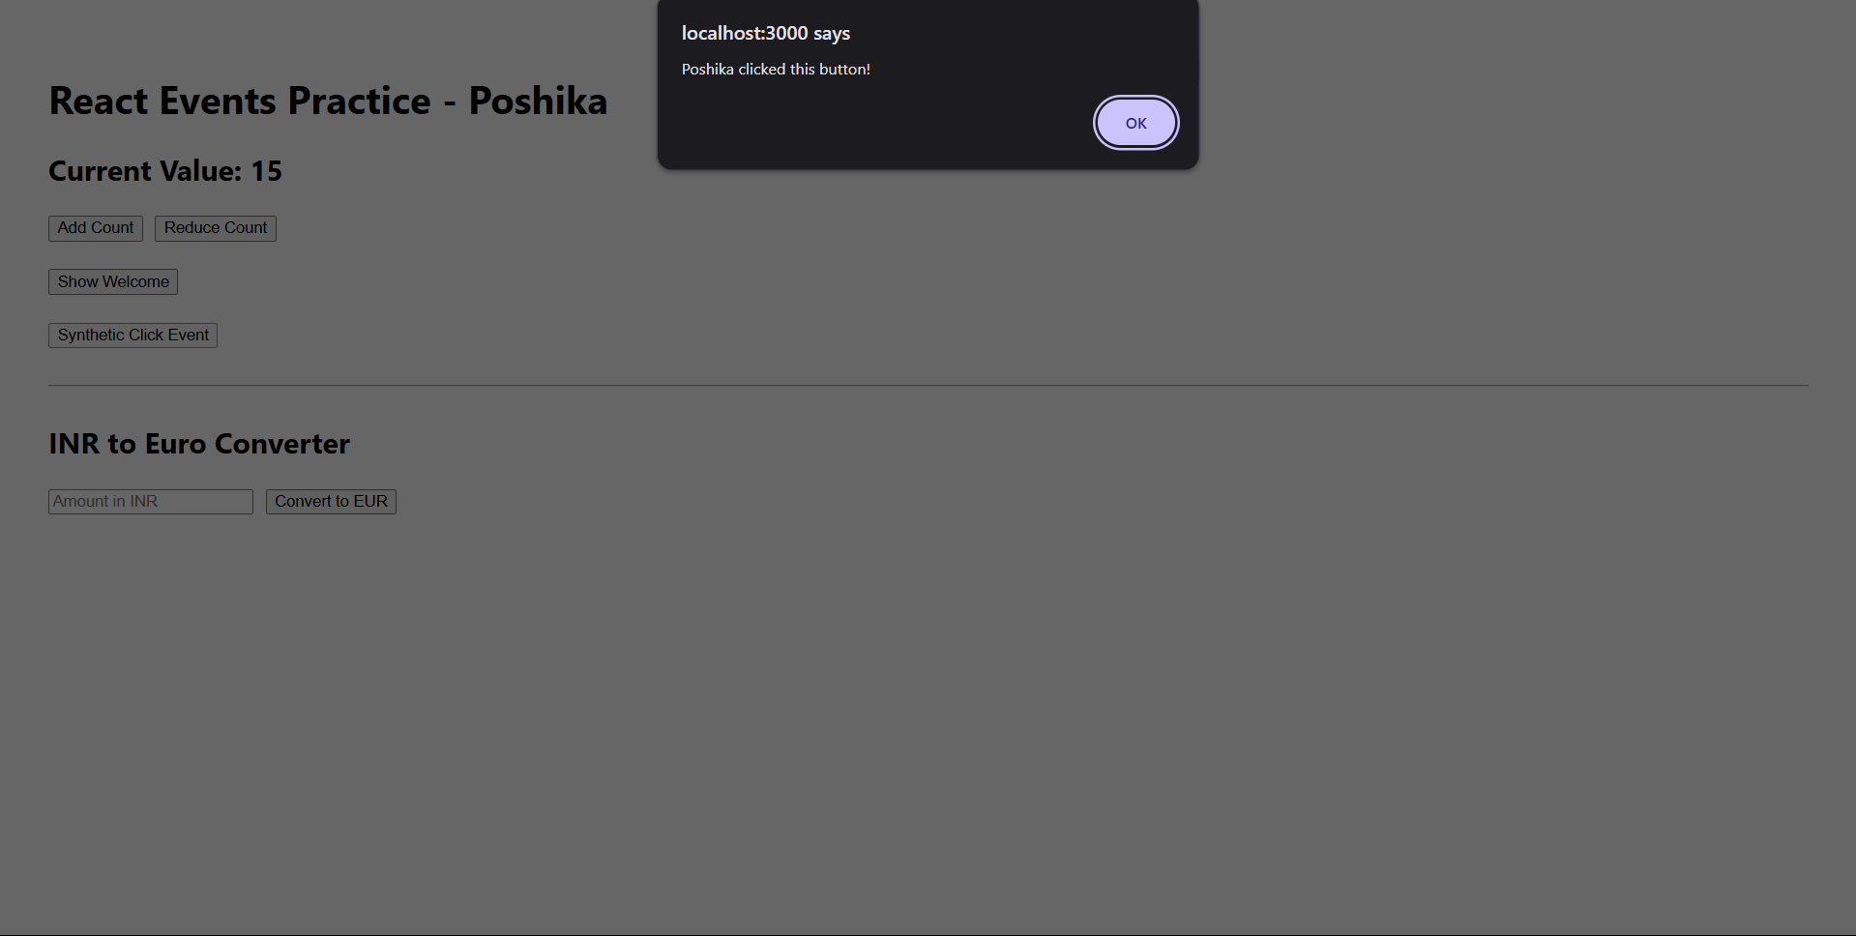

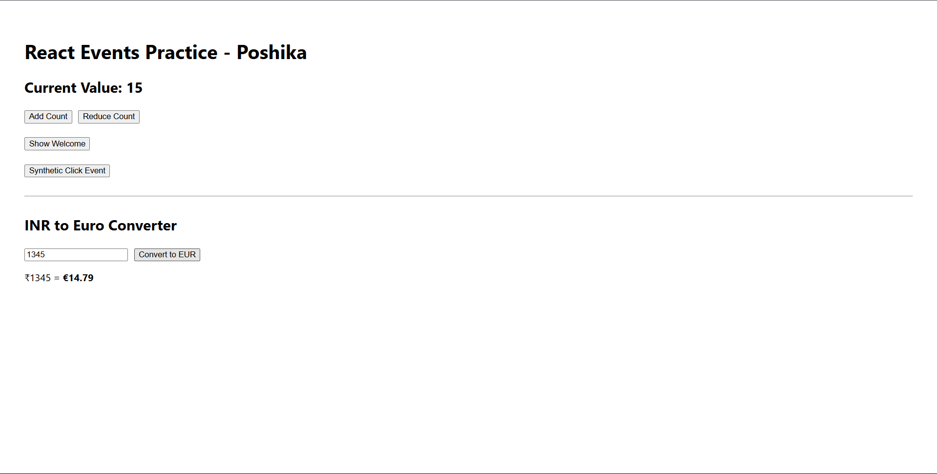

**Ex 12**

**App.js**

import React, { useState } from 'react';

import GuestView from './GuestView';

import MemberView from './MemberView';

const App = () => {

const [isUserLoggedIn, setIsUserLoggedIn] = useState(false);

const loginUser = () => setIsUserLoggedIn(true);

const logoutUser = () => setIsUserLoggedIn(false);

return (

<div style={{ padding: '40px', fontFamily: 'Verdana' }}>

<h1>✈️ Ticket Booking Portal</h1>

{isUserLoggedIn ? (

<MemberView onLogoutClick={logoutUser} />

) : (

<GuestView onLoginClick={loginUser} />

)}

</div>

);

};

export default App;

**GuestView.js**

import React from 'react';

const GuestView = ({ onLoginClick }) => {

return (

<div>

<h2>Available Flights</h2>

<table border="1" cellPadding="8">

<thead>

<tr>

<th>Flight</th>

<th>Route</th>

<th>Departure</th>

</tr>

</thead>

<tbody>

<tr>

<td>6E505</td>

<td>Hyderabad → Pune</td>

<td>6:00 AM</td>

</tr>

<tr>

<td>AI420</td>

<td>Delhi → Kolkata</td>

<td>9:45 PM</td>

</tr>

</tbody>

</table>

<br />

<button onClick={onLoginClick}>Login to Book</button>

</div>

);

};

export default GuestView;

**MemberView.js**

import React from 'react';

const MemberView = ({ onLogoutClick }) => {

return (

<div>

<h2>Book Your Flight Ticket</h2>

<div style={{ marginBottom: '15px' }}>

<label>Flight Code: </label>

<input type="text" placeholder="e.g., AI420" />

</div>

<div style={{ marginBottom: '15px' }}>

<label>Full Name: </label>

<input type="text" placeholder="e.g., Poshika Sharma" />

</div>

<button>Confirm Booking</button>

<br /><br />

<button onClick={onLogoutClick}>Logout</button>

</div>

);

};

export default MemberView;

**Output :**

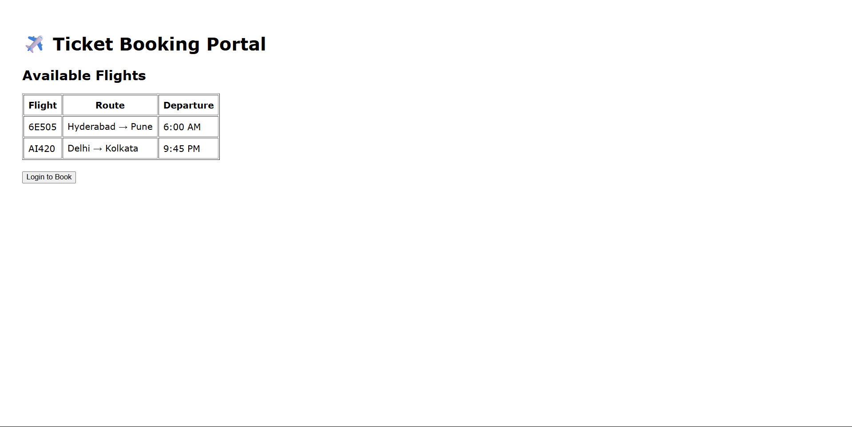

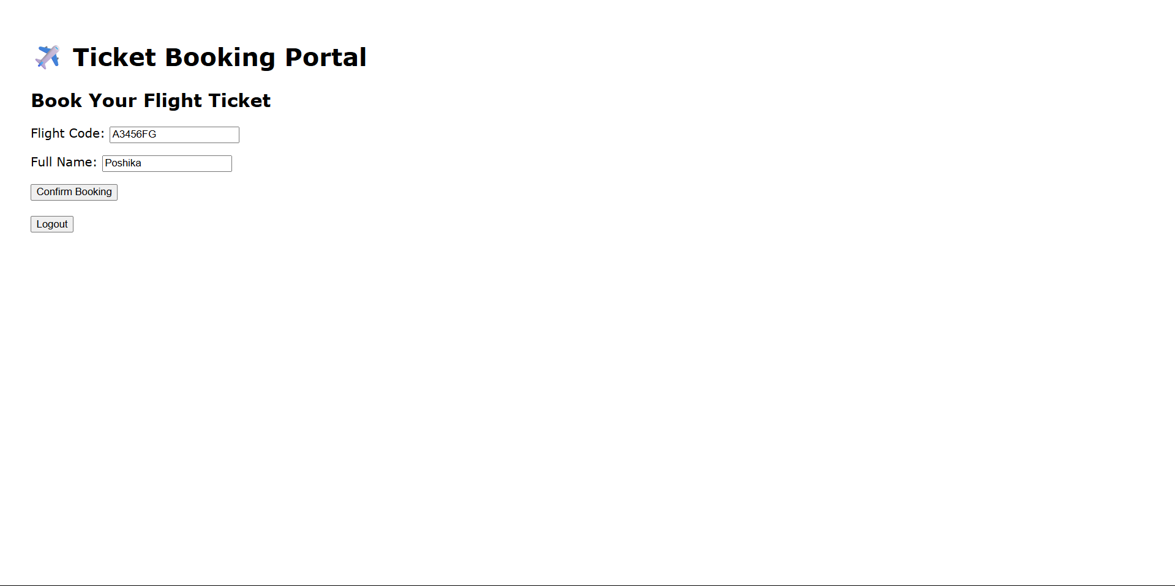

**Ex 13**

**App.js**

import React, { useState } from 'react';

import BookDetails from './BookDetails';

import BlogDetails from './BlogDetails';

import CourseDetails from './CourseDetails';

const App = () => {

const [selected, setSelected] = useState("");

return (

<div style={{ padding: "30px", fontFamily: "Segoe UI" }}>

<h1 style={{ color: "#333" }}>Blogger App</h1>

<div style={{ marginBottom: "20px" }}>

<button onClick={() => setSelected("book")} style={btnStyle}>Books</button>

<button onClick={() => setSelected("blog")} style={btnStyle}>Blogs</button>

<button onClick={() => setSelected("course")} style={btnStyle}>Courses</button>

</div>

<div style={{ borderTop: "1px solid #ccc", paddingTop: "20px" }}>

{selected === "book" && <BookDetails />}

{selected === "blog" && <BlogDetails />}

{selected === "course" && <CourseDetails />}

{selected === "" && <p>Please select a section to display.</p>}

</div>

</div>

);

};

const btnStyle = {

marginRight: "10px",

padding: "8px 16px",

border: "none",

backgroundColor: "#007bff",

color: "white",

borderRadius: "5px",

cursor: "pointer"

};

export default App;

**BookDetails.js**

import React from 'react';

const books = [

{ id: 1, title: "The Secret", author: "Rhonda Byrne" },

{ id: 2, title: "Deep Work", author: "Cal Newport" },

{ id: 3, title: "Think Like a Monk", author: "Jay Shetty" }

];

const BookDetails = () => {

return (

<div>

<h2 style={{ color: "#444" }}>Available Books</h2>

<ul>

{books.map(({ id, title, author }) => (

<li key={id} style={itemStyle}>

<strong>{title}</strong> — <span style={{ color: "#777" }}>{author}</span>

</li>

))}

</ul>

</div>

);

};

const itemStyle = {

padding: "6px 0",

fontSize: "16px"

};

export default BookDetails;

**BlogDetails.js**

import React from 'react';

const blogs = [

{ id: 1, title: "Mastering JavaScript", writer: "Poshika" },

{ id: 2, title: "Top 10 React Hooks", writer: "John Doe" }

];

const BlogDetails = () => {

return (

<div>

<h2 style={{ color: "#444" }}>Recent Blog Posts</h2>

{blogs.length ? (

<div>

{blogs.map(({ id, title, writer }) => (

<div key={id} style={cardStyle}>

<h4>{title}</h4>

<p style={{ margin: 0, color: "#666" }}>By {writer}</p>

</div>

))}

</div>

) : (

<p>No blogs available.</p>

)}

</div>

);

};

const cardStyle = {

backgroundColor: "#f8f8f8",

padding: "10px",

borderRadius: "6px",

marginBottom: "10px"

};

export default BlogDetails;

**CourseDetails.js**

import React from 'react';

const loggedIn = true;

const courses = ["React.js", "TypeScript", "GraphQL"];

const CourseDetails = () => {

let content;

switch (true) {

case !loggedIn:

content = <p>You need to login to see your courses.</p>;

break;

case courses.length === 0:

content = <p>No courses enrolled yet.</p>;

break;

default:

content = (

<ul>

{courses.map((course, index) => (

<li key={index} style={{ padding: "6px 0" }}>{course}</li>

))}

</ul>

);

break;

}

return (

<div>

<h2 style={{ color: "#444" }}>Enrolled Courses</h2>

{content}

</div>

);

};

export default CourseDetails;

**Output :**

