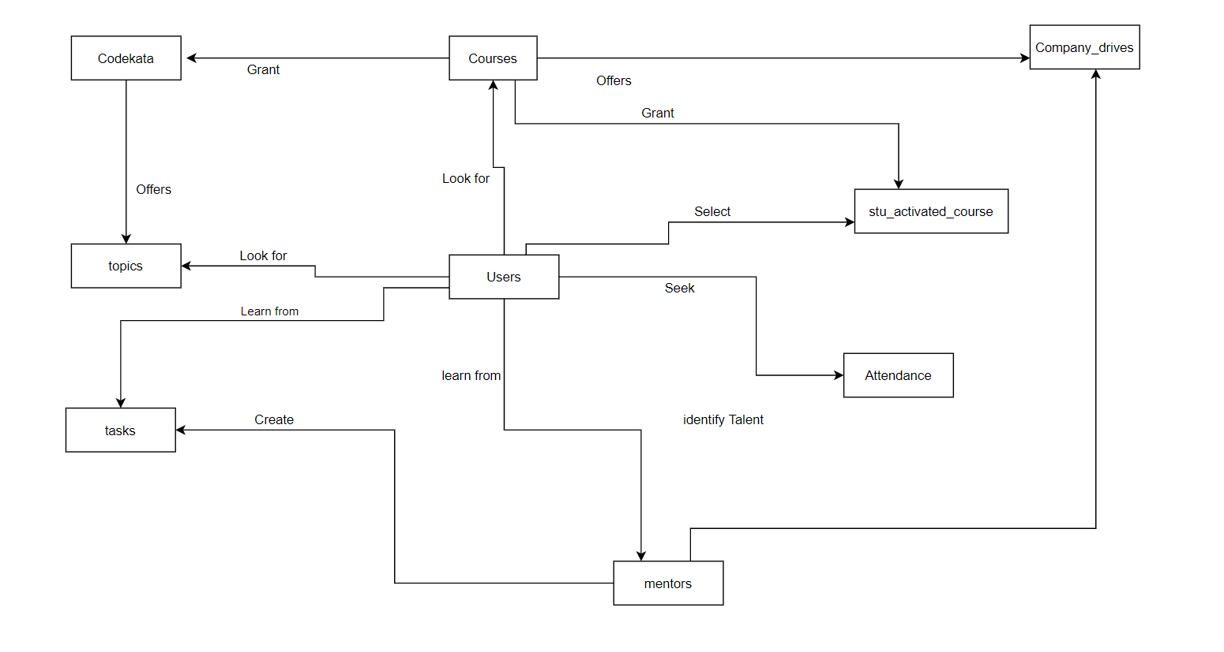

**Table Creation & Insertion**

**Table1**

create table Users(

User_id VARCHAR(20) NOT NULL,

Email VARCHAR(255) NOT NULL,

Name VARCHAR(255) NOT NULL,

Degree VARCHAR(25),

Mentor_name VARCHAR(25),

Course_name VARCHAR(25),

primary key(User_id)

)

Insert into Users values

("Swathi123","xyz@gmail.com","Swathi","Btech","Venkat","FullStack"),

("Swetha123","zzz@gmail.com","Swetha","BE","Venkat","FullStack"),

("Suma12","xxx@gmail.com","Suma","Btech","Ashik","FullStack"),

("Praveen1","xyy@gmail.com","Praveen","BE","Bala","Codeigniter"),

("Praveena1","ooyy@gmail.com","Praveena","Bsc","Balaji","OpenCart"),

("Selva98","yxx@gmail.com","Selva","Btech","Ashika","React JS");

**Table2**

create table Codekata(

User_id VARCHAR(20) NOT NULL ,

Prblm_solved INT(5) NOT NULL

)

Insert into Attendance values

("Swathi123",91),

("Praveen1",93),

("Selva98",99),

("Praveena1",93),

("Swetha123",95),

("Suma12",90);

**Table3**

create table Attendance(

user_id VARCHAR(20) NOT NULL ,

Attendance_Percentage int

)

Insert into Codekata values

("Swathi123",200),

("Praveen1",312),

("Selva98",100),

("Praveena1",78),

("Swetha123",209),

("Suma12",56);

**Table4**

create table Topics(

Course_name VARCHAR(20) NOT NULL,

Topics VARCHAR(20)NOT NULL

);

Insert into Topics values

( "Fullstack","MEAN"),

("Fullstack","LAMP"),

("Fullstack","MERN"),

("FronEnd","HTML,CSS"),

("Backend","JS")

**Table5**

create table Tasks(

user_id VARCHAR(20) NOT NULL ,

Task_name VARCHAR(255) ,

Submitted_date VARCHAR(15)

)

Insert into Tasks values

("Swathi123","Counter","28-08-2020"),

("Praveen1","Calc","09-08-2020"),

("Selva98","Calci","12-2-2020"),

("Praveena1","Docs","23-12-2020"),

("Swetha123","Resume","02-08-2020"),

("Suma12","Newpaper","19-09-2020");

**Table6**

create table Company_drives(

user_id VARCHAR(20) NOT NULL ,

Name VARCHAR(255) NOT NULL,

Drives_Attended INT

)

Insert into Company_drives values

("Swathi123","Swathi",3),

("Praveen1","Praveen",5),

("Selva98","Selva",9),

("Praveena1","Praveena",2),

("Swetha123","Swetha",5),

("Suma12","Suma",1);

**Table7**

create table Mentors(

Name VARCHAR(255) NOT NULL,

Students_Assigned VARCHAR(20)

)

Insert into Mentors values

("Venkat","Swathi"),

("Ashik","Suma"),

("Bala","Praveen"),

("Balaji","Praveena"),

("Ashika","Selva"),

("Arun","Sonam");

**Table8**

create table Students_activated_courses(

'user_id' int(20) NOT NULL ,

Activated_course VARCHAR(255) NOT NULL,

Course_Id VARCHAR(20)

)

Insert into Students_activated_courses values

("Swathi123","FullStack","FS1"),

("Swetha123","FullStack","FS1"),

("Suma12","FullStack","FS1"),

("Praveen1","Codeigniter","Code1"),

("Praveena1","React JS","RJ1"),

("Sureshi123","FullStack","FS1"),

("Som23","FullStack","FS1"),

("Swapna","FullStack","FS1"),

("Praveen1","Codeigniter","Code1"),

("Selva98","React JS","RJ1");

**Table9**

create table Courses(

Course_name VARCHAR

Fees INT,

Course_Id VARCHAR(20)

)

Insert into Courses values

("FullStack",70000,"FS1"),

("FullStack",70000,"FS2"),

("Codeigniter",2000,"Code1"),

("OpenCart",1800,"O01")

("React JS",3000,"RJ1"),

("Php",1500,"PHP01");

**Queries**

SELECT User_id, Name,Prblm_solved

FROM Codekata

INNER JOIN Users

ON Codekata.User_id =Users.User_id;

SELECT User_id, Name,Drives_Attended

FROM Company_drives

SELECT User_id,Activated_course,Course_Id,Course_name,Fees

FROM Students_activated_courses join Courses

WHERE Courses.Course_Id=Students_activated_courses.Course_Id

GROUP BY Courses.Course_name

SELECT Name

FROM Mentors

SELECT Name,Students_Assigned

FROM Mentors