**Exercise 1: Control Structures**

-- STEP 1: Create Tables

CREATE TABLE customers (

customer_id NUMBER PRIMARY KEY,

name VARCHAR2(100),

age NUMBER,

balance NUMBER,

interest_rate NUMBER(5,2),

IsVIP VARCHAR2(5)

);

CREATE TABLE loans (

loan_id NUMBER PRIMARY KEY,

customer_id NUMBER,

due_date DATE,

FOREIGN KEY (customer_id) REFERENCES customers(customer_id)

);

/

-- STEP 2: Insert Sample Data

INSERT INTO customers VALUES (1, 'John Doe', 65, 12000, 8.5, 'FALSE');

INSERT INTO customers VALUES (2, 'Jane Smith', 45, 9000, 7.5, 'FALSE');

INSERT INTO customers VALUES (3, 'Mary Brown', 70, 15000, 9.0, 'FALSE');

INSERT INTO loans VALUES (101, 1, SYSDATE + 10); -- Due in 10 days

INSERT INTO loans VALUES (102, 2, SYSDATE + 40); -- Due in 40 days

INSERT INTO loans VALUES (103, 3, SYSDATE + 5); -- Due in 5 days

COMMIT;

/

-- STEP 3: Scenario 1 - Apply 1% Discount for Customers Over 60

BEGIN

FOR cust_rec IN (SELECT customer_id, interest_rate, age FROM customers) LOOP

IF cust_rec.age > 60 THEN

UPDATE customers

SET interest_rate = interest_rate - 1

WHERE customer_id = cust_rec.customer_id;

END IF;

END LOOP;

COMMIT;

END;

/

-- STEP 4: Scenario 2 - Promote Customers to VIP Based on Balance

BEGIN

FOR bal_rec IN (SELECT customer_id, balance FROM customers) LOOP

IF bal_rec.balance > 10000 THEN

UPDATE customers

SET IsVIP = 'TRUE'

WHERE customer_id = bal_rec.customer_id;

END IF;

END LOOP;

COMMIT;

END;

/

-- STEP 5: Scenario 3 - Send Loan Reminders (Due in Next 30 Days)

BEGIN

FOR loan_rec IN (

SELECT loan_id, customer_id, due_date

FROM loans

WHERE due_date <= SYSDATE + 30

) LOOP

DECLARE

customer_name customers.name%TYPE;

BEGIN

SELECT name INTO customer_name

FROM customers

WHERE customer_id = loan_rec.customer_id;

DBMS_OUTPUT.PUT_LINE('Reminder: Loan ID ' || loan_rec.loan_id ||

' for customer ' || customer_name ||

' is due on ' || TO_CHAR(loan_rec.due_date, 'DD-Mon-YYYY'));

END;

END LOOP;

END;

/

**OUTPUT**

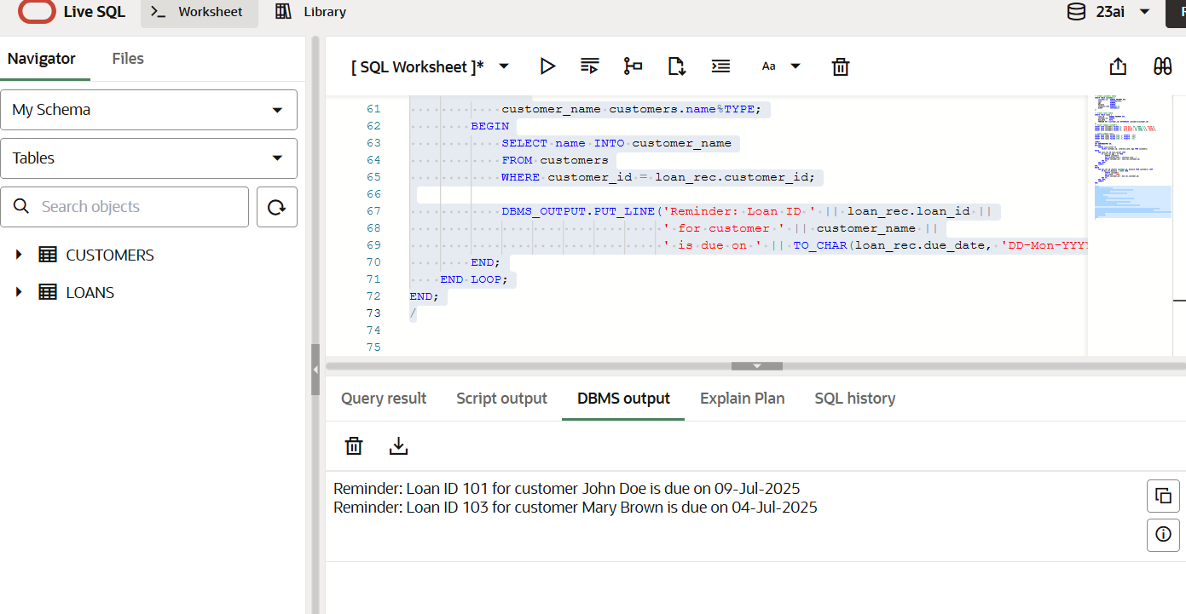

**Exercise 2: Error Handling**

-- ===========================

-- STEP 1: CREATE TABLES

-- ===========================

CREATE TABLE accounts (

acc_id NUMBER PRIMARY KEY,

acc_name VARCHAR2(100),

balance NUMBER

);

CREATE TABLE employees (

emp_id NUMBER PRIMARY KEY,

emp_name VARCHAR2(100),

salary NUMBER

);

CREATE TABLE customers (

cust_id NUMBER PRIMARY KEY,

cust_name VARCHAR2(100),

age NUMBER

);

CREATE TABLE log_table (

log_id NUMBER GENERATED ALWAYS AS IDENTITY PRIMARY KEY,

log_time TIMESTAMP DEFAULT SYSTIMESTAMP,

message VARCHAR2(4000)

);

/

-- ===========================

-- STEP 2: INSERT SAMPLE DATA

-- ===========================

INSERT INTO accounts VALUES (1, 'Alice', 5000);

INSERT INTO accounts VALUES (2, 'Bob', 2000);

INSERT INTO employees VALUES (101, 'John', 30000);

COMMIT;

/

-- ===========================

-- STEP 3: PROCEDURE 1 - SafeTransferFunds

-- ===========================

CREATE OR REPLACE PROCEDURE SafeTransferFunds(

p_from_acc IN NUMBER,

p_to_acc IN NUMBER,

p_amount IN NUMBER

)

IS

v_balance NUMBER;

v_message VARCHAR2(4000);

BEGIN

SELECT balance INTO v_balance FROM accounts WHERE acc_id = p_from_acc;

IF v_balance < p_amount THEN

RAISE_APPLICATION_ERROR(-20001, 'Insufficient funds');

END IF;

UPDATE accounts SET balance = balance - p_amount WHERE acc_id = p_from_acc;

UPDATE accounts SET balance = balance + p_amount WHERE acc_id = p_to_acc;

COMMIT;

EXCEPTION

WHEN OTHERS THEN

ROLLBACK;

v_message := 'Transfer failed from account ' || TO_CHAR(p_from_acc) ||

' to account ' || TO_CHAR(p_to_acc) || ': ' || SQLERRM;

INSERT INTO log_table(message) VALUES(v_message);

END;

/

-- ===========================

-- STEP 4: PROCEDURE 2 - UpdateSalary

-- ===========================

CREATE OR REPLACE PROCEDURE UpdateSalary(

p_emp_id IN NUMBER,

p_percent IN NUMBER

)

IS

v_message VARCHAR2(4000);

BEGIN

UPDATE employees

SET salary = salary + (salary * p_percent / 100)

WHERE emp_id = p_emp_id;

IF SQL%ROWCOUNT = 0 THEN

RAISE_APPLICATION_ERROR(-20002, 'Employee not found');

END IF;

COMMIT;

EXCEPTION

WHEN OTHERS THEN

ROLLBACK;

v_message := 'Salary update failed for emp_id ' || TO_CHAR(p_emp_id) || ': ' || SQLERRM;

INSERT INTO log_table(message) VALUES (v_message);

END;

/

-- ===========================

-- STEP 5: PROCEDURE 3 - AddNewCustomer

-- ===========================

CREATE OR REPLACE PROCEDURE AddNewCustomer(

p_cust_id IN NUMBER,

p_cust_name IN VARCHAR2,

p_age IN NUMBER

)

IS

v_message VARCHAR2(4000);

BEGIN

INSERT INTO customers(cust_id, cust_name, age)

VALUES(p_cust_id, p_cust_name, p_age);

COMMIT;

EXCEPTION

WHEN DUP_VAL_ON_INDEX THEN

v_message := 'Customer ID ' || TO_CHAR(p_cust_id) || ' already exists.';

INSERT INTO log_table(message) VALUES(v_message);

WHEN OTHERS THEN

v_message := 'Add customer failed for cust_id ' || TO_CHAR(p_cust_id) || ': ' || SQLERRM;

INSERT INTO log_table(message) VALUES(v_message);

END;

/

-- ===========================

-- STEP 6: TEST PROCEDURES

-- ===========================

-- Transfer funds from Alice to Bob

EXEC SafeTransferFunds(1, 2, 1000);

-- Update John's salary by 10%

EXEC UpdateSalary(101, 10);

-- Add a new customer (should succeed)

EXEC AddNewCustomer(201, 'Alice Smith', 28);

-- Add same customer again (should log error)

EXEC AddNewCustomer(201, 'Duplicate Entry', 40);

-- ===========================

-- STEP 7: VIEW LOGS AND DATA

-- ===========================

-- Check accounts

SELECT * FROM accounts;

-- Check employees

SELECT * FROM employees;

-- Check customers

SELECT * FROM customers;

-- Check log table

SELECT * FROM log_table ORDER BY log_time DESC;

**OUTPUT**

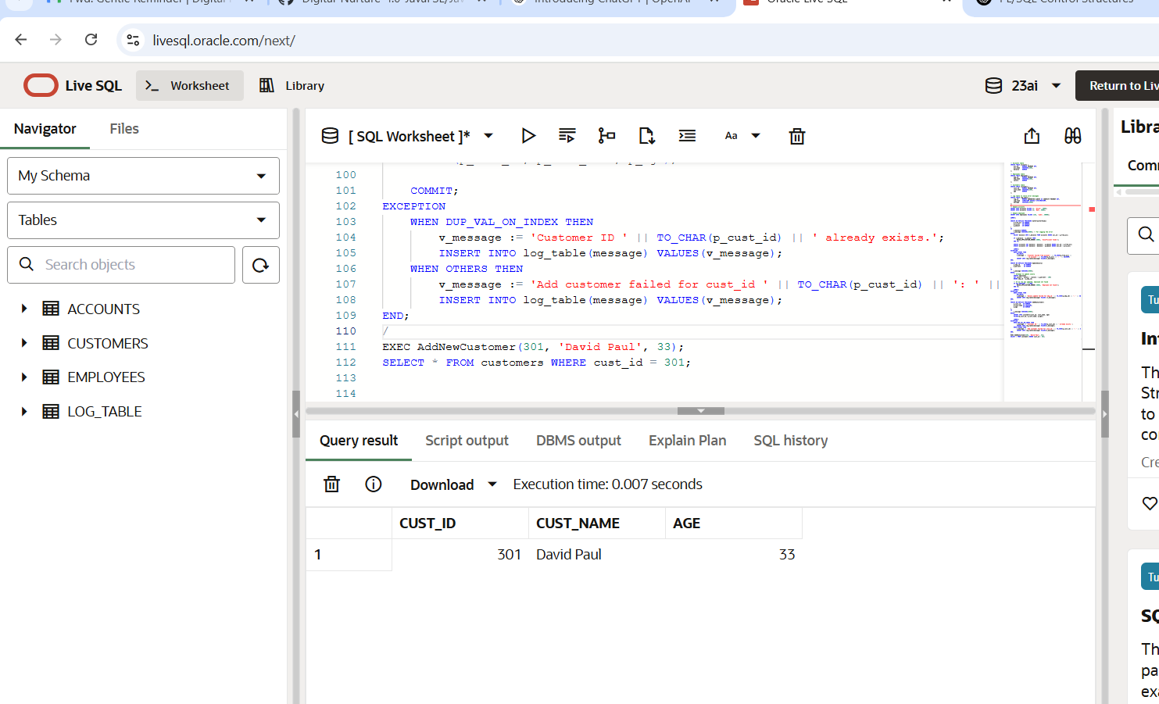

**Exercise 3: Stored Procedures**

-- =======================================

-- STEP 1: Create Tables (if not existing)

-- =======================================

-- Accounts table

CREATE TABLE accounts (

acc_id NUMBER PRIMARY KEY,

acc_type VARCHAR2(20), -- 'savings' or 'current'

acc_name VARCHAR2(100),

balance NUMBER

);

-- Employees table

CREATE TABLE employees (

emp_id NUMBER PRIMARY KEY,

emp_name VARCHAR2(100),

department VARCHAR2(50),

salary NUMBER

);

-- Log table

CREATE TABLE log_table (

log_id NUMBER GENERATED ALWAYS AS IDENTITY PRIMARY KEY,

log_time TIMESTAMP DEFAULT SYSTIMESTAMP,

message VARCHAR2(4000)

);

/

-- =======================================

-- STEP 2: Insert Sample Data

-- =======================================

-- Insert savings and current accounts

INSERT INTO accounts VALUES (1, 'savings', 'Alice', 10000);

INSERT INTO accounts VALUES (2, 'savings', 'Bob', 5000);

INSERT INTO accounts VALUES (3, 'current', 'Charlie', 8000);

-- Insert employees

INSERT INTO employees VALUES (101, 'John', 'HR', 30000);

INSERT INTO employees VALUES (102, 'Priya', 'IT', 40000);

INSERT INTO employees VALUES (103, 'David', 'IT', 45000);

COMMIT;

/

-- =======================================

-- STEP 3: PROCEDURE - ProcessMonthlyInterest

-- =======================================

CREATE OR REPLACE PROCEDURE ProcessMonthlyInterest

IS

BEGIN

UPDATE accounts

SET balance = balance + (balance * 0.01)

WHERE acc_type = 'savings';

COMMIT;

END;

/

-- =======================================

-- STEP 4: PROCEDURE - UpdateEmployeeBonus

-- =======================================

CREATE OR REPLACE PROCEDURE UpdateEmployeeBonus(

p_department IN VARCHAR2,

p_bonus_percent IN NUMBER

)

IS

v_message VARCHAR2(4000);

BEGIN

UPDATE employees

SET salary = salary + (salary * p_bonus_percent / 100)

WHERE department = p_department;

IF SQL%ROWCOUNT = 0 THEN

v_message := 'No employees found in department: ' || p_department;

INSERT INTO log_table(message) VALUES(v_message);

ELSE

COMMIT;

END IF;

EXCEPTION

WHEN OTHERS THEN

ROLLBACK;

v_message := 'Bonus update failed for department ' || p_department || ': ' || SQLERRM;

INSERT INTO log_table(message) VALUES(v_message);

END;

/

-- =======================================

-- STEP 5: PROCEDURE - TransferFunds

-- =======================================

CREATE OR REPLACE PROCEDURE TransferFunds(

p_from_acc IN NUMBER,

p_to_acc IN NUMBER,

p_amount IN NUMBER

)

IS

v_balance NUMBER;

v_message VARCHAR2(4000);

BEGIN

SELECT balance INTO v_balance FROM accounts WHERE acc_id = p_from_acc;

IF v_balance < p_amount THEN

RAISE_APPLICATION_ERROR(-20001, 'Insufficient funds');

END IF;

UPDATE accounts SET balance = balance - p_amount WHERE acc_id = p_from_acc;

UPDATE accounts SET balance = balance + p_amount WHERE acc_id = p_to_acc;

COMMIT;

EXCEPTION

WHEN OTHERS THEN

ROLLBACK;

v_message := 'Transfer failed from account ' || TO_CHAR(p_from_acc) ||

' to account ' || TO_CHAR(p_to_acc) || ': ' || SQLERRM;

INSERT INTO log_table(message) VALUES(v_message);

END;

/

-- =======================================

-- STEP 6: TEST THE PROCEDURES

-- =======================================

-- Apply interest to all savings accounts

EXEC ProcessMonthlyInterest;

-- Give 5% bonus to IT department

EXEC UpdateEmployeeBonus('IT', 5);

-- Transfer 2000 from Alice to Bob

EXEC TransferFunds(1, 2, 2000);

-- Test error: Transfer too much

EXEC TransferFunds(3, 2, 9000);

-- =======================================

-- STEP 7: VIEW TABLES

-- =======================================

-- View account balances

SELECT * FROM accounts;

-- View employee salaries

SELECT * FROM employees;

-- View logged errors

SELECT * FROM log_table ORDER BY log_time DESC;

**OUTPUT**

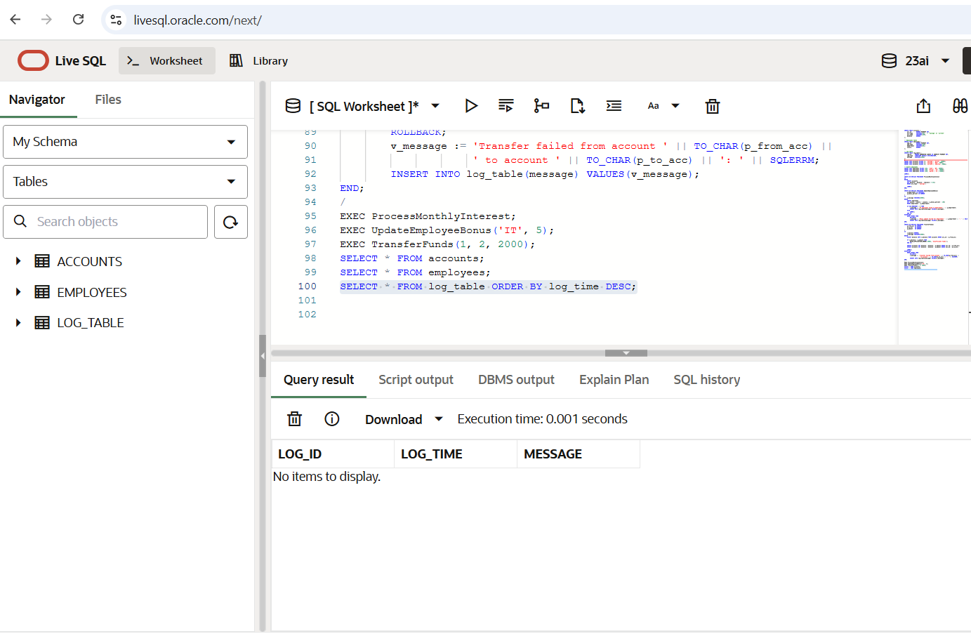

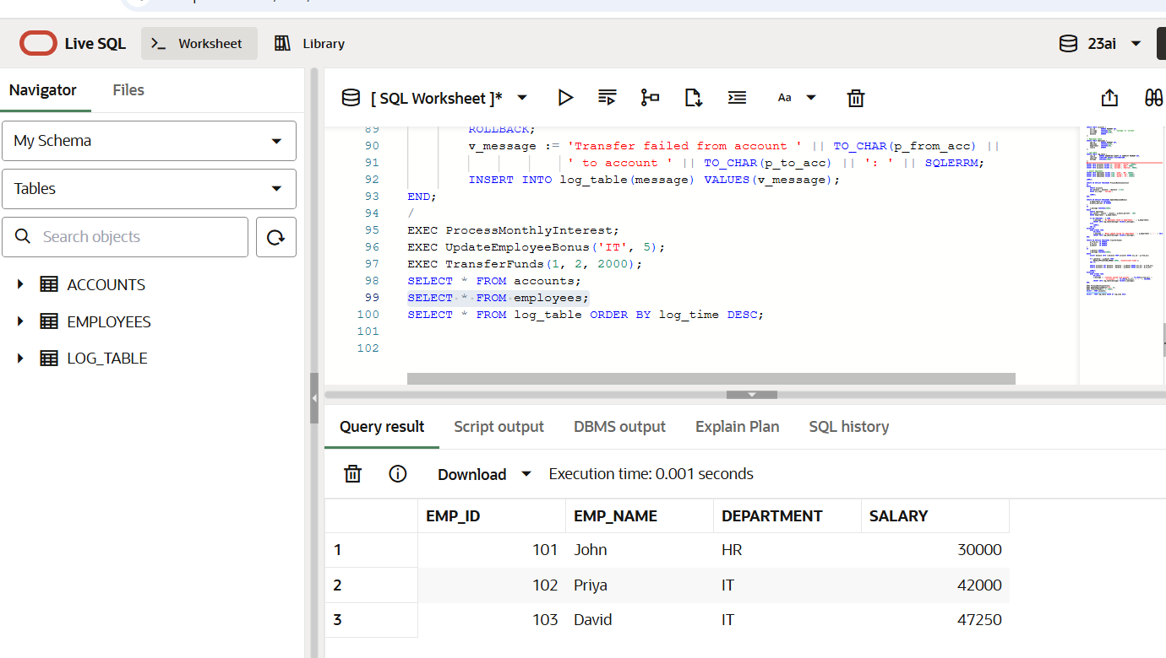

**Exercise 4: Functions**

-- ======================================

-- STEP 1: Table Setup (if not already created)

-- ======================================

-- Customers table with date of birth

CREATE TABLE customers (

cust_id NUMBER PRIMARY KEY,

cust_name VARCHAR2(100),

dob DATE

);

-- Accounts table with balances

CREATE TABLE accounts (

acc_id NUMBER PRIMARY KEY,

acc_name VARCHAR2(100),

balance NUMBER

);

/

-- ======================================

-- STEP 2: Insert Sample Data

-- ======================================

-- Insert sample customers

INSERT INTO customers VALUES (101, 'Alice', TO_DATE('1985-05-10', 'YYYY-MM-DD'));

INSERT INTO customers VALUES (102, 'Bob', TO_DATE('2000-08-20', 'YYYY-MM-DD'));

-- Insert sample accounts

INSERT INTO accounts VALUES (1, 'Alice', 8000);

INSERT INTO accounts VALUES (2, 'Bob', 3000);

COMMIT;

/

-- ======================================

-- STEP 3: FUNCTION - CalculateAge

-- ======================================

CREATE OR REPLACE FUNCTION CalculateAge(p_dob DATE)

RETURN NUMBER

IS

v_age NUMBER;

BEGIN

v_age := TRUNC(MONTHS_BETWEEN(SYSDATE, p_dob) / 12);

RETURN v_age;

END;

/

-- Example usage:

-- SELECT CalculateAge(TO_DATE('1990-01-01','YYYY-MM-DD')) FROM dual;

-- ======================================

-- STEP 4: FUNCTION - CalculateMonthlyInstallment

-- Formula: EMI = [P * R * (1+R)^N] / [(1+R)^N - 1]

-- Where:

-- P = loan amount

-- R = monthly interest rate (annual rate / 12 / 100)

-- N = number of monthly payments (years * 12)

CREATE OR REPLACE FUNCTION CalculateMonthlyInstallment(

p_loan_amount NUMBER,

p_annual_interest NUMBER,

p_years NUMBER

)

RETURN NUMBER

IS

r NUMBER := p_annual_interest / 12 / 100;

n NUMBER := p_years * 12;

emi NUMBER;

BEGIN

IF r = 0 THEN

emi := p_loan_amount / n;

ELSE

emi := p_loan_amount * r * POWER(1 + r, n) / (POWER(1 + r, n) - 1);

END IF;

RETURN ROUND(emi, 2);

END;

/

-- Example usage:

-- SELECT CalculateMonthlyInstallment(100000, 10, 5) FROM dual;

-- ======================================

-- STEP 5: FUNCTION - HasSufficientBalance

-- ======================================

CREATE OR REPLACE FUNCTION HasSufficientBalance(

p_acc_id IN NUMBER,

p_amount IN NUMBER

)

RETURN BOOLEAN

IS

v_balance NUMBER;

BEGIN

SELECT balance INTO v_balance FROM accounts WHERE acc_id = p_acc_id;

RETURN v_balance >= p_amount;

EXCEPTION

WHEN NO_DATA_FOUND THEN

RETURN FALSE;

END;

/

-- Example usage (in PL/SQL block):

-- DECLARE

-- result BOOLEAN;

-- BEGIN

-- result := HasSufficientBalance(1, 5000);

-- IF result THEN

-- DBMS_OUTPUT.PUT_LINE('Sufficient balance');

-- ELSE

-- DBMS_OUTPUT.PUT_LINE('Insufficient balance');

-- END IF;

-- END;

-- /

-- ======================================

-- STEP 6: TEST FUNCTION CALLS

-- ======================================

-- Age of Alice

SELECT cust_name, CalculateAge(dob) AS age FROM customers;

-- Calculate EMI

SELECT CalculateMonthlyInstallment(500000, 7.5, 10) AS Monthly_EMI FROM dual;

-- Check balance

DECLARE

result BOOLEAN;

BEGIN

result := HasSufficientBalance(1, 6000);

IF result THEN

DBMS_OUTPUT.PUT_LINE('Account 1: Sufficient balance');

ELSE

DBMS_OUTPUT.PUT_LINE('Account 1: Insufficient balance');

END IF;

END;

/

**OUTPUT**

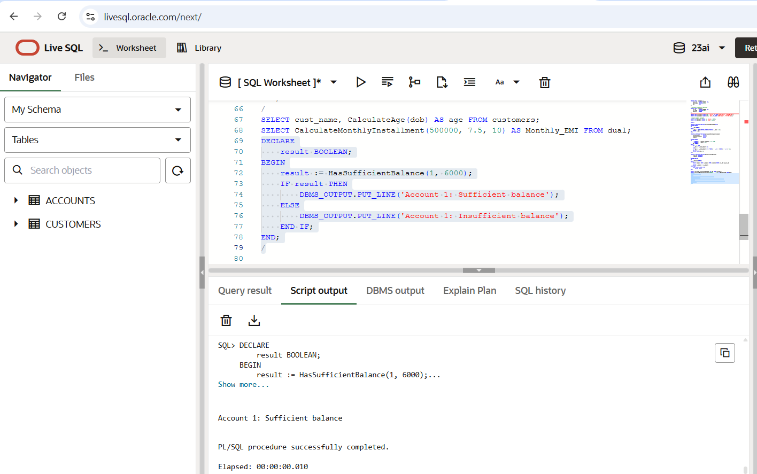

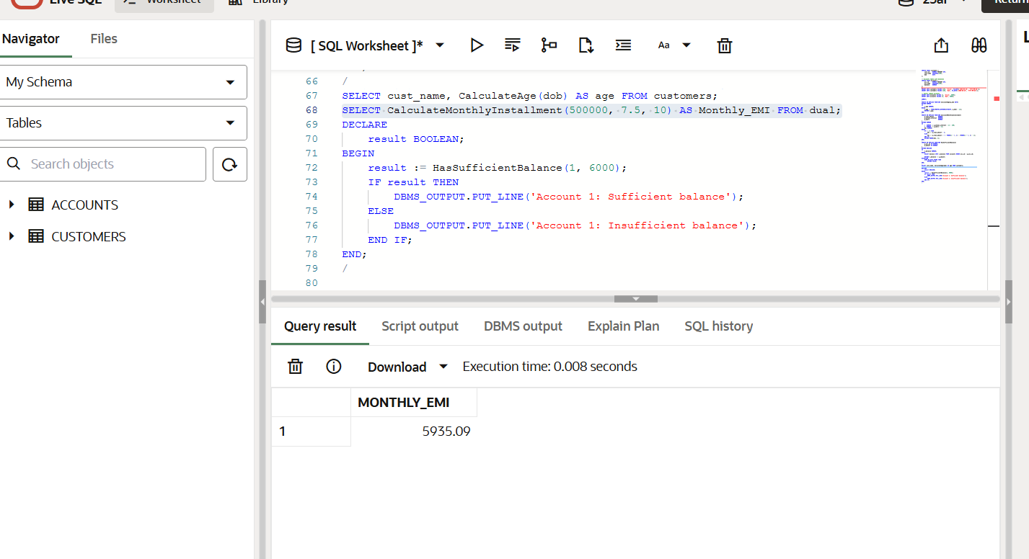

**Exercise 5: Triggers**

-- ======================================

-- STEP 1: Create Tables

-- ======================================

CREATE TABLE customers (

cust_id NUMBER PRIMARY KEY,

cust_name VARCHAR2(100),

dob DATE,

last_modified DATE

);

CREATE TABLE transactions (

trans_id NUMBER GENERATED ALWAYS AS IDENTITY PRIMARY KEY,

acc_id NUMBER,

trans_type VARCHAR2(20), -- 'deposit' or 'withdrawal'

amount NUMBER,

trans_date DATE DEFAULT SYSDATE

);

CREATE TABLE accounts (

acc_id NUMBER PRIMARY KEY,

acc_name VARCHAR2(100),

balance NUMBER

);

CREATE TABLE audit_log (

audit_id NUMBER GENERATED ALWAYS AS IDENTITY PRIMARY KEY,

action_time TIMESTAMP DEFAULT SYSTIMESTAMP,

trans_id NUMBER,

acc_id NUMBER,

trans_type VARCHAR2(20),

amount NUMBER

);

/

-- ======================================

-- STEP 2: Insert Sample Data

-- ======================================

INSERT INTO customers VALUES (1, 'Alice', TO_DATE('1985-05-10','YYYY-MM-DD'), NULL);

INSERT INTO customers VALUES (2, 'Bob', TO_DATE('2000-08-20','YYYY-MM-DD'), NULL);

INSERT INTO accounts VALUES (1, 'Alice', 10000);

INSERT INTO accounts VALUES (2, 'Bob', 5000);

COMMIT;

/

-- ======================================

-- STEP 3: Trigger - UpdateCustomerLastModified

-- ======================================

CREATE OR REPLACE TRIGGER UpdateCustomerLastModified

BEFORE UPDATE ON customers

FOR EACH ROW

BEGIN

:NEW.last_modified := SYSDATE;

END;

/

-- ======================================

-- STEP 4: Trigger - LogTransaction

-- ======================================

CREATE OR REPLACE TRIGGER LogTransaction

AFTER INSERT ON transactions

FOR EACH ROW

BEGIN

INSERT INTO audit_log(trans_id, acc_id, trans_type, amount)

VALUES(:NEW.trans_id, :NEW.acc_id, :NEW.trans_type, :NEW.amount);

END;

/

-- ======================================

-- STEP 5: Trigger - CheckTransactionRules

-- ======================================

CREATE OR REPLACE TRIGGER CheckTransactionRules

BEFORE INSERT ON transactions

FOR EACH ROW

DECLARE

v_balance NUMBER;

BEGIN

-- Check if amount is positive

IF :NEW.amount <= 0 THEN

RAISE_APPLICATION_ERROR(-20001, 'Amount must be greater than zero');

END IF;

-- Check withdrawal rules

IF :NEW.trans_type = 'withdrawal' THEN

SELECT balance INTO v_balance FROM accounts WHERE acc_id = :NEW.acc_id;

IF :NEW.amount > v_balance THEN

RAISE_APPLICATION_ERROR(-20002, 'Insufficient balance for withdrawal');

END IF;

END IF;

END;

/

-- ======================================

-- STEP 6: Test the Triggers

-- ======================================

-- Update customer to see last_modified change

UPDATE customers SET cust_name = 'Alice Updated' WHERE cust_id = 1;

-- Valid deposit (should be logged)

INSERT INTO transactions(acc_id, trans_type, amount) VALUES (1, 'deposit', 500);

-- Invalid withdrawal (should raise error)

-- INSERT INTO transactions(acc_id, trans_type, amount) VALUES (1, 'withdrawal', 999999); -- Uncomment to test

-- ======================================

-- STEP 7: View Results

-- ======================================

-- Check customer last modified

SELECT cust_id, cust_name, last_modified FROM customers;

-- Check all transactions

SELECT * FROM transactions;

-- Check audit log

SELECT * FROM audit_log;

**OUTPUT**

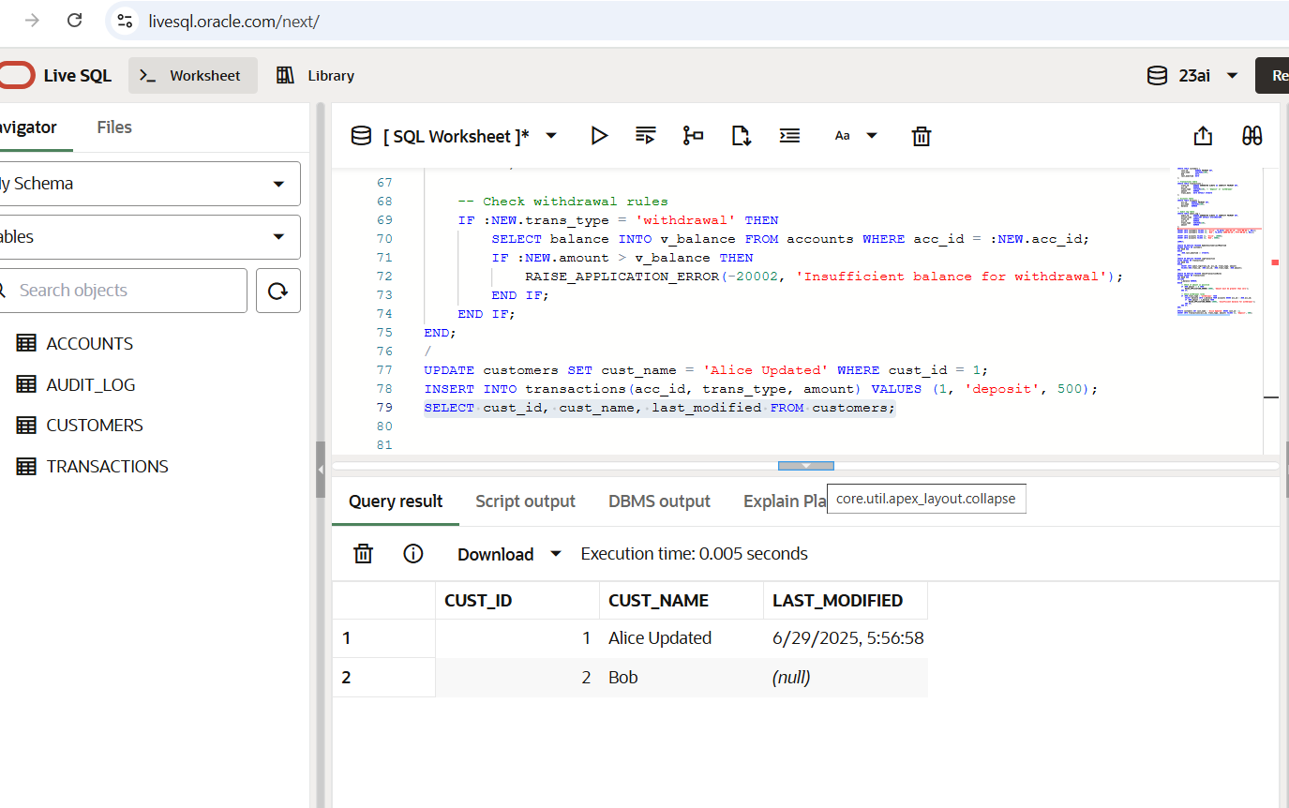

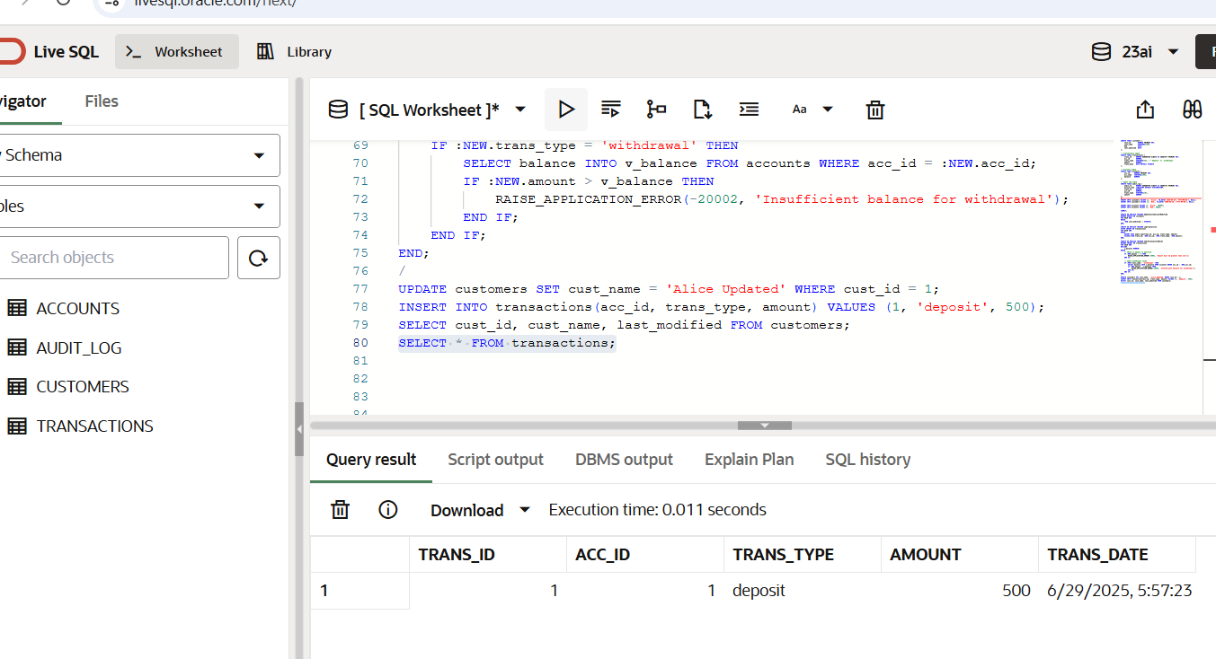

**Exercise 6: Cursors**

-- ============================================

-- STEP 1: TABLE SETUP

-- ============================================

CREATE TABLE transactions (

trans_id NUMBER GENERATED ALWAYS AS IDENTITY PRIMARY KEY,

cust_id NUMBER,

acc_id NUMBER,

trans_type VARCHAR2(20), -- deposit / withdrawal

amount NUMBER,

trans_date DATE

);

CREATE TABLE customers (

cust_id NUMBER PRIMARY KEY,

cust_name VARCHAR2(100)

);

CREATE TABLE accounts (

acc_id NUMBER PRIMARY KEY,

cust_id NUMBER,

balance NUMBER

);

CREATE TABLE loans (

loan_id NUMBER PRIMARY KEY,

cust_id NUMBER,

principal NUMBER,

interest_rate NUMBER -- in percent

);

/

-- ============================================

-- STEP 2: SAMPLE DATA

-- ============================================

-- Insert customers

INSERT INTO customers VALUES (1, 'Alice');

INSERT INTO customers VALUES (2, 'Bob');

-- Insert accounts

INSERT INTO accounts VALUES (101, 1, 10000);

INSERT INTO accounts VALUES (102, 2, 8000);

-- Insert transactions

INSERT INTO transactions (cust_id, acc_id, trans_type, amount, trans_date) VALUES (1, 101, 'deposit', 2000, SYSDATE);

INSERT INTO transactions (cust_id, acc_id, trans_type, amount, trans_date) VALUES (1, 101, 'withdrawal', 1000, SYSDATE - 20);

INSERT INTO transactions (cust_id, acc_id, trans_type, amount, trans_date) VALUES (2, 102, 'deposit', 3000, SYSDATE);

-- Insert loans

INSERT INTO loans VALUES (1, 1, 50000, 8.5);

INSERT INTO loans VALUES (2, 2, 75000, 9.0);

COMMIT;

/

-- ============================================

-- SCENARIO 1: GenerateMonthlyStatements

-- ============================================

DECLARE

CURSOR c_statements IS

SELECT c.cust_name, t.acc_id, t.trans_type, t.amount, t.trans_date

FROM transactions t

JOIN customers c ON t.cust_id = c.cust_id

WHERE TO_CHAR(t.trans_date, 'MMYYYY') = TO_CHAR(SYSDATE, 'MMYYYY')

ORDER BY c.cust_name, t.trans_date;

v_name customers.cust_name%TYPE;

v_acc_id transactions.acc_id%TYPE;

v_type transactions.trans_type%TYPE;

v_amt transactions.amount%TYPE;

v_date transactions.trans_date%TYPE;

BEGIN

DBMS_OUTPUT.PUT_LINE('--- Monthly Statements ---');

FOR rec IN c_statements LOOP

v_name := rec.cust_name;

v_acc_id := rec.acc_id;

v_type := rec.trans_type;

v_amt := rec.amount;

v_date := rec.trans_date;

DBMS_OUTPUT.PUT_LINE('Customer: ' || v_name || ', Account: ' || v_acc_id ||

', ' || v_type || ': ' || v_amt || ', Date: ' || TO_CHAR(v_date, 'DD-MON-YYYY'));

END LOOP;

END;

/

-- ============================================

-- SCENARIO 2: ApplyAnnualFee

-- ============================================

DECLARE

CURSOR c_accounts IS

SELECT acc_id, balance FROM accounts;

v_acc_id accounts.acc_id%TYPE;

v_balance accounts.balance%TYPE;

v_fee CONSTANT NUMBER := 500;

BEGIN

FOR rec IN c_accounts LOOP

v_acc_id := rec.acc_id;

v_balance := rec.balance;

IF v_balance >= v_fee THEN

UPDATE accounts SET balance = balance - v_fee WHERE acc_id = v_acc_id;

DBMS_OUTPUT.PUT_LINE('Annual fee of ' || v_fee || ' applied to Account ' || v_acc_id);

ELSE

DBMS_OUTPUT.PUT_LINE('Account ' || v_acc_id || ' has insufficient balance for annual fee.');

END IF;

END LOOP;

COMMIT;

END;

/

-- ============================================

-- SCENARIO 3: UpdateLoanInterestRates

-- ============================================

DECLARE

CURSOR c_loans IS

SELECT loan_id, interest_rate FROM loans;

v_loan_id loans.loan_id%TYPE;

v_interest loans.interest_rate%TYPE;

BEGIN

FOR rec IN c_loans LOOP

v_loan_id := rec.loan_id;

v_interest := rec.interest_rate;

-- Example rule: reduce 0.5% if current interest > 8.5%

IF v_interest > 8.5 THEN

UPDATE loans

SET interest_rate = interest_rate - 0.5

WHERE loan_id = v_loan_id;

DBMS_OUTPUT.PUT_LINE('Loan ' || v_loan_id || ': Interest reduced to ' || (v_interest - 0.5));

ELSE

DBMS_OUTPUT.PUT_LINE('Loan ' || v_loan_id || ': No change.');

END IF;

END LOOP;

COMMIT;

END;

/

-- ============================================

-- VIEW RESULTS

-- ============================================

-- Check account balances after fee

SELECT * FROM accounts;

-- Check loan interest updates

SELECT * FROM loans;

-- Optional: Check current month transactions

SELECT * FROM transactions WHERE TO_CHAR(trans_date, 'MMYYYY') = TO_CHAR(SYSDATE, 'MMYYYY');

**OUTPUT**

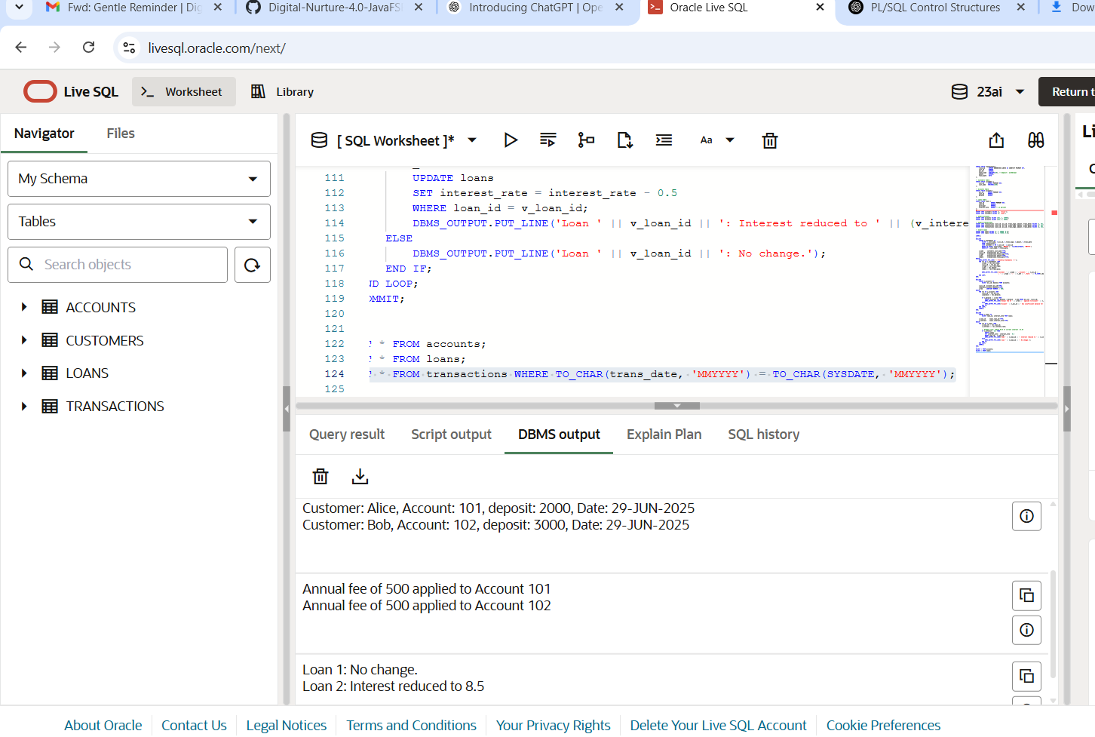

**Exercise 7: Packages**

-- ============================================================

-- STEP 1: CREATE TABLES

-- ============================================================

CREATE TABLE Customers (

CustomerID NUMBER PRIMARY KEY,

Name VARCHAR2(100),

DOB DATE,

Balance NUMBER,

LastModified DATE

);

CREATE TABLE Accounts (

AccountID NUMBER PRIMARY KEY,

CustomerID NUMBER,

AccountType VARCHAR2(20),

Balance NUMBER,

LastModified DATE,

FOREIGN KEY (CustomerID) REFERENCES Customers(CustomerID)

);

CREATE TABLE Transactions (

TransactionID NUMBER PRIMARY KEY,

AccountID NUMBER,

TransactionDate DATE,

Amount NUMBER,

TransactionType VARCHAR2(10),

FOREIGN KEY (AccountID) REFERENCES Accounts(AccountID)

);

CREATE TABLE Loans (

LoanID NUMBER PRIMARY KEY,

CustomerID NUMBER,

LoanAmount NUMBER,

InterestRate NUMBER,

StartDate DATE,

EndDate DATE,

FOREIGN KEY (CustomerID) REFERENCES Customers(CustomerID)

);

CREATE TABLE Employees (

EmployeeID NUMBER PRIMARY KEY,

Name VARCHAR2(100),

Position VARCHAR2(50),

Salary NUMBER,

Department VARCHAR2(50),

HireDate DATE

);

/

-- ============================================================

-- STEP 2: SAMPLE DATA

-- ============================================================

INSERT INTO Customers VALUES (1, 'John Doe', TO_DATE('1985-05-15', 'YYYY-MM-DD'), 1000, SYSDATE);

INSERT INTO Customers VALUES (2, 'Jane Smith', TO_DATE('1990-07-20', 'YYYY-MM-DD'), 1500, SYSDATE);

INSERT INTO Accounts VALUES (1, 1, 'Savings', 1000, SYSDATE);

INSERT INTO Accounts VALUES (2, 2, 'Checking', 1500, SYSDATE);

INSERT INTO Transactions VALUES (1, 1, SYSDATE, 200, 'Deposit');

INSERT INTO Transactions VALUES (2, 2, SYSDATE, 300, 'Withdrawal');

INSERT INTO Loans VALUES (1, 1, 5000, 5, SYSDATE, ADD_MONTHS(SYSDATE, 60));

INSERT INTO Employees VALUES (1, 'Alice Johnson', 'Manager', 70000, 'HR', TO_DATE('2015-06-15', 'YYYY-MM-DD'));

INSERT INTO Employees VALUES (2, 'Bob Brown', 'Developer', 60000, 'IT', TO_DATE('2017-03-20', 'YYYY-MM-DD'));

COMMIT;

/

-- ============================================================

-- STEP 3: PACKAGE - CustomerManagement

-- ============================================================

CREATE OR REPLACE PACKAGE CustomerManagement IS

PROCEDURE AddCustomer(p_id NUMBER, p_name VARCHAR2, p_dob DATE, p_balance NUMBER);

PROCEDURE UpdateCustomer(p_id NUMBER, p_name VARCHAR2, p_dob DATE);

FUNCTION GetCustomerBalance(p_id NUMBER) RETURN NUMBER;

END CustomerManagement;

/

CREATE OR REPLACE PACKAGE BODY CustomerManagement IS

PROCEDURE AddCustomer(p_id NUMBER, p_name VARCHAR2, p_dob DATE, p_balance NUMBER) IS

BEGIN

INSERT INTO Customers VALUES (p_id, p_name, p_dob, p_balance, SYSDATE);

END;

PROCEDURE UpdateCustomer(p_id NUMBER, p_name VARCHAR2, p_dob DATE) IS

BEGIN

UPDATE Customers

SET Name = p_name,

DOB = p_dob,

LastModified = SYSDATE

WHERE CustomerID = p_id;

END;

FUNCTION GetCustomerBalance(p_id NUMBER) RETURN NUMBER IS

v_balance NUMBER;

BEGIN

SELECT Balance INTO v_balance FROM Customers WHERE CustomerID = p_id;

RETURN v_balance;

END;

END CustomerManagement;

/

-- ============================================================

-- STEP 4: PACKAGE - EmployeeManagement

-- ============================================================

CREATE OR REPLACE PACKAGE EmployeeManagement IS

PROCEDURE HireEmployee(p_id NUMBER, p_name VARCHAR2, p_position VARCHAR2, p_salary NUMBER, p_dept VARCHAR2, p_date DATE);

PROCEDURE UpdateEmployee(p_id NUMBER, p_position VARCHAR2, p_salary NUMBER);

FUNCTION GetAnnualSalary(p_id NUMBER) RETURN NUMBER;

END EmployeeManagement;

/

CREATE OR REPLACE PACKAGE BODY EmployeeManagement IS

PROCEDURE HireEmployee(p_id NUMBER, p_name VARCHAR2, p_position VARCHAR2, p_salary NUMBER, p_dept VARCHAR2, p_date DATE) IS

BEGIN

INSERT INTO Employees VALUES (p_id, p_name, p_position, p_salary, p_dept, p_date);

END;

PROCEDURE UpdateEmployee(p_id NUMBER, p_position VARCHAR2, p_salary NUMBER) IS

BEGIN

UPDATE Employees

SET Position = p_position,

Salary = p_salary

WHERE EmployeeID = p_id;

END;

FUNCTION GetAnnualSalary(p_id NUMBER) RETURN NUMBER IS

v_salary NUMBER;

BEGIN

SELECT Salary INTO v_salary FROM Employees WHERE EmployeeID = p_id;

RETURN v_salary * 12;

END;

END EmployeeManagement;

/

-- ============================================================

-- STEP 5: PACKAGE - AccountOperations

-- ============================================================

CREATE OR REPLACE PACKAGE AccountOperations IS

PROCEDURE OpenAccount(p_acc_id NUMBER, p_cust_id NUMBER, p_type VARCHAR2, p_balance NUMBER);

PROCEDURE CloseAccount(p_acc_id NUMBER);

FUNCTION GetTotalCustomerBalance(p_cust_id NUMBER) RETURN NUMBER;

END AccountOperations;

/

CREATE OR REPLACE PACKAGE BODY AccountOperations IS

PROCEDURE OpenAccount(p_acc_id NUMBER, p_cust_id NUMBER, p_type VARCHAR2, p_balance NUMBER) IS

BEGIN

INSERT INTO Accounts(AccountID, CustomerID, AccountType, Balance, LastModified)

VALUES (p_acc_id, p_cust_id, p_type, p_balance, SYSDATE);

END;

PROCEDURE CloseAccount(p_acc_id NUMBER) IS

BEGIN

DELETE FROM Accounts WHERE AccountID = p_acc_id;

END;

FUNCTION GetTotalCustomerBalance(p_cust_id NUMBER) RETURN NUMBER IS

v_total NUMBER := 0;

BEGIN

SELECT SUM(Balance) INTO v_total FROM Accounts WHERE CustomerID = p_cust_id;

RETURN NVL(v_total, 0);

END;

END AccountOperations;

/

-- ============================================================

-- STEP 6: TESTING EXAMPLES (Optional)

-- ============================================================

-- EXEC CustomerManagement.AddCustomer(3, 'Mark Twain', TO_DATE('1970-01-01','YYYY-MM-DD'), 2000);

-- EXEC EmployeeManagement.HireEmployee(3, 'Lisa Green', 'Analyst', 55000, 'Finance', SYSDATE);

-- EXEC AccountOperations.OpenAccount(3, 1, 'Savings', 3000);

-- SELECT CustomerManagement.GetCustomerBalance(1) FROM dual;

-- SELECT EmployeeManagement.GetAnnualSalary(1) FROM dual;

-- SELECT AccountOperations.GetTotalCustomerBalance(1) FROM dual;

**OUTPUT**

