Notes

Estimated time to complete this lab: 30 minutes.
Create a react app for Student Management Portal named scorecalculatorapp and create a function component named “CalculateScore” which will accept Name, School, Total and goal in order to calculate the average score of a student and display the same.

- Create a React project named “scorecalculatorapp” type the following command in terminal of Visual studio:

- Create a new folder under Src folder with the name “Components”. Add a new file named “CalculateScore.js”

- Type the following code in CalculateScore.js

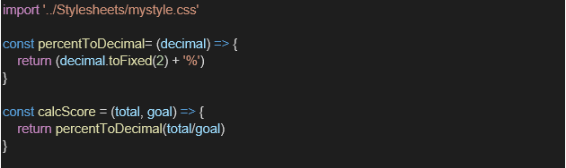
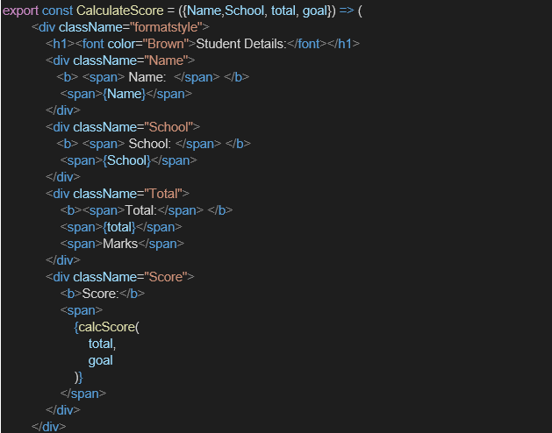

- Create a Folder named Stylesheets and add a file named “mystyle.css” in order to add some styles to the components:

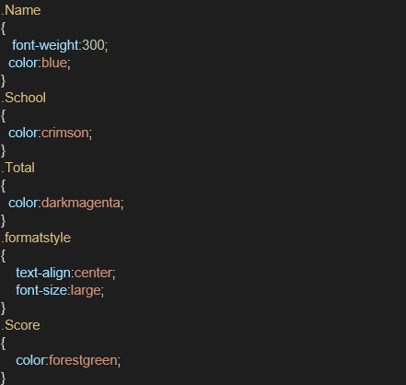

- Edit the App.js to invoke the CalculateScore functional component as follows:

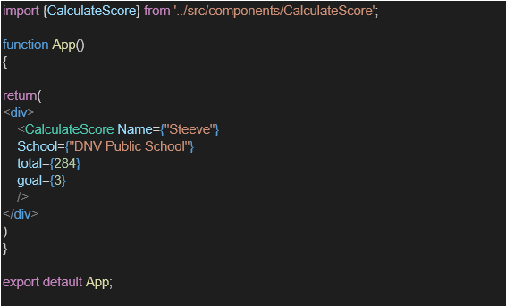

- In command Prompt, navigate into scorecalculatorapp and execute the code by typing the following command:

- Open browser and type “localhost:3000” in the address bar:

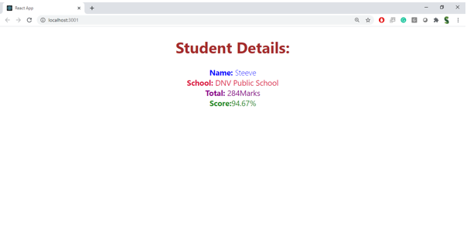

Explain React Components:
Components are the building blocks of a React application.
They allow you to split the UI into independent, reusable pieces.

Differences Between Components and JavaScript Functions:
Feature | React Components | JavaScript Functions
Purpose | Build UI in React | Perform logic or return values
Return | JSX (UI markup) | Data or values
Lifecycle Methods | Available (in class components) | Not available
Integration with React | Can maintain state, props, and render views | Cannot directly work with JSX or React state

Types of Components:
Class Components – Use ES6 classes, support lifecycle methods.
Function Components – Simpler, use hooks for state/lifecycle.

Explain Class Component:
A class that extends React.Component.
Must have a render() method that returns JSX.

class Home extends React.Component {
render() {
return <h1>Welcome to Home</h1>;
}
}

Explain Function Component:
A simple JavaScript function that returns JSX.
Can use React Hooks like useState, useEffect.
function Home() {
return <h1>Welcome to Home</h1>;
}

Define Component Constructor:
Special method in class component used for initializing state and binding methods.
constructor(props) {
super(props);
this.state = { name: 'Student' };
}

Define render() Function:
Used inside class components.
Must return JSX content to be displayed.

