**Spring Core – Load Country from Spring Configuration XML** 

    <bean id="country" class="com.cognizant.springlearn.Country">

        <property name="code" value="IN" />

        <property name="name" value="India" />

    </bean>

ApplicationContext context = new ClassPathXmlApplicationContext("country.xml");

Country country = (Country) context.getBean("country", Country.class);

LOGGER.debug("Country : {}", country.toString());

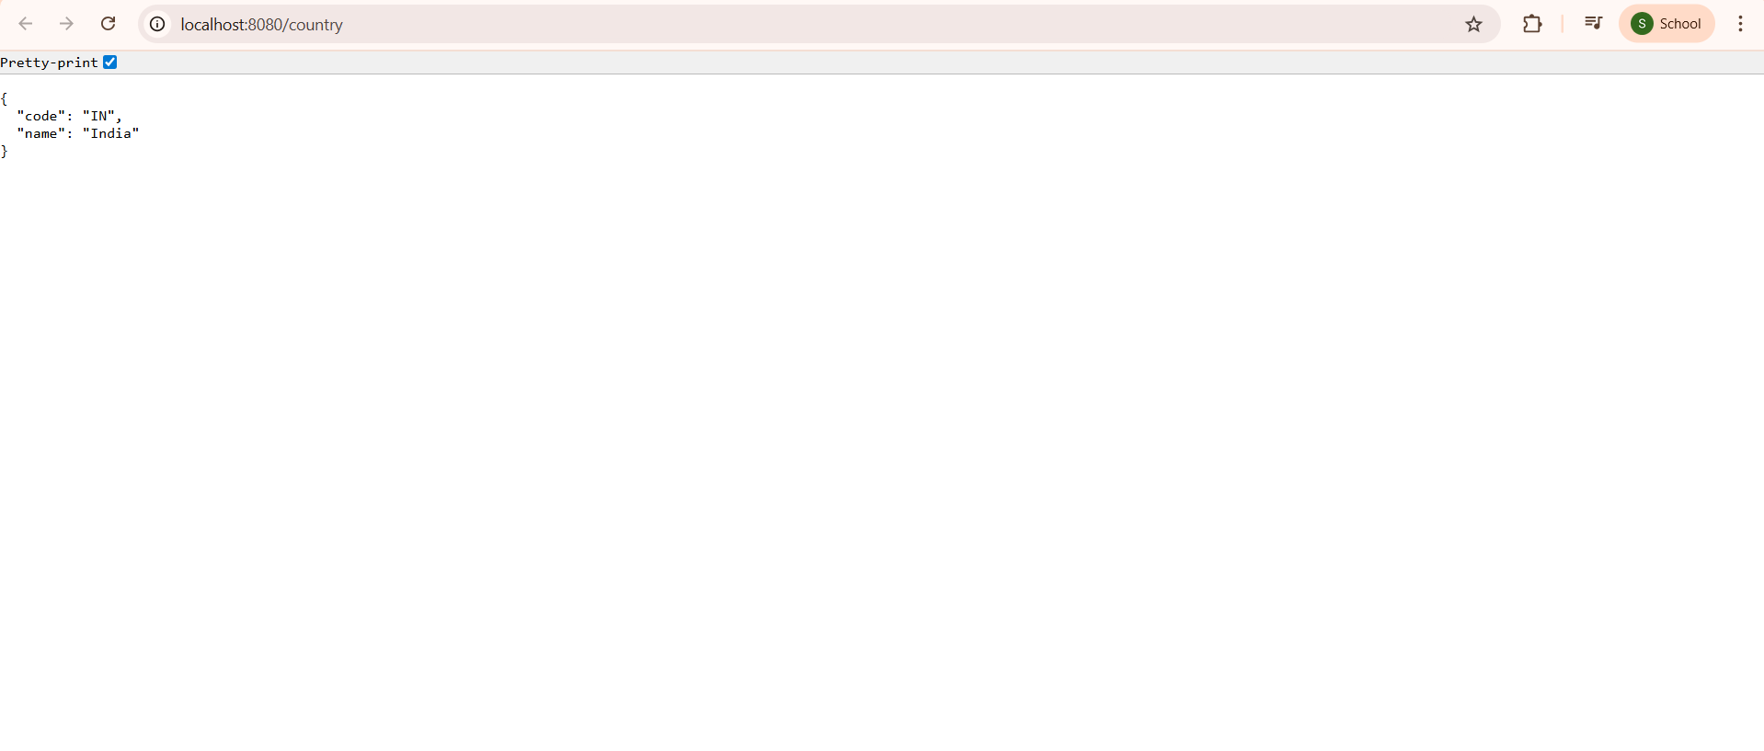

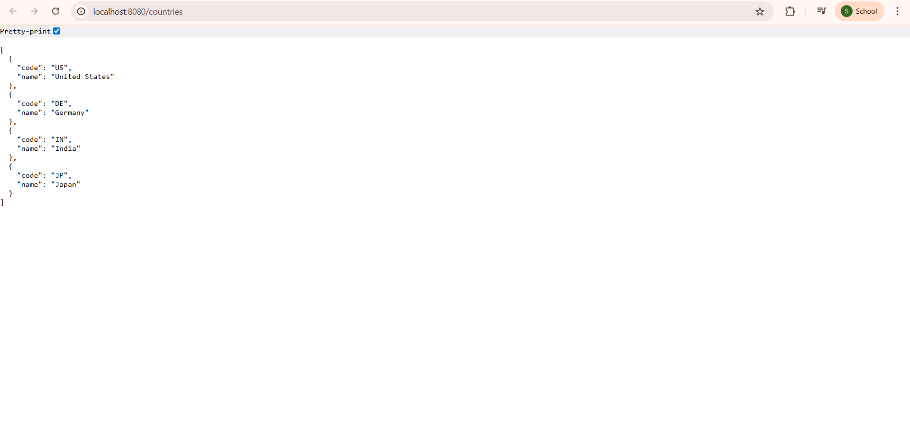

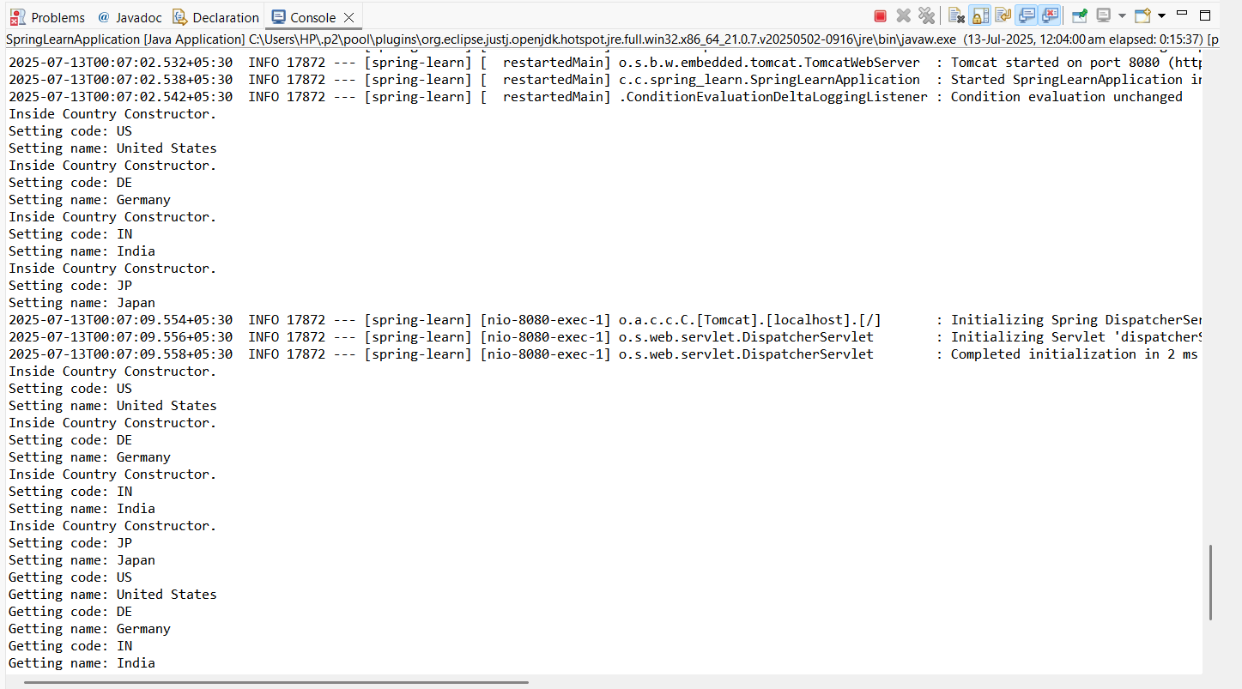

**COUNTRY.JAVA**

**package** com.cognizant.spring_learn;

**public** **class** Country {

**private** String code;

**private** String name;

**public** Country() {

System.***out***.println("Inside Country Constructor.");

}

**public** String getCode() {

System.***out***.println("Getting code: " + code);

**return** code;

}

**public** **void** setCode(String code) {

System.***out***.println("Setting code: " + code);

**this**.code = code;

}

**public** String getName() {

System.***out***.println("Getting name: " + name);

**return** name;

}

**public** **void** setName(String name) {

System.***out***.println("Setting name: " + name);

**this**.name = name;

}

@Override

**public** String toString() {

**return** "Country: " + code + " " + name;

}

}

**SPRINGLEARNAPPLICATION.JAVA**

**package** com.cognizant.spring_learn;

**import** org.slf4j.Logger;

**import** org.slf4j.LoggerFactory;

**import** org.springframework.boot.SpringApplication;

**import** org.springframework.boot.autoconfigure.SpringBootApplication;

**import** org.springframework.context.ApplicationContext;

**import** org.springframework.context.support.ClassPathXmlApplicationContext;

@SpringBootApplication

**public** **class** SpringLearnApplication {

**private** **static** **final** Logger ***LOGGER*** = LoggerFactory.*getLogger*(SpringLearnApplication.**class**);

**public** **static** **void** main(String[] args) {

SpringApplication.*run*(SpringLearnApplication.**class**, args);

*displayCountries*();

}

**public** **static** **void** displayCountries() {

ApplicationContext context = **new** ClassPathXmlApplicationContext("country.xml");

Country countryIN = context.getBean("countryIN", Country.**class**);

Country countryUS = context.getBean("countryUS", Country.**class**);

Country countryDE = context.getBean("countryDE", Country.**class**);

Country countryJP = context.getBean("countryJP", Country.**class**);

***LOGGER***.debug("Country : {}", countryIN);

***LOGGER***.debug("Country : {}", countryUS);

***LOGGER***.debug("Country : {}", countryDE);

***LOGGER***.debug("Country : {}", countryJP);

}

}

**COUNTRYCONTROLLER.JAVA**

**package** com.cognizant.spring_learn.controller;

**import** com.cognizant.spring_learn.Country;

**import** org.springframework.context.ApplicationContext;

**import** org.springframework.context.support.ClassPathXmlApplicationContext;

**import** org.springframework.web.bind.annotation.GetMapping;

**import** org.springframework.web.bind.annotation.RestController;

**import** java.util.List;

@RestController

**public** **class** CountryController {

@GetMapping("/countries")

**public** List<Country> getCountries() {

ApplicationContext context = **new** ClassPathXmlApplicationContext("country.xml");

List<Country> countryList = context.getBean("countryList", List.**class**);

**return** countryList;

}

@GetMapping("/country")

**public** Country getSingleCountry() {

ApplicationContext context = **new** ClassPathXmlApplicationContext("country.xml");

Country country = context.getBean("countryIN", Country.**class**);

**return** country;

}

}

**COUNTRY.XML**

<?xml version="1.0" encoding="UTF-8"?>

<beans xmlns="http://www.springframework.org/schema/beans"

xmlns:xsi="http://www.w3.org/2001/XMLSchema-instance"

xsi:schemaLocation="

http://www.springframework.org/schema/beans

http://www.springframework.org/schema/beans/spring-beans.xsd">

<bean id="countryUS" class="com.cognizant.spring_learn.Country">

<property name="code" value="US"/>

<property name="name" value="United States"/>

</bean>

<bean id="countryDE" class="com.cognizant.spring_learn.Country">

<property name="code" value="DE"/>

<property name="name" value="Germany"/>

</bean>

<bean id="countryIN" class="com.cognizant.spring_learn.Country">

<property name="code" value="IN"/>

<property name="name" value="India"/>

</bean>

<bean id="countryJP" class="com.cognizant.spring_learn.Country">

<property name="code" value="JP"/>

<property name="name" value="Japan"/>

</bean>

<bean id="countryList" class="java.util.ArrayList">

<constructor-arg>

<list>

<ref bean="countryUS"/>

<ref bean="countryDE"/>

<ref bean="countryIN"/>

<ref bean="countryJP"/>

</list>

</constructor-arg>

</bean>

</beans>