## Objectives

•Define SPA and its benefits

•Define React and identify its working

•Identify the differences between SPA and MPA

•Explain Pros & Cons of Single-Page Application

•Explain about React

•Define virtual DOM

•Explain Features of React

In this hands-on lab, you will learn how to:

•Set up a react environment

•Use create-react-app

## Notes

Estimated time to complete this lab: **30 minutes.**

Create a new React Application with the name “myfirstreact”, Run the application to print “welcome to the first session of React” as heading of that page.

1. To create a new React app, Install Nodejs and Npm from the following link:

<https://nodejs.org/en/download/>

2. Install Create-react-app by running the following command in the command prompt:

IMG_256

3. To create a React Application with the name of “myfirstreact”, type the following command:

IMG_257

4. Once the App is created, navigate into the folder of myfirstreact by typing the following command:

IMG_258

5. Open the folder of myfirstreact in Visual Studio Code

6. Open the App.js file in Src Folder of myfirstreact

7. Remove the current content of “App.js”

8. Replace it with the following:

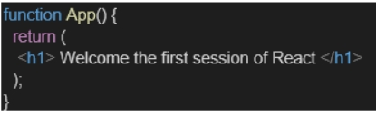

9. Run the following command to execute the React application:

IMG_260

10. Open a new browser window and type “localhost:3000” in the address bar

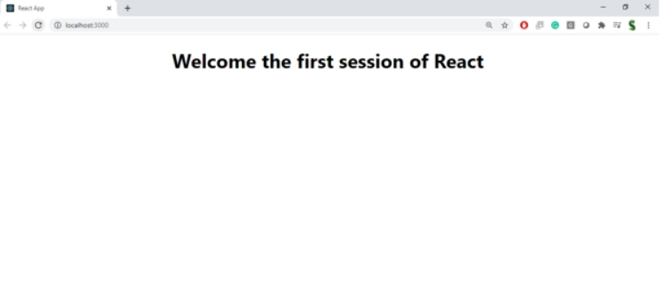

### Define SPA and Its Benefits:

**SPA (Single-Page Application)** is a web application that loads a single HTML page and dynamically updates content without reloading the entire page.

**Benefits**:

Faster navigation.

Better user experience.

Reduced server load.

Efficient data usage via APIs.

### Define React and Identify Its Working:

**React** is a JavaScript library developed by Facebook for building user interfaces, especially SPAs.

**How it works**:

Uses components for modular UI building.

Employs a Virtual DOM to update only the changed parts of a page.

React uses JSX to write HTML-like code in JavaScript.

### Differences between SPA and MPA:

| **Feature** | **SPA (Single-Page)** | **MPA (Multi-Page)** |
| --- | --- | --- |
| Page Load | Initial load, then content updates | Full page loads for every request |
| Speed | Faster after first load | Slower due to full reloads |
| Development Focus | Frontend-heavy | Backend + Frontend combined |
| Examples | Gmail, Facebook | Amazon, Wikipedia |

### Pros & Cons of Single-Page Applications:

**Pros**:

Improved performance.

Seamless user experience.

Easy to debug with browser tools.

**Cons**:

Initial load might be large.

SEO challenges.

Requires JavaScript enabled.

### Explain About React:

React is a declarative, component-based JavaScript library.

It allows developers to build reusable UI components.

Supports efficient updates using Virtual DOM.

Ideal for building modern web apps.

### Define Virtual DOM:

Virtual DOM is a lightweight copy of the actual DOM.

React updates the Virtual DOM first and then syncs it with the real DOM.

It minimizes direct DOM manipulation, boosting performance.

### Features of React:

Component-Based Architecture.

Virtual DOM.

Unidirectional Data Flow.

JSX Syntax.

Reusable Components.

Fast Rendering.

Large Community Support.

