## Notes

Estimated time to complete this lab: **90 minutes.**

Create a React Application “eventexamplesapp” to handle various events of the form elements in HTML.

1. Create “Increment” button to increase the value of the counter and “Decrement” button to decrease the value of the counter. The “Increase” button should invoke multiple methods.
   1. To increment the value
   2. Say Hello followed by a static message.

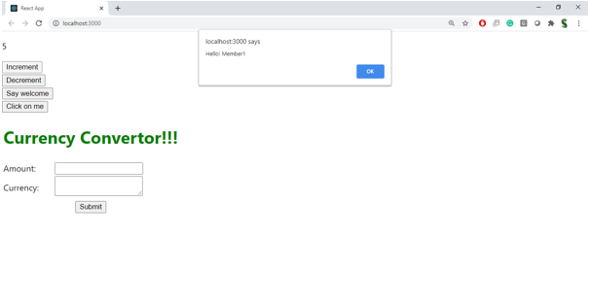

1. Create a button “Say Welcome” which invokes the function which takes “welcome” as an argument.

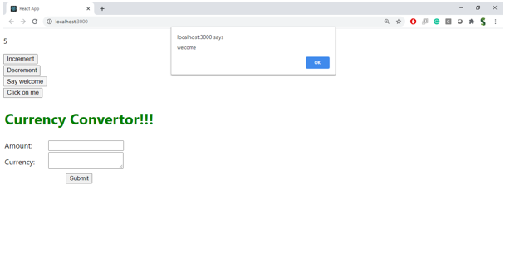

1. Create a button which invokes synthetic event “OnPress” which display “I was clicked”

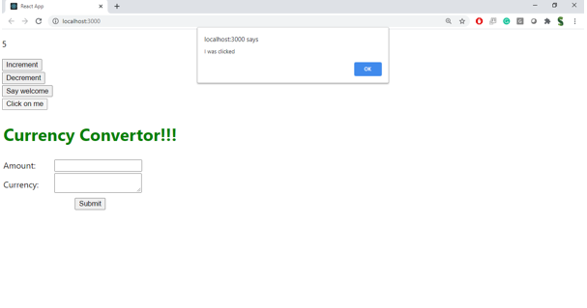

Create a “CurrencyConvertor” component which will convert the Indian Rupees to Euro when the Convert button is clicked.

Handle the Click event of the button to invoke the handleSubmit event and handle the conversion of the euro to rupees.

