## Notes

Estimated time to complete this lab: **60 minutes.**

Create a React App named “bloggerapp” in with 3 components.

1. Book Details
2. Blog Details
3. Course Details

Implement this with as many ways possible of Conditional Rendering.

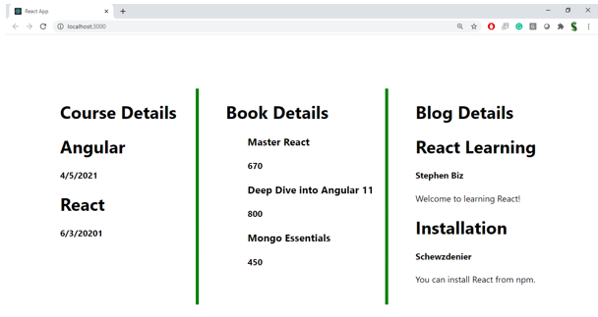

**Hint:**

