## Notes

Estimated time to complete this lab: **60 minutes.**

Create a React Application named “cricketapp” with the following components:

1. ListofPlayers

* Declare an array with 11 players and store details of their names and scores using the map feature of ES6

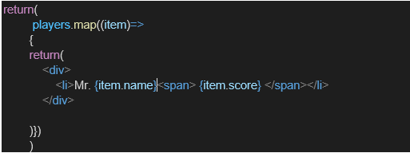

* Filter the players with scores below 70 using arrow functions of ES6.

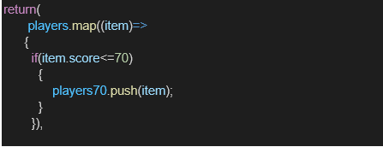

1. IndianPlayers
   1. Display the Odd Team Player and Even Team players using the Destructuring features of ES6

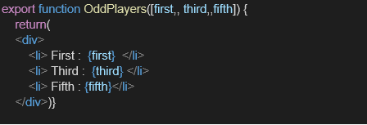

* 1. Declare two arrays T20players and RanjiTrophy players and merge the two arrays and display them using the Merge feature of ES6

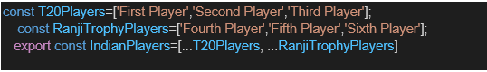

Display these two components in the same home page using a simple if else in the flag variable.

**Output:**

When Flag=true

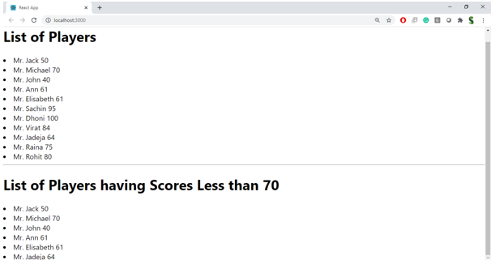

When Flag=false

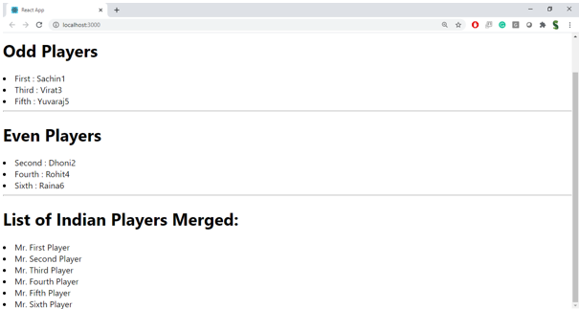

**Hint:**

