

**Department of Computing**

**Te Horo Rorohiko**

**CH3880 Bachelor of Information and Communications Technology**

**November 21st 2017**

**BCCE301 Cooperative Education Project**

**Analysis of JavaScript Testing Frameworks in Canterbury**

**FINAL REPORT**

Swathi Soman

99162569

**Contents**

**Executive Summary** 3

**Introduction 3**

**Project Summary 4**

**Progress Made** 5

Halfway 5

Wider system on Half-way 5

Recreation of the testing framework 5

Survey 6

Paper Survey 6

Online Survey 6

Popular Frameworks 7

**Progress Made** 8

Final Stage 8

Overview of objectives 8

**Reflection of Learning** 9

**Overview of Tasks Performed** 10

**Course Management** 12

Time Management 12

Subject PR203 chosen with the project 12

Other Priorities 13

Weekly reports and meetings 13

**Evaluation of Courses** 13

**Mile Stones Achieved** 14

Half Way 14

After Half Way 15

Future Plans to achieve 15

**Problems encountered** 16

**Quality Assurance** 17

How to improve quality plans: 20

Documentation: 20

Reflections 21

**Risk Management Plan** 21

Survey Risk: 21

Coding Phase Risk: 22

Complete Risk analysis of the project 23

Reflections 25

**Methodology** 26

Methodology of Project 26

Methodology essay summary 26

**Bibliography** 27

**Appendices**: 28

Project -- Weekly Progress Report 28

# Executive Summary

The following document serves as a summary of my experiences so far, while undertaking my capstone project for the BCCE301 Co-operative Education Project at Ara Institute of Canterbury.

The report below gives the details about the work done throughout the project. It contains all the details of the work which is undertaken. Recreation of existing JavaScript test using the JavaScript testing framework. Survey analysis details which was conducted among the professionals to identify the common JavaScript testing framework in the industry. The frameworks which are popular among the professionals are analysed and used to create Unit tests. I have explained the subjects studied in the ICT Graduate Diploma course and how it helped me in my capstone project. Detailed risk analysis of survey phase as well as coding phase is included along with the descriptive risk assessment. Comparison of Quality assurance plans and Quality improvement plans are notified. Summary of methodology essay in on Test Driven Development (TDD) and an abstract of agile methodology followed is also added in this report.

Survey and Analysis were the main tasks involved in the project, which was in the first phase whereas, in the second half Coding was given more importance. Paper survey was conducted among 113 IT professionals in Canterbury during the first phase. Selenium Web driver, Selenium IDE, Mocha, Cucumber are identified as the most popular frameworks. Practical test code for BCSE101 was created in Jasmine, Mocha-Chai Assert and Unit.js in the second phase. Unit test for classical triangle test and Kent beck’s banking system example was done in Jasmine, Mocha- chai expect, Mocha-chai should, QUnit.

# Introduction

The process of executing program with the intent to find strong errors is known as software testing. The testing environment in JavaScript market is a highly competitive one, with rapid release cycles, feature and performance comparisons, and constant superiority between the frameworks. JavaScript is most commonly used client side scripting language. This project aims to identify the most commonly used JavaScript testing frameworks in Canterbury. (Shilman, 2016)

To be in the project as the Research Assistant, I will have the capacity to develop knowledge on diverse testing frameworks. By learning software engineering (SE101) in my previous semester, made me keen to do a project based on testing. Unit testing is a software development process, which is used in the project development, in which the smallest testable parts of an application, called units, are individually and independently scrutinized for proper operation. Unit testing can be done manually but is often automated. All the individual functions or classes are tested by simulating the input and making sure that the output is expected. Unit testing is a component of TDD (Test Driven Development) which is a software development process which mainly relies on the re-occurrence of a very short development cycle. "TDD" refers a programming style which has three activities: coding, testing and design (refactor). BDD (Behaviour Driven Development) is an arrangement of best practices for creating High-Quality test. (Davis, 27 May 2013)

Various testing frameworks are used to reproduce the tests. Jasmine testing framework is used by BCSE101 (Software Engineering) practical test at the Computing Department of Ara Institute of Canterbury, which is replicated with different testing examples. Also, existing practical test examples are further modified into an enhanced form by adding few more examples. Testing frameworks are applied on the practice tests to understand and develop knowledge on its working process. The Testing framework which will be used in the project is (Jasmine, Mocha-Chai (should, expect, assert), Cucumber, QUnit, JStest). All of these frameworks are tested by using different testing examples. Surveys (online and paper) will be held among the IT professionals (IITP, Tech cluster, Recruitment Agencies) in Canterbury area to identify the most used testing framework at their work environment.

The gathered information will be analysed to recognize the well-known testing framework in the industry. Research will be on the different testing frameworks, which are popularly used. With all the data that are collected from the interviews and surveys will be validated to understand and develop knowledge on the popular framework in the industry.

# Project Summary

The project is about the analysis of JavaScript testing frameworks in Canterbury. The first phase was the recreation of the existing program to a new example in SE101. Jasmine framework is used in the program. Analysis of the popular frameworks were done based on the survey. The survey was conducted in two ways paper survey and online survey. The paper survey was conducted on 14th of September in Canterbury tech cluster and JavaScript meetup. There were around 113 professionals and analysis on the framework was made based on the survey .The online survey will be held on “Survey Monkey” (online tool). The survey link will be shared among the professionals in the JavaScript Meetup group and Tech summit group. From the analysis on the survey it is identified that “Selenium Web Driver”, “Selenium IDE”, “Cucumber”, Jasmine, Mocha-Chai(should, expect, assert) are the most widely used testing frameworks

Unit tests are written based on the survey result obtained. It is written on Mocha (should, expect and assert), cucumber, Jasmine and few other different testing frameworks with various examples.

# Progress Made

## Halfway

From the half way point of view in the project the main tasks which were completed are the survey and the replication of the existing frameworks with different examples and enhancing it.

### Wider system on Half-way

JavaScript is an object oriented scripting language, which is inside host environment. To provide programmatic control over JavaScript, it can be connected to the objects of its environment (chrisdavidmills, 2017)*.*

### Recreation of the testing framework

Software Engineering (BCSE101) is one of the subject which is been taught by the Computing Department at Ara Institute of Canterbury, the practical lab of the subject contains different practical exercises which needs to be tested. The Jasmine is the framework which is used for the creation of the practical tests. These practical tests require some alteration by using a different example for the execution. The example which was used was (The cake Shop). The unit tests were run for “The cake Shop” by using the jasmine framework. The Jasmine version 2.7 was used in the creation of tests. There were src, spec and lib files for the execution. The lib file had the jasmine framework, spec file contained the tests which needs to verify and the src had the source code for the execution.

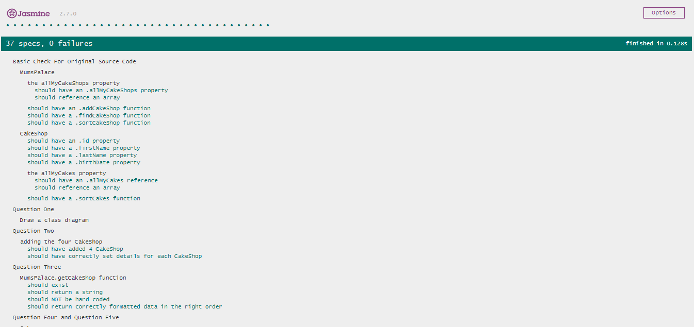Fig1: Testing Jasmine framework

The above image describes about the specs in the jasmine tool which is run without any failure. There are 37 specs which is executed.

## Survey

The survey was conducted among the Canterbury Tech Custer and JavaScript Meetup groups to identify the most widely used JavaScript testing frameworks. Survey was conducted based on the ethics approved from the department of computing. The ethical approval contained few forms which needs to be approved before the survey is conducted. Survey was conducted in two ways Paper Survey and Online Survey.

### Paper Survey

The survey was conducted among the professionals in Canterbury to identify the most commonly used JavaScript testing framework. The questions were asked among the professionals in two ways first was to identify their organisational details and then the questions were about the testing frameworks. Survey was conducted on 14 September 2017.

There were 113 professionals participated in the survey it was conducted in JavaScript Meetup group and Canterbury Tech cluster. The questions asked among the professionals was of 4 types. The first three questions was about the Organisational type, Organisation size and the job role. The fourth question was testing frameworks. The professionals had to choose from the frameworks. There were around 20 testing frameworks listed for the survey. The survey was further analysed to obtain the appropriate result. From the survey result it was clearly identified that Selenium IDE, Selenium Web Driver, Mocha chai (should, expect and assert), Cucumber and Jasmine are the mostly widely used frameworks.

### Online Survey

Online survey will be conducted to analyse the popular JavaScript testing framework. A separate ethical approval is required for the online survey to be conducted from the Department of Computing. The survey will be held on survey monkey (a tool to conduct surveys). The survey online contains of 24 questions and to conduct it the survey monkey has to be upgraded with an amount, which was provided by the department. The questions which were asked for the paper survey will be asked even in online survey. All the questions which were required for the survey online was structured well and upgradation of the survey monkey tool was completed before the half way of the project. The process of conducting the online survey will be done by the end of the project. The link to attend the survey will be forwarded to different JavaScript testing groups.

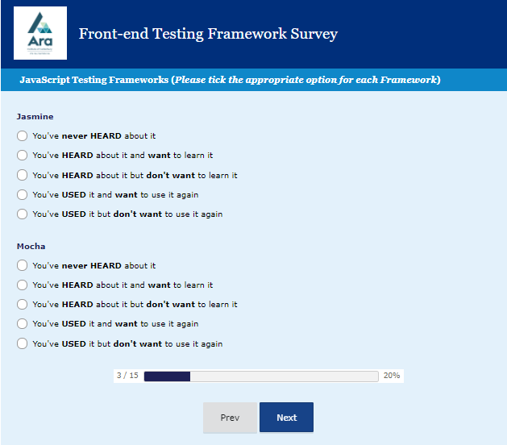

Fig2: Example of online survey

The above diagram shows one of the example of how the questions were asked in survey monkey.

Analysis will be done by the survey monkey for the survey by itself and the results obtained from the online and the paper survey will be verified to decide on which is the most widely used testing framework in Canterbury.

## Popular Frameworks

Unit tests were written on the popular testing frameworks as obtained from the survey.

Unit testing is a software development process were the small testable are called units, are separately and autonomously investigated for legitimate operation. It is often automated, but can be done manually as well. Unit testing can be done manually but is often automated. (Rouse, 2017)

Testing on examples

* External review of the Jasmine tests and code for Triangles
* Replication of the existing examples in Jasmine by adding regular expression
* Creating few more example based on the practice programs in SE101 in Jasmine framework.

Testing on exercise

* Identify ANOTHER classic software testing exercises often repeated in popular web tutorials
* Fork/copy the whole article to the Git Hub repository(Git-Hub is an open source version control system to store the files)
* Get the examples working
* Take note of what the examples are about:

Below are the objectives which are not achieved at the panel stage, it will be completed and submitted after the panel. Which requires a work of 30 hours more.

* JavaScript Kent Beck example using the QUnit, expect and should
* Online survey analysis

Few more examples will be proved by the tutor on different frameworks.

# Progress Made

## Final Stage

### Overview of objectives

The objectives mentioned below gives the details about the progress of the project. All the points mentioned below are the objectives which are obtained after the half and the final stage of the project.

* **Recreation of the existing JavaScript**: The testing example program for SE101 at the Department of Computing, is replicated with a new example. It is added with regular expression and different examples are used in the re-creation of the existing program into a different one. All of these testing uses Jasmine framework.
* **Frameworks after analysis**: After the survey was conducted the popular frameworks were identified to perform unit testing.
* **JavaScript Frameworks**: Most of the frameworks except jasmine wasn’t known. Hence it required quit amount of time in studying those frameworks. Each frameworks which were used for the unit testing in the project were individually identified and gained knowledge on each of the framework.
* **Frameworks**: The frameworks used were.
* Jasmine
* Mocha-chai(expect, should and assert)
* Cucumber
* QUnit
* JStest

All of these frameworks were implemented into different example.

* Creating JavaScript from Java for the Kent Beck banking example and frameworks are implemented into the example and tested.
* Creating Triangle example in JavaScript and frameworks are implemented into the example and tested.
* All the measures which are taken for the Quality assurance are documented
* Risk Management is documented which includes all the persistent recognizable proof and future planning
* The final report shows the complete detail about the project and all the necessary changes made after the half way.

# Reflection of Learning

The below gives the details about the learning gained from the project in the following areas.

* The principle of the JavaScript programming.
* Testing JavaScript code, were code is written for each module of an application.
* The tests can be divided into different types:
* Unit test: Texting if individual class or functions for mocking input and making sure that the output is expected.
* Integration test: Testing several modules to make sure that they work as expected.
* Functional test: Testing a scenario on the product itself regardless of the structure to ensure the expected behaviour.
* Learning on the different JavaScript testing frameworks
* Familiarity to conduct the surveys among the professionals
* Understood the rules and regulation on different forms and formality which is required in an institution to conduct a survey
* Analysis of the survey which was conducted and how to prepare the questions for the online survey in an online tool.
* Skill and experience in refactoring code in a framework efficiently and safely.
* The knowledge and ability to use the testing framework Jasmine, Mocha (expect, should, assert), QUnit, Cucumber, JStest.
* Understanding the method of using the frameworks with respect to their API.
* Learning on converting a Java code to JavaScript.
* The value to be gained of doing wide research at the beginning of a project.
* The importance of creating and maintaining a well-considered risk management plan.
* The value to be gained from conducting a rigorous and thorough QA program.
* All the learnings above will help in being a test analyst or a developer in near future.

# Overview of Tasks Performed

The tasks such as unit tests which were performed using different frameworks are shown with screenshots in this sections in the below given diagram. All the tests which were performed were passed as well as failed.

**Jasmine**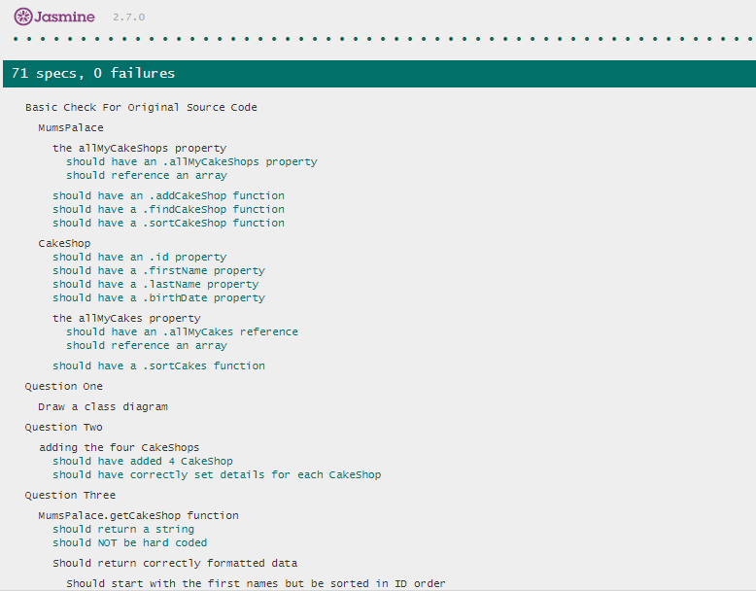

**Mocha-Chai expect**

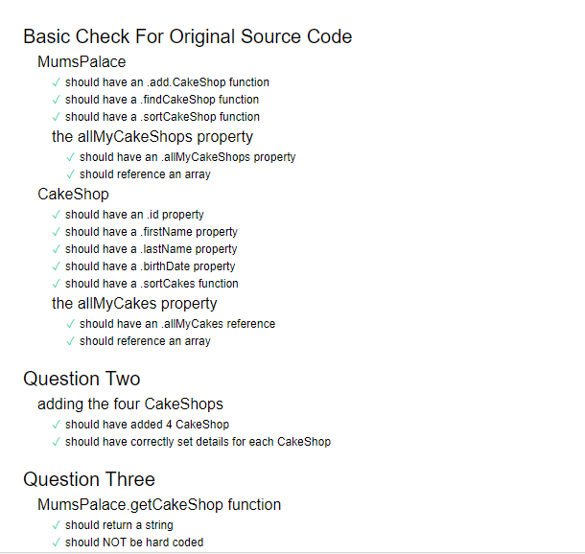

**Mocha-chai should**

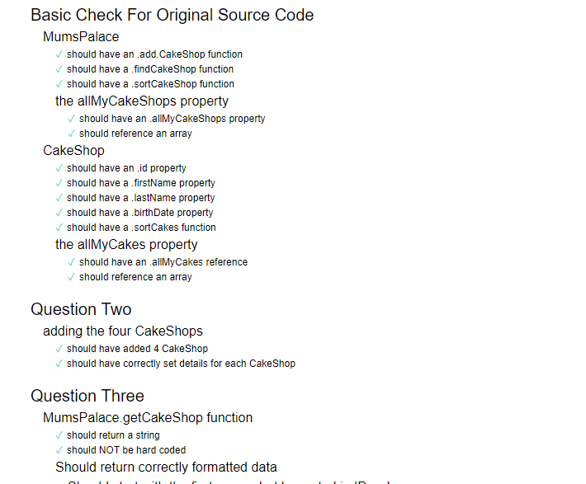

**QUnit**

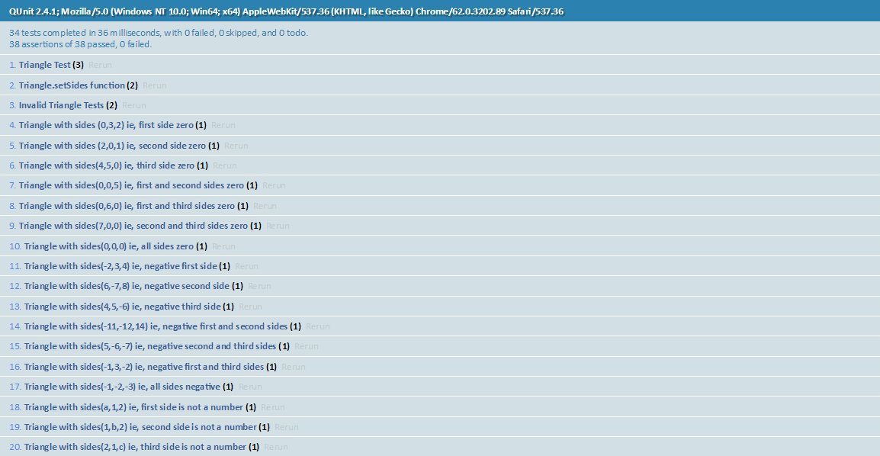

# Course Management

### Time Management

* Spending time to work on the project as and when possible
* Per week will spend almost around 20 to 25 hours on the project, if there is not assignments from other subjects.
* Dividing hours equally for the project and the subject. But providing much more effort in the project.
* 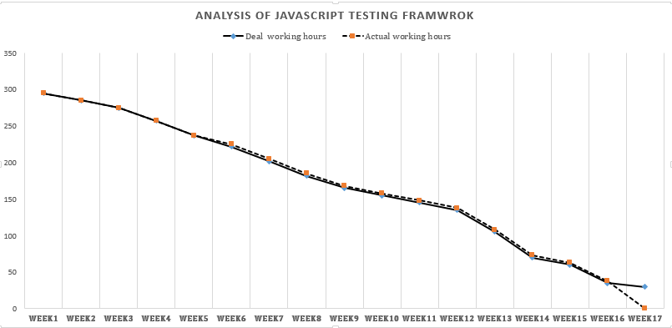The below chart gives the complete detail about the project time line.

Fig3: Burndown chart

Week 17 shows that the project is not yet completed and it requires 30 hours more for the completion of work. Which will be completed after the panel. The panel will be completed at the total of 270 hours and the remaining 30 hours will be allotted for completing and submitting the remaining part of the project.

### Subject PR203 chosen with the project

* Unable to focus on the project when there are tasks given by the subject at the same time
* Could acquire knowledge on the subject which would be useful for my future and career.

### Other Priorities

* Assignments and exams in PR203,
* Part time work
* Family and Friends
* Relaxing

### Weekly reports and meetings

* Weekly reports and meeting held with the industry as well as the academic supervisors
* Frequent updates on to the industry and academic supervisor on the project
* Guidance from the supervisor’s for the further progress
* Keeping a track of the tasks and hours used to work on the task daily.

# Evaluation of Courses

|  |  |  |  |
| --- | --- | --- | --- |
| Course Title | Course Description and Learnings | Skills relevant to project | Suggestions |
| BCIS301 - Management of Information and Communication Technologies | * Learnt about Management of ICT, structured framework. * Documentation skills, Function framework, * RiskIT and COBIT in organisations. * Learning on different case study examples and presenting it with respect to the Cobit or functional framework. | * Documentation Skills, * Quality Assurance * How to evaluate a task with respect to scenario and drive an appropriate solution to it. * Time Management skills * Project Management skills | It is one of the relevant course for ICT students. Which helps in knowing the industrial standards and it helps a lot with the industrial project. |
| BCIT388 Mobile Technology | * Basics of MIT APP Inventor. * Learnt on topics like Wireless communication technologies, Ubiquitous Computing, Virtual Reality Web analytics, Cloud computing * Research on online topics and report preparation. | * APA referencing * Online research on topics * Self-learning | This course includes nothing much in depth on any topic. But it can just give an overview of technology with respect to mobile |
| BCIT141 - Website Development | * HTML5 and CSS were the main topics. * Responsive design and Scripting. * Creation of Specification document | * Time Management * Scripting * Think innovatively * Preparation of specification document | Well organised training and an interesting subject which have quite a lot to learn about the website. |
| BCSE101 - Software Engineering 1 A | * BYOB * JavaScript * Class Diagram * Transaction Diagram * Framework * Testing Using Jasmine * Static Diagram | Knowledge on JavaScript testing using framework and class diagram | The main course for those who are willing to be a tester or developer which teaches all the topics from basics. |
| BCPR203 - Database Management Systems | * Database management concepts * Normalisation * SQL Scripting * Data Dictionary and warehousing * Views and Index’s | Research online and report creation | Will be able to learn basics of DBMS. Interesting for those who like scripting. |

# Mile Stones Achieved

## Half Way

**Recreation of the existing framework**:

* Created Practice Practical Tests for BCSE101 in latest version of Jasmine 2.7.0 and ES6 standard.
* Regular Expressions were included in the spec file and modified the question structure.

**Framework Setup**

* Learnt to set up Cucumber, Jasmine, QUnit, Mocha-Chai should, Mocha-Chai expect, Mocha-Chai assert from the local machine

**Survey**

* Got ethical approval for Paper Survey as well as the online survey from Department of Computing
* Conducted Survey among 113 IT professionals.
* Built Online Survey and launched in Survey Monkey.

**Risk and Quality**

* All the major risks triggered are documented and planned accordingly
* All the tasks listed in the project meets all the necessary quality.

## After Half Way

**Halfway and Methodology**

* Reports were created for half way and methodology essay
* Code was review and improvised for the Practical Test in SE101
* Replicated new tests with the existing tests
* Recreated the practice tests in Jasmine, Mocha-chai should, Mocha-chai expect and QUnit.
* Poster created for the industry review.
* Unit tests for Kent Beck’s Banking system example and Triangle were written in Jasmine, Mocha- chai should, Mocha –chai expect and QUnit.
* Preparing Triangle example for UnitJs and JStest.
* Quality assurance was done throughout the project.
* Risk analysis was done for all of the coding phase.

## Future Plans to achieve

* Finish the practical tests, triangle example and Kent Beck banking system example in other frameworks.
* Conduct Online survey analysis
* Finish the project and submit to the industry supervisor.

# Problems encountered

|  |  |  |  |
| --- | --- | --- | --- |
| Problem | Impact | Action | Learning |
| Confirmation on survey questions | High | Followed up with the survey committee and Tutor to finalise the questions | Made sure to submit the survey questions before time. |
| Confirmation in getting the ethics approved | High | Followed up with ethical committee until the ethics are approved. | Learned to submit the ethics 2 to 3 weeks in prior of conducting the survey. So that it would get approved. |
| Approval from the department to conduct an online survey | Low | Department was informed about the issue and fund was raised | Make sure that the department should be aware of all the online process |
| Unable to find professionals with JavaScript Testing Knowledge | Medium | Check with the participant before conducting survey | Learn how to conduct survey and interact with the professionals.  Networking was the best of all while conducting survey. |
| Unavailability of the ticket to attend the Tech Summit meetup | Low | Department was informed about it and the ticket was arranged | Make sure of getting the tickets in prior if there is any such plan of going for any events. |
| Unexpected sickness of tutor (Industry Supervisor) | High | Email communication with the tutor | Plan things in prior about the tasks with the tutor. |
| Team member’s Sickness | Medium | Check with the team member about the requirements | Be safe and healthy always. |
| Lack of Knowledge on the JavaScript | High | Frequent learning on the topic | Learning on the topics online. Make sure that different websites are referred on the topic. Check with the tutor frequently if there is any doubt in the topic. |

# Quality Assurance

Quality assurance is required to ensure that the system meets the pre-established requirements and standard. Quality Assurance involvement will be from the beginning to the end of the project life cycle. It is also a plan effort to ensure that the software product fulfil criteria and has additional attribute specific to that product. The Quality Assurance can be described in two ways internal quality assurance and external quality assurance.

Internal quality assurance is the quality of the program of how the program works internally, its flexibility of use, usability, testability and much more. This mainly checks on the quality that is within the program execution.

External quality assurance is mainly about how the programs works when the users use it. If the developed code is easy to use, if it’s well-structured or if the code works correctly. Some of the characteristics of the internal and external quality assurance overlap. But each of these have different meanings in each stages.

The quality of the overall project is taken care. All the deliverables for the project is presented with a good quality and standard. The details of the quality is mentioned below.

|  |  |  |  |
| --- | --- | --- | --- |
| Quality Factor | Main Target | Action Performed | Deliverables |
| Internal Quality | | | |
| Maintainability | The simplicity with which the framework can be changed or include abilities, enhance execution, or correct imperfections | Use simple coding tricks and add regular expression than hard coding. | Create more example questions and upload all the necessary documents in GitHub. |
| Flexibility | The ease of using a program or conditions other than those for which it was particularly outlined. | Develop code which can run in multiple browsers | Easily executable code. |
| Portability | The simplicity with which a program can be altered to work in a situation unique in relation to that for which it was particularly planned | Increasing the program portability was always focused throughout the project development as the program developed should work in all the platform. | Testing in different frameworks |
| Readability | The ease of learning and developing knowledge by understanding the frameworks. | It was made sure that the code developed was legible and understandable by all users. | The code is of well readable standard and all the documentation in the project are readable |
| External Quality | | | |
| Correctness | It was made sure that all the data which was obtained from the conducted survey is true and relevant. The data analysis which was made after the survey is correct and accurate. | * Check with the basic syntax of the code. * Correct the errors with the supervisors. * Testing of code. | Error free code is developed for SE101, Training material is provide for quality |
| Efficiency | Insignificant utilization of framework assets, including memory and execution time. | The code developed using frameworks are run with effectiveness and efficiency. The code developed reduces the resource consumption and completion time | Code which is executable easily. |
| Adaptability | The framework can be utilized, without alteration, in applications or conditions other than those for which it was particularly planned | Upgrading the testing framework  Download the version which is the latest for testing  Follow ES6 standard  Make a simple design so that it’s understandable and adaptable to improvements | Easily upgradeable (ES6) and adaptable to all the platforms |

When compared to that of the initial stage and the half way of the project the quality is the same and is maintained well throughout the project. The below given chart describes in detail about the quality in the half stage and current quality assurance.

|  |  |  |  |
| --- | --- | --- | --- |
| Quality Factor | Work done | Issues | Learnings |
| Internal Quality | | | |
| Maintainability | GitHub and Regular expressions | Issues while correcting regular expression which was later fixed. | GitHub is the repository in which can be used for storing the documents. Regular expression improves the code. |
| Flexibility | Usable and flexible code which can executed in all the browser | NIL | Learned how to make a code user friendly and flexible. |
| Portability | Write test case using different frameworks | Choosing on which framework and learning the basics of it. | Choose the most suitable framework and learning of different kinds of framework |
| Readability | Create code which is error Free and satisfied to the supervisor | Spelling mistakes and grammatical errors | Proof read the document before the submission |
| External Quality | | | |
| Correctness | Create code that matches the requirements of the supervisor | Lot of corrections in the initial stage and time delay for the code review | Develop code which is adaptable to changes which occur frequently |
| Efficiency | Code which is efficient and according to the standard of ES6 | Errors which were unable to fix, was corrected by the tutor | Develop a code which is error free. |
| Adaptability | Version upgradation  ES6 standard | Nil | Knowledge in JS Testing Frameworks and ES6 JavaScript |

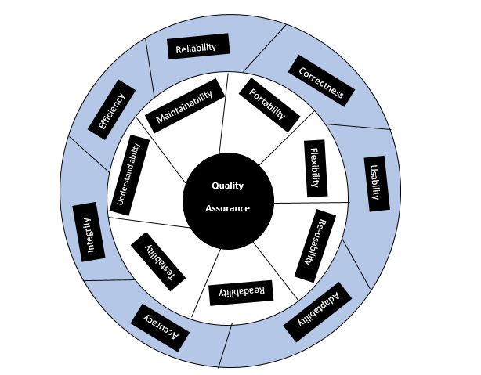Fig4: Quality Assurance chart

### How to improve quality plans:

* Perform unit tests
* Check online for tests
* Before performing actual tests practice the test.
* Review of the code by the industry supervisor

### Documentation:

* Communicate with supervisors frequently about the documents
* Burn down chart and Time chart for checking on the time.
* Update the tutor with the weekly reports.
* Proof read of the document.

## Reflections

There are mainly two qualities in the project which is the quality of the code or technical and the quality for documentation.

Learnings for the Quality assurance in the project.

* Qualities are in two forms external and internal quality.
* Technical quality can be maintained easily with respect to the tools it support and coding.
* Quality of the coding is maintain the syntax and the structure throughout the task. So that the developed code is readable, executable and understandable
* Proper communication is required in the documentation which is understandable shows the quality in academic.

# Risk Management Plan

From the risks which are mentioned below in the table and when compared to the proposal and the half way it is identified that the risks have changed accordingly. Most of the risks mentioned seemed to be high when compared to that of the proposal and half way. The major risks were observed in the survey phase and coding phase of the project. Both the risks are mentioned separately in the table.

## Survey Risk:

|  |  |  |  |
| --- | --- | --- | --- |
| Risk Description | Impact | Level | Mitigation Plan |
| Survey Questions:   * Preparing survey questions took some time. * Supervisor’s had different opinions * Survey Monkey had very less features | Survey question prepared was not approved and the supervisors had different opinions on it. Later got it sorted out | Medium | * Meeting with the supervisor’s frequently to know about their suggestions. Email conversations only in group * Upgradation of the Survey Monkey account |
| Ethics :   * Delay in getting the ethics approved * Improper communication with the tutor * Ethical approval should be forwarded by the tutor for the further proceedings * Unavailability of supervisor | The ethical form for conducting the survey was delayed.  Which impacted the project to large extend | High | * Before the survey the ethical form should be submitted to the ethical committee 2 weeks prior. * Check with the committee frequently about the application. |
| Survey :   * Unable to meet people who use JavaScript. * Very low participants in the meetup * Incomplete survey forms | Finding professionals with JavaScript testing knowledge was difficult | Medium | * Make sure that the professionals who fills the forms are familiar with JavaScript * Give information about the survey and project |
| Analysis on the survey | Perform accurate survey analysis which was satisfied by the tutor was delayed a bit. | Medium | Check with data twice before it is submitted |

## Coding Phase Risk:

|  |  |  |  |
| --- | --- | --- | --- |
| Risk Description | Impact | Level | Mitigation Plan |
| Delay in code review:   * The code which was written was not reviewed in the starting * The supervisor was unavailable | Code written was not reviewed by the tutor at the beginning. Which caused to correct the errors after long. | High | All the files which were required in coding was uploaded in GitHub and informed tutor via email or carry a pen drive when the tutor is available. |
| Lack of Knowledge on the topic:  I have not studied testing course before and I just had the basics of the course with SE101, found it difficult in understanding certain concepts | Unable to develop code easily due to lack of knowledge on the topic. | High | * Studied by referring the online tutorials * Referring YouTube videos and Documents on testing. |
| Unsatisfied tutor:  Certain information provided in the tests was not satisfied by the tutor which required frequent editing | Tutor was unsatisfied with the code wording and it required corrections. | Medium | Checking with the tutor on the requirements and updating it as soon as possible. |

## Complete Risk analysis of the project

|  |  |  |  |
| --- | --- | --- | --- |
| Risk | Impact | Level | Mitigation Plan |
| Professionals using the same testing framework | Unable to professionals using JavaScript testing framework. Which was later resolved by checking with them individually | Medium | Difficulties in finding IT professionals in the survey and while conducting interviews using the same Java Script testing framework. Meeting up with professionals through social network such as Meetup groups, to identify the testing frameworks used. |
| Privacy and security issues | All the data which was collected after the survey was secured as it was not given to anyone else for review. | Low |  |
| Product Risk & Project Risk | The code which was developed should be error free and of good quality | High | The risk at which the process of the code execution is carried out. It is made sure that the code which is tested after implementation is without any errors and submission of the project which of the latest version and executable in any platform. |
| Tight timelines | Project was delayed and finishing of the project was not as expected | High | The project have crossed the timeline when compared to the time frame proposed in the initial stage. Unexpected sick leave of the tutor and the team member |
| Operational Risks   * Failure to address priority conflicts * Improper subject training * Improper communication with the tutors * Failure to resolve the responsibilities | Lack of knowledge in the subject and it took more amount of time to study about the topic and implement code | High | Unable to identify the actual concept. Due to lack of training and less communication with tutor to know about the issue. The given responsibilities cannot be completed due to lack of dedication and unawareness about the topic. The operational risk in the final stage is high when compared from that of the initial and half way |
| Technical Risks   * Continuously changing requirements - Change of product requirements continuously can cause delay in project submission and unclear about the details required to execute the project. * Difficult project module integration. * No advanced technology available or the existing technology is in initial stages * Complex product to implement. | The requirements of the tutor was not understandable sometimes. Which caused miscommunication with the tutor and couldn’t develop things as expected by the tutor | High | * Difficulty in submitting the tasks as per the requirements. Unavailability of the tutor is the major risk. Unable to complete the project at the expected time. * Most of the topics in the final stage of the project is unclear and unaware. The topics which was used is not studied earlier and it took more time to learn about the topic and implement it into the project. * Most of the frameworks are implemented in Node.js, Unable to understand the concept and it takes lot more time to implement it into the frameworks. Hence, the frameworks used in Node.js is not used. |
| Personal Risk   * Multiple exams and assignments, which may interrupt the project. * Impact on personal career and life if the project fails or succeeds. * Emotional impact. * Impact on health. * Ethical and professional compromise required | Assignments and exams of PR203, Part time job and health | High | * Multiple assignments on other subjects (PR203) which will interrupt in the project creation. It will also cause stress in dealing with the topics due to too much of workload. * The exams and assignments on the topic at the same time of the project. * Emotionally affected as all of these topics results in too much of work pressure. * Team member falling sick. Unable to discuss about the tasks with the team member. |
| Programmatic Risks   * Unaware of the latest technology and trends. * Changing customer priority and strategy. * Running out of funds. * Change in market strategies. | Not sure of the latest technology and change in needs of the tutor | Medium | * Unaware of the latest trends in technology will cause difficulty in project creation according to the latest update. * Certain version of the frameworks which are available are of old version and it requires frequent updating. |
| Schedule Risk   * Wrong time estimation * Failure to identify complex functionalities and time required to develop those functionalities. * Resources are not tracked properly. | Estimation of the time was not as expected, which was spent for the project. | High | * The following the correct resources to follow the time estimation. Unable to know the exact time spend for the project each day. * Unable to complete on time. |
| Natural Disaster   * It can cause data to lose and the scheduled activities can be ruined. | Natural disaster was not observed | Low |  |
| Conformity required for the external and internal policy. | The forms for the ethical approval was not signed before the date of survey which caused delay in getting it approved. | High | Conformation in getting the ethics approved was delayed. Which caused delayed in the project and it did not work as planned. |
| Quality of the product, which is developed. | It is mandatory to maintain the quality throughout the project | Medium | Once the product is developed or the program is created. It is made sure that it meet the quality and standard. I.e. the program should run without errors. |
| Project Deadline | The project has reached the deadline and its unfinished as planned | High | Submission of the project has almost reached its end. Hurrying up on completing the tasks and submitting the project. |

### Reflections

Risk Management played an important role in the project. Through risk analysis in the initial stage and the half way stage the risks were identified and provided with mitigation.

There are risk which happened all of sudden and it was unexpected. It is good to do certain tasks in prior to avoid the risks.

Learning:

* Always be alert of tasks being done. Do things in prior so that there won’t be any delay if there is any sudden risk.
* All the projects are identified with risk of its own. But it’s always good to be alert and precautionary measures to avoid it.

# Methodology

## Methodology of Project

In the report, the methodology used is Agile. Which seeks the traditional project management and can respond to unpredictability through iterative and incremental approach. Agile can be used to access the development of the project throughout the development lifecycle. This is accomplished through iterations, towards the end there should be the product which is deliverable. By concentrating on the reiteration of contracted work cycles and in addition the useful product they yield, agile methodology is portrayed as "iterative" and "incremental." When there is a stop and look at the project every two weeks, there is always time to control it in another way. Agile development methodology enables to fabricate the correct product. It reduces risk and allows product to adapt changes quickly. Rather than resolving to advertise a bit of programming that hasn't been written yet, agile enables to persistently re-plan their discharge to optimize its value throughout the development, enabling to be as focused as conceivable in the commercial centre. Agile methodology prevents a product's critical phase and ensures that it won’t be stopped in the middle. (Agile Methodology, n.d.)

## Methodology essay summary

The methodology essay for the project was on Test-driven development (TDD), which is a software development process which mainly relies on the re-occurrence of a very short development cycle. "TDD" refers to a programming style which has three activities: coding, testing and design (refactoring). Requirements are analysed to certain automated test cases, and then the improved software is used to pass the new tests. It is a transformative way to deal with development, which combines TDD, where tests are written before the code to satisfy that test and refactoring. TDD is an approach of development in which the test is written by the developer which shows the piece of work which is worked, and then the code is written further so that the test passes. It is development technique in which the tests are written which fails before a new code is written. The result of the TDD is best when the code is improved. It can drive the way the program has design their application, without any fear of breaking it. (Agile Alliance, n.d.).

TDD is an extensible and modularized code. It is the powerful practice in the industry. TDD helps to deliver value quickly to the user while reducing the stress of developing the program and its release to the production environment. The software can be considered as small units where it is tested and written independently by the developers. By using TDD in organisation it helps to update the software according to the business requirements painlessly. If there is any changes in the environment and the organisation reacts to it, only then the organisation is successful and it can make further changes in the environment. By using TDD it makes maintainability, extensibility and flexibility possible. It solves many issues by implementing refactoring, good practice of coding and testing can be followed by the programmers. (wikipedia, 2017).

# Bibliography

*Agile Alliance*. (n.d.). Retrieved from www.agilealliance.org: https://www.agilealliance.org/glossary/tdd/#q=~(filters~(postType~(~'page~'post~'aa_book~'aa_event_session~'aa_experience_report~'aa_glossary~'aa_research_paper~'aa_video)~tags~(~'tdd))~searchTerm~'~sort~false~sortDirection~'asc~page~1)

*Agile Methodology*. (n.d.). Retrieved from agilemethodology.org: http://agilemethodology.org/

chrisdavidmills. (2017, May 25). *MDN web docs.* Retrieved from developer.mozilla.org: https://developer.mozilla.org/en-US/docs/Web/JavaScript/Guide/Introduction

Davis, J. (27 May 2013). *TDD and BDD.*

Rouse, M. (2017). *TechTarget*. Retrieved from /searchsoftwarequality.techtarget.com: http://searchsoftwarequality.techtarget.com/definition/unit-testing

Shilman, M. (2016). *stateofjs.com.* Retrieved from Testing Frameworks: https://stateofjs.com/2016/testing/

*wikipedia*. (2017). Retrieved from en.wikipedia.org: https://en.wikipedia.org/wiki/Test-driven_development

# Appendices:

* TDD : Test Driven Development
* BDD : Behaviour Driven Development

## Project -- Weekly Progress Report

Project Title: **Analysis on JavaScript Testing frameworks**

Student’s Name: **Swathi Soman**

Total Hours spent on the project this week: 18 Hours

Total Hours spent on the CE301 this week: 2 Hours

Supervisor: **Phillip Roxborogh**

Prepared for meeting with Academic Supervisor on: **Every Thursday**

|  |  |
| --- | --- |
| Progress/achievements since last meeting | * Working on (Mocha-chai, assert, should, expect), QUnit and tried with jest, Casper, wallaby by using nodeJS but it doesn’t work as expected * Worked on the replication of the test for SE101 (cakeShop and Elephant) which required additional features to be added to the test(regular expression) * Creating a Java (Banking example) to JavaScript and made tests for them * Completed methodology essay part c * Prepared skeleton for panel presentation |
| Barriers to progress | * All go so far |
| Possible solutions to barriers |  |
| Status | 1. not started 2. on track and continuing as planned 3. **behind schedule but achievable** 4. behind schedule, unlikely to be completed as planned 5. not achievable by deadline 6. abandoned 7. completed |
| Supervisor’s comments on progress |  |
| Actions for next meeting: Student | Test practices (JavaScript Testing frameworks (CakeShop in Jasmine, Mocha-Chai assert, should and expect), QUnit, Creating a Java program to JavaScript. Starting with the Final report, Methodology essay and Presentation. |
| Actions for next meeting: Supervisor | Complete Methodology essay ,skeleton for presentation and Brief on Final Report |

Signature of student: Swathi Soman, Date: 08/11/2017

Signature of supervisor _______________________________ Date: