Name : Swathi Soman

ID : 99162569

Analysis of JavaScript Testing Frameworks in Canterbury

Half Way Report

Contents

Project Name 2

Executive Summary 2

Background 2

The wider system 3

Recreation of the testing framework 3

Survey 4

Paper Survey 4

Online Survey 7

Frameworks 8

Project Summary 8

Progress Made 9

Overview of objectives 9

Mile Stones Achieved 9

Recreation of the existing framework 9

Survey 9

Popular Framework 9

Quality Assurance Plan 9

Risk Management Plan 9

Problems encountered 10

Course Management 10

Time Management 10

Subject PR203 chosen with the project 10

Other Priorities 10

Weekly reports and meetings 10

Quality Assurance 11

Risk 12

Methodology Essay on Test Driven Development(TDD) 14

Advantages of TDD 15

Disadvantages of TDD 15

Bibliography 16

# Project Name

Analysis of JavaScript Testing Frameworks in Canterbury

# Executive Summary

The following document serves as a summary of my experiences so far, while undertaking my capstone project for the BCCE301 Co-operative Education Project at Ara Institute of Canterbury.

# Background

Software testing is the process of executing program with intent to find strong errors. Like the rest of JavaScript market, the testing environment is a highly competitive one, with rapid release cycles, feature and performance comparisons, and constant superiority between the frameworks. This project aims to identify the popular JavaScript testing frameworks in the industry. (Shilman)

As being the Research Assistant in the project, I will have the capacity to develop knowledge on diverse testing frameworks. Also, have learnt the Jasmine Testing Framework in my previous semester, which made me keen to do a project based on testing. Unit testing is a software development process, which will be used in the project development, in which the smallest testable parts of an application, called units, are individually and independently scrutinized for proper operation. Unit testing can be done manually but is often automated. Testing of individual functions or classes by simulating input and making sure the output is as expected. Unit testing is a component of TDD (Test Driven Development) a down to business technique that adopts a careful strategy to building an item by methods for nonstop testing and amendment. BDD (Behaviour Driven Development) is an arrangement of best practices for creating an High-Quality test. BDD can, and should be, utilised together with TDD and unit testing techniques. One of the key things BDD addresses is usage detail in unit tests.(Davis, 27 May 2013)

Diverse testing frameworks are utilized to reproduce the current tests. Jasmine and Cumber are the three frameworks, which is used for BDD in the project, Mocha, QUnit and AVA is used for TDD (Test Driven Development). At present, The Jasmine testing tool is utilized for the BCSE101(Software Engineering) practical test at the Computing Department of Ara Institute of Canterbury, which requires some alteration to enhance the execution. Few Unit testing frameworks are applied on the practice tests to understand and develop knowledge on its working process. The unit testing framework which will be utilized for testing are ( Mocha-Chai (should, expect, assert), Cucumber, Selenium IDE).

Surveys (online and paper) will be held among the IT professionals (IITP, Tech cluster, Recruitment Agencies) in Canterbury area to identify the most used testing framework at their work environment.

The gathered information will be analysed to recognize the well-known testing framework in the industry. There is also plan in figuring out how to utilize node.js. Will likewise have the capacity to build up a mastery with selenium IDE. Research will be on the different testing frameworks, which are popularly used. With all the data that are collected from the interviews and surveys will be validated to understand and develop knowledge on the popular framework in the industry.

# The wider system

JavaScript is a cross-platform, object-oriented scripting language. It is a small and lightweight language. Inside a host environment (for example, a web browser), JavaScript can be connected to the objects of its environment to provide programmatic control over them. (chrisdavidmills, 2017)*.*

Software testing is an investigation conducted to provide stakeholders with information about the quality of the software product or service under test. Software testing can also provide an objective, independent view of the software to allow the business to appreciate and understand the risks of software implementation. Test techniques include the process of executing a program or application with the intent of finding software bugs (errors or other defects), and verifying that the software product is fit for use. (Software_testing, 2017)

## Recreation of the testing framework

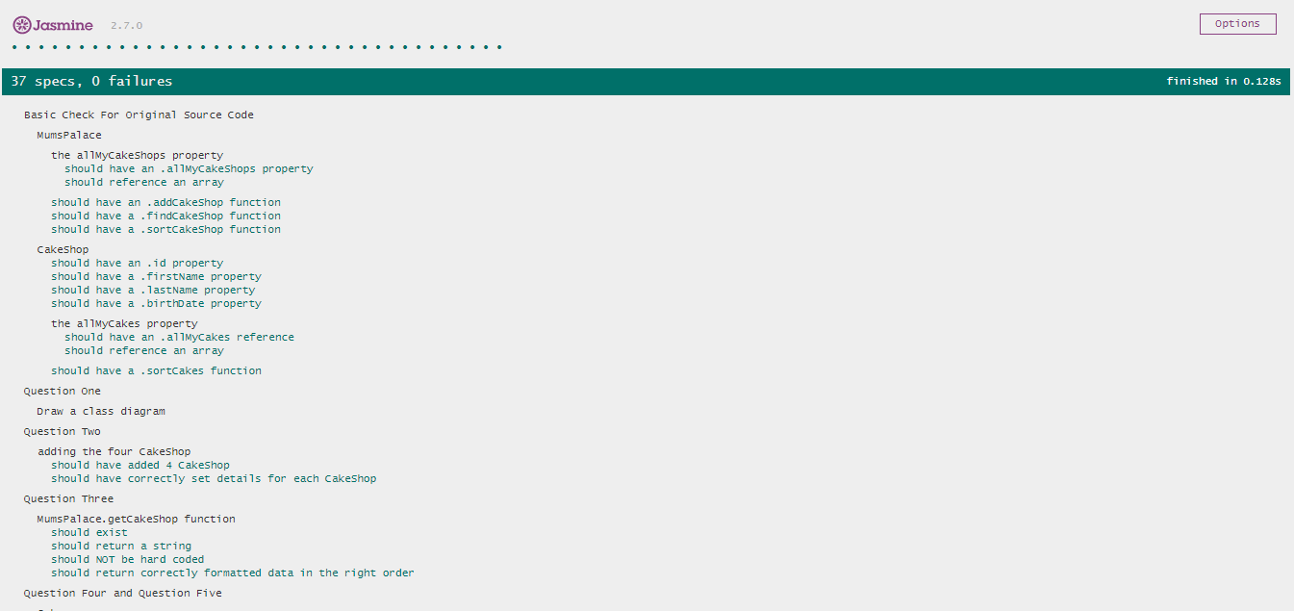Software Engineering (BCSE101) is one of the subject which is been taught by the Computing Department at Ara Institute of Canterbury, the practical lab of the subject contains different practical sessions which needs to be executed. The Jasmine is the framework which is used for the creation of the practical tests. These practical tests require some alteration by using a different example for the execution. The example which was used was (The cake Shop). The unit tests were run for “The cake Shop” by using the jasmine framework. The Jasmine version 2.7 was used in the creation of tests. There were src, spec and lib files for the execution. The lib file had the jasmine framework, spec file contained the tests which needs to verify and the src had the source code for the execution.

The above image describes about the specs in the jasmine tool which is run without any failure. There are 37 specs which is executed.

## Survey

The survey was conducted among the Canterbury Tech Custer and JavaScript Meetup groups to identify the most widely used JavaScript testing frameworks. Survey was conducted based on the ethics approved from the department of computing. The ethical approval contained few forms which needs to be approved before the survey is conducted.

Survey was conducted in two ways Paper Survey and Online Survey.

### Paper Survey

The survey was conducted among the professionals in Canterbury to identify the most commonly used JavaScript testing framework. The questions were asked among the professionals in two ways first was to identify their organisational details and then the questions were about the testing frameworks. Survey was conducted on 14 September 2017

Organisational details contained following questions like organisational type, job role and organisational size.

#### Organisation Type

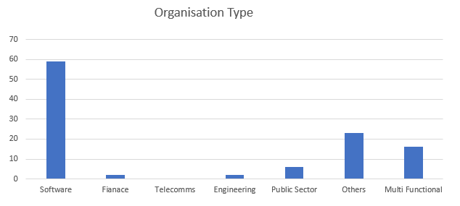The organisational type was to know about the types of different organisations in Canterbury and to know about the list of professionals working in each of them and which industry are they working for. There was mainly software, finance, telecoms, engineering, public sector and other.

From the above graph it is clearly understood that most of the professionals are into Software industry. In the graph the software mainly focuses on people working in a software industry such as developers, Testers, Analysts. Finance is about the people in banking sector or any investment business, Telecoms is on mainly people those who work on telecommunication department, Engineering is about the people who are mainly into mechanical or civil engineering, Public Sector are for accountants, advocates, etc. Other is about people working as recruiters, students or teachers etc, Multi-Functional is the combination of more than one option where they work in more than one industry.

#### Job Role

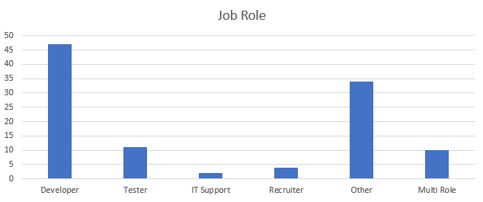A good job description performs many important functions: It describes the skills and competencies that are needed to perform the role; It defines where the job fits within the overall company hierarchy; It is used as the basis for the employment contract; and. It is a valuable performance management tool. Here the job role is used to find out what the professionals work as in Canterbury. This mainly included Developer, Tester, IT Support, Recruiter and other.

From the graph is clearly understood that most of the IT professionals are developers.

#### Organisation Size

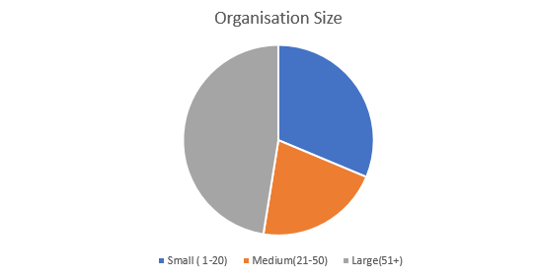The size of each organisation is identified to find the list of people working in organisation and to record the count of IT professionals.

From the pie chart above it is understood that most of the organisations are large with employee’s greater than 51.

#### JavaScript Testing Framework

Testing in JavaScript is becoming expected by developers more and more. There are different choices of frameworks available and the developers choose the framework accordingly. In the survey there were 20 different JS testing frameworks. Which were used to identify the most popular framework. There were five questions asked along with the frameworks to choose among them.

The five questions were.

* You’ve Never heard about it
* You’ve Heard about it and want to learn it
* You’ve Heard about it but don’t want to learn it
* You’ve Used it and want to use it again use it again
* You’ve Used it but don’t want to use it again

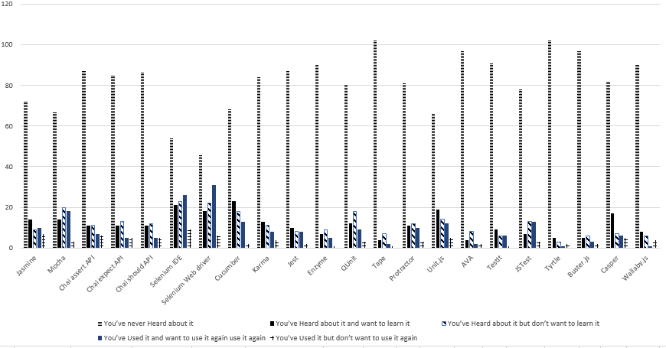

From the graph it is identified that the most widely used and preferred framework is “Selenium Web Driver”, were the employees have used it and want to use it again. Second is “Selenium IDE” in which the users have used it and want to use it again. The framework which the users have never heard of is “Tape” and “Turtle”.

### Online Survey

Online survey was conducted to analyse the popular JavaScript testing framework. A separate ethical approval is required for the online survey from the Department of Computing. The same questions which were asked for the paper survey was asked in online survey. The survey was conducted in “survey monkey” and the link was being passed to different JavaScript testing groups.

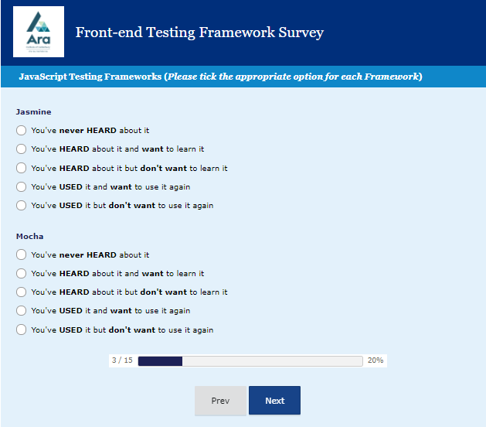The below diagram shows one of the example of how the questions are asked in survey monkey.

From the analysis in the survey monkey it was identified that the selenium web driver and selenium IDE are most widely used testing frameworks. These testing frameworks will be further used for the unit testing.

## Frameworks

Unit tests were written on the popular testing frameworks as obtained from the survey.

Unit testing is a software development process in which the smallest testable parts of an application, called units, are individually and independently scrutinized for proper operation. Unit testing can be done manually but is often automated. (Rouse, 2017)

Testing on examples

* External review of the Jasmine tests and code for Triangles
* Replicate tests for Triangles with other testing frameworks. Initially Mocha-Chai-Expect/ Mocha-Chai-Should, and Mocha-Chai-Assert
* Replicate tests for Triangles with Cucumber
* Replicate tests for Triangles with Selenium IDE

Testing on exercise

* Identify ANOTHER classic software testing exercises often repeated in popular web tutorials
* Find top 5 google on-line tutorials for a JavaScript testing framework
* Fork/copy the whole article to the repository
* Get the examples working
* Take note of what the examples are about:

# Project Summary

The project is about the analysis of JavaScript testing frameworks in Canterbury. The first phase was the recreation of the existing program to a new example in SE101. Jasmine framework is used in the program. Analysis of the popular frameworks were done based on the survey. The survey was done in two ways paper survey and online survey. The paper survey was conducted on 14th of September in Canterbury tech cluster and JavaScript meetup. There were around 113 people, analysis was made based on that, and the online survey was done using the “Survey Monkey”. The survey link was shared among the professionals in the JavaScript Meetup group and Tech summit group. From the analysis on the survey it is identified that “Selenium Web Driver”, “Selenium IDE”, “Cucumber” are the most widely used testing tool.

Unit tests are written based on the survey result obtained. It is written on Mocha (should, expect and assert), cucumber, selenium IDE, Jasmine for the Triangle program example. Few software testing exercise was identified in web and work on the examples.

# Progress Made

### Overview of objectives

* Measures taken for Quality assurance documented
* Risk Management is documented which includes all the persistent recognizable proof and future planning
* The half way report shows how the project is in progress and all the required adjustments are made as necessary
* Recreation of the existing JavaScript testing example program for SE101 at the Department of Computing.
* Adding further regular expressions into the testing program.
* Getting the ethics approved from the department to conduct the survey.
* Conduct the survey to analyse the popular JavaScript testing framework. Survey was conducted at Christchurch Tech Cluster and JavaScript meetup.
* Unit testing was performed on the framework which was analysed after the survey.
* Identified ANOTHER classic software testing exercises often repeated in popular web tutorials

# Mile Stones Achieved

### Recreation of the existing framework

* New example was created with respect to the existing JavaScript Program in SE101
* The program was created using the Jasmine Framework
* Regular expression was added into the program to identify a sequence of symbols and characters expressing a string or pattern to be searched for within a longer piece of text.

### Survey

* Survey was conducted among the IT professionals on 14 September 2017
* It was conducted through paper and online.
* Survey was mainly held to identify the popular JavaScript testing framework.
* The framework was identified from almost around 113 professionals in the survey.

### Popular Framework

* Unit Test were written on the popular framework which was identified from the survey.
* Different tests were performed using the framework
* The popular framework which was identified after survey is “Selenium IDE”, “Selenium Web Driver”, Mocha chai (should, expect, assert), Cucumber.

### Quality Assurance Plan

* All the tasks listed in the project meets all the necessary quality.
* The success of the final product is determined in metrics.

### Risk Management Plan

* All the major the risks triggered are documented and planned accordingly
* Detailed mitigation plan is created for the top 9 risks.

# Problems encountered

* Confirmation on survey questions.
* Confirmation in getting the ethics approved
* Approval from the department to conduct an online survey.
* Unable to conduct survey as the ethics are not approved
* Unavailability of the ticket to attend the Tech Summit meetup
* Misunderstanding between the tutors in the survey questions.
* Delay in getting the ethical form signed off from the department
* Unable to upgrade the version of online as it needs to be funded by the department
* Unavailability of the Tutor who assisted in the project
* Team member in the project fell sick
* Lack of understandability of certain tasks provided by the tutor

# Course Management

### Time Management

* Spending time to work on the project as and when possible

### Subject PR203 chosen with the project

* Unable to focus on the project when there are tasks given by the subject at the same time
* Could gather knowledge on the subject.

### Other Priorities

* Assignments and exams in PR203,
* Part time work
* Family and Friends
* Relaxing

### Weekly reports and meetings

* Weekly reports and meeting held with the industry as well as the academic supervisors
* Keeping a track of the tasks and hours used to work on the task daily.

# Quality Assurance

Quality assurance is required to ensure that the system meets the pre-established requirements and standard. Quality Assurance involvement will be from the beginning to the end of the project life cycle. It is also a plan effort to ensure that the software product fulfil criteria and has additional attribute specific to that product. The Quality Assurance can be described in two ways internal quality assurance and external quality assurance.

|  |  |
| --- | --- |
| Internal Quality Assurance | External Quality Assurance |
| Maintainability: The simplicity with which the framework can be changed or include abilities, enhance execution, or correct imperfections. | **Correctness**: For the data which is obtained from the survey and interview, code developed using framework should be correct and relevant. |
| Flexibility: The ease of using a program or conditions other than those for which it was particularly outlined | **Usability:** The ease to learn and utilize a framework. |
| Portability: The simplicity with which a framework can be altered to work in a situation unique in relation to that for which it was particularly planned | **Efficiency**: Insignificant utilization of framework assets, including memory and execution time. The code developed using frameworks should be well organised or structured |
| Reusability: the ease with which the developed code using a certain framework can be reused again. | **Reliability:** The capacity of a framework to play out its required capacities under expressed conditions at whatever point required. Creating a program which is trustworthy and with no errors. The data which is collected from the professionals after the interview and survey should be reliable. |
| Readability: The ease of learning and developing knowledge by understanding the frameworks. | **Integrity**: The framework used anticipates unapproved or despicable access to its projects and its information. The possibility of honesty incorporates confining unapproved data gets to and also guaranteeing that information is gotten to appropriately. All the information which is obtained from survey and interview should be honest and received through proper needs. |
| Testability: Test the code to check if it runs without error and does it meet the requirement. | **Adaptability:** The framework can be utilized, without alteration, in applications or conditions other than those for which it was particularly planned. The code which can be utilized without any errors and easily driven to output. |
| Understand ability: The ease of understanding the frameworks and implementing them. | **Accuracy**: The framework, as constructed, is free from mistake; it is an assurance of how well a code developed using framework does the work without any malfunction. |

**Correctness** and **Accuracy** are mainly used for the survey and interview at the Canterbury Cluster, IITP. To comprehend the precision of the data gave by the employee about the testing frameworks.

**Portability** and **Reusability** are utilized as a part of coding to check the straight forwardness with which code can be altered and work in a situation not quite the same as that for which it was particularly outlined, the degree to which and the simplicity with which code can be utilized as a part of framework.

**Testability** can be used to check if the codes, which are developed, are executable and can it be run without any errors.

**Efficiency** is used to check insignificant utilization of framework assets, including memory and execution time. The code developed using frameworks should be well organised or structured

# Risk

|  |  |  |
| --- | --- | --- |
| Risk | Level | Mitigation Plan |
| Professionals using the same testing framework | Medium | Difficulties in finding IT professionals in the survey and while conducting interviews using the same Java Script testing framework. Meeting up with professionals through social network such as Meetup groups, to identify the testing frameworks used. |
| Privacy and security issues | Medium | The data collected after the survey and interview should be secured and protected. Leaking the confidential data causes major risk. Hence all the data which is being collected should be well protected and safe. |
| Issues in the data analysis | Medium | The data being improper and in appropriate after data analysis. The lack of information or lack of clarity causes the issues with data analysis. Hence, relevant and correct information should be collected from the survey and interview. |
| Product Risk & Project Risk | High | The factor in which what is produced by work, i.e. the things, which is being, tested . Testing of the code after the implementation is required to check if the implemented code do not have any errors and the Factor relating to the way the work is carried out, i.e. the test project |
| Tight timelines | High | The project have crossed the timeline as it was mentioned earlier. Unexpected sick leave of the tutor and the team member |
| Operational Risks   * Failure to address priority conflicts * Improper subject training * Improper communication with the tutors * Failure to resolve the responsibilities | High | Unable to identify the actual concept. Due to lack of training and less communication with tutor to know about the issue. The given responsibilities cannot be completed due to lack of concentration, dedication and unawareness about the topic |
| Technical Risks   * Continuously changing requirements - Change of product requirements continuously can cause delay in project submission and unclear about the details required to execute the project. * Difficult project module integration. * No advanced technology available or the existing technology is in initial stages * Complex product to implement. | High | Difficulty in submitting the half way report due to continuous change in the requirements. Unavailability of the tutor is the major risk. Unable to complete the project at the expected time |
| Personal Risk   * Multiple exams and assignments, which may interrupt the project. * Impact on personal career and life if the project fails or succeeds. * Emotional impact. * Impact on health. * Ethical and professional compromise required | High | * Multiple assignments on other subjects (DBMS) which will interrupt in the project creation. It will also cause stress in dealing with the topics due to too much of workload. * Emotionally affected as all of these creates lot of stress. * Team member not well. |
| Programmatic Risks   * Unaware of the latest technology and trends. * Changing customer priority and strategy. * Running out of funds. * Change in market strategies. | High | Unaware of the latest trends in technology will cause difficulty in project creation according to the latest update. |
| Schedule Risk   * Wrong time estimation * Failure to identify complex functionalities and time required to develop those functionalities. * Resources are not tracked properly. | High | Not tracking the resources properly and creating or performing tasks without the time estimation.  Unable to complete on time. |
| Natural Disaster   * It can cause data to lose and the scheduled activities can be ruined. | Low |  |
| Conformity required for the external and internal policy. | Medium | Needed the confirmation for the ethics to be approved |
| Quality of the product, which is developed. | Medium | Once the product is developed or the program is created. It should meet the quality and standard. I.e. the program should run without errors. |
| Unable to identify the project complexities and functionalities before the project execution. | High | Complexities and functionalities of the project is identified |
| Loss caused by failure to mitigate risk | Low |  |
| Unavailability of professionals | Low |  |
| Project Deadline | High | Unable to finish the project in the expected deadline |

# Methodology Essay on Test Driven Development(TDD)

The method Test-driven development (TDD) is a software development process that relies on the repetition of a very short development cycle. "TDD" refers a programming style which has three activities: coding, testing and design (refactor) (Agile Alliance, n.d.)

Requirements are analysed to certain automated test cases, and then the improved software is used to pass the new tests. It is an evolutionary approach to development, which combines TDD where tests are written before you write a production code to fulfil that test and refactoring (Test-driven_development, n.d.). Refactoring is the process of changing the structure of the code without changing its behaviour; with this, the code developed would be easier to understand.

For every small functionality of an application in TDD it starts with designing and developing tests. In the below given figure1 the developer writes an automated test case that is initially failing which defines improvement or new function, then will produce a code to pass the test, and then the new code would be refactored to the acceptable standards.

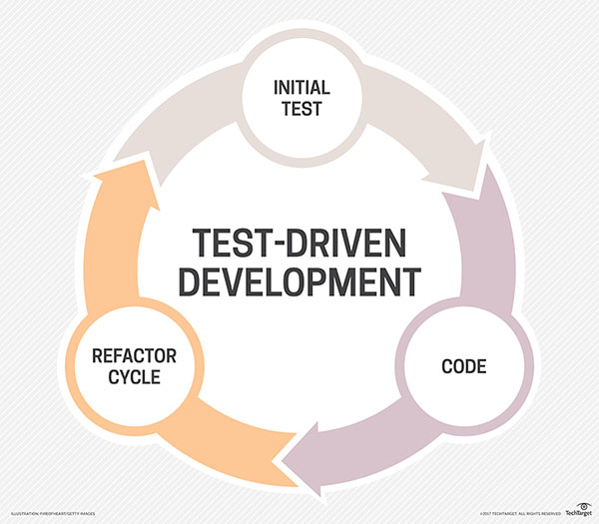

Fig1: Test-Driven Development (Rouse, 2017)

It starts with the designing and developing tests for all little functionality of an application. In TDD approach, the test which is developed first specifies and validates what the code must do. It can be shown as “red-green-refactor cycle”. Before the code is written and any new functionality is added to an application, an automated test would be written by the developer stating how the code should behave, and wait for it to turn red (fail to pass). Then the code would be written to the specification which would turn the test to green (test passes). Finally, the developer will make sure that code written will be clean and executable (refactoring) (wikipedia, 2017)

## Advantages of TDD

TDD is a software development method in which the code is tested constantly. TDD develops software of high quality in a short span of time. It saves cost, effort and much more. Below list mentions few advantages of TDD

* It is first a safety net. All the existing code is tested. As human programmers make mistakes when the code is changed or improved
* TDD will allow to spot bugs quicker. All the errors in the program while testing is identifiable easily.
* TDD focuses on good design. To make the code testable, it must have a good structure.
* TDD helps to maintain the code easily and refactor. The code implemented is of good clarity.
* Helps prevents defects – If there is any issue with the requirements or with design at the beginning it is found. If there are any small mistakes it is caught immediately and thus helps the programmers to find the mistakes.
* Helps the programmers really understand their code – The code written by the programmers are easily understandable
* Helps support refactoring as needs and design changes
* Provides early warning to design problems: If there is any errors in the code. Early warnings will be provided
* Programmers learn how to write other kinds of tests: Programmers learn different form of tests
* It encourages small steps and the principle that it is easier to keep a system working than fix it after you break it (Grenning, 2016)

## Disadvantages of TDD

Even though there are many advantages for TDD, there are few disadvantages, which makes the TDD less efficient. Below list shows some of the main disadvantages

* It consumes a lot of time and effort for the development - Takes lot of time thinking of how to write the test, which requires lot of effort.
* Concentrating on the least difficult plan now and not thinking ahead can mean major refactoring prerequisites.
* It's hard to write great tests that cover the fundamentals and keep away from the unnecessary.
* It requires significant investment and push to keep up the test suite – it must be reconfigured for most extreme esteem.
* If there is rapid change in the design, the test should be changed frequently. Most of the time would be wasted by writing tests (Hill, 2015)

# Bibliography

*Agile Alliance*. (n.d.). Retrieved from www.agilealliance.org: https://www.agilealliance.org/glossary/tdd/#q=~(filters~(postType~(~'page~'post~'aa_book~'aa_event_session~'aa_experience_report~'aa_glossary~'aa_research_paper~'aa_video)~tags~(~'tdd))~searchTerm~'~sort~false~sortDirection~'asc~pag

chrisdavidmills. (2017, May 25). *MDN web docs.* Retrieved from developer.mozilla.org: https://developer.mozilla.org/en-US/docs/Web/JavaScript/Guide/Introduction

Davis, J. (27 May 2013). *TDD and BDD.*

Grenning, J. (2016, May 11). *quora*. Retrieved from https://www.quora.com: https://www.quora.com/What-are-the-pros-and-cons-of-test-driven-development

Hill, S. (2015, Feb 2015). *leantesting*. Retrieved from https://leantesting.com: https://leantesting.com/test-driven-development/

Rouse, M. (2017). *TechTarget*. Retrieved from /searchsoftwarequality.techtarget.com: http://searchsoftwarequality.techtarget.com/definition/unit-testing

Shilman, M. (n.d.). *stateofjs.com.* Retrieved from Testing Frameworks: https://stateofjs.com/2016/testing/

*Software_testing*. (2017, September 25). Retrieved from wiki/Software testing: https://en.wikipedia.org/wiki/Software_testing

*wikipedia*. (2017). Retrieved from en.wikipedia.org: https://en.wikipedia.org/wiki/Test-driven_development