**DIGITAL ASSESSMENT-2**

**SOCIAL AND INFORMATION NETWORKS**

**A symmetrized snapshot of the structure of the Internet at the level of Autonomous system (AS) – Given real world social network.**

**Use R programming**

1. **Find the number of Autonoumous systems in the network and top 20 popular Ases. Also give the details of the organizations and countries to which top 20 ASes belong.**

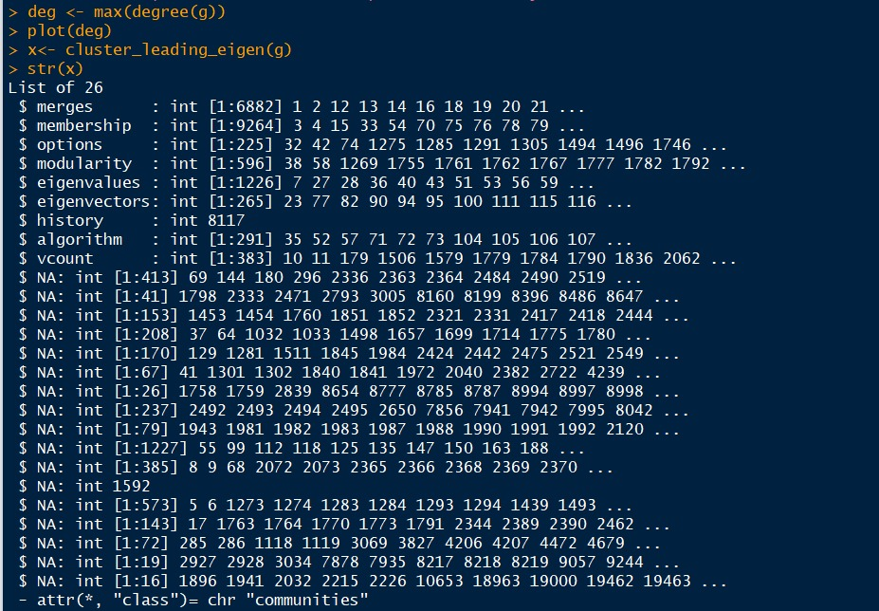

1. **Find the number of AS links in the network.**



**3) Compute average degree distribution, clustering coefficient and average path length for the given network.**

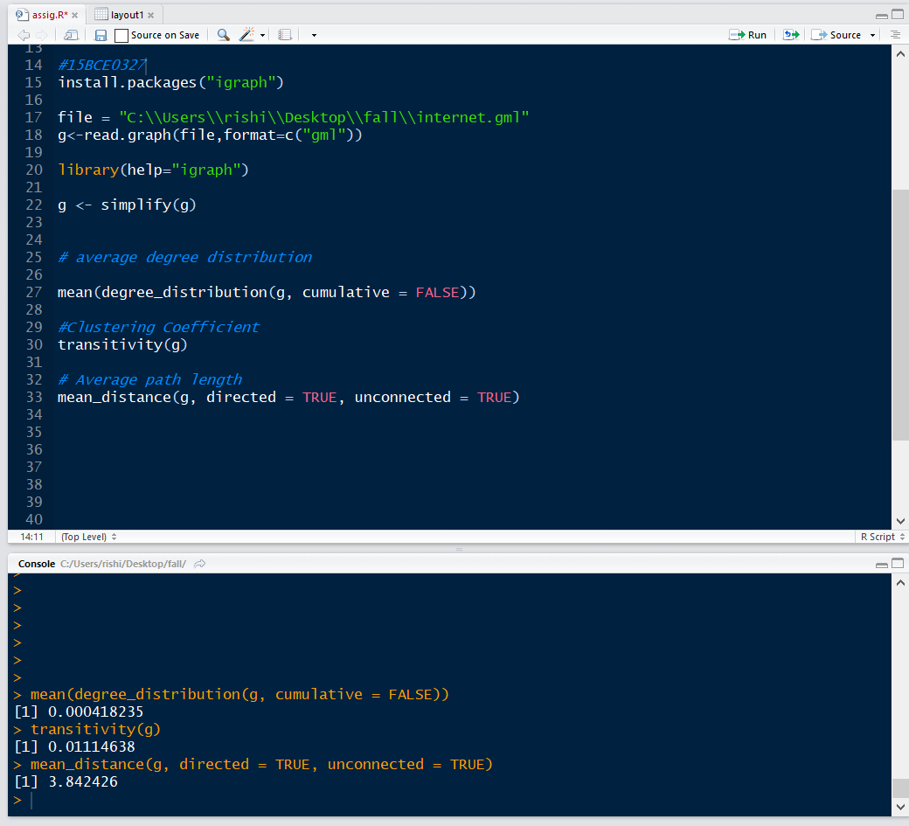

1. **Simulate the given social network using random graph model G(20,p). Compute the p value from c = (n-1)p, where c is average degree of the given network.**

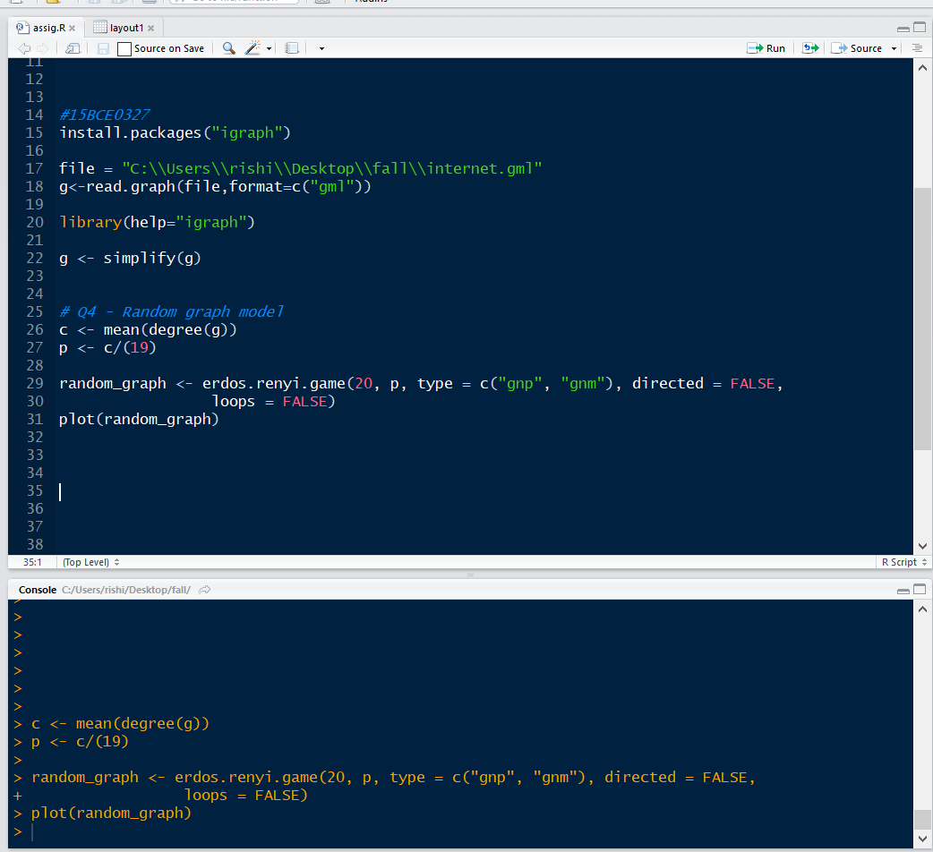

**5) Simulate the given social network using small world properties model for 20 nodes. Compute the beta value from C(p) = (1-p)^3 * C(0), in which beta = p, C(p)= clustering coefficent of given**

**network, C(0) is clustering coefficent of regular lattice .**

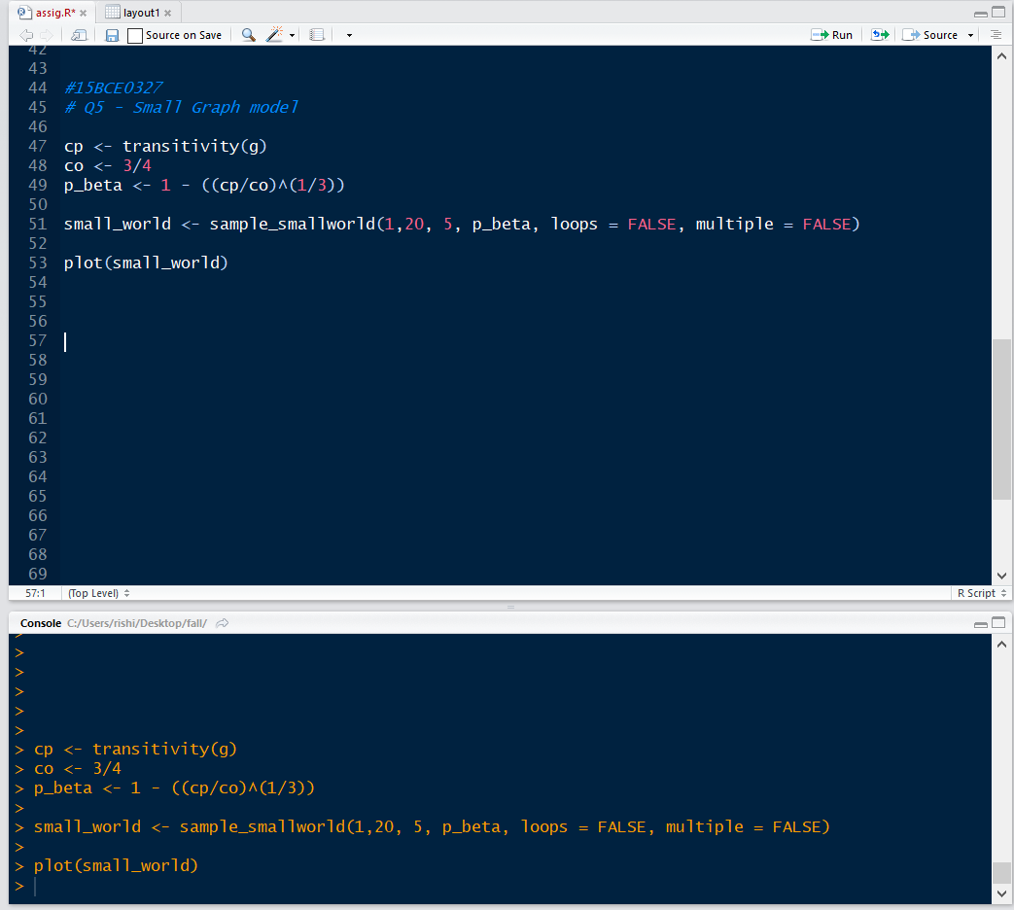

**6) Simulate the given social network using preferential attachment model for 20 nodes with expected degree m computed from real networks.**

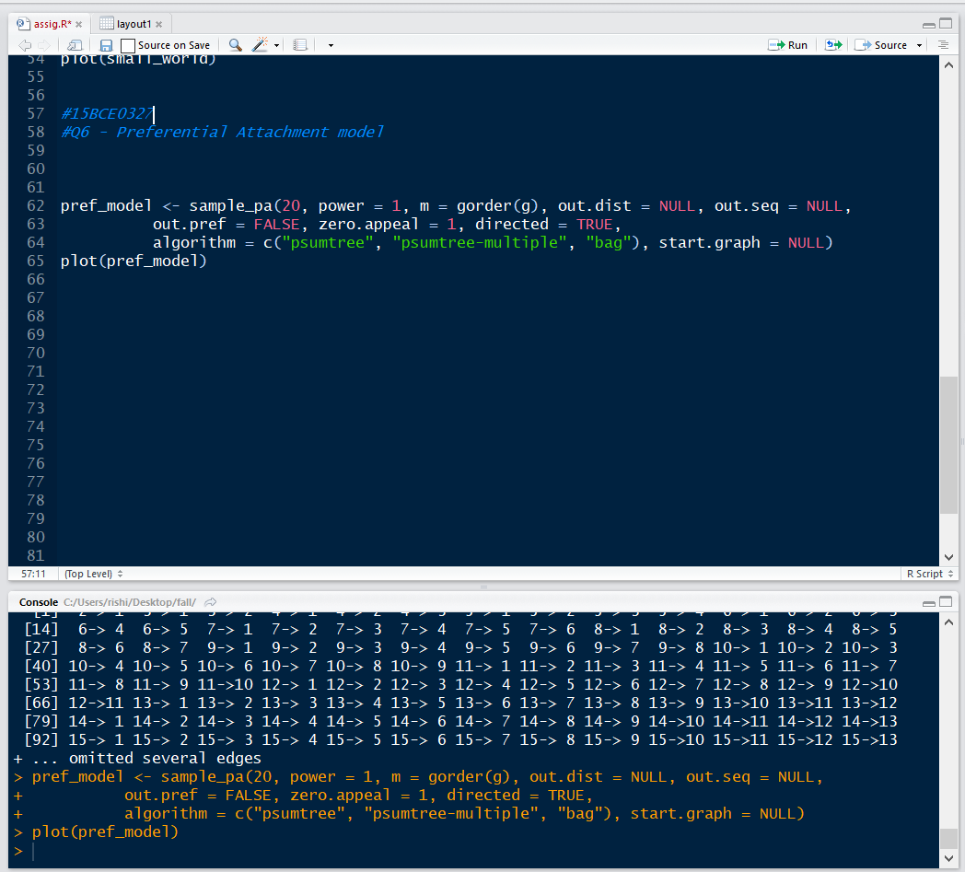

**7)Compare the clustering coefficient and average path length properties of real time and simulater networks**

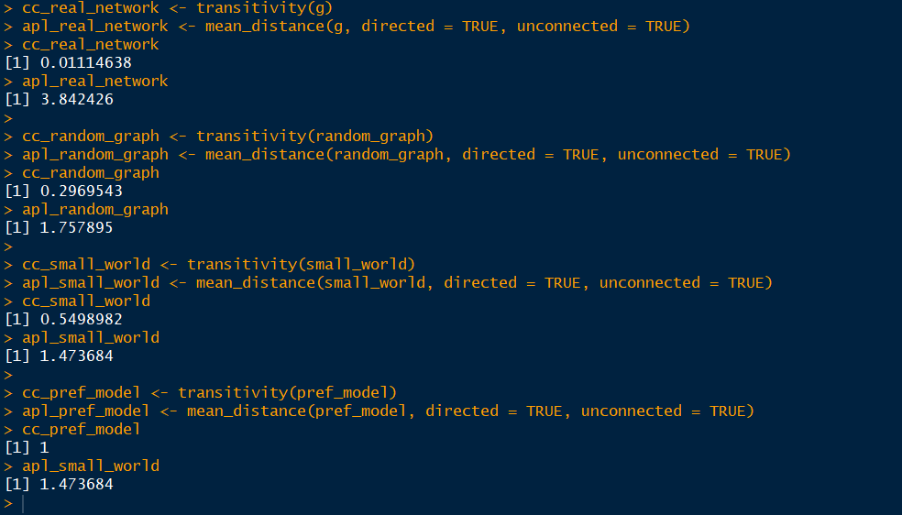

**8) Show the average degree distribution for preferential attachment model follows power law distribution.**

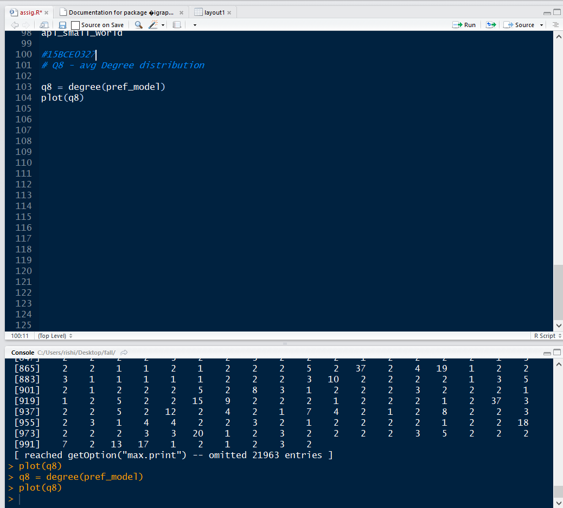

**9) With the simulated preferential attachment model graph in 6, detect the communities using any one of the node similarity based method and edge betweenness method.**

