Machine Learning Operations (MLOps) — AIMLCZG523
Assignment 01
Heart Disease Risk Prediction:
An End-to-End MLOps Pipeline from Data to Monitored Kubernetes API
Student name | A Swathi
BITS ID | 2025AE05795
Course | AIMLCZG523 — Machine Learning Operations
Code repository | https://github.com/SwathiVeerapalli/heart-disease-mlops
Pipeline runs evidenced | GitHub Actions ml-pipeline runs #1, #3 and #4 — all 7 jobs passed
Submission date | October 2026

1. Introduction and Summary
The objective of this assignment is to build a machine learning classifier that predicts the presence of heart disease from routine patient measurements, and to take it all the way to a cloud-ready, monitored API using MLOps practices: reproducible data processing, experiment tracking, automated testing, CI/CD, containerisation, Kubernetes deployment and observability.
The solution is organised as a single GitHub repository. Every step, from downloading the UCI data to deploying the API on Kubernetes and capturing monitoring dashboards, runs automatically in a seven-stage GitHub Actions pipeline on every push to main. The evidence in this report (metrics, screenshots and logs) was produced by that pipeline and committed back to the repository by the pipeline itself, so each result can be traced to a specific workflow run.
Table 1. Summary of results
Area | Outcome
Data | UCI Cleveland heart disease data, 303 patients, 13 features; 6 missing values imputed inside the model pipeline
Models | Logistic Regression and Random Forest, tuned with GridSearchCV (16 and 18 configurations) and 5-fold stratified CV
Selected model | Logistic Regression (C = 0.1, L2): CV ROC-AUC 0.912 ± 0.017; hold-out ROC-AUC 0.962, accuracy 0.885, recall 0.929
Tracking | MLflow: parameters, CV/test metrics, tuning grids, plots and signed models logged for every run; champion tagged
CI/CD | lint → test (20 tests) → train → docker → deploy-k8s ∥ monitoring → publish; run #1 succeeded in 8 min 34 s
Serving | FastAPI /predict in a non-root Docker image, pushed to GHCR; 2 replicas on Kubernetes behind NGINX Ingress
Monitoring | Structured JSON request logs; Prometheus metrics; provisioned 6-panel Grafana dashboard

2. System Architecture
Figure 1 shows the three layers of the system. The ML pipeline (Python package heart/) acquires and cleans data, produces EDA figures, trains and tunes candidate models and logs everything to MLflow. The CI/CD layer orchestrates those steps and adds quality gates and deployment. The runtime layer serves the exported model as a containerised FastAPI service on Kubernetes, with Prometheus scraping the service and Grafana visualising it.
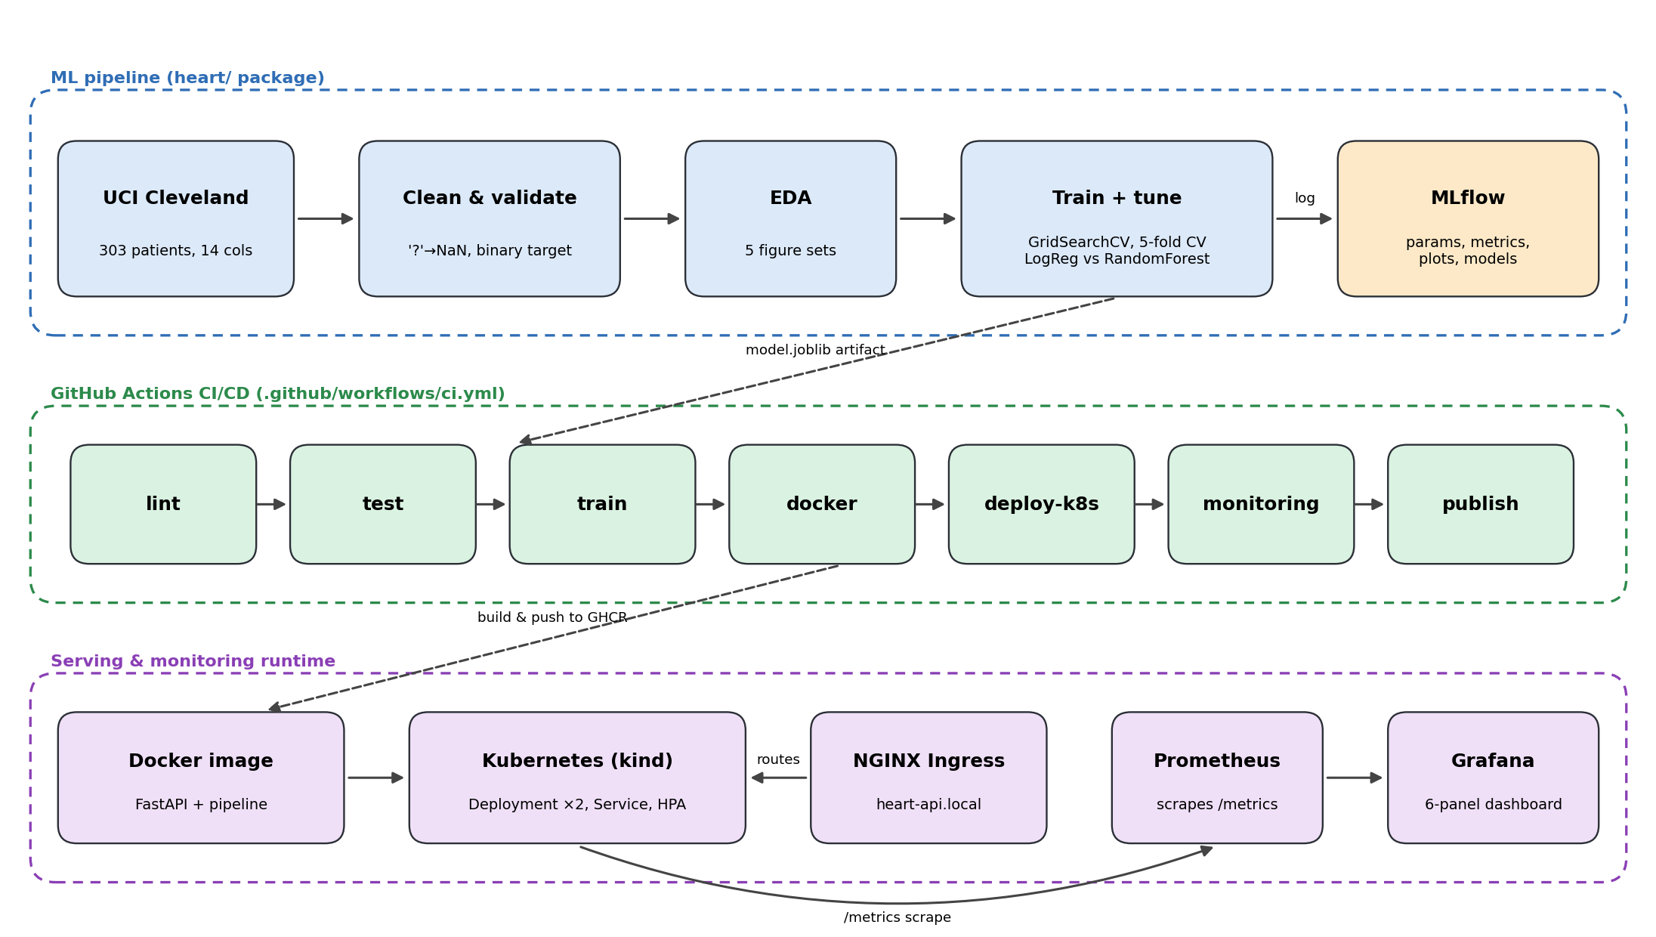
Figure 1. End-to-end architecture: ML pipeline, GitHub Actions CI/CD and serving/monitoring runtime
A key design decision is that preprocessing and the classifier are saved together as one scikit-learn Pipeline. The API therefore receives raw clinical values and applies exactly the same imputation, scaling and encoding that was used in training, removing a common source of training/serving skew.
Table 2. Repository layout
Path | Contents
heart/ | download.py, data.py, features.py, eda.py, train.py, predict.py (inference), config.py
app/main.py | FastAPI service: /predict, /health, /model-info, /metrics, JSON request logging
test/ | Pytest suites for data, features, model training and the API (20 tests)
.github/workflows/ci.yml | Seven-job CI/CD pipeline
Dockerfile, requirements*.txt | Serving image and pinned training / serving / dev dependencies
k8s/ | Namespace, Deployment, LoadBalancer Service, Ingress, HPA; k8s/kind/ cluster config
monitoring/ | docker-compose stack, Prometheus config, Grafana provisioning + dashboard, load generator
data/processed/, reports/, screenshots/ | Cleaned dataset, EDA and model figures, and run evidence (committed by CI)

3. Setup and Run Instructions

3.1 Prerequisites
Python 3.11, Git and Docker are required. For the Kubernetes steps either Minikube or kind with kubectl is needed. All Python dependencies are pinned in requirements.txt (training and EDA), requirements-serve.txt (API runtime) and requirements-dev.txt (tests and linting).

3.2 Train and evaluate from a clean checkout
git clone https://github.com/SwathiVeerapalli/heart-disease-mlops.git && cd heart-disease-mlops
python -m venv .venv && source .venv/bin/activate # Windows: .venv\Scripts\activate
pip install -r requirements-dev.txt

python -m heart.download # download UCI file, clean, validate -> data/processed/heart_clean.csv
python -m heart.eda # figures -> reports/figures/
python -m heart.train # tuning + CV, MLflow runs in ./mlruns, model -> models/model.joblib
mlflow ui --backend-store-uri ./mlruns # http://localhost:5000
pytest -v # 20 unit tests
ruff check . && ruff format --check .

3.3 Serve the model
uvicorn app.main:app --port 8000 # Swagger UI at http://localhost:8000/docs
docker build -t heart-api:1.0.0 . && docker run --rm -p 8000:8000 heart-api:1.0.0
curl -X POST localhost:8000/predict -H 'Content-Type: application/json' -d @sample_request.json

3.4 Deploy to Kubernetes
# Minikube (LoadBalancer service)
minikube start && minikube image load heart-api:1.0.0
kubectl apply -f k8s/ && kubectl -n heart-mlops rollout status deploy/heart-api
minikube tunnel # assigns the external IP
curl -X POST http://<EXTERNAL-IP>/predict -H 'Content-Type: application/json' -d @sample_request.json

# kind with NGINX Ingress (same as CI)
kind create cluster --name heart --config k8s/kind/kind-config.yaml
kubectl apply -f https://raw.githubusercontent.com/kubernetes/ingress-nginx/controller-v1.11.2/deploy/static/provider/kind/deploy.yaml
kind load docker-image heart-api:1.0.0 --name heart && kubectl apply -f k8s/
curl -H 'Host: heart-api.local' http://localhost/health

3.5 Monitoring stack
docker compose -f monitoring/docker-compose.yml up --build -d # API :8000, Prometheus :9090, Grafana :3000
bash monitoring/load_test.sh http://localhost:8000 300
Running the full pipeline needs no local setup: any push to main (or a manual Run workflow from the Actions tab) executes every step above on GitHub-hosted runners.

4. Data Acquisition and Exploratory Data Analysis

4.1 Acquisition and cleaning
heart/download.py fetches processed.cleveland.data from the UCI Machine Learning Repository, with three retries for transient network errors. The raw file has no header and marks missing values with ?. Cleaning (heart/data.py) applies the documented column schema and converts ? to NaN. It also treats physiologically impossible zero values of resting blood pressure and cholesterol as missing, and binarises the original 0–4 diagnosis into the target (0 = no disease, 1 = disease). Finally it removes duplicates and validates the schema before anything is trained. The result has 303 rows, 13 features and no duplicates. Only ca (4 rows) and thal (2 rows) contain missing values.
Missing values are intentionally not filled during cleaning. Imputation lives inside the model pipeline (median for numeric, most-frequent for categorical), so the identical logic is applied to API requests. A request can therefore omit ca or thal and still be scored.

4.2 Findings
The classes are reasonably balanced: 164 patients (54.1%) without disease and 139 (45.9%) with disease. Plain accuracy is therefore meaningful, but stratified splits are still used throughout. The correlation analysis (Figure 2, right) and per-category disease rates (Figure 4) identify the strongest signals:
- thal (thallium stress test) has the strongest correlation with the target (0.53). Reversible defects (7) show a 76% disease rate versus 22% for normal results.
- ca (vessels coloured by fluoroscopy, 0.46) has a nearly monotonic effect: the disease rate is 26% with no coloured vessels and 82–85% with two or three.
- exang (exercise-induced angina, 0.43) has a 77% disease rate when present versus 31% when absent. oldpeak (ST depression, 0.43) behaves similarly.
- cp = 4 (asymptomatic chest pain) carries a 73% disease rate, much higher than the typical-angina categories. Asymptomatic presentation is a known risk marker.
- thalach (maximum heart rate) is negatively correlated (−0.42), so lower exercise capacity indicates higher risk.
- chol (0.09) and fbs (0.03) are only weakly related to the target on their own. They are kept because the regularised models can down-weight them.
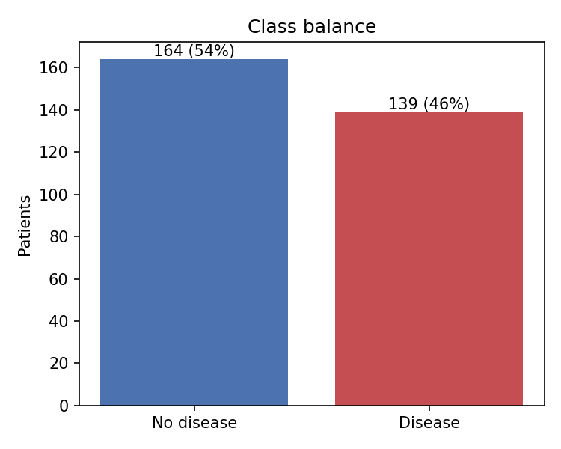 | 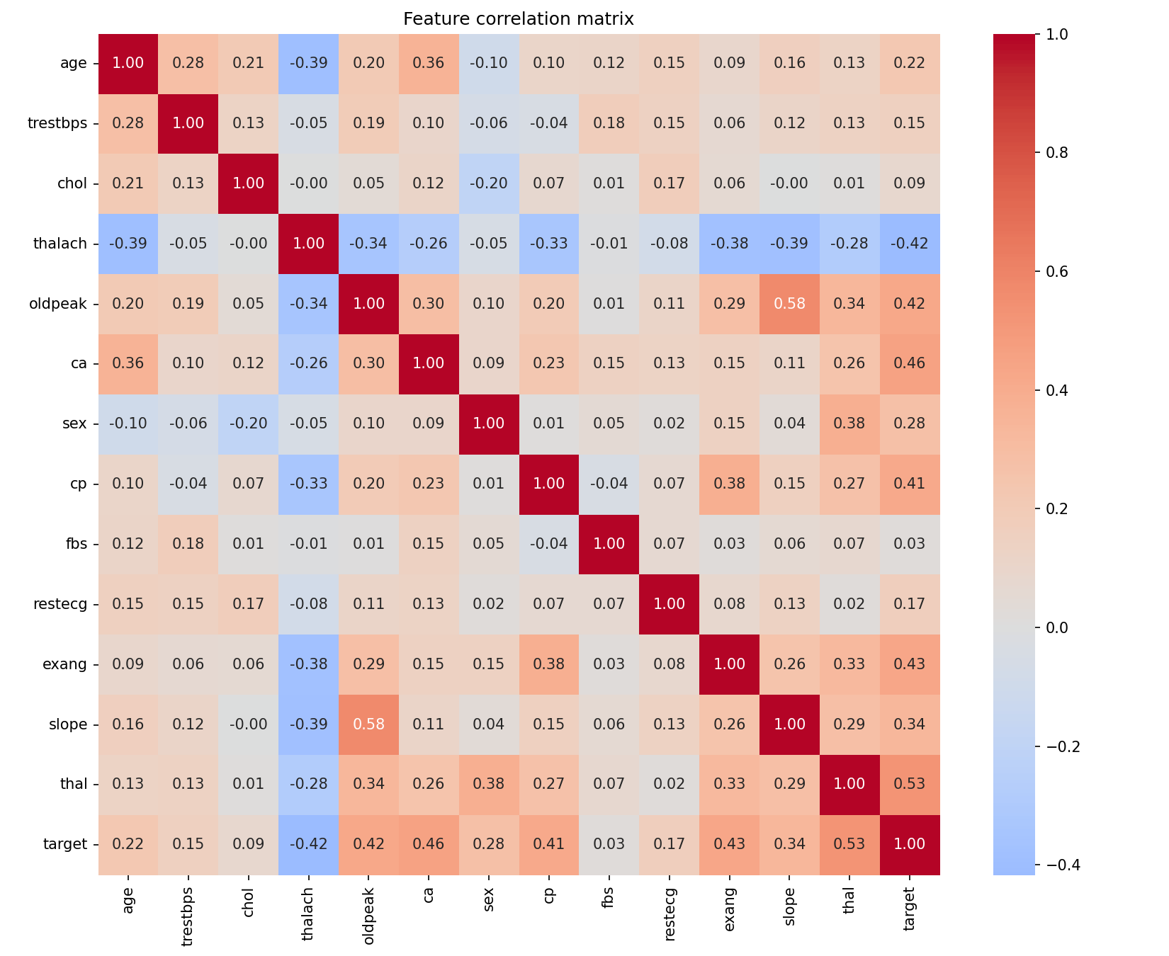
Figure 2. Class balance (left) and feature correlation matrix (right)
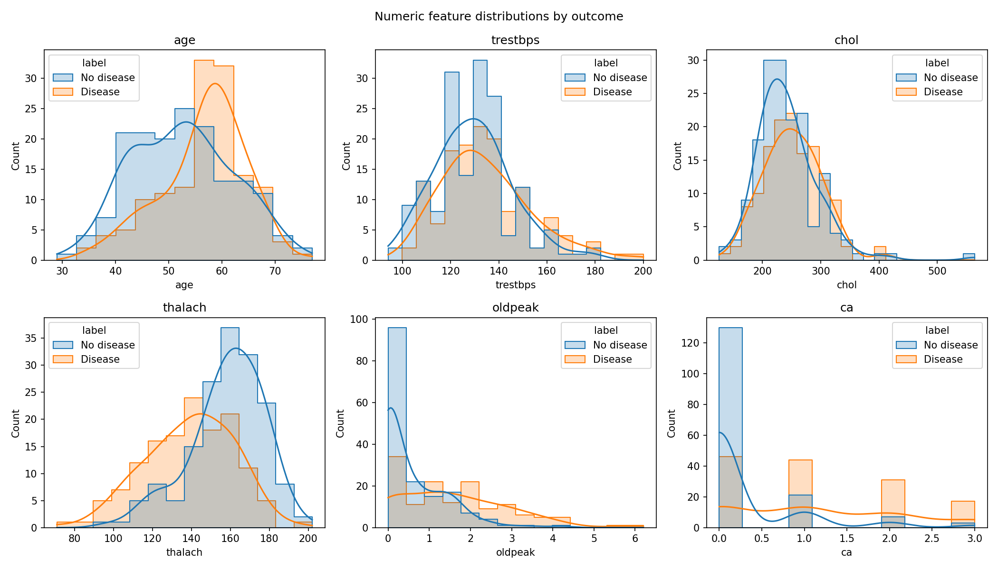
Figure 3. Distributions of numeric features split by outcome
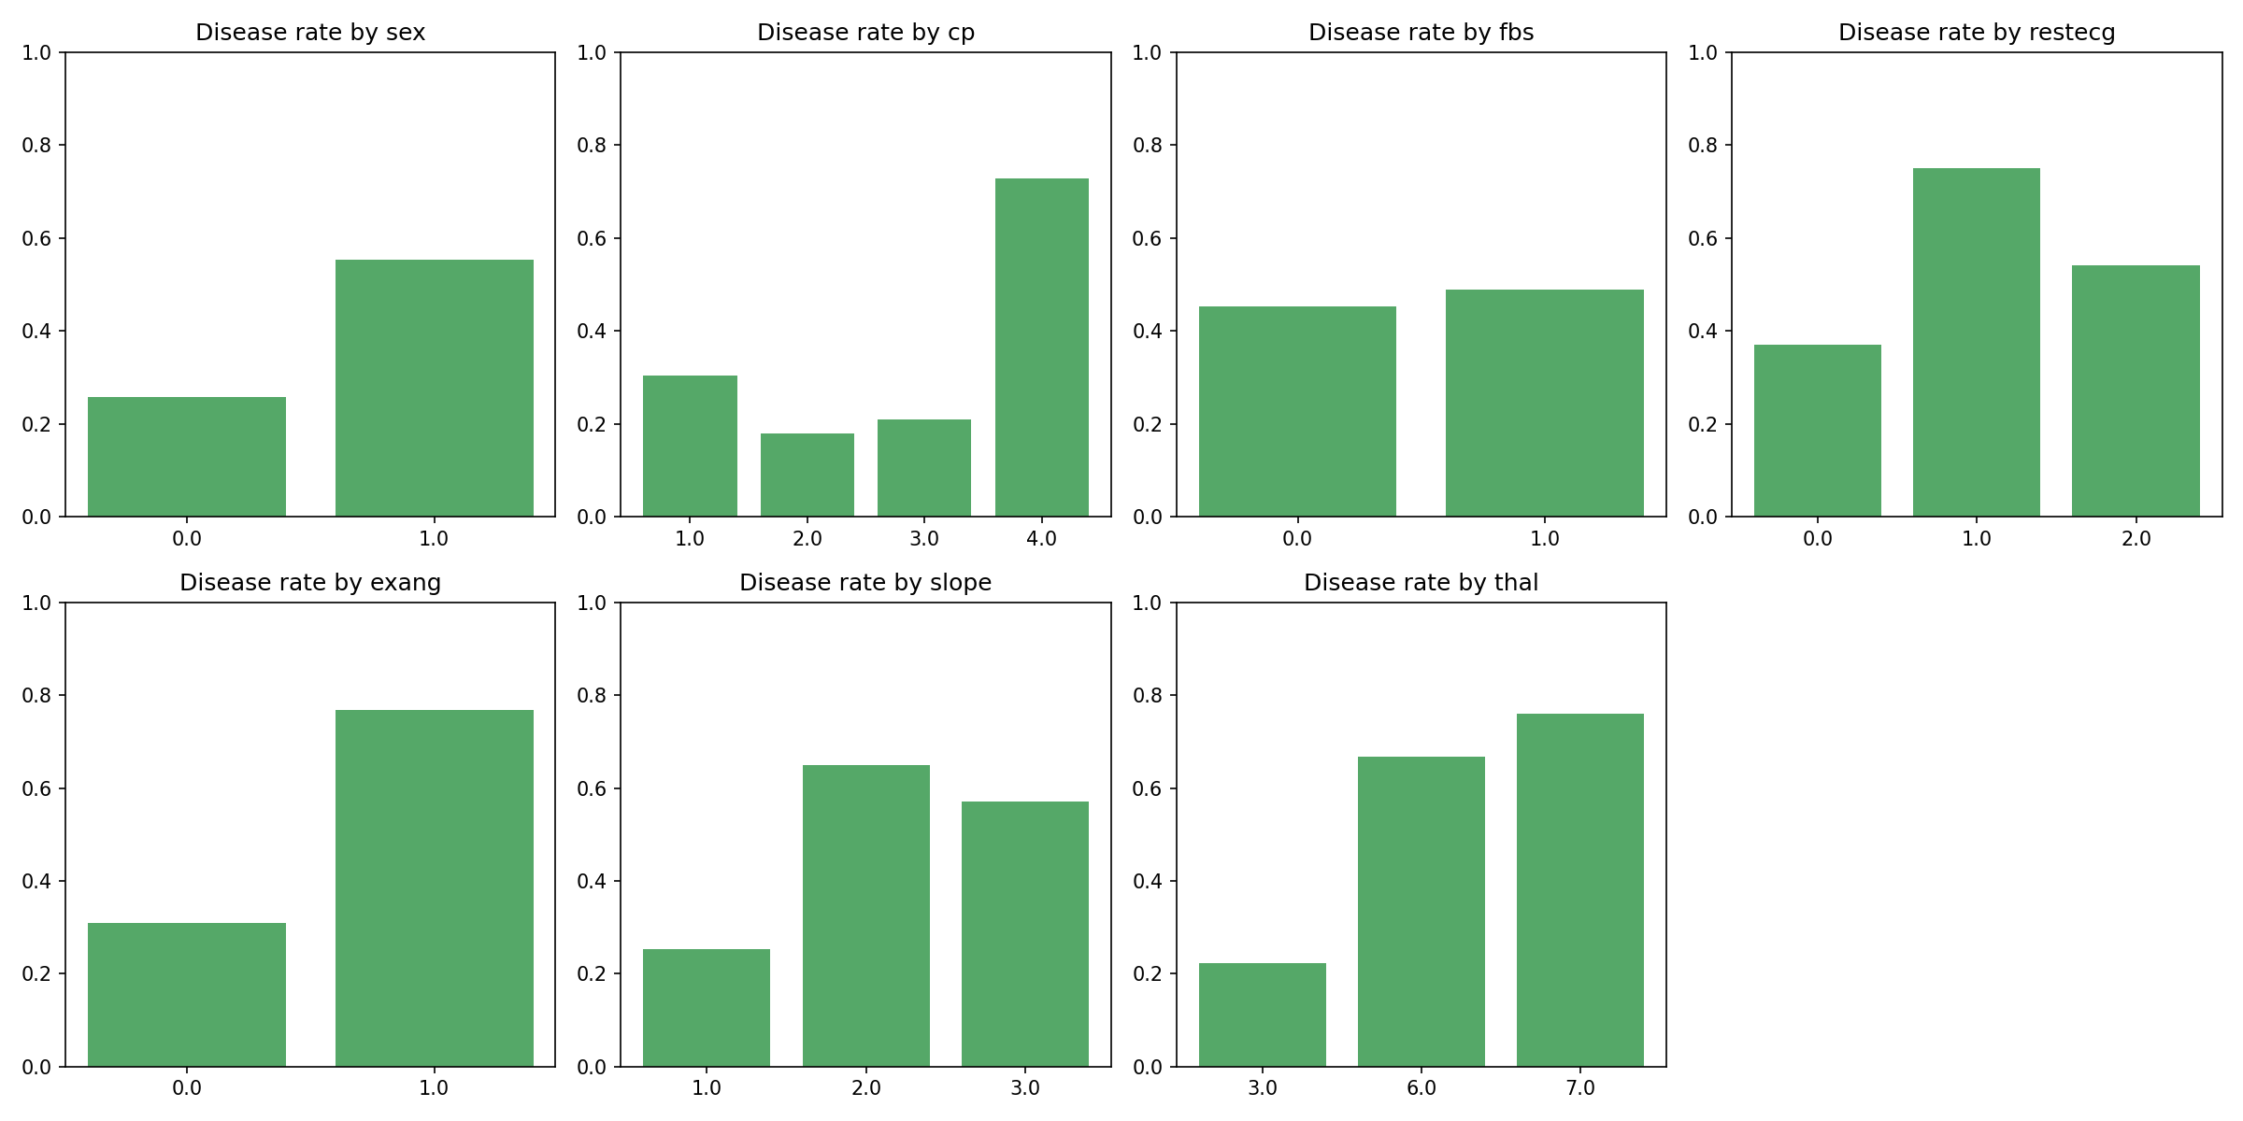
Figure 4. Disease rate by category for each categorical feature
The outlier box plots (reports/figures/05_outliers.png) show a few extreme cholesterol values (up to 564 mg/dl) and ST depressions up to 6.2. These are clinically plausible, so they were retained. Standard scaling limits their influence on the linear model.

5. Feature Engineering and Model Development

5.1 Feature pipeline
heart/features.py defines a ColumnTransformer with two branches. Numeric features (age, trestbps, chol, thalach, oldpeak, ca) are median-imputed and standardised. Categorical features (sex, cp, fbs, restecg, exang, slope, thal) are mode-imputed and one-hot encoded with handle_unknown="ignore", so an unseen category at inference time cannot crash the service. ca is kept numeric because it is an ordinal count with a monotonic relationship to risk.

5.2 Candidate models and tuning
Two model families with different inductive biases were compared. Data was split 80/20 (242 training, 61 hold-out) with stratification and a fixed seed of 42. Each candidate was tuned with GridSearchCV on the training set using 5-fold stratified cross-validation, optimising ROC-AUC. ROC-AUC was chosen because it is threshold-independent and reflects ranking quality, which matters for risk scoring. The tuned pipeline was then re-evaluated with cross-validation on accuracy, precision, recall, F1 and ROC-AUC, and scored once on the untouched hold-out set.
Table 3. Hyper-parameter search
Model | Search space | Best configuration
Logistic Regression (liblinear) | C ∈ {0.01, 0.1, 1, 10}; penalty ∈ {L1, L2}; class_weight ∈ {none, balanced} — 16 fits × 5 folds | C = 0.1, L2, no class weighting
Random Forest | n_estimators ∈ {200, 400}; max_depth ∈ {none, 4, 8}; min_samples_leaf ∈ {1, 3, 5} — 18 fits × 5 folds | 200 trees, max_depth = 4, min_samples_leaf = 5

Table 4. Cross-validated and hold-out performance (real UCI data, CI run #1)
Metric | Logistic Regression | Random Forest
CV ROC-AUC (mean ± sd) | 0.912 ± 0.017 | 0.900 ± 0.032
CV accuracy | 0.847 ± 0.029 | 0.810 ± 0.037
CV precision | 0.869 ± 0.066 | 0.814 ± 0.050
CV recall | 0.792 ± 0.048 | 0.764 ± 0.089
CV F1 | 0.826 ± 0.030 | 0.784 ± 0.047
Hold-out ROC-AUC | 0.962 | 0.955
Hold-out accuracy / precision / recall / F1 | 0.885 / 0.839 / 0.929 / 0.881 | 0.885 / 0.839 / 0.929 / 0.881

5.3 Model selection
The champion is selected automatically on mean cross-validated ROC-AUC, not on the single 61-row hold-out set, which is too small to separate close models reliably. Logistic Regression wins on every cross-validated metric and has roughly half the fold-to-fold variance of the Random Forest. It is also directly interpretable through its coefficients (reports/model_plots/). The tuned forest converged to shallow, heavily regularised trees (depth 4, leaf size 5), which suggests the dataset is too small for a high-variance learner to show an advantage.
On the hold-out set the champion reaches 0.962 ROC-AUC with recall 0.929: it misses only 2 of 28 disease cases (Figure 5, right). In a screening setting false negatives are the costlier error, so this is the most important number. The decision threshold is the default 0.5. The API also returns the raw probability, so a client can apply a more conservative threshold.
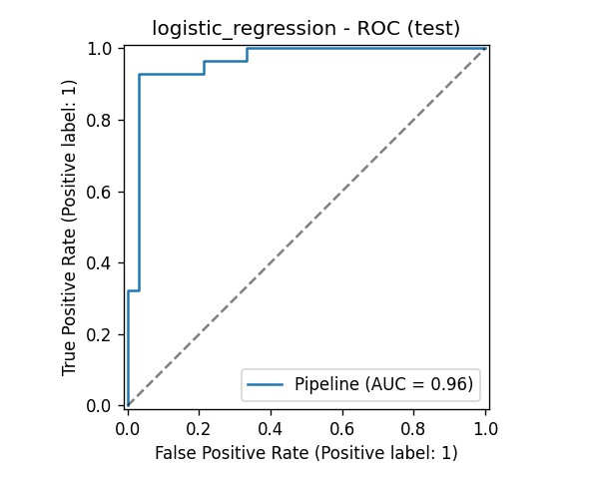 | 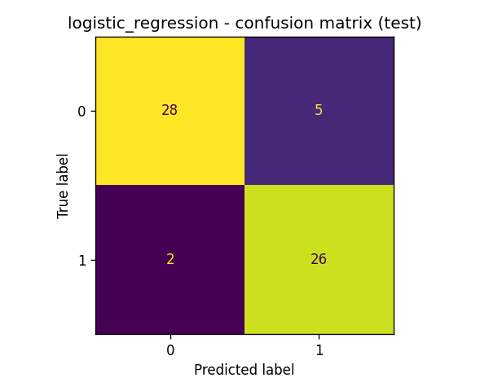
Figure 5. Champion model on the hold-out set: ROC curve (left) and confusion matrix (right)

6. Experiment Tracking with MLflow
Every training run is tracked in MLflow (experiment heart-disease). For each candidate the pipeline logs the following:
- Parameters: model type, best hyper-parameters, CV folds, seed, train/test sizes and grid size.
- Metrics: mean and standard deviation of all five CV metrics, plus the five hold-out metrics.
- Artifacts: the full grid-search results (CSV), confusion matrix, ROC curve and feature-importance plots.
- Model: the full sklearn pipeline with an inferred input/output signature and an input example, so it can be served by MLflow directly.
After both runs finish, the winning run is tagged champion=true, and its run ID is written into models/metadata.json. This links any deployed model version back to its experiment. In CI the mlruns/ directory is uploaded as a workflow artifact, and the MLflow UI is captured automatically (Figure 6).
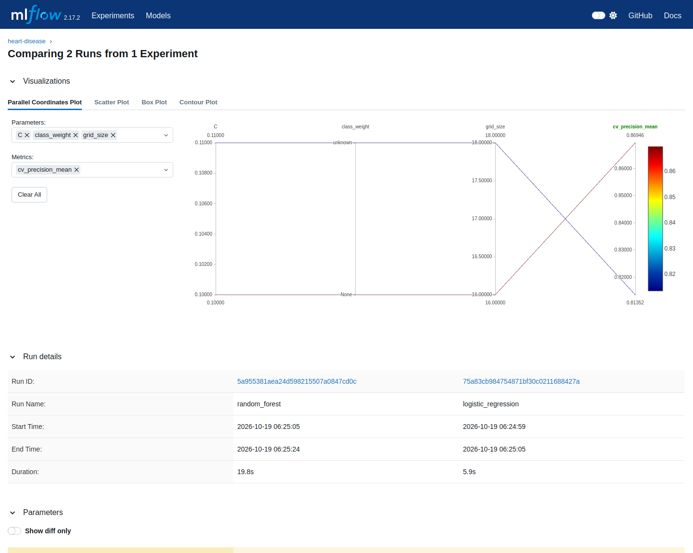
Figure 6. MLflow run comparison: parameters and metrics side by side

7. Model Packaging and Reproducibility
- Single artifact: models/model.joblib contains preprocessing and classifier together. metadata.json records the model name, version timestamp, MLflow run ID, scikit-learn version, feature order, best parameters and all metrics.
- Pinned environments: every package is pinned to an exact version. The serving image uses a smaller requirements-serve.txt with the same pins as training, so the pickled pipeline is always loaded by the scikit-learn version that produced it (1.5.2).
- Determinism: all splits, CV folds and models use seed 42. Re-running heart.train on the committed data/processed/heart_clean.csv on a separate machine reproduced CI run #1 exactly: CV ROC-AUC 0.9117 and hold-out ROC-AUC 0.9621 for the champion.
- Clean-setup guarantee: each CI job starts from a fresh runner and installs only from the requirements files, which proves that every script runs from a clean setup.
- Inference script: python -m heart.predict sample_request.json provides offline batch scoring with the same artifact.

8. CI/CD Pipeline and Automated Testing

8.1 Unit tests
The test/ folder contains 20 Pytest tests that run against synthetic data in the UCI schema, so the test stage never depends on the network:
- test_data.py (7 tests): ? parsing; binary target; zero-cholesterol handling; duplicate removal; column order; schema and target validation errors.
- test_features.py (3 tests): no NaNs after preprocessing; numeric scaling; unseen categories handled.
- test_model.py (5 tests): at least two candidates exist; model and metadata are exported; probabilities are valid; the model learns signal (CV ROC-AUC > 0.6); runs are logged to MLflow with exactly one champion.
- test_api.py (5 tests): /health works; /predict returns a prediction, confidence and request ID; optional fields can be omitted; invalid input is rejected with HTTP 422; Prometheus metrics are exposed.

8.2 Pipeline design
Table 5. GitHub Actions jobs (total run time 8 min 34 s)
Job | What it does | Run #1 time
lint | ruff lint and format check; fails the pipeline on any violation | 9 s
test | Pytest with coverage; JUnit XML and coverage reports uploaded as artifacts | 1 m 40 s
train | Downloads real UCI data, runs EDA and training; publishes the model, MLflow runs and plots; writes the champion metrics to the job summary | 1 m 13 s
docker | Builds the image, runs it, asserts /health, a valid /predict and a 422 for bad input; pushes to GHCR on main | 53 s
deploy-k8s | Creates a kind cluster with NGINX Ingress, deploys the manifests, waits for rollout and calls the API through the Ingress | 2 m 10 s
monitoring | Starts MLflow UI, API, Prometheus and Grafana; generates traffic; captures UI screenshots | 3 m 49 s
publish-evidence | Renders logs and commits the cleaned dataset, figures and screenshots back to the repository | 35 s

Jobs are chained with needs, so a lint error or failing test stops the pipeline before training or deployment. Every shell step runs with set -o pipefail, which means a failure is never masked by tee. On failure, dedicated steps dump pod descriptions and service logs, which keeps the logs clear. Each run uploads ten artifacts, including test reports, the model, MLflow runs, EDA plots and evidence logs.
Issue found and fixed. A manual re-run of an older run failed in the publish job. The job had checked out the old commit, while main already contained evidence from a later run, so the push hit merge conflicts on the same screenshot files. The fix checks out the latest branch head (ref: ${{ github.ref_name }}) and resolves any concurrent update in favour of the newest evidence (git pull --rebase -X theirs). Run #4 then passed all seven jobs in 7 min 59 s with identical model metrics, which confirms both the fix and the reproducibility of training.
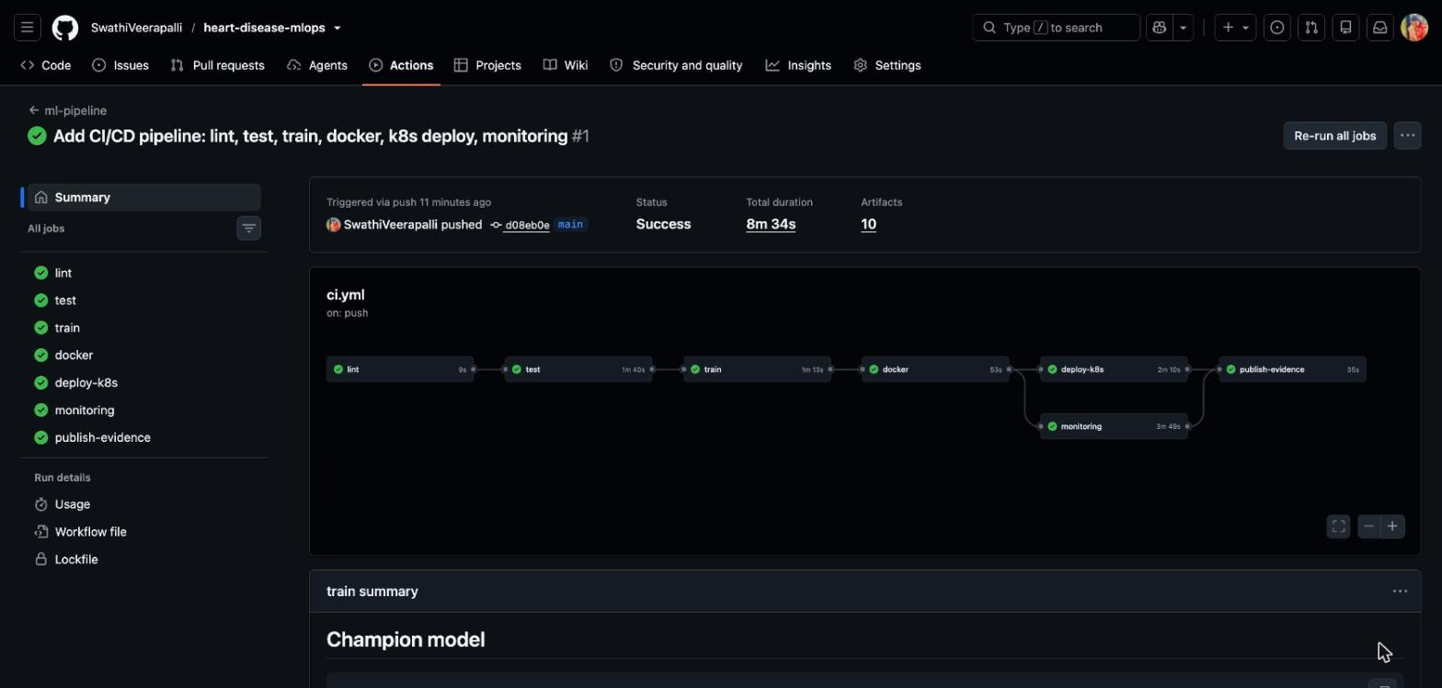
Figure 7. GitHub Actions run #1: all seven jobs succeeded
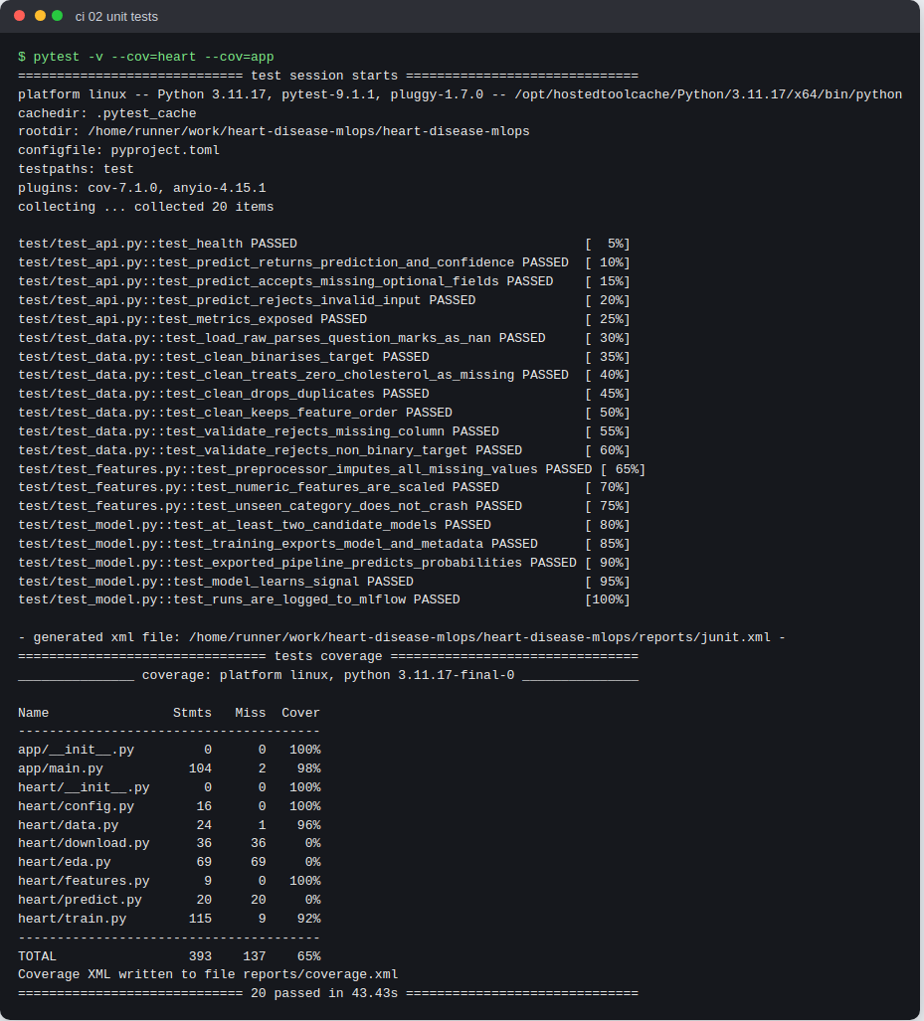
Figure 8. Unit-test stage output in CI: 20 tests passed
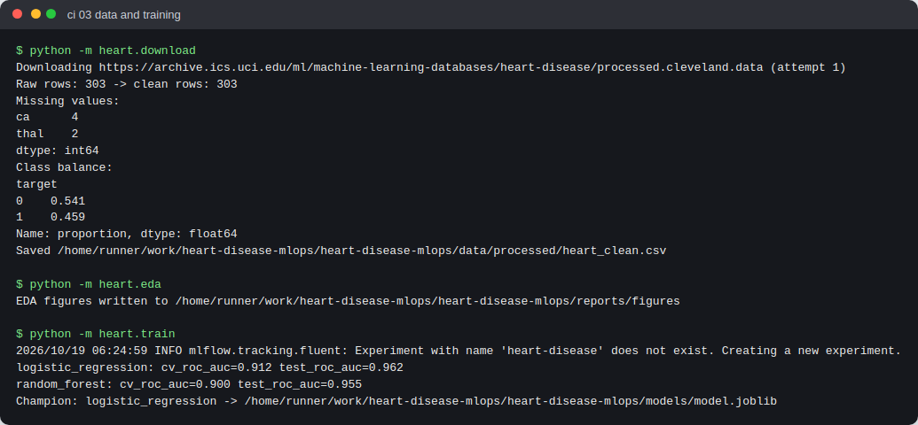
Figure 9. Training stage on the real dataset: download, cleaning, EDA and model selection

9. Model Containerisation and API
The API (app/main.py) is built with FastAPI. Requests are validated by a Pydantic schema with clinical range checks: for example, age must be 1–120, cp must be 1–4 and thal must be 3, 6 or 7. Invalid input is rejected with HTTP 422 before it reaches the model. The model loads once at startup.
Table 6. API contract
Endpoint | Purpose
POST /predict | JSON patient record → prediction (0/1), label, confidence, probability_disease, model_version, request_id
GET /health | Liveness/readiness probe; 503 if the model is not loaded
GET /model-info | Model metadata (name, version, metrics, MLflow run ID)
GET /metrics | Prometheus exposition format
GET /docs | Interactive Swagger documentation with a ready-to-run example request

The Dockerfile is based on python:3.11-slim and installs only the serving requirements. It runs as a non-root user (UID 10001) and defines a HEALTHCHECK. It uses a single Uvicorn worker per container, so the Prometheus counters stay consistent, and scaling is handled by Kubernetes replicas instead. The CI docker job proves the container builds and serves correctly in isolation (Figure 10). The interactive Swagger UI is captured in screenshots/api_01_swagger_docs.png.
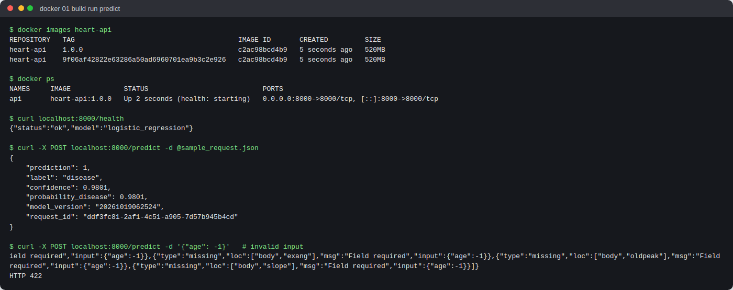
Figure 10. Container build-and-run proof from CI: image, running container, health check, prediction and input validation

10. Production Deployment on Kubernetes
The manifests in k8s/ define a dedicated namespace and a Deployment with 2 replicas and rolling updates (maxUnavailable 0). The pods have readiness and liveness probes on /health and CPU and memory requests and limits, and they run with a hardened security context (non-root, read-only root filesystem, no privilege escalation). Pod annotations enable Prometheus scraping. Traffic reaches the pods through a LoadBalancer Service and an NGINX Ingress (heart-api.local). A HorizontalPodAutoscaler scales between 2 and 5 replicas at 70% CPU.
In CI the deployment is verified on an ephemeral kind cluster with the NGINX Ingress controller. Both pods become ready, and real requests are routed through the Ingress (Figures 11–12). The same manifests deploy to Minikube (Section 3.4) or a managed cluster such as EKS, GKE or AKS. For a managed cluster, point the Deployment image at the published GHCR image ghcr.io/swathiveerapalli/heart-disease-mlops/heart-api:latest.
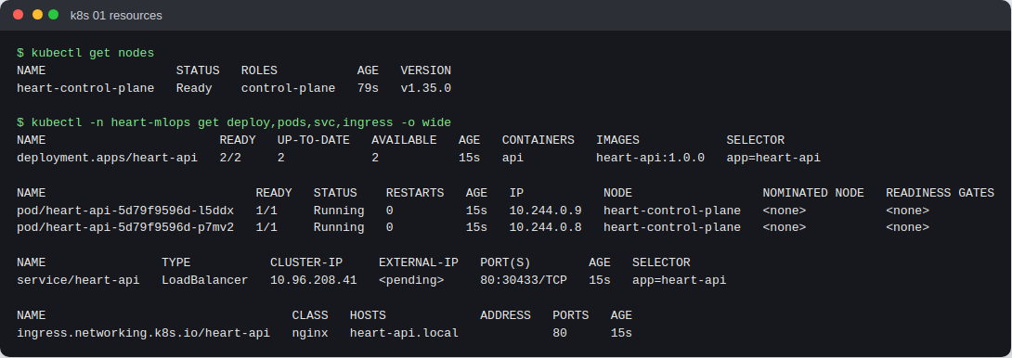
Figure 11. Kubernetes resources: node, deployment (2/2 ready), pods, LoadBalancer service and ingress
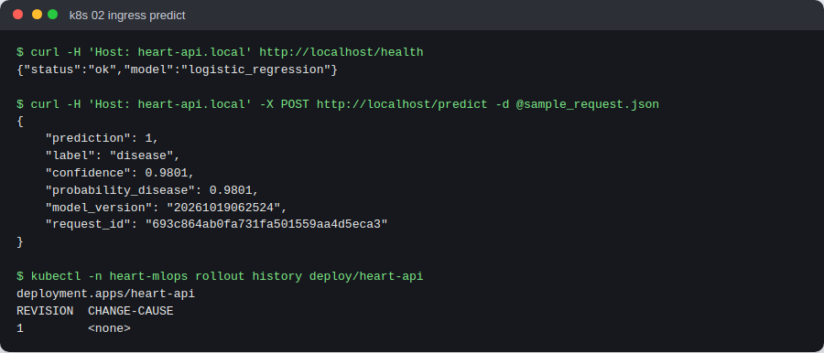
Figure 12. Health check and prediction through the NGINX Ingress

11. Monitoring and Logging
Logging. A middleware writes one structured JSON line per request, containing the request ID, method, path, status, latency and client. A second line records each prediction with its confidence. The request ID is also returned in the x-request-id header, so a client-side problem can be matched to a server log line. Because the logs go to stdout, they are collected by docker logs and kubectl logs and can be shipped by any standard log agent (Figure 13).
Metrics. The service exposes api_requests_total (by method, path and status), the api_request_latency_seconds histogram, model_predictions_total by predicted class, a model_prediction_confidence histogram and a model_loaded gauge. Prometheus scrapes them every 10 seconds. Grafana is provisioned automatically with a dashboard showing request rate, p95 latency, predictions by class, error rate, median confidence and model status.
In the monitoring CI job, about 500 synthetic requests (5% deliberately invalid) were sent to the API. The dashboard shows a p95 latency of about 5 ms after warm-up and an error-rate spike matching the injected bad requests. It also shows a stable split between predicted classes, which is the basis for detecting prediction drift (Figure 14). Prometheus target health is in screenshots/monitoring_01_prometheus_targets.png.
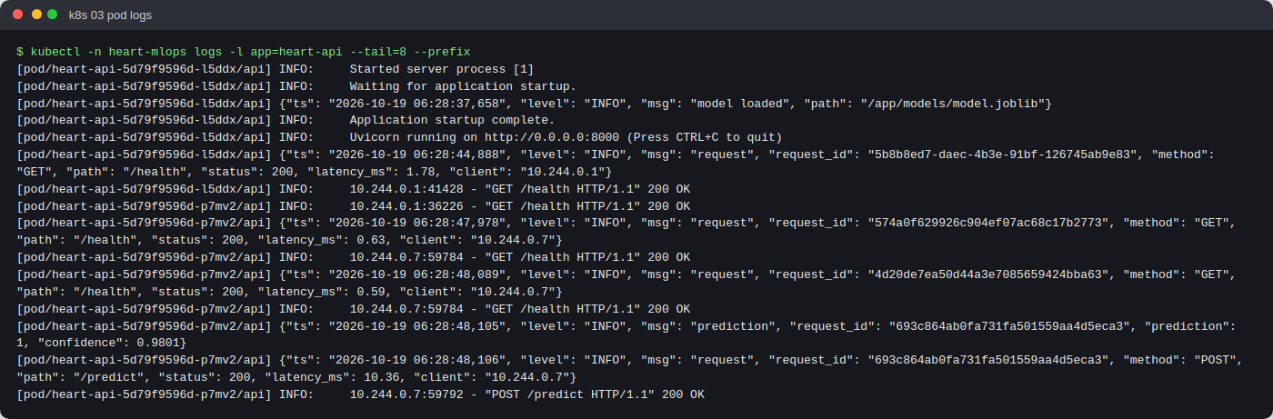
Figure 13. Structured JSON request and prediction logs from the Kubernetes pods
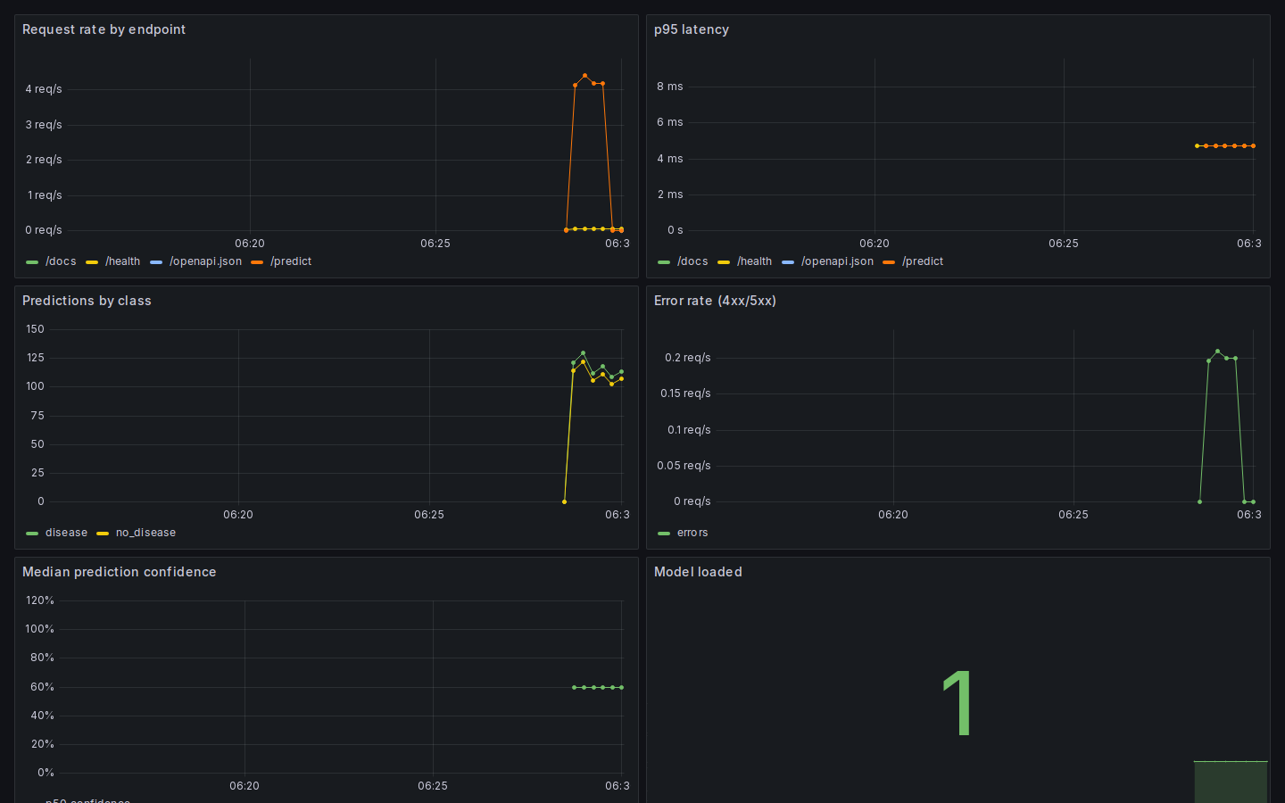
Figure 14. Grafana dashboard generated from live traffic in the CI monitoring job

12. Deliverables and Access
Table 7. Deliverables checklist
Required deliverable | Location
Code, Dockerfile, requirements | heart/, app/, Dockerfile, requirements*.txt
Cleaned dataset + download script | data/processed/heart_clean.csv, heart/download.py
Scripts for EDA, training, inference | heart/eda.py, heart/train.py, heart/predict.py
test/ folder with unit tests | test/ (20 tests)
GitHub Actions workflow | .github/workflows/ci.yml
Deployment manifests | k8s/ (+ k8s/kind/kind-config.yaml)
Screenshot folder | screenshots/ (CI, Docker, Kubernetes, MLflow, monitoring)
Final report | This document
API access | Local or Kubernetes deployment per Section 3; container image on GHCR

Repository: https://github.com/SwathiVeerapalli/heart-disease-mlops
Pipeline run: https://github.com/SwathiVeerapalli/heart-disease-mlops/actions/runs/39206495186

13. Conclusion
The project delivers a reproducible, automated path from the raw UCI dataset to a monitored prediction service. A regularised Logistic Regression was selected over a Random Forest on cross-validated ROC-AUC (0.912 vs 0.900). It generalises to the hold-out set with 0.962 ROC-AUC and 93% recall. Every stage is enforced by CI, which includes quality gates, a container smoke test, a real Kubernetes rollout behind an Ingress, and live monitoring.
Natural next steps would be:
- Calibrate probabilities and choose the decision threshold from a clinical cost matrix.
- Add data-drift checks on incoming feature distributions.
- Promote models through the MLflow Model Registry with a manual approval gate before production.
- Deploy to a managed cluster with the AWS Load Balancer Controller or equivalent for a persistent public endpoint.

