* Create a Component (DLL) with two classes FirstT and SecondT . FirstT is hidden in the namespace and SecondT is exposed. Make class SecondT exposing the features of class FirstT indirectly

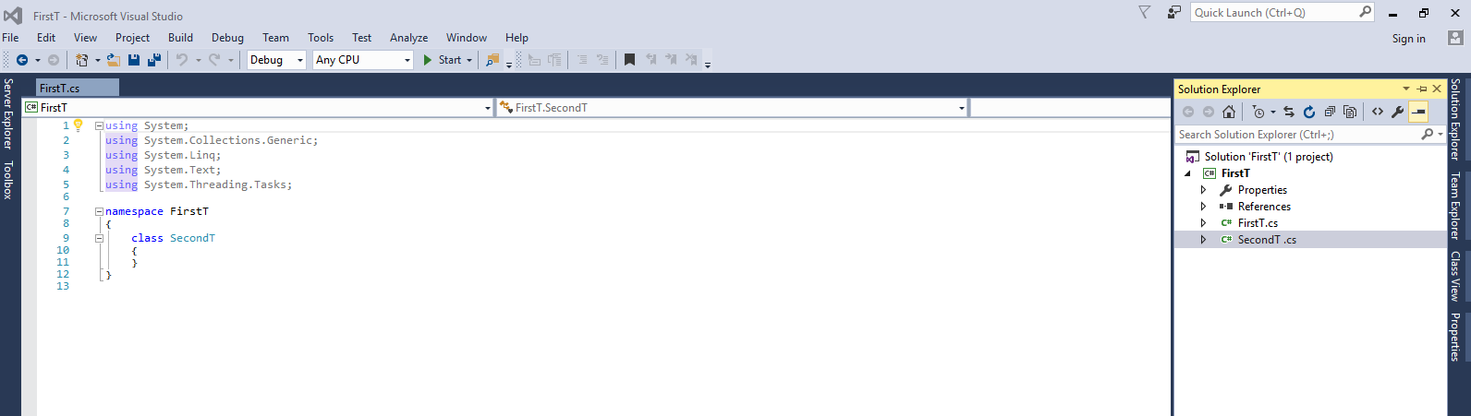

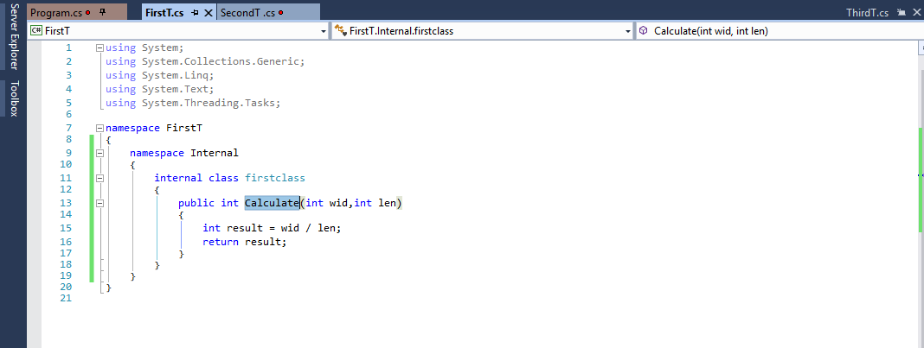

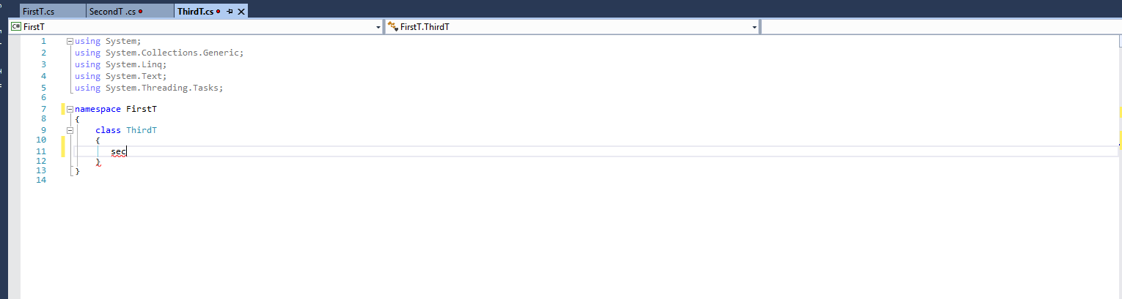

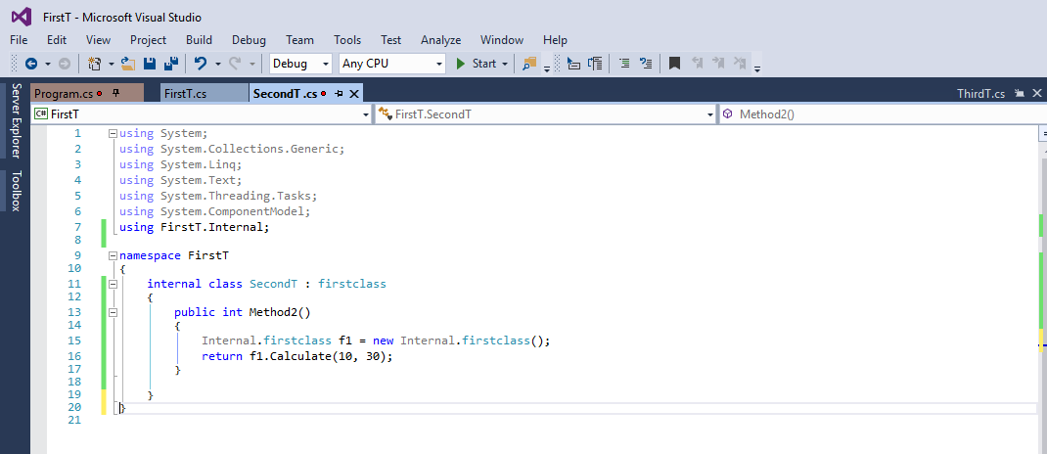

* Create a Component (DLL) with outer namespace MyNameSpace and sub namespace ChildSpace. Both the namespaces should contain classes called Policies. Use namespace aliasing or namespace member aliasing technique

