* Write an simple hello world console application

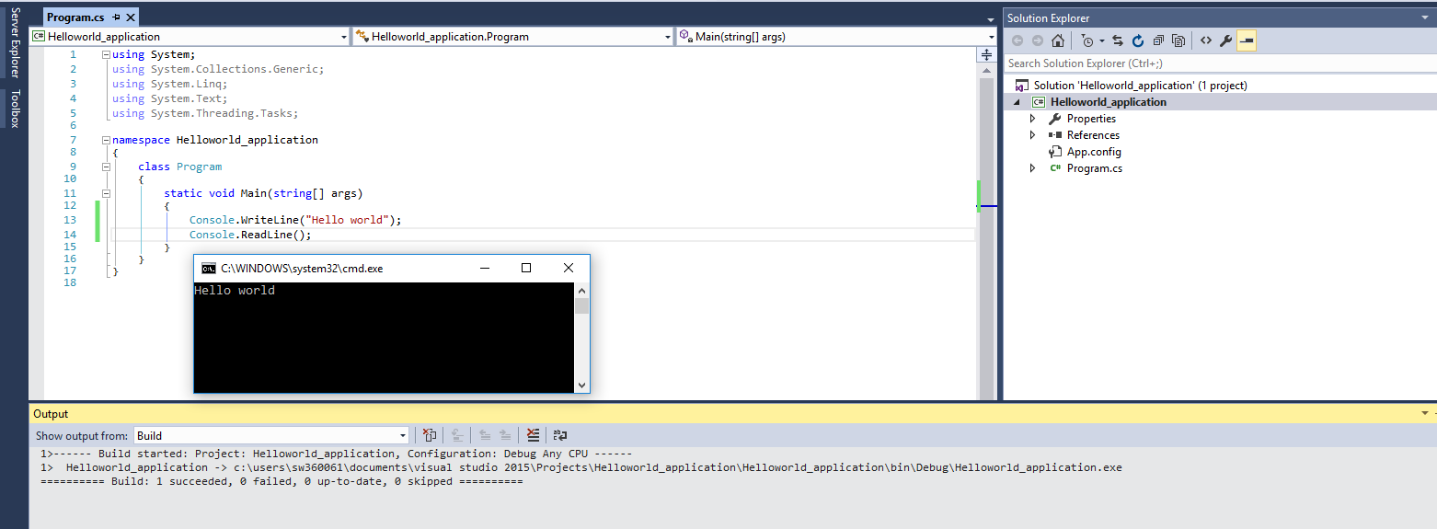

* Create a Console Application to accept the side of the square and print the area of the square

