8. Exception Handling

* Write a simple console application to take a input from the screen and use it for division and generate an exception with this by dividing by 0. Use this to generate error and add try catch block and finally block to handle these.

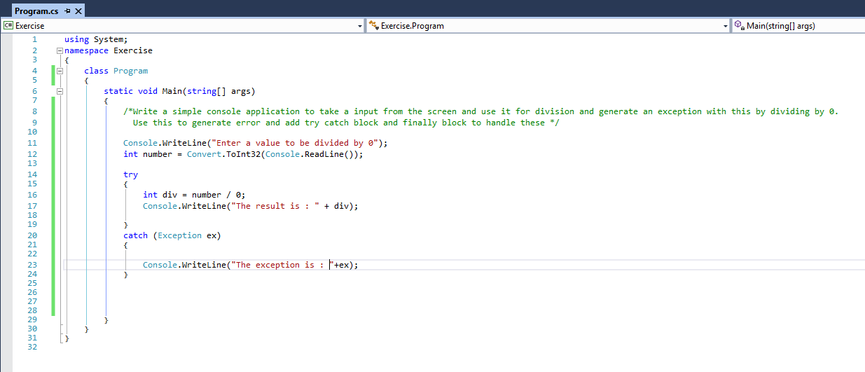

* Write a Program to take care of Number Format Exception if user enters values other than integer for calculating average marks of 2 students. The name of the students and marks in 3 subjects are taken from the user while executing the program. In the same Program write your own Exception classes to take care of Negative values and values out of range (i.e. other than in the range of 0-100)

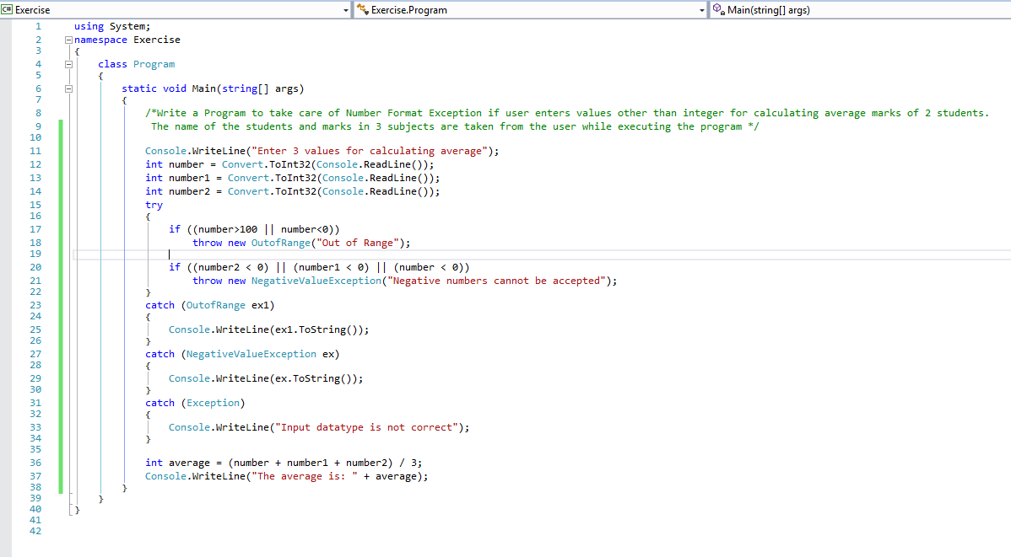

* In this exercise, you will add functionality to the program that you created in Control Structures. The program will examine the initial day number that is entered by the user. If it is less than 1 or greater than 365, the program will throw an InvalidArgument exception (“Day out of range”). The program will trap this exception in a catch clause and display a diagnostic message on the console.

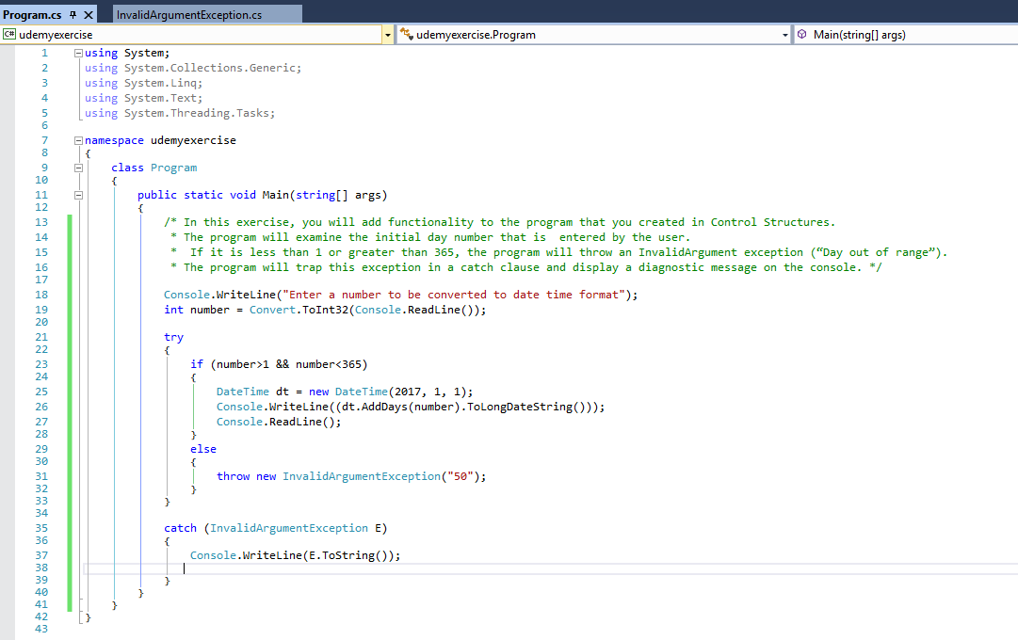

* Adding more functionality to the above program. The program will prompt the user for a year in addition to a day number. The program will detect whether the specified year is a leap year. It will validate whether the day number is between 1 and 366 if the year is a leap year, or whether it is between 1 and 365 if the year is not a leap year. Finally, it will use a new foreach statement to correctly calculate the month and day pair for leap years.

