**GitHub Actions**

[**Actions**](https://docs.github.com/en/actions/about-github-actions/understanding-github-actions#actions)

a continuous integration and continuous delivery (CI/CD) platform that allows you to automate your build, test, and deployment pipeline. You can create workflows that build and test every pull request to your repository, or deploy merged pull requests to production.

An action is a custom application for the GitHub Actions platform that performs a complex but frequently repeated task. Use an action to help reduce the amount of repetitive code that you write in your workflow files. An action can pull your Git repository from GitHub, set up the correct toolchain for your build environment, or set up the authentication to your cloud provider.

[**Overview**](https://docs.github.com/en/actions/about-github-actions/understanding-github-actions#overview)

GitHub Actions is a continuous integration and continuous delivery (CI/CD) platform that allows you to automate your build, test, and deployment pipeline. You can create workflows that build and test every pull request to your repository, or deploy merged pull requests to production.

GitHub Actions goes beyond just DevOps and lets you run workflows when other events happen in your repository. For example, you can run a workflow to automatically add the appropriate labels whenever someone creates a new issue in your repository.

GitHub provides Linux, Windows, and macOS virtual machines to run your workflows, or you can host your own self-hosted runners in your own data center or cloud infrastructure.

[**The components of GitHub Actions**](https://docs.github.com/en/actions/about-github-actions/understanding-github-actions#the-components-of-github-actions)

You can configure a GitHub Actions **workflow** to be triggered when an **event** occurs in your repository, such as a pull request being opened or an issue being created. Your workflow contains one or more **jobs** which can run in sequential order or in parallel. Each job will run inside its own virtual machine **runner**, or inside a container, and has one or more **steps** that either run a script that you define or run an **action**, which is a reusable extension that can simplify your workflow.

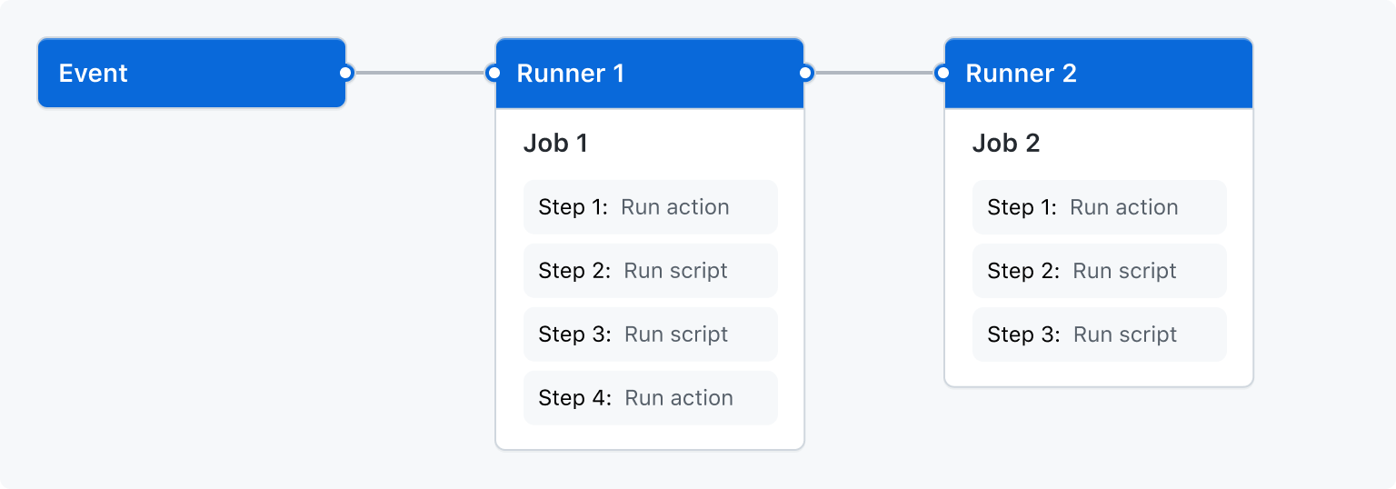

[**Workflows**](https://docs.github.com/en/actions/about-github-actions/understanding-github-actions#workflows)

A **workflow** is a configurable automated process that will run one or more jobs. Workflows are defined by a YAML file checked in to your repository and will run when triggered by an event in your repository, or they can be triggered manually, or at a defined schedule.

Workflows are defined in the .github/workflows directory in a repository. A repository can have multiple workflows, each which can perform a different set of tasks such as:

* Building and testing pull requests.
* Deploying your application every time a release is created.
* Adding a label whenever a new issue is opened.

You can reference a workflow within another workflow. For more information, see "[Reusing workflows](https://docs.github.com/en/actions/using-workflows/reusing-workflows)."

For more information, see "[Writing workflows](https://docs.github.com/en/actions/using-workflows)."

[**Events**](https://docs.github.com/en/actions/about-github-actions/understanding-github-actions#events)

An **event** is a specific activity in a repository that triggers a **workflow** run. For example, an activity can originate from GitHub when someone creates a pull request, opens an issue, or pushes a commit to a repository. You can also trigger a workflow to run on a [schedule](https://docs.github.com/en/actions/using-workflows/events-that-trigger-workflows#schedule), by [posting to a REST API](https://docs.github.com/en/rest/repos/repos#create-a-repository-dispatch-event), or manually.

For a complete list of events that can be used to trigger workflows, see [Events that trigger workflows](https://docs.github.com/en/actions/using-workflows/events-that-trigger-workflows).

[**Jobs**](https://docs.github.com/en/actions/about-github-actions/understanding-github-actions#jobs)

A job is a set of steps in a workflow that is executed on the same runner. Each step is either a shell script that will be executed, or an action that will be run. Steps are executed in order and are dependent on each other. Since each step is executed on the same runner, you can share data from one step to another. For example, you can have a step that builds your application followed by a step that tests the application that was built.

[**Next steps**](https://docs.github.com/en/actions/about-github-actions/understanding-github-actions#next-steps)

GitHub Actions can help you automate nearly every aspect of your application development processes. Ready to get started? Here are some helpful resources for taking your next steps with GitHub Actions:

* To create a GitHub Actions workflow, see "[Using workflow templates](https://docs.github.com/en/actions/learn-github-actions/using-starter-workflows)."
* For continuous integration (CI) workflows, see "[Building and testing](https://docs.github.com/en/actions/automating-builds-and-tests)."
* For building and publishing packages, see "[Publishing packages](https://docs.github.com/en/actions/publishing-packages)."
* For deploying projects, see "[Use cases and examples](https://docs.github.com/en/actions/deployment)."
* For automating tasks and processes on GitHub, see "[Managing projects](https://docs.github.com/en/actions/managing-issues-and-pull-requests)."
* For examples that demonstrate more complex features of GitHub Actions, see "[Use cases and examples](https://docs.github.com/en/actions/examples)." These detailed examples explain how to test your code on a runner, access the GitHub CLI, and use advanced features such as concurrency and test matrices.
* To certify your proficiency in automating workflows and accelerating development with GitHub Actions, earn a GitHub Actions certificate with GitHub Certifications. For more information, see "[About GitHub Certifications](https://docs.github.com/en/get-started/showcase-your-expertise-with-github-certifications/about-github-certifications)."