**1.** **Split_funcation**

split splits a string into an array of substrings, based on a delimiter that you choose, and returns the item specified by the position.

You can only add split to a calculated field during data preparation, not to an analysis.

**Syntax :**

split(*expression*, *delimiter* , *position*)

***expression :***

*It can be the name of a field that uses the string data type, a literal value like '12 Main Street;1402 35th Ave;1818 Elm Ct;11 Janes Lane', or a call to another function that outputs a string.*

***Delimiter :***

*The character that delimits where the string is broken into substrings. For example, split('one|two|three', '|', 2)*

*one*

*two*

*three*

*If you choose position = 2, split returns 'two'.*

***Example :***

*example splits a string into an array, using the semicolon character (;) as the delimiter, and returns the third element of the array.*

*split('123 Test St;1402 35th Ave;1818 Elm Ct;11 Janes Lane', ';', 3)*

***output :***

*1818 Elm Ct*

*Incorrect  
({ProductName}, ’ ', 1)*

*Correct  
({ProductName}, ’ ', 1)  
or  
({ProductName}, " ", 1)  
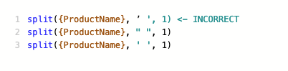*

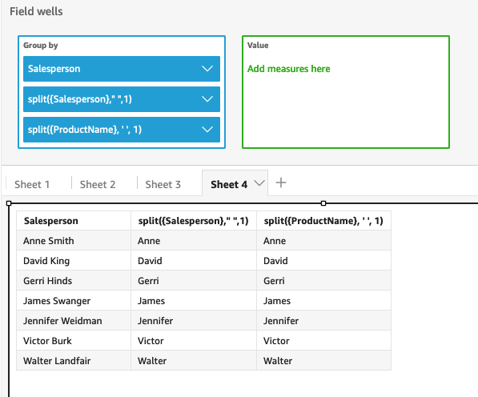

**2. Locate_funcation**

locate locates a substring that you specify within another string, and returns the number of characters until the first character in the substring.

**Syntax :**

locate(*expression*, *substring*, *start*)

**Examples :**

locate('1 and 2 and 3 and 4', 'and')

3

locate('1 and 2 and 3 and 4', 'and', 4)

9

**3. Substring_funcation :**

substring returns the characters in a string, starting at the location specified by the *start* argument and proceeding for the number of characters specified by the *length* arguments.

**Syntax**

substring(*expression*, *start*, *length*)

**Example :**

substring('Fantasy and Science Fiction',13,7)

output :

Science

**4.update dags**

To add or update a DAG, move the Python . py file for the DAG to the /dags folder in the environment's bucket.

In the list of environments, find a row with the name of your environment and in the DAGs folder column click the DAGs link.