**19CSE461 Net Centric Programming**

**Evaluation Lab 1 (15th September 2022)**

**Duration: 3 Slots**

**Instructions :**

1. **Students can copy the table that has the split up for each question in the sheet**
2. **Create a word document and place the following:**
3. **Place the URL of the online server where the web application has been hosted**
4. **Points explaining how the relevant features were completed for each question**
5. **Output for each application with its screenshot**
6. **Unique features added to an application other than asked for each question**
7. **Students can upload their submission under**
8. **Create two folders named Q1 and Q2**
9. **Under Q1 and Q2 place the respective folders**
10. **Place the prepared word document under the folder.**

**https://amritavishwavidyapeetham-my.sharepoint.com/:f:/g/personal/t_senthilkumar_cb_amrita_edu/EsjtHvtck-ROofjcnWU8Hy4BJqRXjpSMkTE0tEFptzkj4A?e=FLrmgX**

**Official**

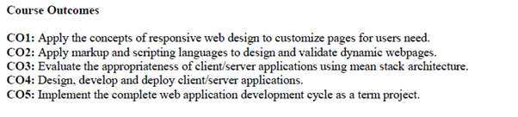 **Total Marks :50**

1. Design the following Responsive Webpage using Flexbox. Each block of this page should have its own style design descriptions with possible responsive features. Use the media query to display the same for the mobile screens as shown in Figure 1 (Note the block ‘Class Rooms’ is removed in the mobile display).

Try to accommodate the ratio of each block as shown in the picture.

The content layout is shown below for a Desktop version:

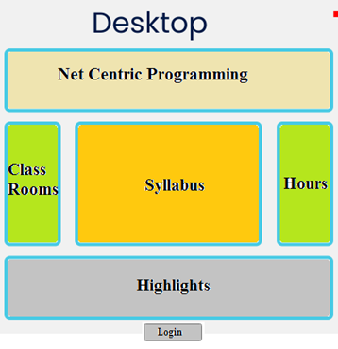

The content layout is shown below for a Mobile version

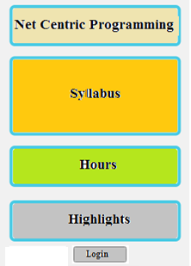

--- 15 Marks

|  |  |
| --- | --- |
| Form Design (5) |  |
| Desktop Version (5) |  |
| Mobile version (5) |  |

1. When the Login button is pressed, it has to navigate to another screen which has a form as below:

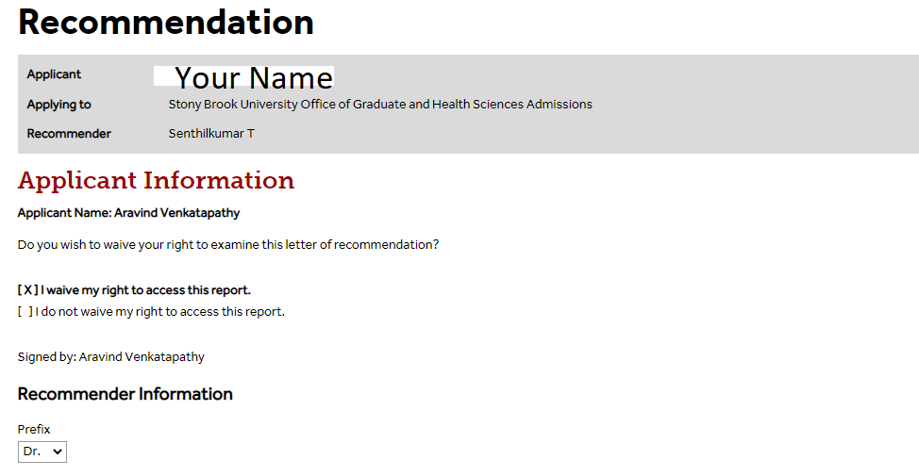

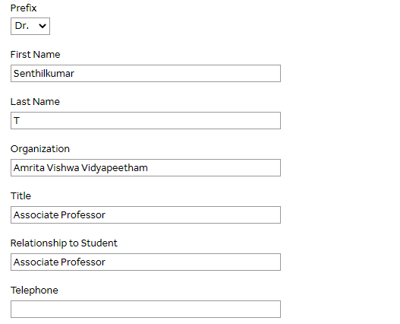



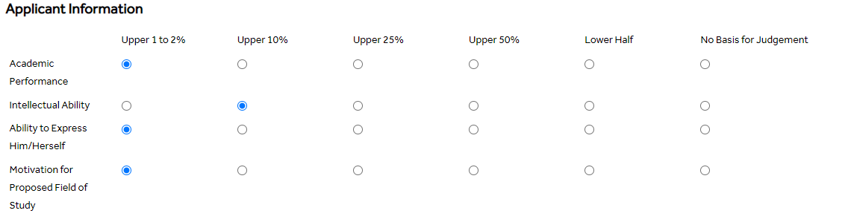







The validations to be done with Javascript are:

1. emailild should not be empty
2. The email should have a @ symbol
3. On clicking Display it should display the details of Email and Applicant information

--- 20 Marks

|  |  |
| --- | --- |
| Form Design | 10 |
| Java Script Validation | 10 |

1. Create a XML and XML DTD for the form above and validate the DTD .

---15 Marks

|  |  |
| --- | --- |
| XML File | 5 Marks |
| DTD File Validation | 10 Marks |