**InnovativeApp Using Django Framework:**

*Screenshots:*

1. **Running the code in terminal:**

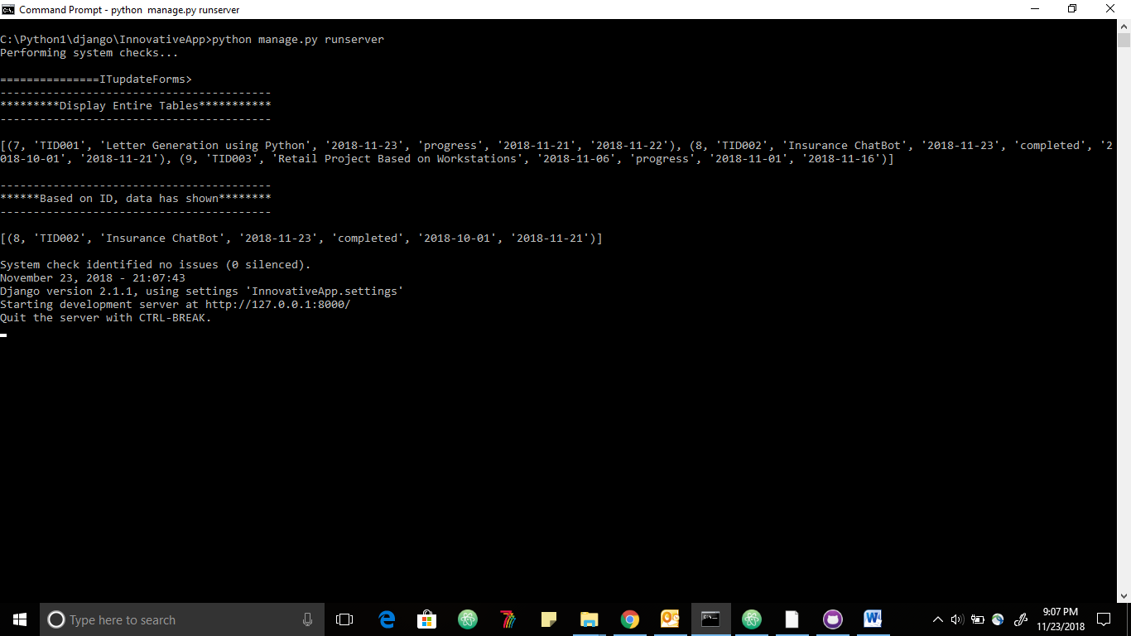

It will list all items in the database and also show particular task id details.

1. **View all items in the list.**

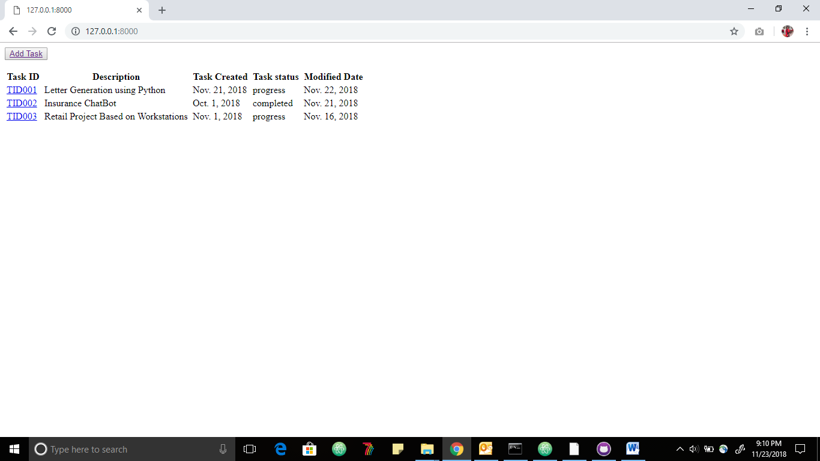

1. Added new row
2. 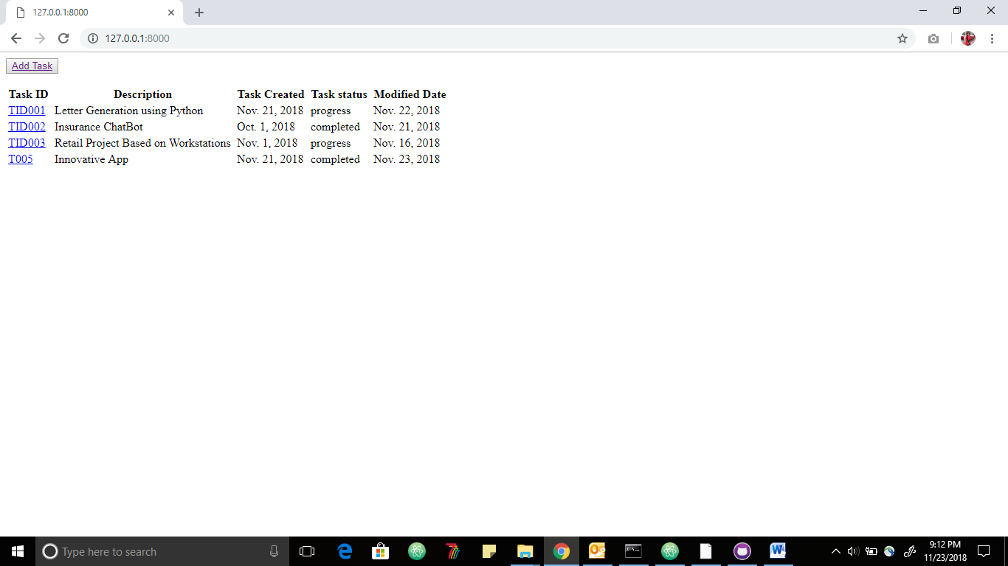Admin page view

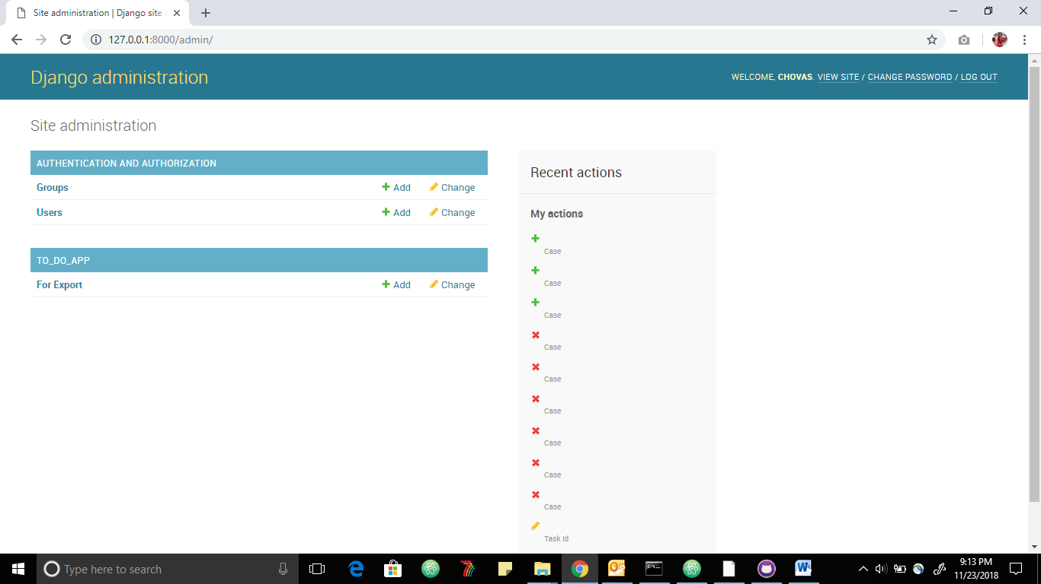

1. Added search and filtering and also export csv files

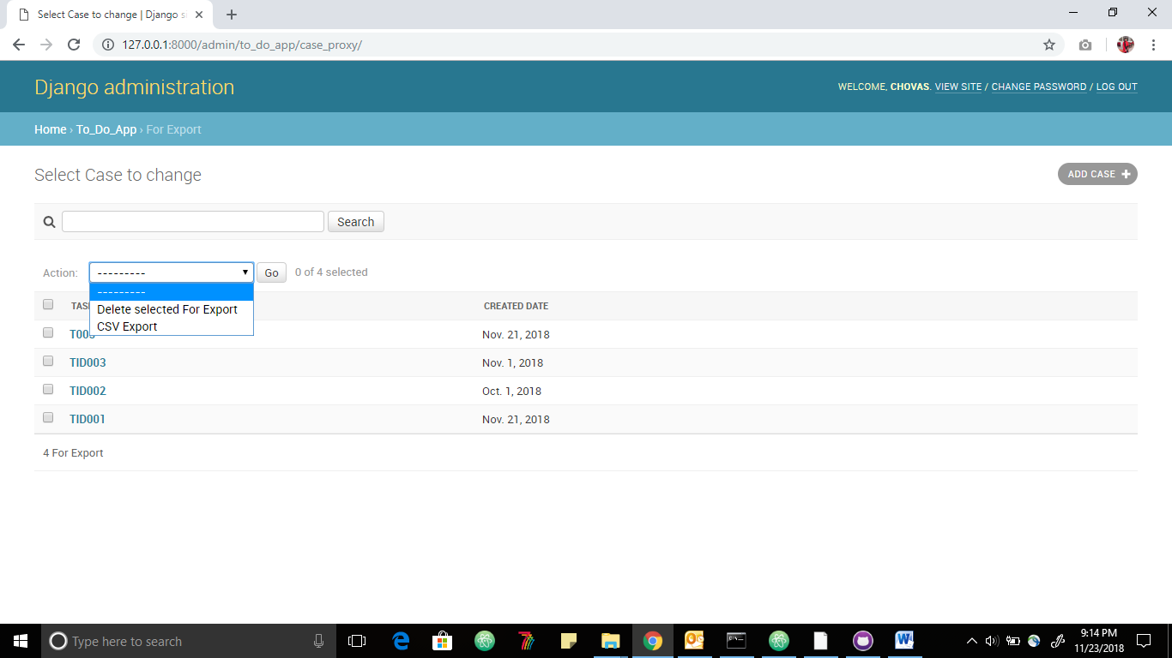

1. csv files

